**Bed Management Solution (BMS)**

**User Guide**



**BMS version 2.3**

**November 2016**

**Revision History**

| **Date** | **Version** | **Description/Comments** | **Author(s)** |
| --- | --- | --- | --- |
| 11/22/2016 | 2.3 | Added/removed screenshots and descriptions for the SSO (Single Sign On) PIV login pages. | D. Horn |
| 11/3/2016 | 2.2 | Address 508 conformance | D. Bishop |
| 9/15/2016 | 2.1 | Updated TOC | D. Bishop |
| 06/07/2016 | 2.0 | Updated screenshots and additional functionality done through BMS 2.0 | D. Horn |
| 04/05/2016 | 1.6 | Added missing 1.3 update from 10/14/2013 | P. O’Reilly |
| 03/18/2016 | 1.6 | Updated for accessibility | L. Harth and P. O’Reilly |
| 03/04/2016 | 1.6 | Updated for BMS version 1.6.  The following Figures were updated:   * Figure 10 – BMS VISN Network Bed Boards Screen * Figure 11 – BMS National/Regional Screen * Figure 241 – VISN Bed Boards Page * Figure 242 – Adding a Patient to Patients Pending Bed Placement List * Figure 248 – VISN Bed Boards Page – Summary Reports * Figure 255 – BMS National / Regional Home Page * Figure 258 – Accessing Administration Section Page from National/Regional page | L. Harth |
| 8/11/2015 | 0.6 | Updated for BMS version 1.5 and fixes to document formatting. The following sections were modified:   * 3.2.1 – Obtain BMS Access – pages 17-18 * 3.2.3 – Log in – pages 18-19 * 4.1.5.1 – Ward Whiteboard Kiosk URL Settings – pages 48-49 * 4.1.5.2 – EMS Mobile URL Settings – page 49 * Figure 166 – Scheduled Admissions Report – page 129 * Table 24 – Scheduled Admissions Parameters – page 130 * Figure 187 – Scheduled Admissions by Date – page 148 * Table 38 – Scheduled Admissions Parameters – Page 149 * 4.2.4.1 – Taking a Bed out of Service – Last paragraph – Page 162 * 4.9.6.5 – Generating an icon usage report – Pages 213-214 * Figure 277 – Adminstration Section – Icon Usage Report – Page 214 | P. O’Reilly |
| 04/01/2015 | 0.5 | Updated ADT description in section 4.9.12.3. | P. O’Reilly |
| 03/30/2015 | 0.4 | Technical edit. | R. Wilder |
| 07/18/2013 | 0.3 | Updated section 4.1.5 Facility Settings, section 4.1.5.1 Ward Whiteboard Kiosk URL Settings, section4.4.2 EMS Staff Page for Mobile Devices, section 4.9.4 Edit BMS Facility Settings Page, section 4.9.12.5 NUMI, section 4.9.13 Clear Cache confirmation Page, and added Figure 316. | S. Greenacre |
| 10/14/2013 | (1.3) | Updated tables 22 and 42 DISCH STATUS description. | S. Greenacre |
| 7/29/2013 | 0.2 | Updated section 4.9.12.1 to add the MDWS Endpoint. | S. Greenacre |
| 06/18/2013 | 0.1 | Initial baseline. | S. Greenacre |

**Table of Contents**

1 Introduction 30

1.1 Intended Audience 30

1.2 Document Conventions 30

1.3 Reference Materials 30

2 User Computing Environments 31

2.1 System Requirements 31

2.2 Internet Explorer Settings 31

3 BMS User Manual 32

3.1 What is BMS 32

3.2 Getting Started 33

3.2.1 Obtain BMS Access 33

3.2.2 Launch BMS 34

3.2.3 Log in 34

3.2.4 BMS Main Pages 36

3.2.5 Working with data grids 41

3.2.5.1 Sort Information within Columns 41

4 BMS Instructions/User Types 41

4.1 Facility Administrators Users 41

4.1.1 Bed Board Site Configuration Main Page 42

4.1.2 VistA Ward Add/Edit Page 43

4.1.2.1 Adding a VistA Ward to the Ward Groups Defined for the Current Facility 45

4.1.2.2 Editing a Ward Group 47

4.1.2.3 Deleting a Ward Group 49

4.1.3 Bed Board BMS Orderable Items Configuration Page 52

4.1.4 EMS Bed Notification Page 55

4.1.5 Facility Setting Page 66

4.1.5.1 Ward Whiteboard Kiosk URL Settings 68

4.1.5.2 EMS Mobile URL Settings 69

4.1.6 EMS Staff Add/Edit/Delete Users Page 70

4.1.6.1 Adding an EMS User 70

4.1.7 Bed Board Site Unavailable Reason Page 78

4.1.8 Bed Board Discharge Appointment Clinic Configuration Page 87

4.1.9 Events Notifications Page 90

4.1.10 Site Configurable Icons Page 99

4.1.10.1 Editing an Icon 100

4.1.11 Add/Edit BMS User Page 100

4.1.11.1 Adding a BMS User to the current facility site 101

4.1.11.2 Editing BMS user rights for the current facility site 104

4.1.11.3 Deleting a BMS user for the current facility site 107

4.1.12 Background Processors Page 110

4.1.13 Patient Waiting Areas Page 112

4.1.13.1 Adding a Waiting Area 115

4.1.13.2 Editing a Waiting Area 118

4.1.13.3 Deleting a Waiting Area 121

4.1.14 Bed Board Module Activation and Configuration Page 124

4.1.14.1 Activating a Bed Board Module 125

4.1.14.2 Disabling a Bed Board Module 125

4.1.15 Bed Management Board Icons Page 125

4.1.16 Audit Log Report Page 127

4.1.16.1 Site Configurable Icons Report 128

4.1.16.2 Facility Patient Pending Bed Placement List Report 129

4.1.16.3 VISN Patient Pending Bed Placement List Report 131

4.1.16.4 Staff Assignment Report 132

4.1.16.5 Whiteboard Usage Report 133

4.1.16.6 PPBP Usage (VISN) Report 134

4.1.16.7 PPBP Usage (Facility) Report 135

4.1.16.8 Icon Usage Report 136

4.1.17 Contingency Settings 137

4.1.18 Evacuation On/Off 138

4.2 Site Users 139

4.2.1 The Facility Home Page 139

4.2.1.1 Patient Pending Bed Placement (PPBP) Features 147

PPBP Column Grouping 147

PPBP Column Ordering 148

PPBP Customization 149

Exporting PPBP Data 150

PPBP Page Functions 151

4.2.1.2 Adding a Patient to the Patients Pending Bed Placement List 151

4.2.1.3 Editing the Details of an Entry in the Patients Pending Bed Placement List 157

4.2.1.4 Removing Patient from the Patient Pending Bed Placement List 158

4.2.1.5 Undo Remove Patient from Patients Pending Bed Placement List 159

4.2.1.6 Adding an Interfacility Transfer 159

4.2.1.7 Ward Occupancy Report 162

4.2.1.8 Bed Groupings Report 163

4.2.1.9 Scheduled Admissions Report 166

4.2.1.10 Patient Movement Report 167

4.2.1.11 Other Reports 169

4.2.1.12 Active Admission Order Report 169

4.2.1.13 Active Discharge Order Report 171

4.2.1.14 Anticipated Discharge Report 172

4.2.1.15 Bed Summary Report 173

4.2.1.16 Bed Turnaround Time Report 175

4.2.1.17 Beds Out of Service Report All 177

4.2.1.18 Beds Out of Service Report - by Date 178

4.2.1.19 Emergency Management Report 179

4.2.1.20 Discharges in Progress Report 182

4.2.1.21 EMS Bed Status Report - Admin 184

4.2.1.22 Patients with Discharge Appointments Report 185

4.2.1.23 Patient Movements by Date 186

4.2.1.24 Scheduled Admissions by Date 187

4.2.1.25 Patients Pending Bed Placement Status Report 189

4.2.1.26 Active Transfer Orders Report 190

4.2.1.27 Bed Switch Report 191

4.2.2 The Facility Diversion Page 192

4.2.2.1 Setting a Facility Area/Ward or ED to Diversion Status 193

4.2.2.2 Edit an existing Facility Diversion Entry 195

4.2.3 The Events Page 195

4.2.3.1 View/Generate Patient Movement Report 196

4.2.4 The Ward Whiteboard Home Page 197

4.2.4.1 Taking a Bed out of Service 202

4.2.4.2 Flagging a bed/patient with different icons 205

4.2.4.3 Assigning a bed to a nurse 208

4.2.4.4 Editing the nurse assignment for a bed 208

4.2.4.5 Assigning several beds to medical staff 209

4.2.4.6 Display the patient details 210

4.2.4.7 Generate the ward whiteboard report for the selected wards 211

4.2.5 The Ward Whiteboard Page 211

4.2.5.1 Request cleaning/EMS services for a bed 213

4.3 EMS Supervisor 214

4.3.1 Environmental Management Service Bed Status Page 214

4.3.1.1 Assigning a bed clean request 216

4.3.1.2 Assigning a batch of bed clean requests 218

4.3.1.3 Commenting a bed clean request 219

4.4 EMS User 220

4.4.1 Environmental Management Service Bed Status Page 220

4.4.1.1 Assigning a bed clean request 221

4.4.1.2 Mark a bed clean request as completed 223

4.4.2 EMS Staff Page for Mobile Devices 224

4.5 VISN Users 227

4.5.1 VISN Network Bed Boards Page 227

4.5.2 Adding a Patient to the Patients Pending Bed Placement List 230

4.5.3 Editing the Details of a Patient in the Patients Pending Bed Placement List 232

4.5.4 Finalizing a Patient’s Stay in the Community Hospital 233

4.5.5 VISN Bed Boards Reports 234

4.5.5.1 VISN Bed Summary Report 234

4.5.5.2 Facility Bed Summary Report 235

4.5.5.3 Active Patients in Community Hospitals Report 236

4.5.5.4 Contract Patients in Community Hospitals Report 237

4.5.5.5 Patients in Community Hospitals Date Audit Report 238

4.5.5.6 Disposition Report for Patients in Community Hospitals 239

4.5.6 VISN Audit Log Reports 240

4.5.6.1 Site Configurable Icons 241

4.5.6.2 Facility Patients Pending Bed Placement List Report 241

4.5.6.3 VISN Patients Pending Bed Placement List Report 242

4.5.6.4 Staff Assignment Report 242

4.5.6.5 Whiteboard Usage Report 242

4.5.6.6 PPBP Usage (VISN) 242

4.5.6.7 PPBP Usage (Facility) 242

4.5.6.8 Icon Usage 242

4.6 Regional Users 242

4.6.1 National Bed Availability Report 244

4.7 National Users 245

4.8 Guest User 245

4.9 Support Users 246

4.9.1 Log in to the Administration Section Page 246

4.9.2 Maintain Marquee Text Page 247

4.9.3 Add/Edit BMS User Page 248

4.9.3.1 Adding a user 249

4.9.3.2 Editing user rights 251

4.9.3.3 Deleting a user 252

4.9.4 Edit BMS Facility Settings Page 254

4.9.5 Edit Sister Sites Page 257

4.9.5.1 Adding a Sister Sites List 257

4.9.5.2 Editing a Sister Sites List 258

4.9.6 Add/Edit Icon Page 258

4.9.6.1 Modifying the position of an icon in the icon list 260

4.9.6.2 Editing the details of an icon in the icon list 260

4.9.6.3 Adding an icon to the icon list 261

4.9.6.4 Searching an Icon 262

4.9.6.5 Generating an icon usage report 263

4.9.7 Common Medical Terms Page 265

4.9.7.1 Adding a Common Medical Term 266

4.9.7.2 Editing a Common Medical Term 266

4.9.7.3 Deleting a Common Medical Term 266

4.9.8 View Audit Log Page - Support 266

4.9.8.1 Standard Icons 267

4.9.8.2 Site Configurable Icons 267

4.9.8.3 Facility Patients Pending Bed Placement List Report 267

4.9.8.4 VISN Patients Pending Bed Placement List Report 267

4.9.8.5 Staff Assignment Report 267

4.9.8.6 Whiteboard Usage Report 267

4.9.8.7 PPBP Usage (VISN) 268

4.9.8.8 PPBP Usage (Facility) 268

4.9.8.9 Icon Usage 268

4.9.9 Treating Specialty/NUMA/HAvBED Edit Page 268

4.9.9.1 Adding a NUMA Specialty 268

4.9.9.2 Adding a HAvBED Specialty 269

4.9.9.3 Editing a NUMA/HavBED Specialty 270

4.9.9.4 Deleting a NUMA/HavBED Specialty 271

4.9.9.5 Mapping a VistA specialty with a NUMA/HavBED Specialty 271

4.9.10 National Waiting Area 272

4.9.10.1 Adding a National Waiting Area 273

4.9.10.2 Editing a National Waiting Area 274

4.9.10.3 Deleting a Waiting Area 276

4.9.11 National Unavailable Reason 277

4.9.11.1 Adding an National Unavailable Reason 278

4.9.11.2 Editing an National Unavailable Reason 279

4.9.11.3 Deleting a National Unavailable Reason 281

4.9.12 Background Processors Page 282

4.9.12.1 VistA Sites 283

4.9.12.2 Schedulers 284

4.9.12.3 Adding a new scheduler 285

4.9.12.4 VistA Integration 285

4.9.12.5 Audit 287

4.9.12.6 NUMI 289

4.9.12.7 Whiteboard Report 290

5 Troubleshooting 291

6 Acronyms/Glossary 292

7 Index 294

**List of Figures**

Figure 1 - Internet Explorer Settings 32

Figure 2 – VA Single Sign-On Screen 34

Figure 3 – VA Single Sign-On Page 35

Figure 4 - Other Sign-In Options 36

Figure 5 – BMS Facility Home Screen 38

Figure 6 – BMS Ward Whiteboard Screen 39

Figure 7 – BMS Facility New Events Screen 39

Figure 8 – BMS Bed Board Site Configuration/Site Options Screen 40

Figure 9 – BMS Facility Diversion Screen 40

Figure 10 – BMS VISN Network Bed Boards Screen 41

Figure 11 - BMS National/Regional Screen 42

Figure 12 - BMS Administration Section Screen 43

Figure 13 – Sort information within columns by clicking on column headers 43

Figure 14 – Bed Board Site Configuration Page 45

Figure 15 – Add/Edit Ward Page 46

Figure 16 – Selecting Site Options 47

Figure 17 – Selecting VistA Ward Add/Edit Page 48

Figure 18 – Adding/Editing Ward 48

Figure 19 – Selecting Site Options 49

Figure 20 – Selecting VistA Ward Add/Edit Page 50

Figure 21 – Selecting a ward group to edit 50

Figure 22 – Editing a ward group 51

Figure 23 – Selecting Site Options 52

Figure 24 – Selecting VistA Ward Add/Edit Page 53

Figure 25 – Deleting a VistA Ward Group 53

Figure 26 - Confirm Deletion of VistA Ward Group 54

Figure 27 – Bed Board BMS Orderable Items Configuration Page 54

Figure 28 – Selecting Site Options 55

Figure 29 – Selecting BMS Orderable Items Add/Delete 56

Figure 30 – Adding/Editing BMS Orderable Items 56

Figure 31 - BMS Orderable Items - Add 57

Figure 32 – BMS Orderable Items - Delete 57

Figure 33 – EMS Bed Notification Page 57

Figure 34 - Selecting Site Options 59

Figure 35 – Selecting EMS Notification Add/Edit 60

Figure 36 – EMS Bed Notification – Add Location Name 60

Figure 37 – Notifications Add – Edit Parameters 61

Figure 38 – EMS Bed Notification Added 61

Figure 39 – Selecting Site Options 63

Figure 40 – Selecting EMS Notification Add/Edit 64

Figure 41 – EMS Bed Notification – Select notification for edit 64

Figure 42 – Notifications Add – Edit Parameters 65

Figure 43 – Selecting Site Options 66

Figure 44 – Selecting EMS Notification Add/Edit 67

Figure 45 – EMS Bed Notification – Delete notification 67

Figure 46 – EMS Bed Notification – Confirm Notification Deletion 68

Figure 47 - EMS Bed Notification – Notification Deletion 68

Figure 48 – Facility Configuration Page – Integrated Facility 68

Figure 49 - Facility Configuration Page – Non-Integrated Facility 69

Figure 50 – EMS Staff Add/Edit/Delete Users 72

Figure 51 - Selecting Site Options 73

Figure 52 – Selecting EMS Staff Add/Edit/Delete Users 74

Figure 53 – EMS Staff Add/Edit/Delete Users 74

Figure 54 – EMS Staff Add/Edit/Delete Users Page – Add Users 75

Figure 55 – Selecting Site Options 76

Figure 56 – Selecting EMS Staff Add/Edit/Delete Users 77

Figure 57 – Select EMS Staff Account/User to Edit 77

Figure 58 – Edit EMS Staff Account/User 78

Figure 59 – Selecting Site Options 78

Figure 60 – Selecting EMS Staff Add/Edit/Delete Users 79

Figure 61 – Selecting EMS Staff Account/User for Deletion 79

Figure 62 – Delete EMS Staff Account/User 80

Figure 63 – Bed Board Unavailable Reason Page 80

Figure 64 – Selecting Site Options 81

Figure 65 – Selecting Unavailable Reason Add/Edit 82

Figure 66 – Adding an Unavailable Reason 83

Figure 67 – Selecting Site Options 84

Figure 68 – Selecting Unavailable Reason Add/Edit 85

Figure 69 – Selecting an Unavailable Reason for Edit 85

Figure 70 – Editing an Unavailable Reason 86

Figure 71 – Selecting Site Options 87

Figure 72 – Selecting Unavailable Reason Add/Edit 88

Figure 73 – Select an Unavailable Reason for Deletion 88

Figure 74 – Delete an Unavailable Reason 89

Figure 75 – Discharge Appointment Clinics Add/Edit Page 89

Figure 76 – Selecting Site Options 90

Figure 77 - Selecting Discharge Appointment Clinics Add/Delete 91

Figure 78 - Selecting a Discharge Clinic Location 91

Figure 79 – Events Notifications Page 92

Figure 80 – Selecting Site Options 93

Figure 81 – Selecting Event Notification Add/Edit 94

Figure 82 – Selecting the Location of the Events 94

Figure 83 – Edit Event Notification Parameters 95

Figure 84 – Selecting Site Options 96

Figure 85 – Selecting Event Notification Add/Edit 97

Figure 86 – Selecting Event Notification for Edit 97

Figure 87 – Modifying Parameters for an Event Notification 98

Figure 88 – Selecting Site Options 99

Figure 89 – Selecting Event Notification Add/Edit 100

Figure 90 – Selecting Event Notification for Deletion 100

Figure 91 – Delete an Event Notification 101

Figure 92 – Icon Library – Site Configurable Icons Page 101

Figure 93 – Icon Library – Edit Icon Page 102

Figure 94 – User Configuration Page 103

Figure 95 – Selecting Site Options 104

Figure 96 – Selecting Add/Edit BMS User 104

Figure 97 – User Configuration page 104

Figure 98 – Select User 105

Figure 99 – Customize BMS Facility Site User Rights 105

Figure 100 – Selecting Site Options 107

Figure 101 – Selecting Add/Edit BMS User 108

Figure 102 – BMS User Configuration Page 108

Figure 103 – Select User 109

Figure 104 – Customize BMS facility site user rights 109

Figure 105 – Selecting Site Options 110

Figure 106 – Selecting Add/Edit BMS User 111

Figure 107 – BMS User Configuration Page 111

Figure 108 – Select User 112

Figure 109 – Customize BMS Facility Site User Rights 112

Figure 110 – Facility Background Processors 113

Figure 111 – Facility Background Processors 114

Figure 112 – Selecting Site Options 115

Figure 113 – Selecting Waiting Area Add/Edit 116

Figure 114 – Patient Waiting Areas 116

Figure 115 – Selecting Site Options 118

Figure 116 – Selecting Waiting Area Add/Edit 119

Figure 117 – Adding a Waiting Area 119

Figure 118 – Waiting Area Added to the List 120

Figure 119 – Selecting Site Options 121

Figure 120 – Selecting Waiting Area Add/Edit 122

Figure 121 – Selecting Waiting Area for Edit 122

Figure 122 – Edit Waiting Area Name 123

Figure 123 – Waiting Area Edited 123

Figure 124 – Selecting Site Options 124

Figure 125 – Selecting Waiting Area Add/Edit 125

Figure 126 – Select a Waiting Area for Deletion 125

Figure 127 – Deleting a Waiting Area 126

Figure 128 – BMS Bed Board Site Configuration Bed Board Module Enable/Disable Screen 126

Figure 129 – Bed Board Module Activation and Configuration 127

Figure 130 – BMS Bed Board Site Configuration BMS Icon Legend Screen 128

Figure 131 – Bed Management Board Icon Legend Page 129

Figure 132 – BMS Bed Board Site Configuration / View Audit Log Screen 129

Figure 133 – Audit Log Report 130

Figure 134 – Site Configurable Icons Report 130

Figure 135 – Facility Patient Pending Bed Placement List Report 132

Figure 136 – VISN Patient Pending Bed Placement List Report 133

Figure 137 – Staff Assignment Report 134

Figure 138.1 – Whiteboard Usage Report 135

Figure 139.2 – PPBP Usage (VISN) Report 136

Figure 140.3 – PPBP Usage (Facility) Report 137

Figure 141.4 – Icon Usage Report 138

Figure 142 - Contingency Settings Page 139

Figure 143 – Evacuation On/Off 140

Figure 144 – Facility Home Page - Evacuation On 141

Figure 145 – VA Facility Homepage 142

Figure 146 – Selecting from the available integrated sites 143

Figure 147.1 – Facility Diversion Hover 143

Figure 148 – BMS Facility Patients Pending Bed Placement For A Bed View Screen 145

Figure 149 – Patients Pending Bed Placement for a Bed – Fee Utilization View 146

Figure 150 – Patients Pending Bed Placement for a Bed – Patient Flow View 147

Figure 151 – Patients Patient Bed Placement for a Bed – In-House Patients View 148

Figure 152 – Adding a Patient to the Patients Pending Bed Placement List 154

Figure 153 – Add/Edit Patients to the Patients Pending Bed Placement in the VA Facility 154

Figure 154 – Add/Edit Patients Pending Bed Placement – Select Patient 155

Figure 155 – Add/Edit Patients Psending Bed Placement in the VA Facility - Details 156

Figure 156 – Edit Details of the Patient Pending Bed Placement List 160

Figure 157 – Remove Patient from the Pending Bed Placement List 160

Figure 158 – Remove Patient from the Pending Bed Placement List Confirmation 161

Figure 159 – Undo Remove Patient from the Patient Pending Bed Placement List 161

Figure 160 – VISN Interfacility Transfer Sheet – Select Patient 162

Figure 161 – VISN Interfacility Transfer Sheet – Select Patient 162

Figure 162 – VISN Interfacility Transfer Sheet – Enter Patient Data 162

Figure 163 – VISN Interfacility Transfer Sheet – Enter Patient Data 163

Figure 164 – Report page navigation 164

Figure 165 – Selecting Parameters for Ward Occupancy Report 164

Figure 166 – Ward Occupancy Report 165

Figure 167 – Selecting Parameters for Bed Groupings Report 166

Figure 168 – Bed Specialty Report 166

Figure 169 – Bed Specialty Report – Roster View 167

Figure 170 – Selecting Parameters for Scheduled Admissions Report 168

Figure 171 – Scheduled Admissions Report 168

Figure 172 – Selecting Parameters for Patient Movement Report 169

Figure 173 – Patient Movement Report 170

Figure 174 – Other Reports 171

Figure 175 – Active Admission Orders Report 172

Figure 176 – Active Discharge Orders Report 173

Figure 177 – Anticipated Discharge Report 174

Figure 178 – Bed Summary Report – BMS Wards 175

Figure 179 – Bed Summary Report – NUMA Wards 176

Figure 180 – Bed Summary Report – HAvBED Wards 176

Figure 181 – Bed Turnaround Time Report 178

Figure 182 – Beds Out of Service Report - All 179

Figure 183 – Beds Out of Service Report - By Date 180

Figure 184 – Emergency Management Report 182

Figure 185 – Patients Pending Bed Placement- Evacuation Patient 182

Figure 186 – Emergency Management Report - Regulate 183

Figure 187 – Emergency Management Report – Manifest 183

Figure 188 – Discharges in Progress Report 185

Figure 189 – EMS Bed Status Report 186

Figure 190 – Future Discharge Report 187

Figure 191 – Patient Movements by Date 188

Figure 192 – Scheduled Admissions by Date 190

Figure 193 –Patient Pending Bed Placement List Status Report Criteria 191

Figure 194 – Patient Pending Bed Placement List Status Report 192

Figure 195 – Active Transfer Orders Report 192

Figure 196 – Facility Diversion Page 194

Figure 197 – Selecting Facility Diversion 196

Figure 198 – Adding/Editing Details of Facility Diversion 196

Figure 199 – Add New Diversion Status 196

Figure 200 – Edit Diversion Status Details 197

Figure 201 – New Events Page 198

Figure 202 – Patient Movement Report 199

Figure 203 – Ward Whiteboard Home – Select Display Criteria 200

Figure 204 – Ward Whiteboard Home 201

Figure 205 – Ward Whiteboard Home - Ward Census Field 202

Figure 206 – Selecting Ward Whiteboard 204

Figure 207 – Selecting Parameters for Ward Whiteboard 205

Figure 208 – Selecting a Bed from the Ward Whiteboard Page 205

Figure 209 – Taking a Bed Out of Service 206

Figure 210 – Ward Whiteboard Home - Bed Out of Service 206

Figure 211 – Ward Whiteboard Home – Return Bed To In Service 207

Figure 212 – Ward Whiteboard – No Patient Assigned 208

Figure 213 – Ward Whiteboard – Patient Assigned 209

Figure 214 – Ward Whiteboard Home – Bed/Patient Flagged 210

Figure 215 – Ward Whiteboard Home – Select Bed to Assign to a Nurse 210

Figure 216 – Ward Whiteboard Home – Select Nurse 210

Figure 217 – Ward Whiteboard Home – Change Nurse Assignment for Bed 210

Figure 218 – Selecting a Batch Assign Button 211

Figure 219 – Batch Assign Beds to Staff 211

Figure 220 – Beds Assigned 212

Figure 221 – Patient Details – Bed Control Pt Inquiry 212

Figure 222 – Ward Whiteboard Report 213

Figure 223 – The Ward Whiteboard Page 214

Figure 224 – Request Manual Cleaning Area 215

Figure 225 – EMS Bed Status Page 217

Figure 226 – Select Bed Clean Request for Assignation 219

Figure 227 – EMS Bed Status Page – Assign Cleaning 219

Figure 228 – Ward Whiteboard – Cleaning Bed 220

Figure 229 – Select Several Bed Clean Requests 220

Figure 230 – Assign Several Bed Clean Requests 221

Figure 231 – Select a Bed Clean Request for Comment 221

Figure 232 – EMS Bed Status Page – Comment Bed Clean Request 222

Figure 233 – EMS Bed Status Page – EMS User 222

Figure 234 – EMS Bed Status Page – Select Bed Clean Request for Assigning 224

Figure 235 – EMS Bed Status Page – Assign Cleaning 224

Figure 236 – Ward Whiteboard – Cleaning Bed 225

Figure 237 – Select Bed Clean Request to Mark as Completed 225

Figure 238 – EMS Bed Status Page – Completed Cleaning 226

Figure 239 – Ward Whiteboard – Clean Bed 226

Figure 240 – EMS Staff Page for Mobile Devices 227

Figure 241 – EMS Staff Page for Mobile Devices – User Login 228

Figure 242 – EMS Staff Page for Mobile Devices – User Home Page 228

Figure 243 – EMS Staff Page for Mobile Devices – Pending to Assigned 229

Figure 244 – VISN Bed Boards Page 230

Figure 245 – Adding a Patient to Patients Pending Bed Placement List 232

Figure 246 – VISN Interfacility Transfer Sheet – Select Patient 233

Figure 247 – VISN Interfacility Transfer Sheet – Select Patient from List 233

Figure 248 – VISN Interfacility Transfer Sheet – Enter Patient Data 233

Figure 249 – Editing the Details of a Patient in the VISN Patients Pending Bed Placement List 235

Figure 250 – Finalize a Patient’s Stay in Community Hospital 235

Figure 251 – VISN Bed Boards Page – Summary Reports 236

Figure 252 – VISN Bed Boards Page – Summary Reports 237

Figure 253 – Bed Occupancy Summary Report 238

Figure 254 – Patients in Community Hospitals - Active Report 239

Figure 255 – Patients in Community Hospitals - Contract Report 239

Figure 256 – Patients in Community Hospitals – Date Audit Report 241

Figure 257 – Patients in Community Hospitals - Disposition Report 242

Figure 258.1 – Selecting Audit Log from VISN home page 243

Figure 259.1 – VISN Users – Audit Log Report Types 243

Figure 260 – BMS National/Regional Home Page 245

Figure 261 – National Bed Availability Report – Select Criteria 246

Figure 262 – National Bed Availability 247

Figure 263 – Accessing Administration Section Page from National/Regional page 249

Figure 264 – Administration Section Page 249

Figure 265 – Add/ Edit Marquee Text 250

Figure 266 – Administration Section – User Add/Edit Page 250

Figure 267 – Select User 251

Figure 268 – Customize BMS user rights 252

Figure 269 – Select User 253

Figure 270 – Customize BMS user rights 254

Figure 271 – Select User 255

Figure 272 – Customize BMS user rights 256

Figure 273 – Edit BMS Site 257

Figure 274 – Edit BMS Sister Sites 259

Figure 275 – Administration Section – Icon Add/Edit 261

Figure 276 – Administration Section – Change Icon Position in the Icon List 262

Figure 277 – Administration Section – Edit Icon 262

Figure 278 – Administration Section – Add Icon 263

Figure 279 – Selecting an Icon Image File 264

Figure 280 – Administration Section – Icon Search 264

Figure 281 – Site Configurable Icon Search Result 265

Figure 282 – Administration Section – Icon Usage Report 265

Figure 283 – Administration Section – Icon Usage Report 266

Figure 284.1 – Administration Section – Icon Usage Report Drill-Down Feature 266

Figure 285 – Administration Section – Common Medical Terms Add/Edit/Delete 267

Figure 286 – Administration Section – Common Medical Terms Add/Edit/Delete 268

Figure 287 – Administration Section – Audit Log Report Types 268

Figure 288.1– Standard Icons 269

Figure 289 – Administration Section – Treating Specialty/NUMA/HAvBED Edit 270

Figure 290 – Administration Section – Treating Specialty/NUMA/HAvBED Edit 271

Figure 291 – Administration Section – Treating Specialty/NUMA/HAvBED Edit 272

Figure 292 – Mapping A VistA Specialty with NUMA/HAvBED Specialty 273

Figure 293.1 –Hiding a NUMA/HAvBED Specialty 274

Figure 294 – National Waiting Areas 274

Figure 295 – Adding a Waiting Area 275

Figure 296 – Waiting Area Added to the List 276

Figure 297Selecting National Waiting Area 276

Figure 298 – Selecting Waiting Area for Edit 277

Figure 299 – Edit Waiting Area Name 277

Figure 300 – Waiting Area Edited 278

Figure 301 – Selecting National Waiting Area 278

Figure 302 – Select a National Waiting Area for Deletion 279

Figure 303 – Deleting a National Waiting Area 279

Figure 304 – National Unavailable Reason Page 280

Figure 305 – Adding a National Unavailable Reason 281

Figure 306 – Selecting Unavailable Reason for Edit 282

Figure 307 – Editing an Unavailable Reason 282

Figure 308 – Selecting a National Unavailable Reason for Deletion 283

Figure 309 – Delete a National Unavailable Reason 284

Figure 310 – Background Processors Page 285

Figure 311 – Background Processors Page – Adding a VistA Site 285

Figure 312 – Schedulers page 286

Figure 313 – VistA Integration Tab 288

Figure 314 – Audit Page 290

Figure 315 – View Audit Results 291

Figure 316 – NUMI Page 292

Figure 317 – Selecting the VistA Site for Which to Gather NUMI Data 292

Figure 318 – Whiteboard Report page 293

Figure 319 – Selecting the Facility Site Where to Run the Scheduler for the Whiteboard Report 293

**List of Tables**

Table 1 *–* System Requirements 31

Table 2 – Ward Group Parameters 44

Table 3 – Orderable Items Parameters 53

Table 4 – EMS Bed Notification Parameters 56

Table 5 – VA Facility Configuration Parameters 67

Table 6 – Ward Whiteboard URL Configuration Parameters 69

Table 7 – EMS Mobile URL Configuration Parameters 70

Table 8 – Unavailable Reason Parameters 79

Table 9 – Event Notification Parameters 90

Table 10 – Icon Parameters 100

Table 11 – BMS Facility Site User Parameters 103

Table 13– Site Configurable Icons Report Parameters 128

Table 14 – Facility Patient Pending Bed Placement List Report Parameters 130

Table 15 – VISN Patient Pending Bed Placement List Report Parameters 131

Table 16 – Staff Assignment Report Parameters 132

Table 16.1 – Whiteboard Usage Report Parameters 133

Table 16.2 – PPBP Usage (VISN) Report Parameters 134

Table 16.3 – PPBP Usage (Facility) Report Parameters 135

Table 16.4 – Icon Usage Report Parameters 137

Table 17 – VA Facility Standard View Parameters 143

Table 18 – VA Facility Fee Utilization View Parameters 144

Table 19 – VA Facility Patient Flow View Parameters 145

Table 20 – Add/Edit Patients Pending Bed Placement - Parameters 155

Table 21 – Interfacility Transfer Parameters 161

Table 22 – Ward Status Parameters 163

Table 23 – Bed Specialty Parameters 165

Table 24– Scheduled Admissions Parameters 166

Table 25 – Patient Movement Parameters 168

Table 26 – Active Admission Orders Parameters 170

Table 27 – Active Discharge Orders Parameters 171

Table 28 – Anticipated Discharge Orders Parameters 173

Table 29 – Bed Summary Parameters 175

Table 30 – Bed Turnaround Time Parameters 176

Table 31 – Beds Out of Service (All) Parameters 177

Table 32 – Beds Out of Service (by Date) Parameters 179

Table 33 – Emergency Management Reports Parameters 182

Table 34 – Discharges in Progress Parameters 183

Table 35 – EMS Bed Status Parameters 184

Table 36 – Future Discharges Parameters 185

Table 37 – Patient Movement Parameters 187

Table 38 – Scheduled Admissions Parameters 188

Table 39 – Active Transfer Orders Report Parameters 190

Table 40 – Current Diversions Parameters 192

Table 41 – All Diversions Parameters 193

Table 42 – Beds Parameters 200

Table 43 – Bed Parameters 212

Table 44 – EMS Bed Status Parameters 215

Table 45 – EMS Bed Status Parameters 221

Table 46 – Patients Pending Bed Placement - Parameters 229

Table 47 – Interfacility Transfer Parameters 232

Table 48 – Patients in Community Hospitals - Active Report 237

Table 49 – Patients in Community Hospitals - Contract Report 238

Table 50 – Patients in Community Hospitals – Date Audit Report 239

Table 51 – Patients in Community Hospitals - Disposition Report 240

Table 52 – National Patients Pending Bed Placement - Parameters 243

Table 53 – National Beds Availability 245

Table 54 – BMS User Parameters 250

Table 55 – BMS Site Parameters 255

Table 56 – BMS Sister Site Parameters 258

Table 57 – Icon Usage Report 265

Table 58 – Unavailable Reason Parameters 278

Table 59 – New VistA Site Parameters 284

Table 60 – New Scheduler Parameters 285

Table 61 – Patients in Community Hospitals - Active Report 289

Table 62 – Acronyms/Glossary 292

# Introduction

## Intended Audience

This guide provides instructions on how to configure and how to use the Bed Management Solution (BMS) software. Typical audience for this manual will be clinical and administrative staff working in VA facilities. This user guide assumes the average users will have a basic knowledge of how to use a computer and have no previous experience with BMS in a healthcare setting. The user should have a fair understanding of the processes in the healthcare system of the Department of Veterans Affairs (VA) Medical Centers (VAMC). For additional technical information, refer to the technical manual.

## Document Conventions

* + - Bold type indicates application elements (views, panes, links, buttons, and text boxes, for example) and key names.
    - Key names appear in angle brackets <>.
    - Italicized text indicates special emphasis.
    - The warning icon ( ) indicates items of particular importance.
    - Some screens contain 'radio' buttons ( ).Click on the desired radio button to select that option.

**NOTE**: These conventions precede explanations or additional information on a topic.

## Reference Materials

There is no COTS Product documentation required.

# User Computing Environments

## System Requirements

Table 1 *–* System Requirements

|  | **Component** | **Minimum requirement** | **Recommended requirement** |
| --- | --- | --- | --- |
| Hardware | Memory | >=1 GB RAM | >= 2 GB RAM |
| CPU | 1.6 GHz | >= 2.8 GHz dual core |
| HDD | 40GB | >= SATA 60GB |
| Networking | 100 Mbps | 1000 Mbps |
| Video | Integrated video card, minimal supported resolution - 1024x768 | Dedicated video card, minimal supported resolution - 1280x800 |
| Monitor | 17 inch LCD, CRT | 19-20 inch LCD |
| UPS | N/A | 650VA |
| Printer ports | LPT or USB for LaserJet or InkJet | LPT or USB for LaserJet or InkJet |
| USB ports | N/A | 2 x USB 2.0 |
| Software | Browser | Internet Explorer 7 (site compatibility turned off) / Firefox 3.5  Java script enabled | Internet Explorer 9 (site compatibility turned off) / Firefox 7  Java script enabled |

## Internet Explorer Settings

Internet Explorer Privacy must be set to “Medium High” or lower to login.

Tools → Internet Options → Privacy Tab, Settings must be set to “Medium High” or lower.

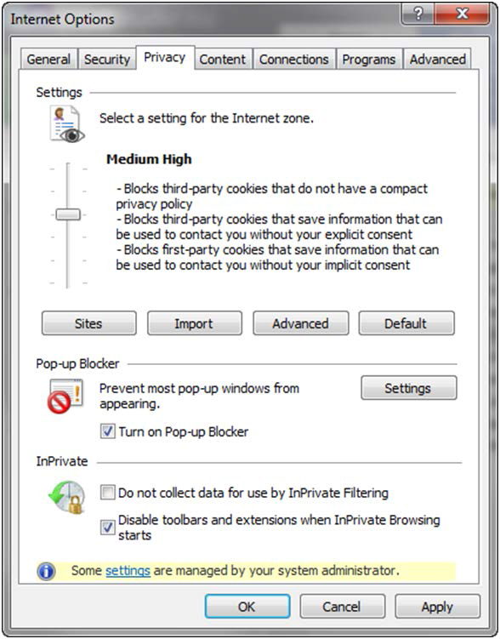

Figure 1 - Internet Explorer Settings

# BMS User Manual

## What is BMS

Bed Management Solution (BMS) is a real-time, user-friendly web-based Veterans Health Information Systems and Technology Architecture (VistA) interface for tracking patient movement, bed status and bed availability within the VA system. It provides performance information that can be used to measure and improve patient flow as it occurs within and between VAMCs. BMS enhances safety, quality of care, patient/staff satisfaction and improves patient flow for process and outcome improvements. BMS, the automated Bed Management Solution, allows administrative and clinical staff to record, manage and report on the planning, patient-movement, patient occupancy, and other activities related to management of beds. All patient admission, discharge, and transfer movements are pulled directly from VistA to BMS resulting in minimal manual data entry.

BMS offers the following features:

* + - Tracks patient movement into, through and out of the hospital;
    - Displays patient and bed occupancy status for all beds in the facility, Veterans Integrated Service Networks (VISN), Regional and National;
    - Provides visibility of bed availability within VAMC’s to support emergency management;
    - Automates request and assignment of beds;
    - Displays and facilitates discharge appointments;
    - Supports and facilitates efficient flow operations and is a catalyst to process improvement and best practices;
    - Provides reports on performance measures associated with bed management and patient flow. BMS provides answers to the following questions:
    - How many beds do we have?
    - How many empty beds do we have?
    - How many available female beds do we have?
    - How many beds are out of service and why?
    - How long does it take to clean a bed?
    - How many patients have been pending bed placement within the VA facility and in the community hospitals?
    - How many admissions, transfers, and discharges did my unit have yesterday?
    - How many discharges will we have tomorrow?
    - How many scheduled admissions do we have for today?

## Getting Started

### Obtain BMS Access

Your manager or BMS Site Coordinator (list of BMS site coordinators is [here](http://go.va.gov/lzgc)) must authorize and provide you access to BMS before you can log in. Your level of access will be dependent upon your role.

You will use your Windows username and password to access BMS, not your PIV card.

### Launch BMS

If your support staff has not provided a desktop shortcut or another way to access BMS, you can access BMS by pointing your browser to [https://vaww.bms.va.gov](https://vaww.bms.va.gov/) — the application’s Uniform Resource Locater (URL).

When you access this URL, the application's security system automatically redirects you to the login page. As it does this, the security system begins its authentication process.

### Log in

When you launch BMS, the application displays the VA Single Sign-On page that will present a few different options to authenticate to the BMS application.

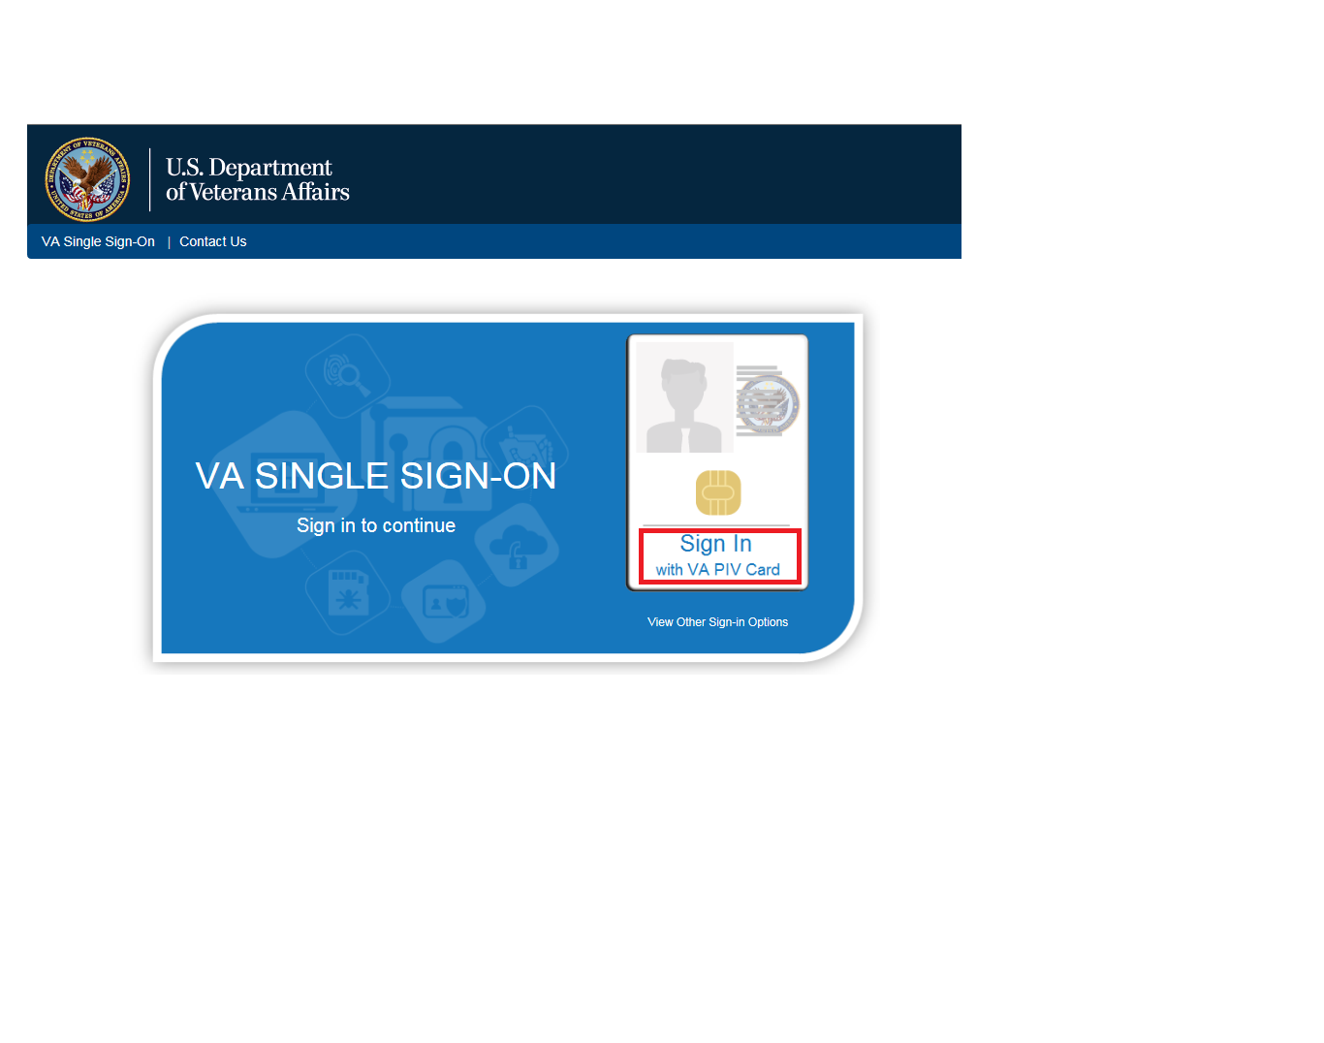

Figure 2 – VA Single Sign-On Screen

To log in, there are 3 different options available to the user to authenticate to the BMS application, though the majority will utilize option #1 if they have a PIV Card:

1. Click on the “Sign In with VA PIV Card”
   * Upon clicking the “Sign In with VA PIV Card”, the user will see the next screen, prompting them for the PIV PIN from the ActivClient Login dialog box, as below:

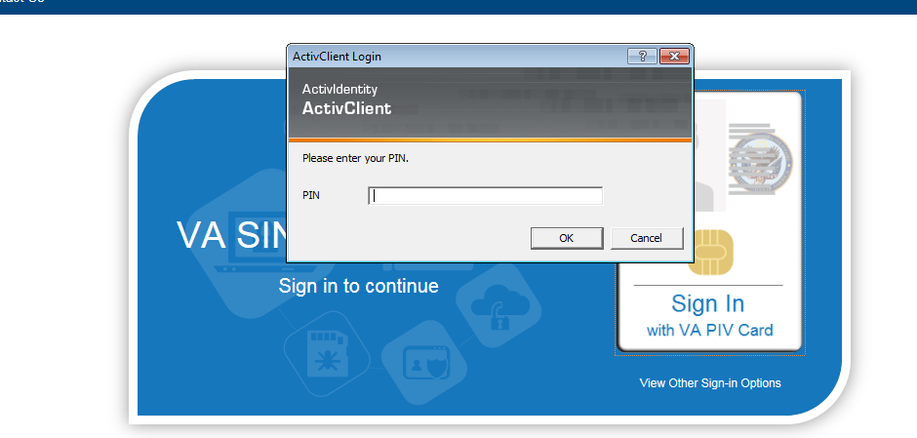

Figure 3 – VA Single Sign-On Page

* + The user will enter their PIV PIN and click OK.

**-OR-**

By clicking on the “View Other Sign-in Options” below the “Sign In with VA PIV Card”, the user is presented with another screen (below), allowing them to select either “Sign in with Windows Authentication” or “Sign in with VA Network ID”. Both are viable options to the user if they have a PIV Exemption (new employee or lost PIV badge are common examples).

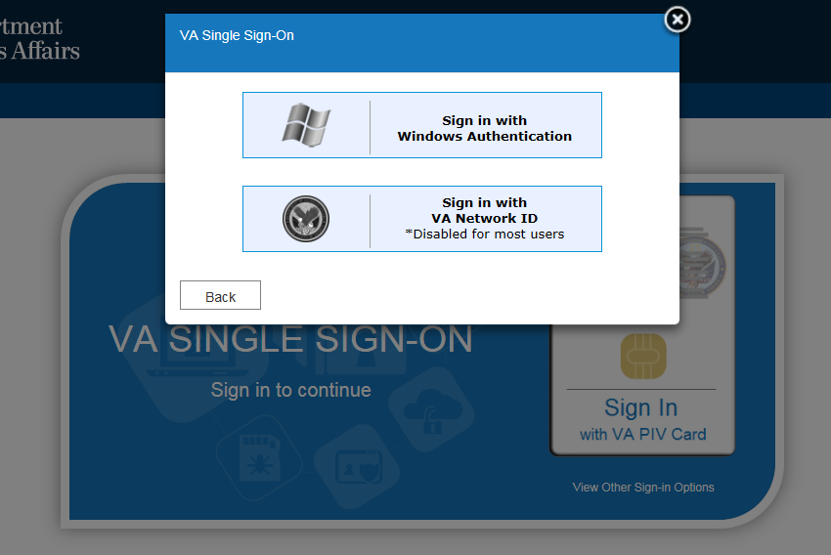

Figure 4 - Other Sign-In Options

1. Other Sign-In Options

In cases where users have not yet obtained their PIV card (new employee) or have lost their PIV card, they must request a PIV exemption by contacting the NSD and requesting a 2-week exemption. The user’s manager needs to follow up with a call or email to NSD to make the exemption permanent. **Without a valid PIV card and/or PIV Exemption, neither of the below options will allow the user to sign into the BMS application.**

* + **Sign In with Windows Authentication**

Clicking this button will utilize the security token issued to the user’s computer upon signing in to the VA network.

* + **Sign In with VA Network ID**

Clicking this button will display a prompt for the user’s VA username and password to authenticate with Active Directory.

If you are having issues with accessing BMS, select the link to the POC list on the login page. This link will take you to a list of the Points of Contact (POC) for each facility. Your facility POC can verify you have the correct access to BMS, or update your access as appropriate. The POC list is [here](http://go.va.gov/lzgc).

Note: The most common reasons for BMS access issues are:

* No BMS access granted by supervisor / site coordinator
* Incorrect Username or Password entered (this may be due to trying to use another User ID and password combination than the Windows User ID and password).
* Windows password expired (Windows passwords expire every 90 days). If your windows password has expired, you will need to contact the National Service Desk (NSD) to request a password reset. This is NOT a BMS password reset, but a reset of your Windows password.
* No PIV badge/exemption. In cases where BMS users do not have their PIV card or have lost their PIV card, they must request a PIV exemption by contacting the NSD and requesting a 2-week exemption. User’s manager needs to follow up with a call or email to NSD to make the exemption permanent

### BMS Main Pages

Here is a list of the main pages available within the BMS application and brief presentation of each page:

The **Facility Home** page displays the list of patients for pending bed placements in the current facility, and allows the user to add patients to the list and generate various reports regarding the bed count and patient movement within the facility. This section is an essential element in the use of BMS. The home page also provides the access to application reports, link to the SharePoint site, and information on how to report a remedy ticket, census rate, banner information, and access to the site configuration settings.

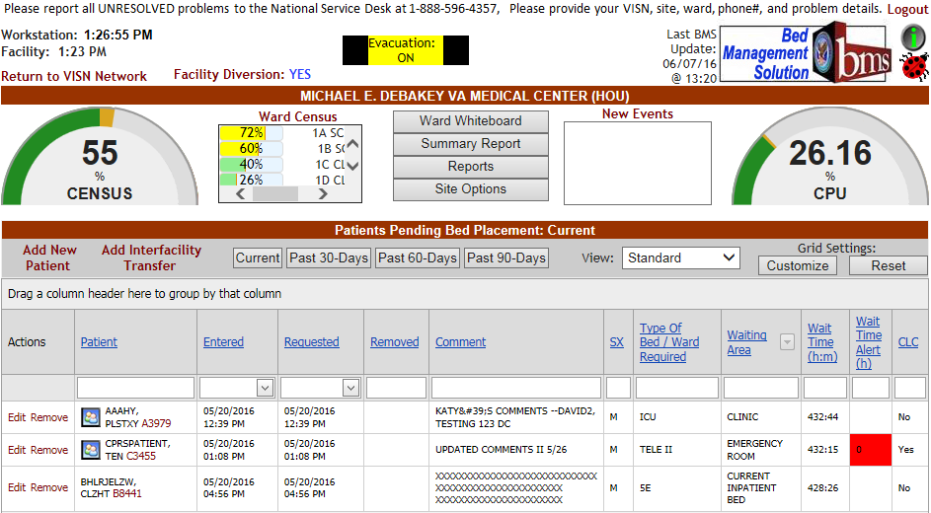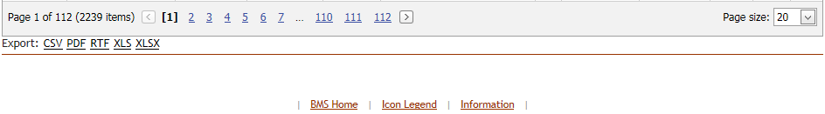

Figure 5 – BMS Facility Home Screen

The **Ward Whiteboard** page presents an overview of the beds in the current facility (or in the selected ward) and allows the user to assess at a glance the bed availability in their facility (or ward).

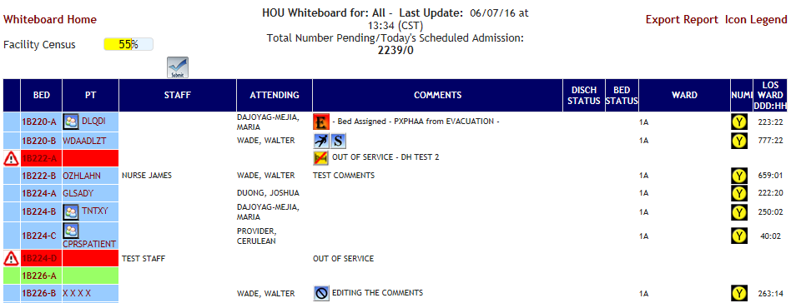

Figure 6 – BMS Ward Whiteboard Screen

The **New Events** page presents a list of events occurring in the current facility (such as admissions, discharges, beds out of service or bed cleaning operations.).

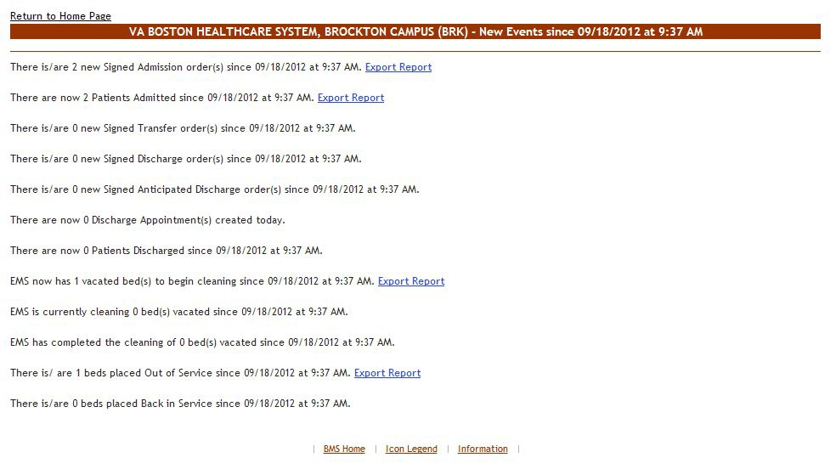

Figure 7 – BMS Facility New Events Screen

The **Bed Board Site Configuration** page presents a series of options that can be used to customize the functioning of the current facility site.

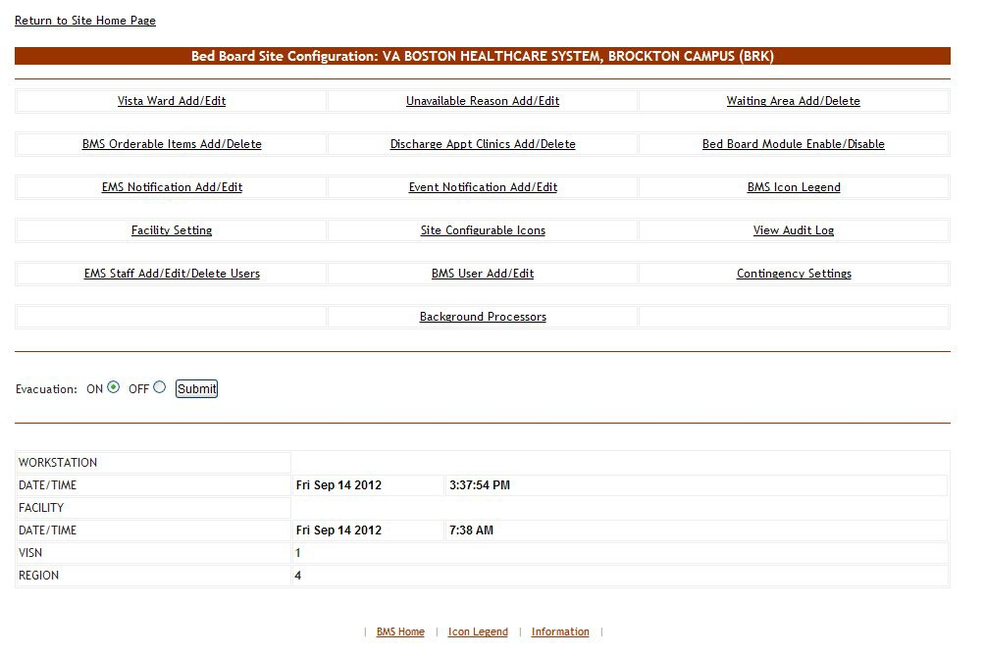

Figure 8 – BMS Bed Board Site Configuration/Site Options Screen

The **Facility Diversion** page allows the user to register a diversion status for the current facility.

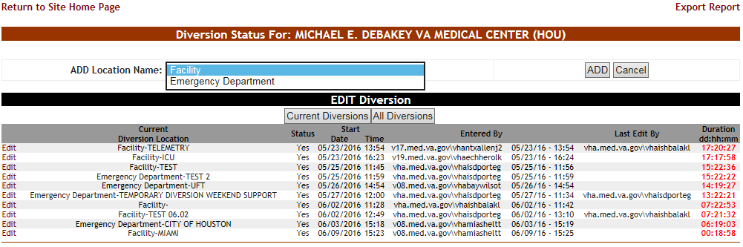

Figure 9 – BMS Facility Diversion Screen

The **VISN Network Bed Boards** page displays a list of facility sites in the current VISN and allows the user to view bed summary reports for each facility in the list, as well as the bed occupancy percentage for each facility and other data. Access to this page is determined by the VISN/Facilities.

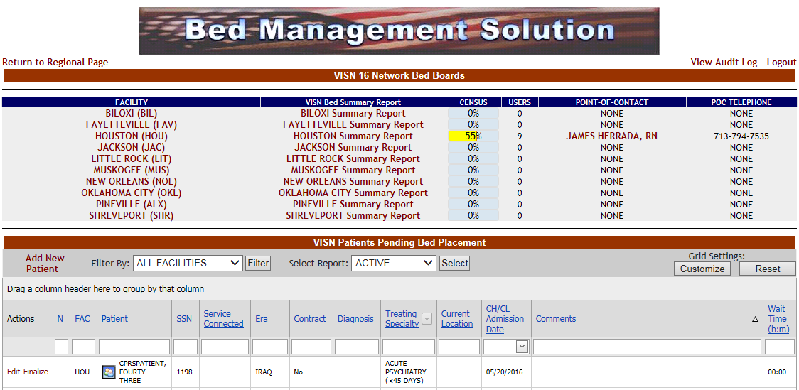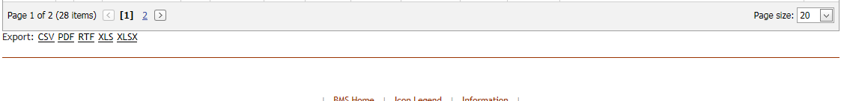

Figure 10 – BMS VISN Network Bed Boards Screen

The **National/Regional** page displays a list of VISN grouped according to the regions they belong to and the list of all the patients pending bed placement at national level.

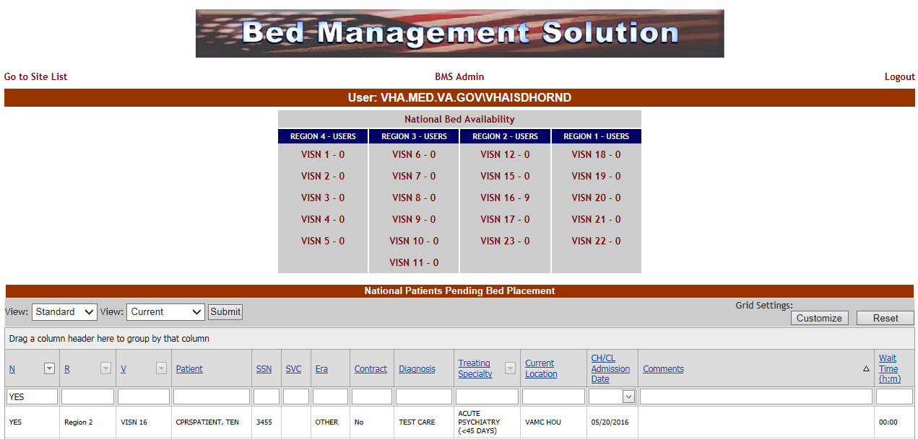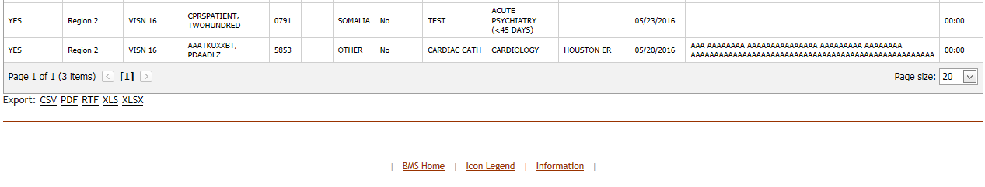

Figure 11 - BMS National/Regional Screen

The **Administration Section** page displays a series of options that can be used to configure BMS for each facility site and is accessible by clicking on the BMS Admin link located in the center of the national page. Access to this page is restricted to national support staff.

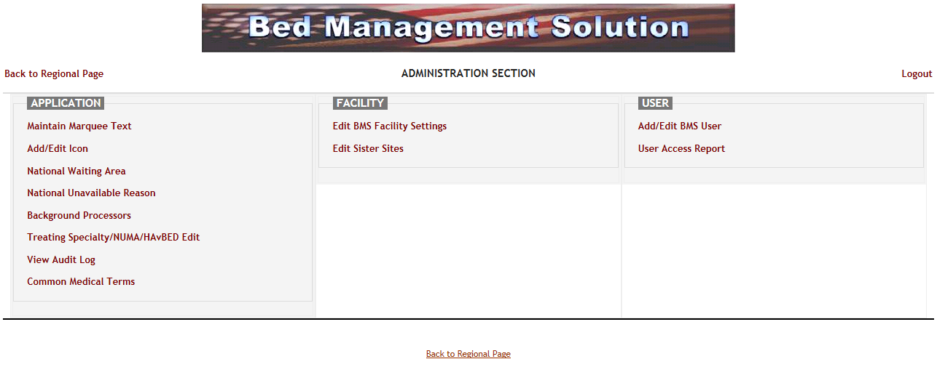

Figure 12 - BMS Administration Section Screen

### Working with data grids

BMS commonly displays information using a tabular—or grid—format. The application’s data grids allow you to sort within columns.

#### 3.2.5.1 Sort Information within Columns

You can sort the information within most columns.

* + - * + Click the column header link to sort the information within the grid by that column.
        + Click the column header again to sort the column’s contents in descending order.

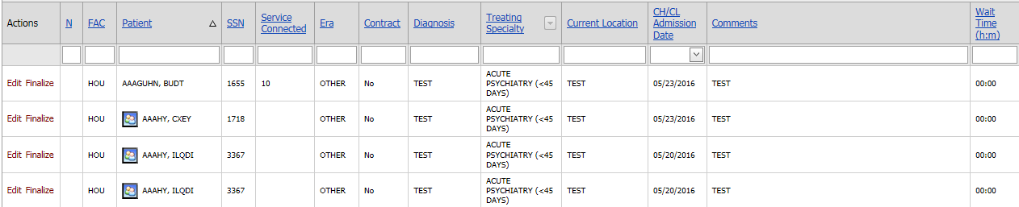

Figure 13 – Sort information within columns by clicking on column headers

# BMS Instructions/User Types

BMS users can be grouped in the following types:

* Administrator Users
* Site Users
* EMS Supervisor Users
* EMS Users
* VISN Users
* Regional Users
* National Users
* Guest User
* Support Users

The following sections present the BMS pages that can be accessed by each type of user, the actions that can be performed by the user in each page and a step-by-step description of each action.

## Facility Administrators Users

Administrator users can customize the generic BMS settings according to the needs of a specific facility. This is done from the **Bed Boards Site Configuration** (**Site Options**) page of the BMS facility site.

Administrator users can access the following pages:

* Bed Board Site Configuration page
* VistA Ward Add/Edit page
* BMS Orderable Items Configuration page
* EMS Bed Notification page
* Facility Settings
* EMS Staff Add/Edit/Delete Users page
* Unavailable Reason page
* Discharge Appointment Clinic Configuration page
* Events Notifications page
* Site Configurable Icons page
* BMS User Add/Edit page
* Background Processors page
* Waiting Area Add/Delete page
* Bed Board Module Enable/Disable Configuration page
* BMS Icon Legend page
* View Audit Log page
* Contingency Settings page

### Bed Board Site Configuration Main Page

The configuration of the VA facility site is done using the options available in the page **Bed Boards Site Configuration** that can be accessed by clicking the **Site Options** link in the upper right corner of the facility home page.

The **Bed Boards Site Configuration** page is displayed as in the following image.



Figure 14 – Bed Board Site Configuration Page

The **Bed Boards Site Configuration** page allows the administrator user to configure several parameters for the site. Click the corresponding link to access the desired page.

The Evacuation ON/OFF option can be used in case of emergency and allows the administrator user to organize the evacuation process. For details, see the section Evacuation On/Off.

In the lower part of the page the system provides information about the date and time of the workstation, the date and time of the facility site as well as the VISN, and the region where the current facility resides.

For details on the options available see the sections below.

### VistA Ward Add/Edit Page

From the Bed Board Site Configuration page, click the VistA Ward Add/Edit link to display the Bed Board Ward Configuration (Facility name) page as in the following image.

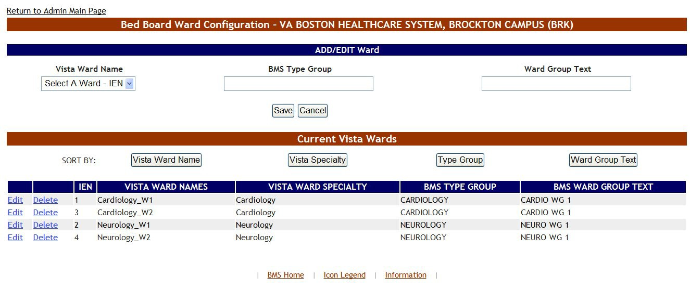

Figure 15 – Add/Edit Ward Page

The options available in this screen allow the administrator user to organize the wards retrieved from VistA according to the specific needs of the current facility.

The list of VistA wards already grouped according to the needs of the current organization is displayed in the list Current VistA Wards, in the lower part of the screen.

The buttons **VistA Ward Name**, **VistA Specialty**, **Type Group** and **Ward Group Text** allow the administrator users to sort the ward group list according to those criteria. Group treating specialties together into one physical ward. For example, 2A-MED, 2A-SURGICAL, 2A-OBSERVATION will all have the same Ward Group name 2A so that all the beds will appear only once for the ward.

For each entry in the list, the following data is available:

Table 2 – Ward Group Parameters

| **Column** | **Description** |
| --- | --- |
| Internal Entry Number (IEN) | The VistA Internal Entry Number for the primary lookup key in the Ward Location #42 file. |
| VistA Ward Name | The name of the ward retrieved from VistA. |
| VistA Ward Specialty | The specialty associated to the selected ward in VistA. |
| BMS Type Group | The specialty assigned to the ward group from the specialties defined for the current facility. (The BMS Type Group field.) |
| BMS Ward Group Text | The ward group assigned for the needs of the current facility. |

The **Edit** and **Delete** links to the left of each ward group in the Current VistA Wards area allow the user either to modify the details of a ward group or to delete the ward group.

The link **Return to the Admin Main Page** in the upper left corner of the page allows the user to go back to the **Bed Board Site Configuration** page on the large screen displays.

#### 4.1.2.1 Adding a VistA Ward to the Ward Groups Defined for the Current Facility

To add a VistA ward to the ward groups defined for the current facility follow the instructions below. From the facility home page, click the **Site Options** link.

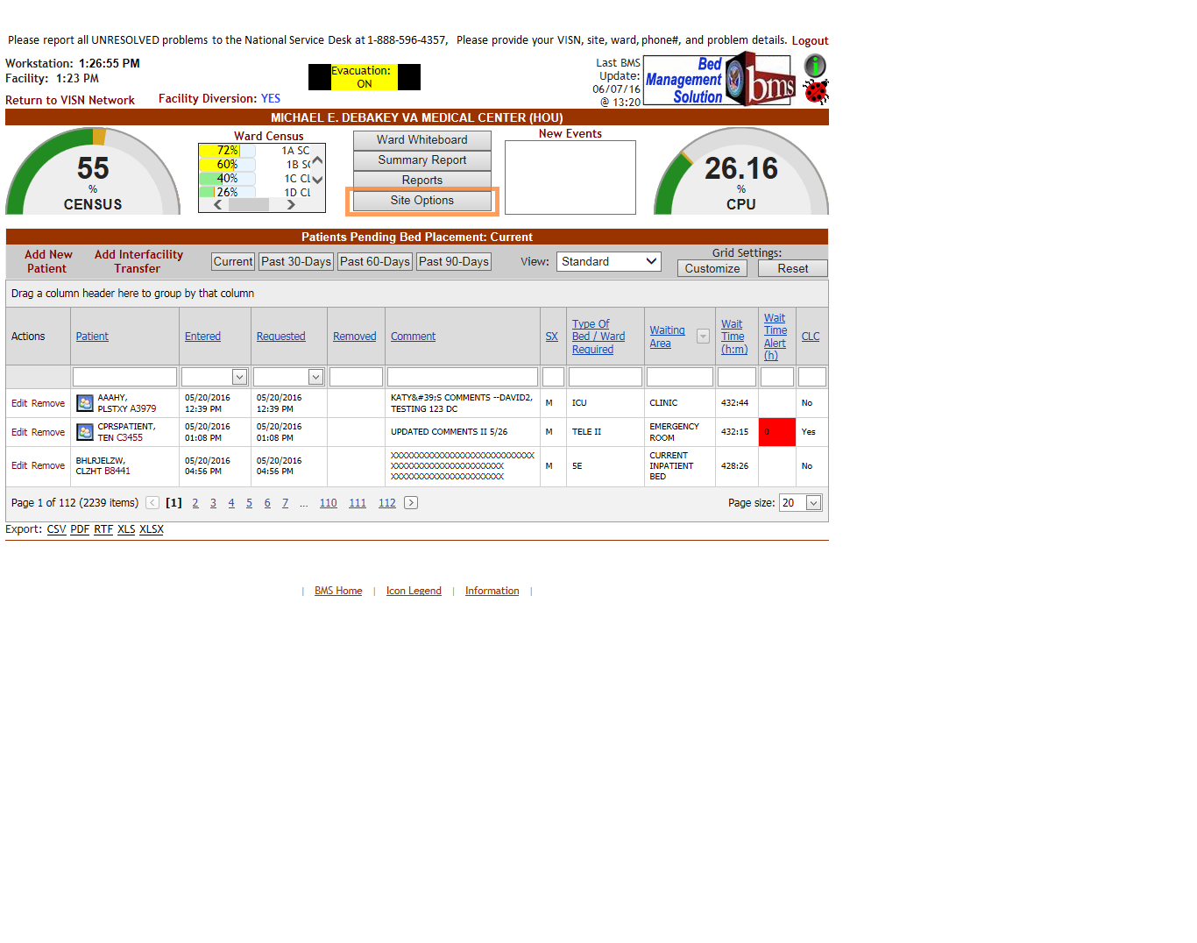

Figure 16 – Selecting Site Options

The **Bed Board Site Configuration** page is displayed as in the image below

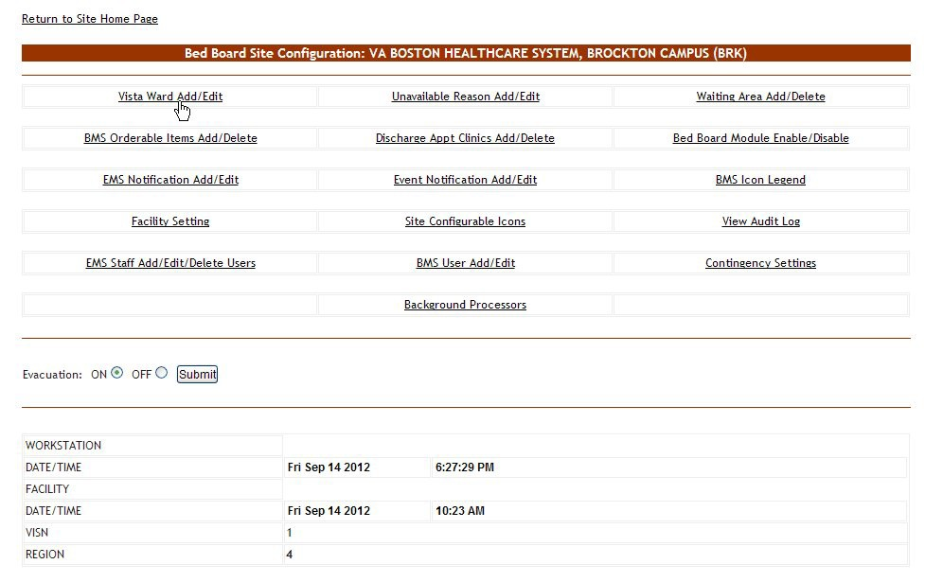

Figure 17 – Selecting VistA Ward Add/Edit Page

Click the **VistA Ward Add/Edit** link to display the corresponding page as in the image below.

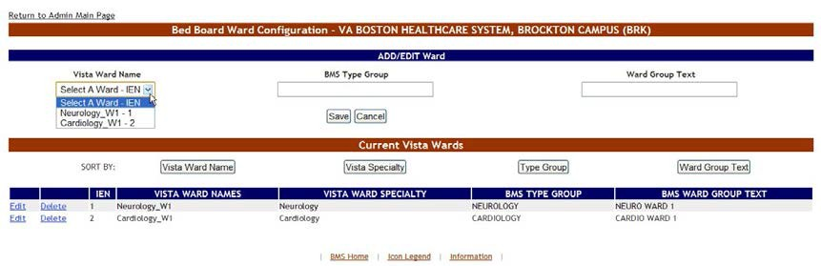

Figure 18 – Adding/Editing Ward

In the ADD Ward area at the top of the screen, click the arrow button of the **VistA Ward Name** field to display the list of VistA wards and select the one you want to add to the ward groups defined for the current facility. Next, in the **BMS Type Group** field enter the name of one of the ward groups defined for the current facility or the name of a new ward group. Next, in the **Ward Group Text** field enter a customized ward group name. Clicking the **Save** button will enter the data into the system: the new ward group will be displayed in the Current VistA Wards list in the lower part of the screen.

#### 4.1.2.2 Editing a Ward Group



To edit one of the ward groups defined for the current facility follow the instructions below. From the facility home page, click the **Site Options** link.

Figure 19 – Selecting Site Options

The **Bed Board Site Configuration** page is displayed as in the image below.



Figure 20 – Selecting VistA Ward Add/Edit Page

Click the **VistA Ward Edit** link to display the corresponding page as in the image below.

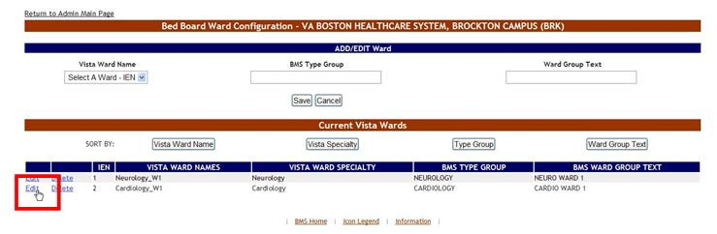

Figure 21 – Selecting a ward group to edit

Click the **Edit** link to the left of an existing ward group: the ward group details will be displayed in the fields in the EDIT Ward area as in the following image.

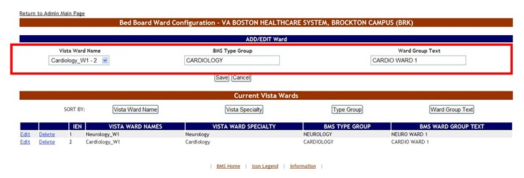

Figure 22 – Editing a ward group

Make the desired changes then press the **Save** button to enter the data into the system. The modified ward group will be displayed in the Current VistA Wards list.

#### 4.1.2.3 Deleting a Ward Group

To delete a ward group follow the instructions below. From the facility home page, click the Site Options link



Figure 23 – Selecting Site Options

The **Bed Board Site Configuration** page is displayed as in the image below.



Figure 24 – Selecting VistA Ward Add/Edit Page

Click the **VistA Ward Add/Edit** link to display the corresponding page as in the image below.

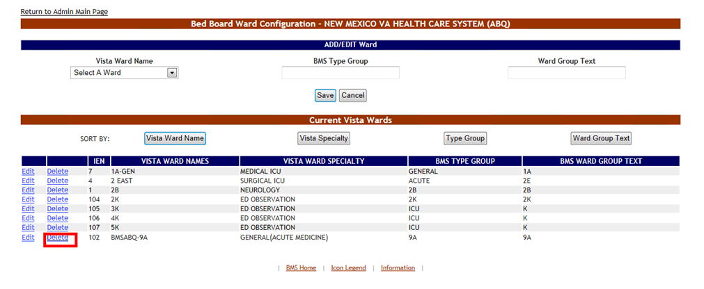

Figure 25 – Deleting a VistA Ward Group

Click the **Delete** link to the left of the ward group you want to delete: a confirmation screen is displayed as in the following image.

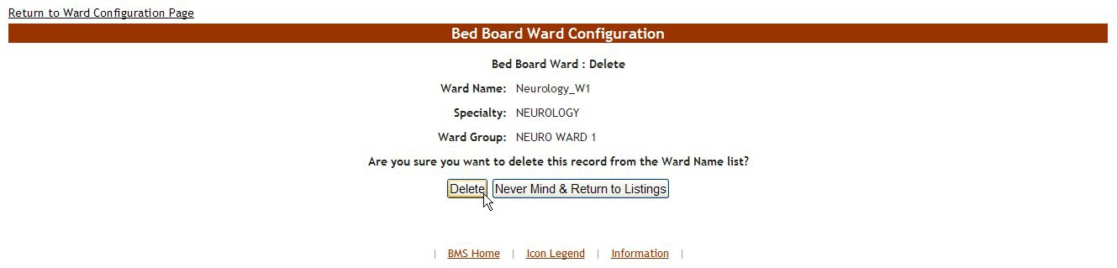

Figure 26 - Confirm Deletion of VistA Ward Group

Click the **Delete** button to delete the ward group defined.

### Bed Board BMS Orderable Items Configuration Page

From the **Bed Board Site Configuration** page, click the **BMS Orderable Items Add/Delete** link to display the following page.

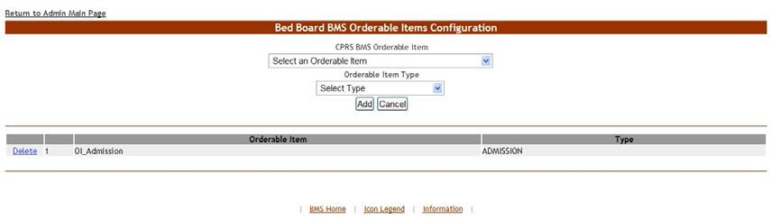

Figure 27 – Bed Board BMS Orderable Items Configuration Page

The **Bed Board BMS Orderable Items Configuration** page allows the user to map the orderable items coming from VistA with orderable items adapted to the needs of their facility/organization.

The drop-down fields in the upper part of the screen allow the administrator users to select the orderable items for mapping. However, only 3 types of orderable items are mapped: admission, discharges and transfers.

The lower part of the screen displays the list of orderable items already mapped. The **Delete** links associated to each entry allow the administrator user to remove an entry from the list.

For each entry in the list, the following data is available:

Table 3 – Orderable Items Parameters

|  |  |
| --- | --- |
| **Column** | **Description** |
| (Orderable item code) | The code of the VistA orderable item. |
| Orderable Item | The name of the orderable item retrieved from VistA. |
| Type | The name of the orderable item for the needs of the current facility. |

The link **Return to the Admin Main Page** in the upper left corner of the page allows the administrator user to go back to the **Bed Board Site Configuration** page.

**4.1.3.1 Adding/Deleting an Orderable Item - Mapping**

To add a new orderable item mapping to the system follow the instructions below.

From the facility home page, click the **Site Options** link.



Figure 28 – Selecting Site Options

The **Bed Board Site Configuration** page is displayed as in the image below.

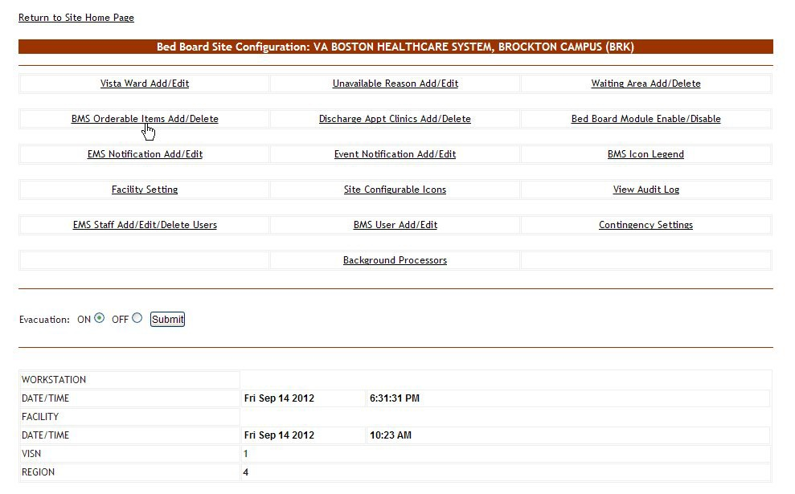

Figure 29 – Selecting BMS Orderable Items Add/Delete

Click the **BMS Orderable Items Add/Delete** link to display the following page.

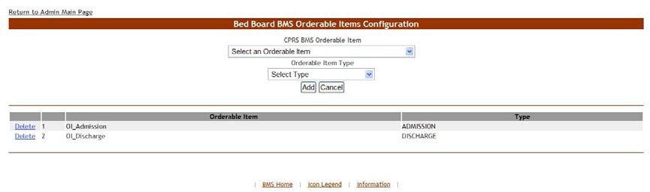

Figure 30 – Adding/Editing BMS Orderable Items

Use the arrow button of the field **CPRS BMS Orderable Item** to display a list of orderable items existing in VistA, and select the one you want to add/map (=rename for use in the current facility). From the field **Orderable Item Type** select the orderable item type you want to use for your facility then click the **Add** button. The newly added (mapped) orderable item will be displayed in the list. You can use the **Delete** link to remove an entry (mapping) from the system.

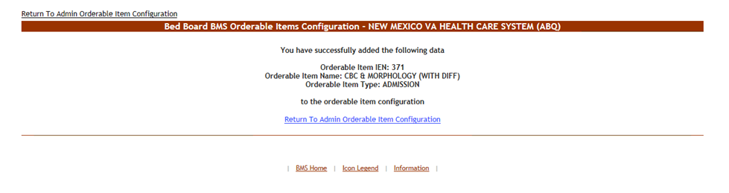

Figure 31 - BMS Orderable Items - Add

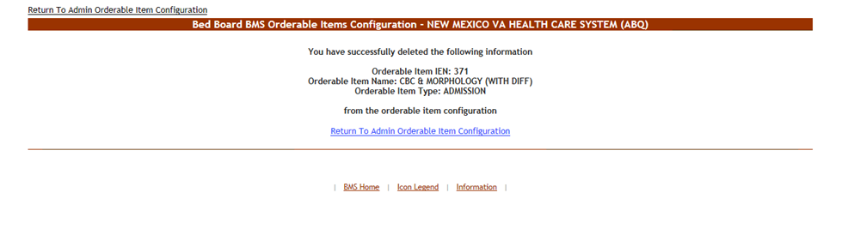

Figure 32 – BMS Orderable Items - Delete

### EMS Bed Notification Page

From the **Bed Board Site Configuration** page, click the **EMS Notification Add/Edit** link to display the following page.

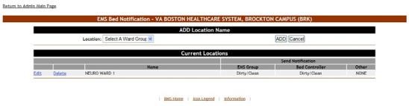

Figure 33 – EMS Bed Notification Page

The options available in this page allow the administrator user to manage the EMS notifications.

**Note:** Notifications can also be sent by printer, pager and cell phones as well as email.

In the ADD Location Name area, the options allow the administrator user to add a new EMS Bed notification in the system.

The list in the lower part of the screen presents the locations for which EMS notifications have already been defined in the system.

For each entry in the list, the following data is available:

Table 4 – EMS Bed Notification Parameters

|  |  |
| --- | --- |
| **Column** | **Description** |
| Name | The name of the BMS Ward Group which the EMS notification has been set up. |
| Send Notification/EMS Group | The event that triggers the notification for the EMS group. |
| Send Notification/Bed Controller | The event that triggers the notification for the bed controller. |
| Send Notification/Other | The event that triggers the notification for other personnel. |

The links **Edit** and **Delete** to the left of each entry allow the administrator user to modify the details of a notification or to delete it.

The link **Return to the Admin Main Page** in the upper left corner of the page allows the administrator user to go back to the **Site Options** page.

* + - 1. **Adding an EMS Bed Notification**

To add an EMS bed notification follow the instructions below.

From the facility home page, click the **Site Options** link



Figure 34 - Selecting Site Options

The **Bed Board Site Configuration** page is displayed as in the image below.

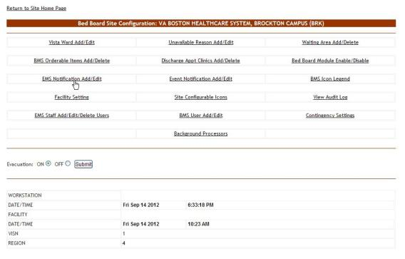

Figure 35 – Selecting EMS Notification Add/Edit

Click the **EMS Notification Add/Edit** link to display the corresponding page as in the image below.

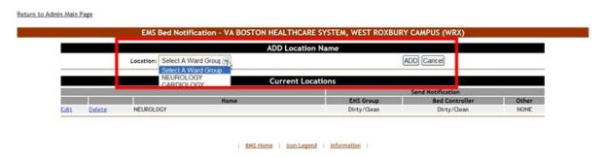

Figure 36 – EMS Bed Notification – Add Location Name

Click the arrow button of the **Select a Ward Group** field to display a list of locations defined in the system then click the **Add** button to enter the details of the notification.

The following page is displayed.

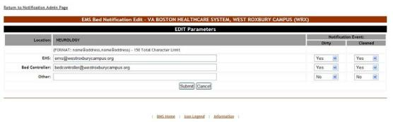

Figure 37 – Notifications Add – Edit Parameters

The name of the selected location is displayed in the page header. In the EDIT Parameters area, enter the email addresses, text pagers, text-compatible cell phones and/or printer where you want to send the current notification: EMS email, Bed Controller email, and Other. From the Notification Event area, select the events that trigger the current notification. Usually a bed clean request will trigger a notification to be sent to the bed controller.

Note: There is a 150-character limit. (FORMAT: name@address,name@address) Refer to Figure 33 as an example.

When you have selected the desired parameters for the current notification click the **Submit** button to enter the data into the system. A confirmation message is displayed and then you return to the main EMS Bed Notification page where the new notification is displayed in the list.

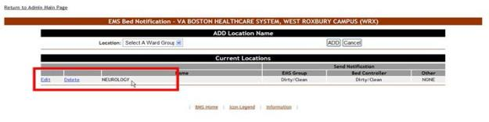

Figure 38 – EMS Bed Notification Added

* + - 1. **Editing an EMS Bed Notification**

To edit an existing EMS bed notification follow the instructions below. From the facility home page, click the **Site Options** link.



Figure 39 – Selecting Site Options

The **Bed Board Site Configuration** page is displayed as in the image below.

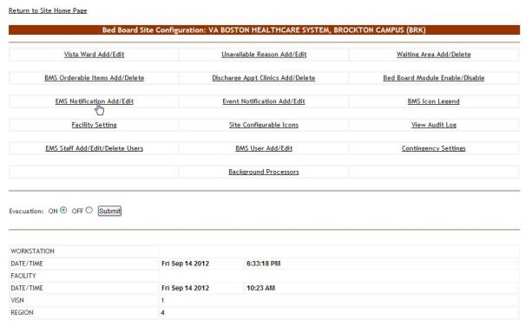

Figure 40 – Selecting EMS Notification Add/Edit

Click the **EMS Notification Add/Edit** link to display the corresponding page as in the image below.

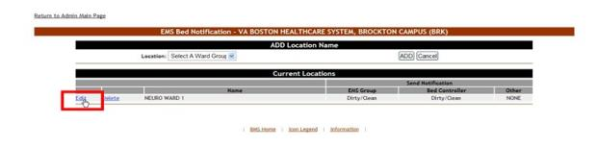

Figure 41 – EMS Bed Notification – Select notification for edit

Click the **Edit** link to the left of an EMS Bed notification: the **EMS Bed Notification Edit** page is displayed as in the image below.

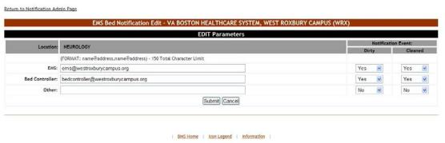

Figure 42 – Notifications Add – Edit Parameters

Note: There is a 150-character limit. (FORMAT: name@address,name@address) Refer to Figure 38 as an example.

Make the desired changes then click the **Submit** button to enter the data into the system.

* + - 1. **Deleting an EMS Bed Notification**

To delete an EMS bed notification follow the instructions below. From the facility home page, click the **Site Options** link.



Figure 43 – Selecting Site Options

The **Bed Board Site Configuration** page is displayed as in the image below.

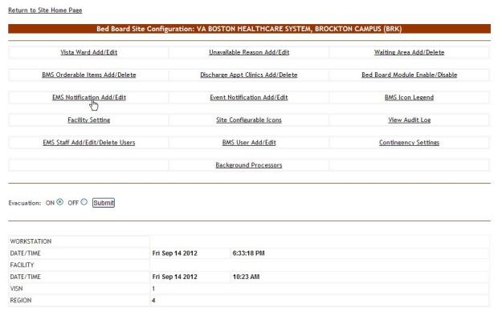

Figure 44 – Selecting EMS Notification Add/Edit

Click the **EMS Notification Add/Edit** link to display the corresponding page as in the image below.

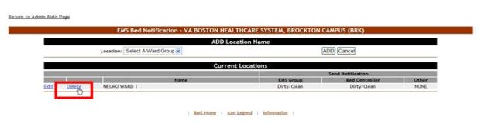

Figure 45 – EMS Bed Notification – Delete notification

Click the **Delete** link to the left of an EMS Bed notification: a confirmation screen is displayed as in the following image.

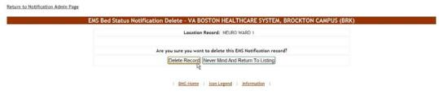

Figure 46 – EMS Bed Notification – Confirm Notification Deletion

Click the **Delete Record** button to delete the notification. A message is displayed in the following image.

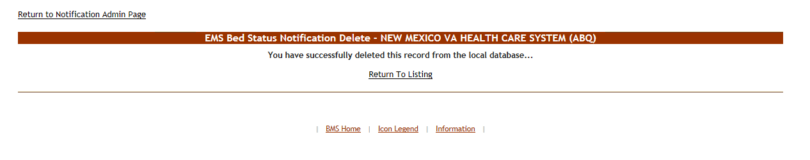

Figure 47 - EMS Bed Notification – Notification Deletion

### Facility Setting Page

From the **Bed Board Site Configuration** page, click the **Facility Setting** link to display the following page.

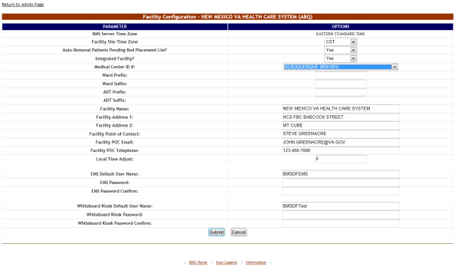

Figure 48 – Facility Configuration Page – Integrated Facility

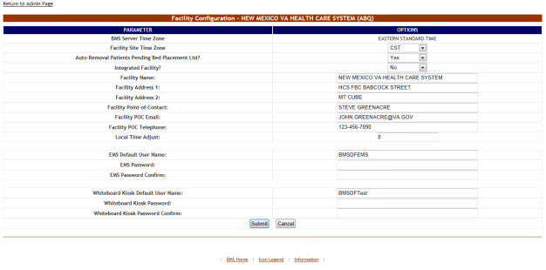

Figure 49 - Facility Configuration Page – Non-Integrated Facility

The following parameters can be configured:

Table 5 – VA Facility Configuration Parameters

| **Column** | **Description** |
| --- | --- |
| BMS Server Time Zone | The time zone of the BMS server where the current facility is connected. |
| Facility Site Time Zone | The time zone of the facility site. |
| Auto-Removal Patient Pending Bed Placement List? | If patients are automatically removed from the local facility Pending Bed Placement List when they are assigned a Room/Bed. |
| Integrated Facility? | If the current facility is integrated with others (sister sites). |
| Integrated Site List | Select one of the sister sites lists available. Sister sites lists are defined in the Edit Sister Sites section of the Administration Section page. |
| Allowed Access – Integrated Sites: (All users can see these sites also). | This field will only become visible after you have selected a sister sites list from the Integrated Site List field, pressed the Submit button and returned to the Facility Configuration page.  A list of sites integrated with the current site is displayed; select the sites where the users of the current facility will have access. |
| Medical Center ID # | The ID number of the medical center associated to the current facility. |
| Ward Prefix | A prefix used for all the wards defined for the current facility. |
| Ward Suffix | A suffix used for all the wards defined for the current facility. |
| ADT Prefix | This is the unique identifier that is the leading part of the ADT (Admission/Discharge/Transfer Orderable Item) and is used to filter the list of ADT OIs that will be displayed, i.e., “BO-“ for Boston. |
| ADT Suffix | This is the unique identifier that is the trailing part of the ADT (Admission/Discharge/Transfer Orderable Item) and is used to filter the list of ADT OIs that will be displayed, i.e., “-BO“ for Boston. |
| Facility Name | The full name of the current facility. |
| Facility Address 1 | The main address of the facility. |
| Facility Address 2 | If applicable, any secondary address of the facility. |
| Facility Point-of-Contact: | The facility point of contact, this can be the triage room, the front desk, others. |
| Facility POC email: | The email for the point of contact with the facility. |
| Facility POC Telephone: | The telephone of the point of contact. |
| Local Time Adjust: | The difference between the local time and the server time. |
| EMS Default User Name: | The BMS Service Account ID needed to load the EMS Mobile Page for Mobile Devices. |
| EMS Password: | The BMS Service Account ID password needed to load the EMS Mobile Page for Mobile Devices. |
| EMS Password confirm: | The confirmation of the password. |
| Whiteboard Kiosk Default User Name: | The BMS Service Account ID needed to load the Whiteboard URL in Kiosk Mode. |
| Whiteboard Kiosk Password: | The BMS Service Account ID password needed to load the Whiteboard URL in Kiosk Mode. |
| Whiteboard Kiosk Password confirm: | The confirmation of the password. |

#### 4.1.5.1 Ward Whiteboard Kiosk URL Settings

The Ward Whiteboard URL is needed in order to display the information in the Ward Whiteboard page on the screens available on the wall(s) at the hospitals.

In order to run the following URL, a Whiteboard Kiosk Default User and password need to be defined in the Site Options> Facility Settings page. The user should be setup as a Service Account and needs to be granted the EMS USER role level of access. See the BMS Technical Manual for additional information.

Below is an example of the URL that should be added to the browser:

<https://vaww.bms.va.gov/WardWhiteboardUrl?facilityCode=BRK&wardName=ALL&splitScreen=No&displayPTCode=LastName&genderColorCode=Blue/Pink&displayFooterCensus=Yes&displayStaffAttending=Staff%20and%20Attending&scrollRate=20>

Description and available values of the page parameters:

Table 6 – Ward Whiteboard URL Configuration Parameters

| **Parameter** | **Short Description** | **Options** |
| --- | --- | --- |
| facilityCode | Code of facility (e.g., BROCKTON = BRK). | Enter the 3 character facility ID. |
| wardName | Name of BMS Ward Name. To see all the wards the value that needs to be configured is ALL. | These are the BMS WARDS as defined in the Facility, Site Options, VistA Ward Add/Edit. The Ward name value should match the "BMS WARD GROUP TEXT". A single ward can be entered or the value "ALL" to display all the wards at the facility. |
| splitScreen | To split the page in two tables enters the value "Yes". | Yes No |
| displayPTCode | How should be displayed the patient under the column "Patient" (full name or 1st+Last 4).  **Note: LastName is required for Kiosk mode due to Privacy regulations**. | FirstAndLast4 LastName |
| genderColorCode | To change the background color for the row according with patient’s gender. | Blue/Pink None |
| displayFooterCensus | To view the footer census. | Yes No |
| displayStaffAttending | What column is displayed in the table? (Staff column, Attending column or both). | Staff and Attending Staff  Attending |
| scrollRate | The timer interval will affect the scrolling speed. This parameter can be absent. (If specified then it represents seconds). | Null or an integer value. |

#### 4.1.5.2 EMS Mobile URL Settings

The EMS Mobile URL is needed in order to display the information in the EMS Mobile page on portable devices used by EMS Staff.

In order to run the following URL, an EMS Default User and password need to be defined in the Site Options>Facility Settings page. The user should be setup as a Service Account and needs to be assigned to the EMS USER role. See the BMS Technical Manual for additional information. This can be the same account that is used for the BMS Kiosk Default User.

Below is an example of the URL that should be added to the browser:

<https://vaww.bms.va.gov/EMSMobileLogon?code=BRK>

Description and available values of the page parameters:

Table 7 – EMS Mobile URL Configuration Parameters

|  |  |  |
| --- | --- | --- |
| **Parameter** | **Short Description** | **Options** |
| code | Code of facility (e.g., BROCKTON = BRK). | Enter the 3 character facility ID. |

### EMS Staff Add/Edit/Delete Users Page

From the **Bed Board Site Configuration** page, click the **EMS Staff Add/Edit/Delete Users** link to display the following page.

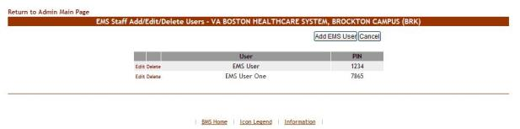

Figure 50 – EMS Staff Add/Edit/Delete Users

This page allows the administrator user to add, edit or delete EMS user accounts and their associated PINs. These EMS user accounts can then be used to access the EMS Staff Page for Mobile Devices. For details see the section EMS Staff Page for Mobile Devices. The EMS users added from this page will be available when a bed clean operation has to be assigned.

**Note:** It is recommended that each facility define at least one default EMS Staff User. This verifies that beds can always be assigned to a cleaner.

#### 4.1.6.1 Adding an EMS User

To add an EMS user for the EMS Staff Page for Mobile Devices, follow the instructions below.

From the facility home page, click the **Site Options** link



Figure 51 - Selecting Site Options

The **Bed Board Site Configuration** page is displayed as in the image below.

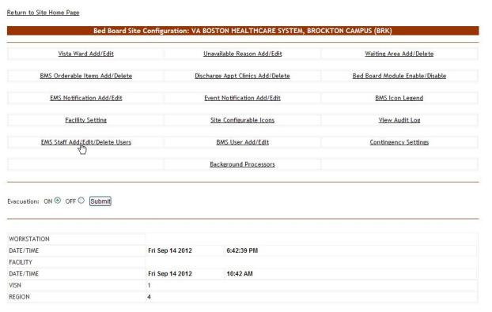

Figure 52 – Selecting EMS Staff Add/Edit/Delete Users

Click the **EMS Staff Add/Edit/Delete Users** link to display the corresponding page as in the image below.

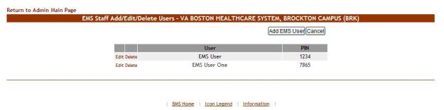

Figure 53 – EMS Staff Add/Edit/Delete Users

Click the **Add EMS User** button to display the following page.

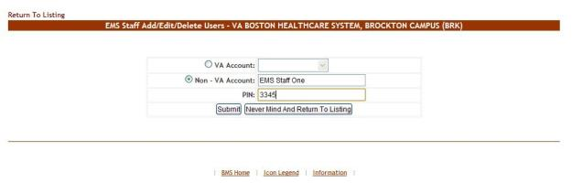

Figure 54 – EMS Staff Add/Edit/Delete Users Page – Add Users

The **VA Account** field will display a list with all the EMS users who already have an account and for whom the current facility is the default facility. Select a name from the list and then enter a PIN number in the PIN field. The selected EMS user will be able to access the EMS Staff Page for Mobile Devices with their current user name and the PIN set in this page.

The second **Non-VA Account** field allows the administrator user to create an account for EMS users who do not have one and to assign a PIN code for this account: the EMS user will then be able to access the EMS Staff Page for Mobile Devices using this account, view information and make changes in that page.

* + - 1. **Editing the details on an EMS User**

To edit the details of an EMS user for the EMS Staff Page for Mobile Devices follow the instructions below.

From the facility home page, click the **Site Options** link.



Figure 55 – Selecting Site Options

The **Bed Board Site Configuration** page is displayed as in the image below.

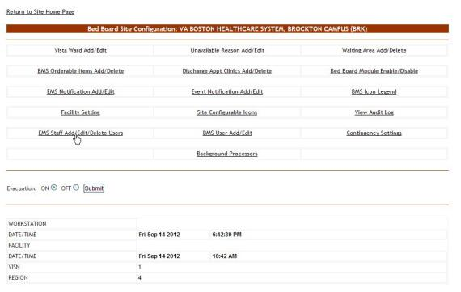

Figure 56 – Selecting EMS Staff Add/Edit/Delete Users

Click the **EMS Staff Add/Edit/Delete Users** link to display the corresponding page as in the image below.

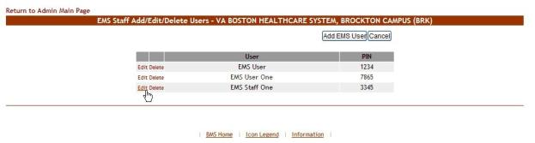

Figure 57 – Select EMS Staff Account/User to Edit

Click the **Edit** link to the left of the EMS user name in the list: the **EMS Staff Add/Edit/Delete Users** page is displayed.

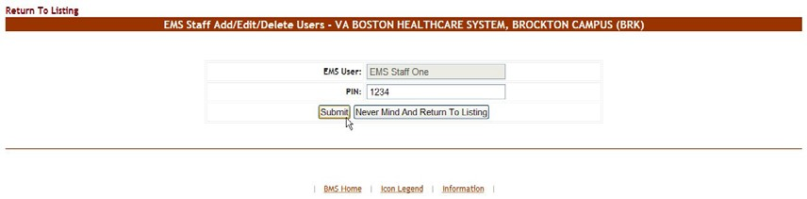

Figure 58 – Edit EMS Staff Account/User



Figure 59 – Selecting Site Options

Change the PIN assigned to the EMS user, then press the **Submit** button to enter the data into the system.

* + - 1. **Deleting an EMS User**

To delete an EMS user for the EMS Staff Page for Mobile Devices follow the instructions below.

From the facility home page, click the **Site Options** link.

The **Bed Board Site Configuration** page is displayed as in the image below.



Figure 60 – Selecting EMS Staff Add/Edit/Delete Users

Click the **EMS Staff Add/Edit/Delete Users** link to display the corresponding page as in the image below.

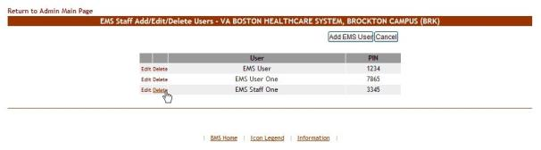

Figure 61 – Selecting EMS Staff Account/User for Deletion

Click the **Delete** link to the left of an EMS user in the list: a confirmation screen is displayed as in the following image.

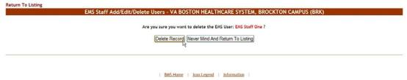

Figure 62 – Delete EMS Staff Account/User

Click the **Delete Record** button to delete the EMS User from the list.

### Bed Board Site Unavailable Reason Page

From the **Bed Board Site Configuration** page, click the **Unavailable Reason Add/Edit** link to display the following page.

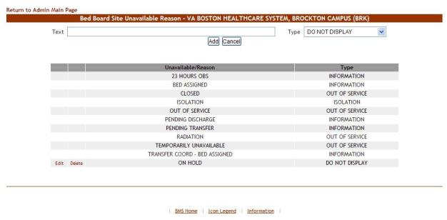

Figure 63 – Bed Board Unavailable Reason Page

The page presents the list of default *unavailable* reasons defined in the system.

The options in this page allow the administrator user to add a new *unavailable reason* for the beds in the current facility.

For each entry in the list, the following data is available:

Table 8 – Unavailable Reason Parameters

|  |  |
| --- | --- |
| **Column** | **Description** |
| Unavailable Reason | The reason why a bed is made unavailable. |
| Type | The type of reason. |

The links **Edit** and **Delete** allow the administrator user to modify the details of a reason or delete it from the system.

The link **Return to the Admin Main Page** in the upper left corner of the page allows the administrator user to go back to the **Site Options** page.

* + - 1. **Adding an Unavailable Reason**

To add an *unavailable reason,* follow the instructions below.

From the home page, click the **Site Options** link.



Figure 64 – Selecting Site Options

The **Bed Board Site Configuration** page is displayed as in the image below.

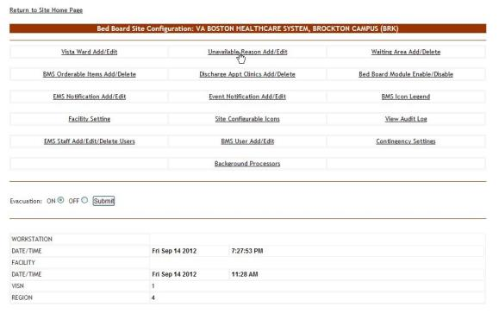

Figure 65 – Selecting Unavailable Reason Add/Edit

Select the **Unavailable Reason Add/Edit** link to display the page in the following image.

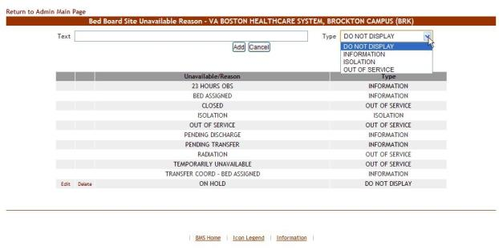

Figure 66 – Adding an Unavailable Reason

In the **Text** field enter the explanation, the reason for the bed unavailability then, from the **Type** field select the type of reason, and click the **Add** button.

In the **Type** field, four types of ‘unavailable’ reasons can be selected:

* Information (no icon appears on the whiteboard)
* Isolation (isolation icon appears on the whiteboard)
* Do Not Display (bed does not appear on the whiteboard)
* Out of Service (bed is colored RED on the whiteboard).

The newly defined reason will be added to list of existing reasons.

You can use the **Edit** link to modify either the text or the type of the reason. Use the **Delete** link to remove the link from the list.

* + - 1. **Editing an Unavailable Reason**

To edit an unavailable reason, follow the instructions below.

From the facility home page, click the **Site Options** link.



Figure 67 – Selecting Site Options

The **Bed Board Site Configuration** page is displayed as in the image below.

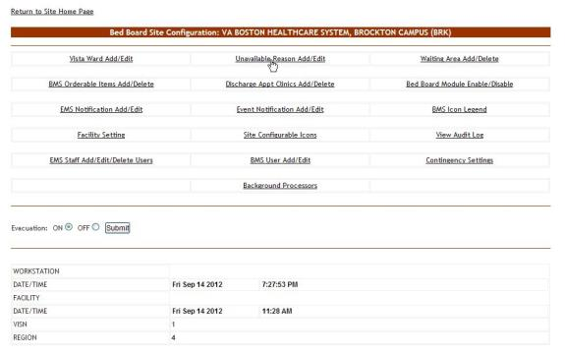

Figure 68 – Selecting Unavailable Reason Add/Edit

Select the **Unavailable Reason Add/Edit** link to display the page in the following image.

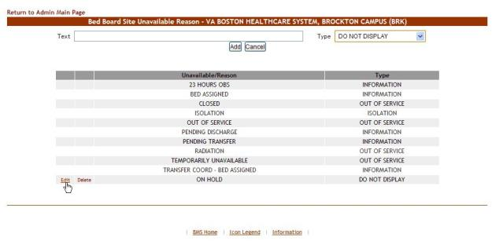

Figure 69 – Selecting an Unavailable Reason for Edit

Click the **Edit** link associated to the *unavailable reason* that you want to modify; the following page is displayed:

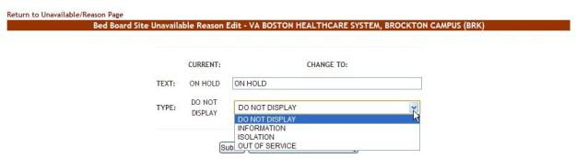

Figure 70 – Editing an Unavailable Reason

Operate the desired changes in the **Text** and/or **Type** fields then press the **Submit** button to enter the data into the system.

* + - 1. **Deleting an Unavailable Reason**

To delete an *unavailable reason,* follow the instructions below.

From the facility home page, click the **Site Options** link.



Figure 71 – Selecting Site Options

The **Bed Board Site Configuration** page is displayed as in the image below.

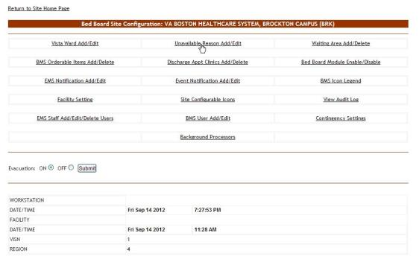

Figure 72 – Selecting Unavailable Reason Add/Edit

Select the **Unavailable Reason Add/Edit** link to display the page in the following image.

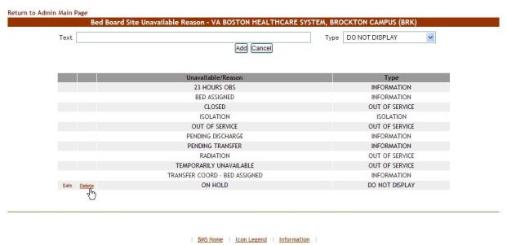

Figure 73 – Select an Unavailable Reason for Deletion

Click the **Delete** link associated to the *unavailable reason* that you want to delete: a confirmation screen is displayed as in the following image.

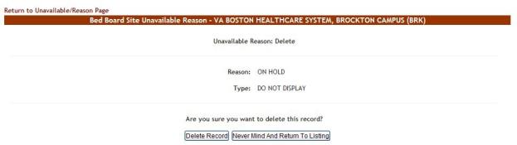

Figure 74 – Delete an Unavailable Reason

Click the **Delete Record** button to delete the *unavailable reason* from the list.

### Bed Board Discharge Appointment Clinic Configuration Page

From the Bed Board Site Configuration page, click the Discharge Appointment Clinics Add/Delete link to display the following page.

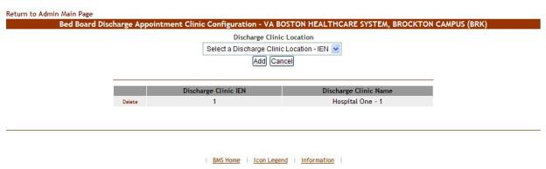

Figure 75 – Discharge Appointment Clinics Add/Edit Page

The options in this screen allow the administrator user the ability to define the discharge clinics used to assist with patient discharges if used by the facilities process.

The options in the upper part of the screen allow the administrator user to define/add a new discharge appointment clinic in the system.

The list in the lower part of the screen presents the discharge appointment clinics already defined in the system. The Delete link to the left of each entry in the list allows the user to delete the clinic from the system.

To go back to the **Bed Board Site Configuration** page click the link **Return to the Admin Main Page**

in the upper left corner of the page.

**4.1.8.1 Adding/Deleting a Discharge Appointment Location**

To add a discharge appointment location, follow the instructions below. From the facility home page, click the **Site Options** link.



Figure 76 – Selecting Site Options

The **Bed Board Site Configuration** page is displayed as in the image below.

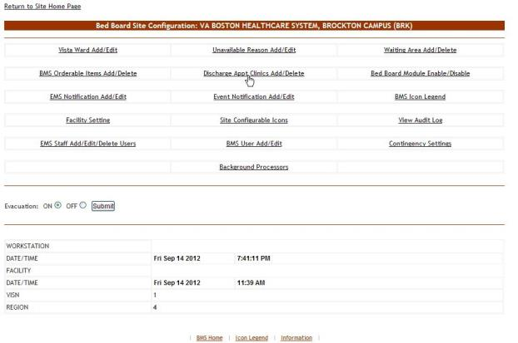

Figure 77 - Selecting Discharge Appointment Clinics Add/Delete

Select the **Discharge Appointment Clinics Add/Delete** link to display the page in the following image.

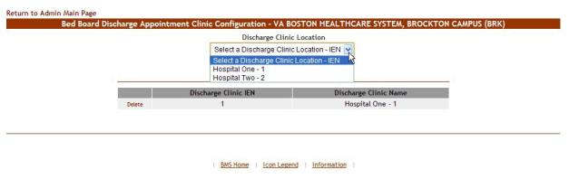

Figure 78 - Selecting a Discharge Clinic Location

Use the arrow button of the field **Discharge Clinic Location** to display the available locations and select the one you want to add then press the **Add** button. The newly added discharge clinic location will be added to the list. To delete an entry from the list use the associated **Delete** link.

### Events Notifications Page

From the **Bed Board Site Configuration** page, click the **Event Notification Add/Edit** page link to display the following page.

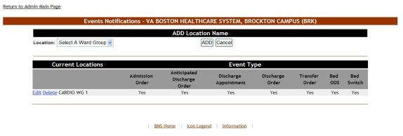

Figure 79 – Events Notifications Page

The options available in this screen allow the administrator user to manage the event notifications in the system.

**Note:** Notifications can also be sent by printer, pager and cell phones as well as email.

For each notification in the list, the following data is available:

Table 9 – Event Notification Parameters

|  |  |
| --- | --- |
| **Column** | **Description** |
| Current Locations | The location for which the event notification has been defined. |
| Event Type | The event type, which triggers the notification. |
| Admission Order | Is there a physician admission order? |
| Anticipated Discharge Order | Is there an Anticipated Discharge order? |
| Discharge Appointment | Is there a discharge appointment? |
| Discharge Order | Is there a physician discharge order? |
| Transfer Order | Is there a physician transfer order? |
| Bed Out of Service (OOS) | Is there a bed OOS? |
| Bed Switch | Is there a bed switch? This occurs when a patient moves from one bed to another within the same ward. (Example: patient movement from Cardio Wing Bed 1 to Cardio Wing Bed 2). Do not confuse bed switch with “transfer” which occurs when a patient moves to a bed on a different ward. |

The link **Edit** to the left of each entry in the list allows the user to modify the details of an event notification. A notification can be deleted using the adjacent **Delete** link.

To go back to the Bed Board Site Configuration page click the link **Return to the Admin Main Page**

in the upper left corner of the page.

* + - 1. **Adding an Events Notification**

To add an events notification, follow the instructions below.

From the facility home page, click the **Site Options** link.



Figure 80 – Selecting Site Options

The **Bed Board Site Configuration** page is displayed as in the image below.

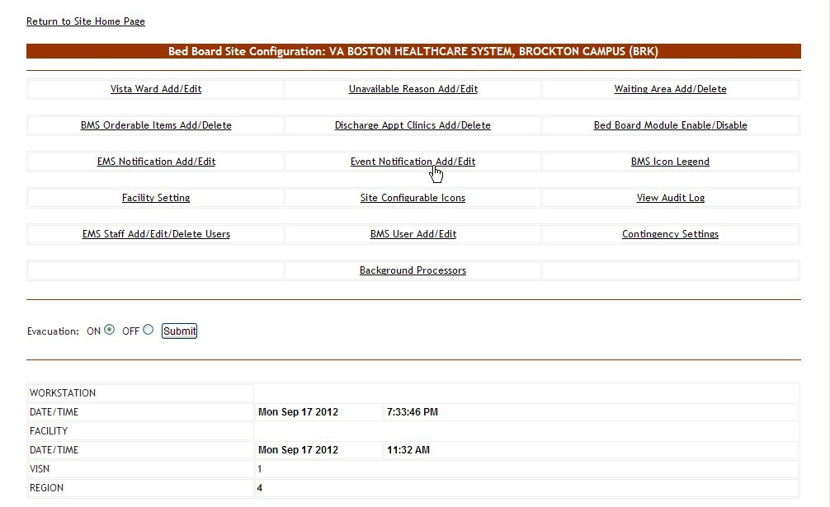

Figure 81 – Selecting Event Notification Add/Edit

Select the **Event Notification Add/Edit** link to display the page in the following image.

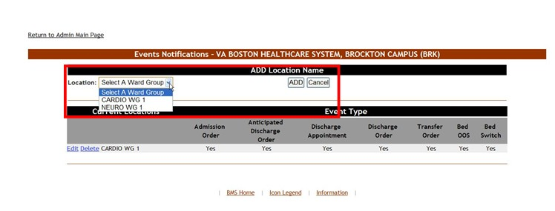

Figure 82 – Selecting the Location of the Events

Click the arrow button of the **Location** field to display the list of ward groups defined in the system then click the ADD button: the following page is displayed.

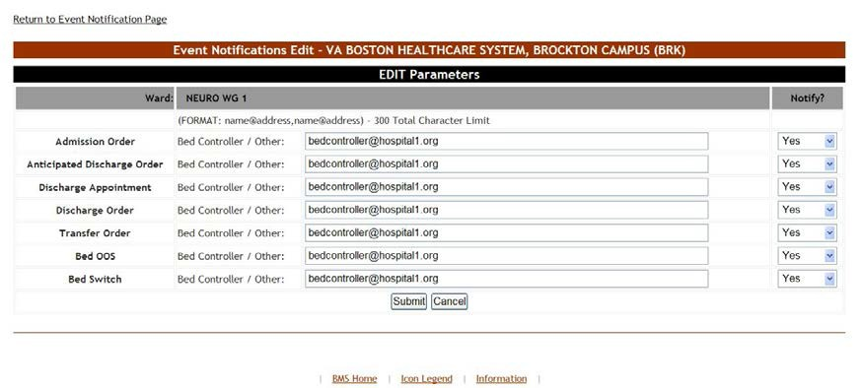

Figure 83 – Edit Event Notification Parameters

The name of the selected location is displayed in the upper part of the screen and a list of events is presented. In the **Bed Controller/Other** field associated to an event enter the email addresses, text pagers, text-compatible cell phones and/or printer where you want to send the notification. From the drop- down fields in the Notify column, set whether the new notification will actually be sent or not then click the **Submit** button to enter the data into the system.

* + - 1. **Editing an Event Notification**

To edit the details of an event notification follow the steps below.

From the facility home page, click the **Site Options** link.



Figure 84 – Selecting Site Options

The **Bed Board Site Configuration** page is displayed as in the image below.

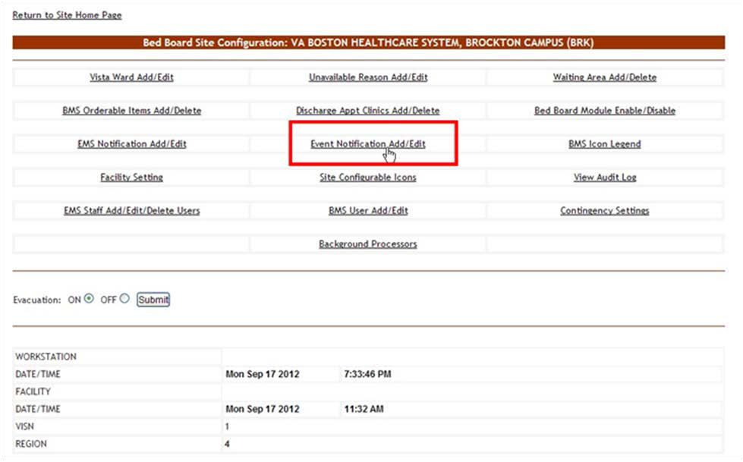

Figure 85 – Selecting Event Notification Add/Edit

Select the **Event Notification Add/Edit** link to display the page in the following image.

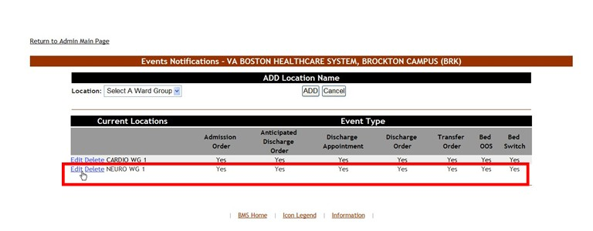

Figure 86 – Selecting Event Notification for Edit

Click the **Edit** link associated to the event notification you want to modify: the following page is displayed.

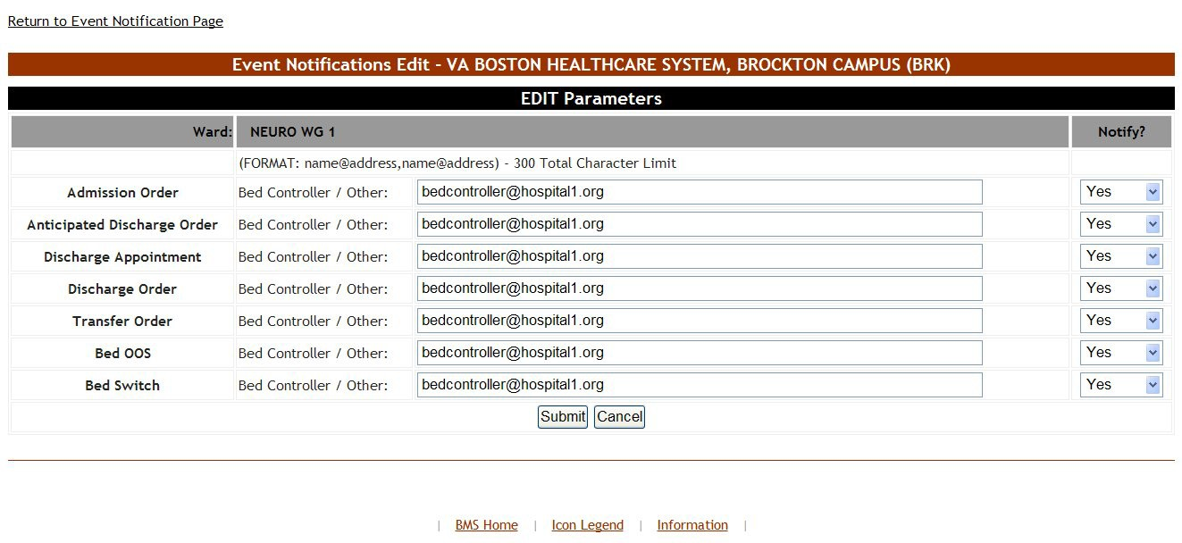

Figure 87 – Modifying Parameters for an Event Notification

Modify the desired settings then press the **Submit** button to enter the data into the system. The modified event notification will be displayed in the event notifications list with the new settings.

* + - 1. **Deleting an Event Notification**

To delete an event notification, follow the steps below.

From the facility home page, click the **Site Options** link.



Figure 88 – Selecting Site Options

The **Bed Board Site Configuration** page is displayed as in the image below.

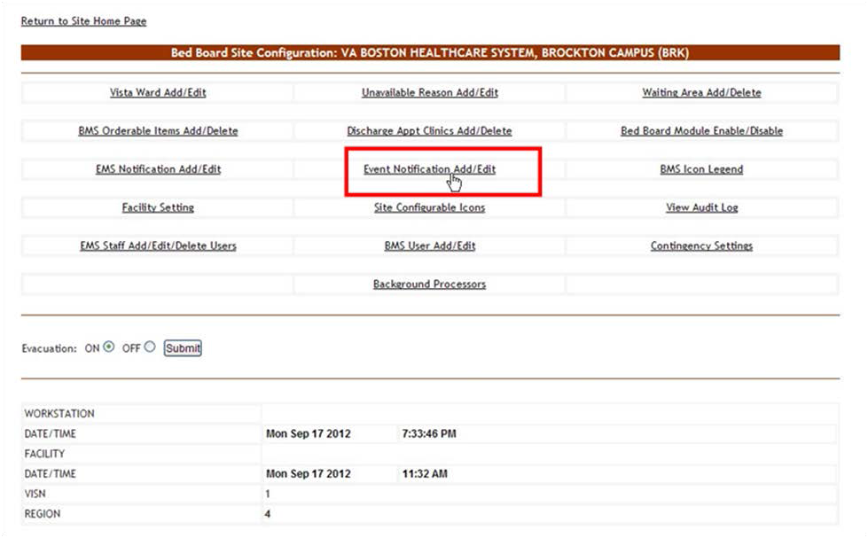

Figure 89 – Selecting Event Notification Add/Edit

Select the **Event Notification Add/Edit** link to display the page in the following image.

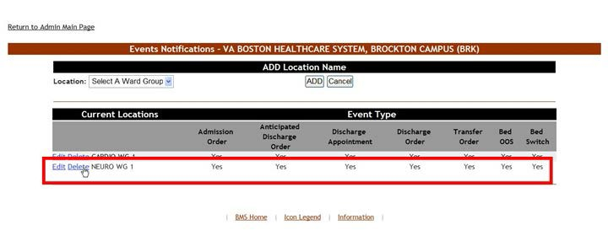

Figure 90 – Selecting Event Notification for Deletion

Click the **Delete** link associated to the events notification that you want to delete: a confirmation screen is displayed as in the following image.

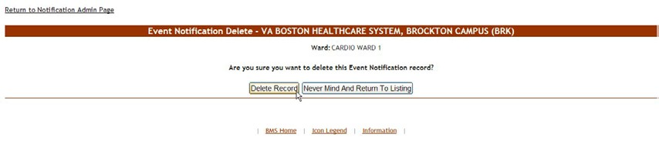

Figure 91 – Delete an Event Notification

Click the **Delete Record** button to delete the events notification from the list.

### Site Configurable Icons Page

From the **Bed Board Site Configuration** page, click the **Site Configurable Icons** link to display the following page.

**Note:** Users are discouraged from using the words DNR/DNI in the comment of the Ward Whiteboard or using any icon to represent DNR/DNI on the Ward Whiteboard.

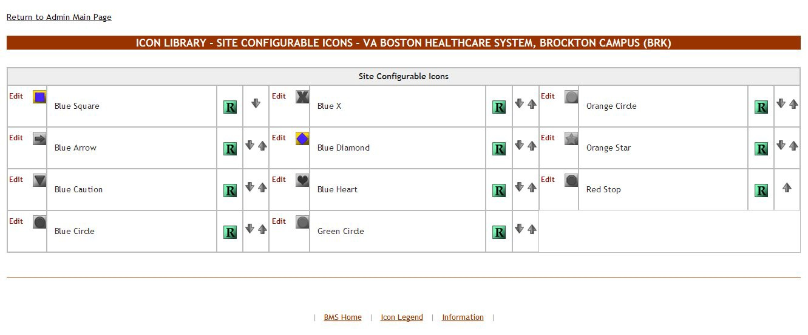

Figure 92 – Icon Library – Site Configurable Icons Page

A list of site configurable icons is displayed. These icons can only be used on the site of the current facility. Colored icons are active and can be used to convey information on the Whiteboard; grayed icons are inactive and cannot be used on the Whiteboard. The user can edit the details of an icon.

To go back to the Bed Board Site Configuration page click the link **Return to the Admin Main Page** in the upper left corner of the page.

#### 4.1.10.1 Editing an Icon

In the **Icon Library – Site Configurable Icons** page click the **Edit** link to the left of the icon you want to edit to display the following image.

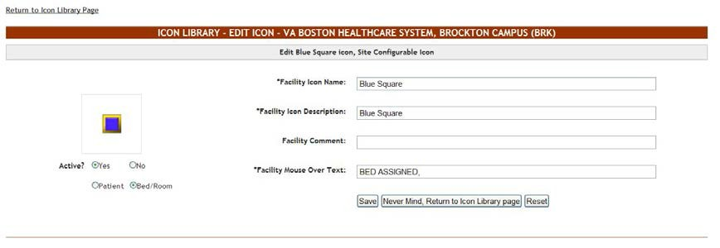

Figure 93 – Icon Library – Edit Icon Page

The following parameters can be set for an icon:

(The fields will only be mandatory if the icon is active.)

Table 10 – Icon Parameters

| **Column** | **Description** |
| --- | --- |
| Active Yes/No | If the icon is active or not. |
| Patient/Bed/Room | If the icon is to be attached to a patient or to a bed/room. |
| Facility Icon Name | Mandatory field, the name of the icon. |
| Facility Icon Description | Mandatory field, the description of the icon. |
| Facility Comment | Any relevant additional info about the icon. |
| Facility Mouse Over Text | Mandatory field, the text to be displayed when the mouse cursor hovers over the icon. |

After you have defining the desired parameters for the icon click the **Save** button to enter the data into the system.

NOTE: once an icon has been used to flag a patient or a bed, it cannot be inactivated. In order to be able to make the icon inactive the user will have to remove the icon from Whiteboard where it has been used.

### Add/Edit BMS User Page

From the **Bed Board Site Configuration** page, click the **Add/Edit BMS User** link to display the following page.

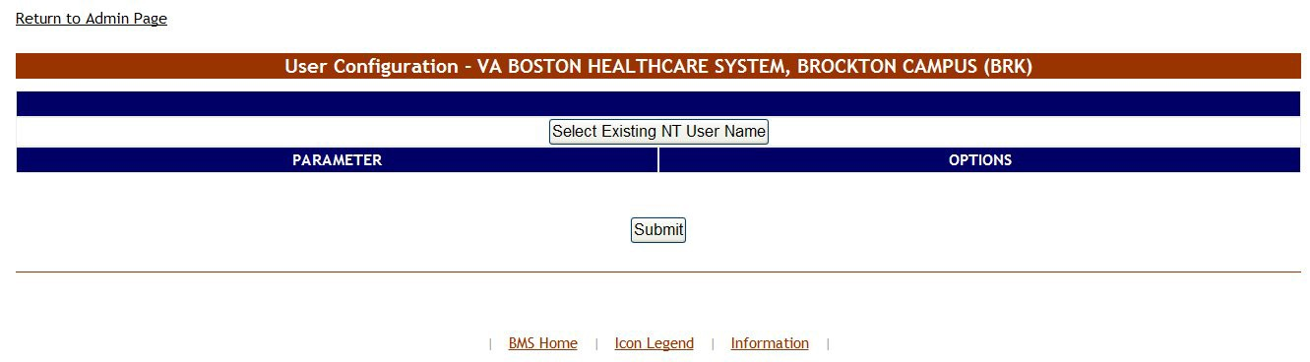

Figure 94 – User Configuration Page

The options available in this screen allow the administrator user to add, edit or delete the rights of the BMS users for the current facility site.

To go back to the Bed Board Site Configuration page click the link **Return to the Admin Main Page** in the upper left corner of the page.

#### 4.1.11.1 Adding a BMS User to the current facility site

To add a BMS user to the current facility site*,* follow the instructions below. From the facility home page, click the **Site Options** link.



Figure 95 – Selecting Site Options

The **Bed Board Site Configuration** page is displayed as in the image below.

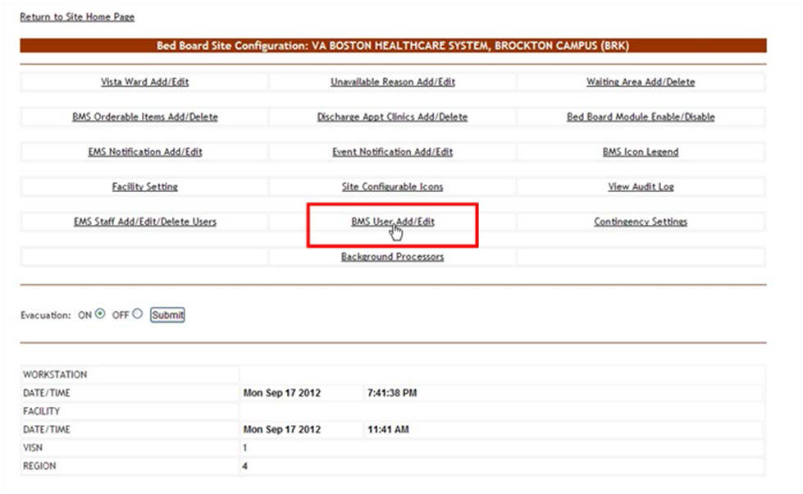

Figure 96 – Selecting Add/Edit BMS User

Select the **BMS User Add/Edit** link to display the page in the following image.



Figure 97 – User Configuration page

Click the button **Select Existing NT User Name** (the user must have an account in VA’s Active Directory) click this button to display the following screen:

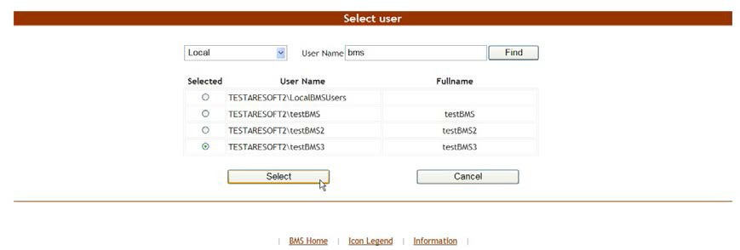

Figure 98 – Select User

From the **Local** field select the domain to which the user currently belongs. Enter part of the name of the user in the **User Name** field then press the **Find** button to locate the user.

From the list in the central part of the screen select the user to whom you want to grant access to the current BMS facility site then press the **Select** button: the following screen is displayed.

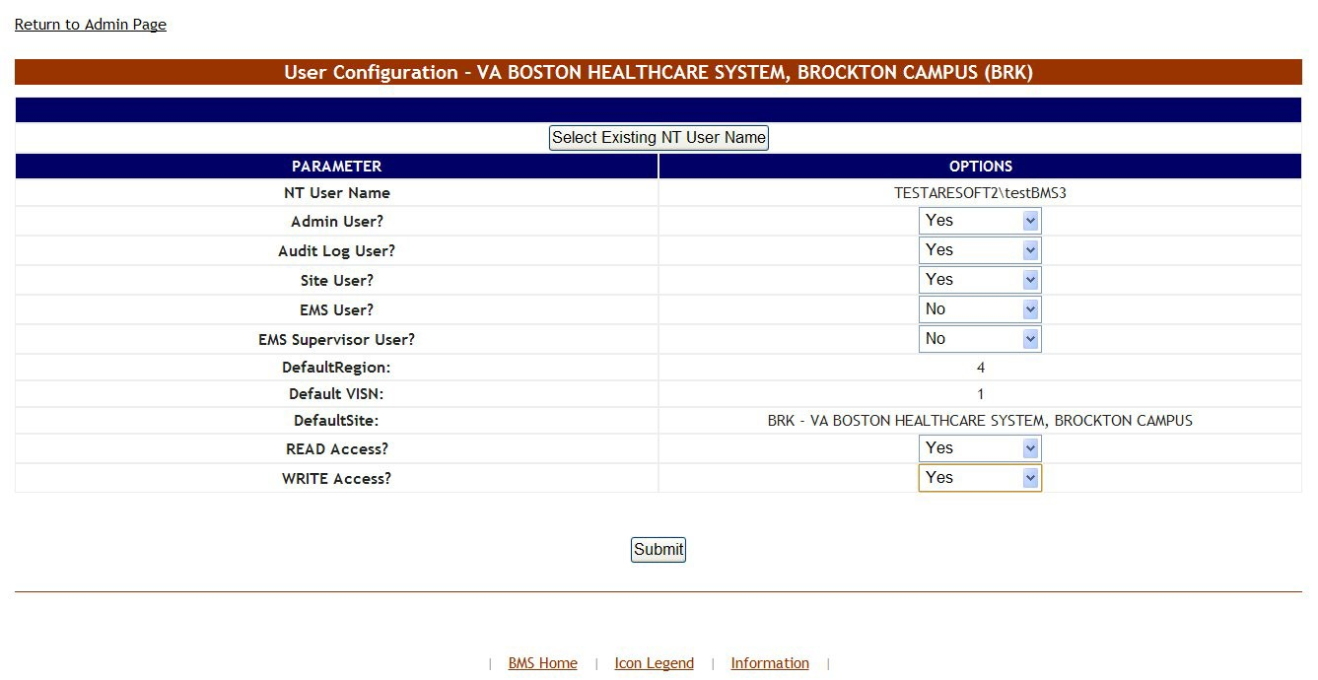

Figure 99 – Customize BMS Facility Site User Rights

The following parameters can be set for a user of a facility site:

Table 11 – BMS Facility Site User Parameters

| **Column** | **Description** |
| --- | --- |
| NT User Name: | NT user who will be given access rights to the facility site. |
| Admin User? | If the new user will have access to the Administration section page. |
| Audit Log User? | If the new user will have access to the Audit Log function. |
| Site User? | If the user will have access to the current facility site. |
| EMS User? | If the new user is part of EMS group. |
| EMS Supervisor User? | If the new user has EMS supervisor rights. |
| Default Region | This field displays the name of the current region (where the current VISN belongs to). |
| Default VISN | This field displays the current VISN (to which the current facility site belongs to). |
| DefaultSite | The default site which is displayed when the new user logs into the system. |
| READ Access | If the selected user has READ rights on the sites in the selected Region/VISN. |
| WRITE Access | If the selected user has WRITE rights on the sites in the selected Region/VISN. |

After setting the desired parameters for the selected user, click the **Submit** button to enter the data into the system.

#### 4.1.11.2 Editing BMS user rights for the current facility site

To edit the rights of a BMS user for the current facility site*,* follow the instructions below. From the facility home page, click the **Site Options** link.



Figure 100 – Selecting Site Options

The **Bed Board Site Configuration** page is displayed as in the image below.

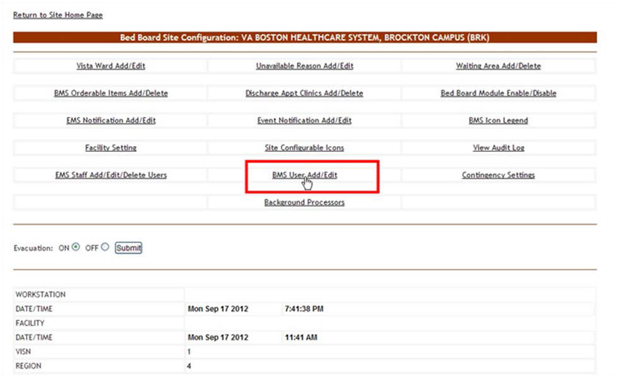

Figure 101 – Selecting Add/Edit BMS User

Select the **BMS User Add/Edit** link to display the page in the following image.



Figure 102 – BMS User Configuration Page

Click the button **Select Existing NT User Name** to display the following screen:



Figure 103 – Select User

From the **Local** field select the domain to which the user currently belongs. Enter part of the name of the user in the **User Name** field then press the **Find** button to locate the user.

From the list in the central part of the screen select the user whose rights for the current facility site you want to edit then **Select** button: the following screen is displayed.

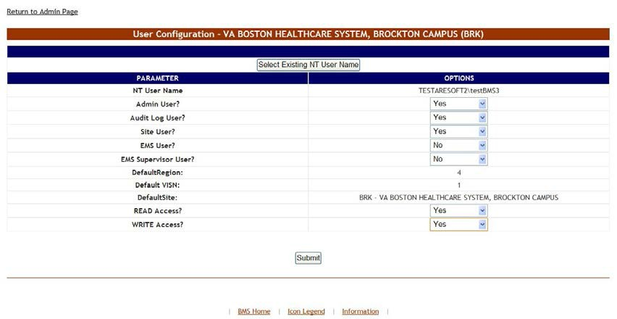

Figure 104 – Customize BMS facility site user rights

Modify the existing selections then click the Submit button to enter the new data into the system.

#### 4.1.11.3 Deleting a BMS user for the current facility site

To delete a BMS user (cancel his/her rights) for the current facility site, follow the instructions below. From the facility home page, click the **Site Options** link



Figure 105 – Selecting Site Options

The **Bed Board Site Configuration** page is displayed as in the image below.

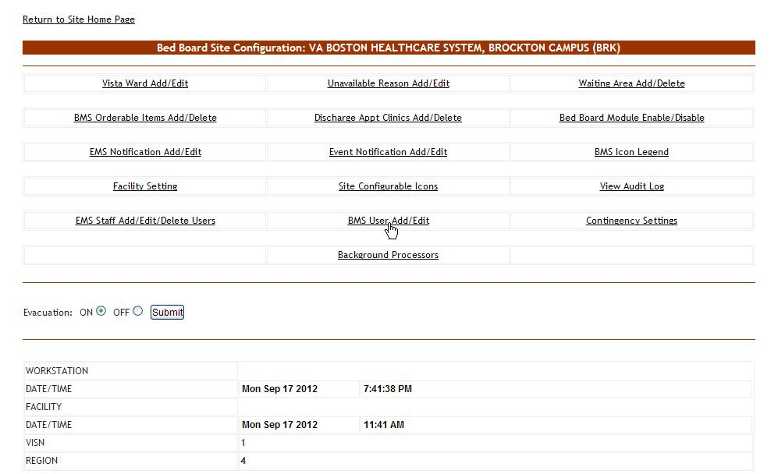

Figure 106 – Selecting Add/Edit BMS User

Select the **BMS User Add/Edit** link to display the page in the following image.



Figure 107 – BMS User Configuration Page

Click the button **Select Existing NT User Name** to display the following screen:

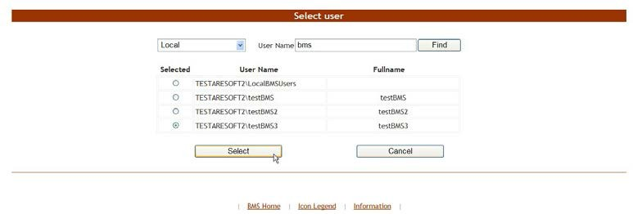

Figure 108 – Select User

From the **Local** field select the domain to which the user currently belongs. Enter part of the name of the user in the **User Name** field then press the **Find** button to locate the user.

From the list in the central part of the screen select the user whose rights for the current facility site you want to edit then **Select** button: the following screen is displayed.



Figure 109 – Customize BMS Facility Site User Rights

Select “No” for all the available options the press the Submit button to enter the data into the system.

### Background Processors Page

From the **Bed Board Site Configuration** page, click the **Background Processors** link to display the following page.

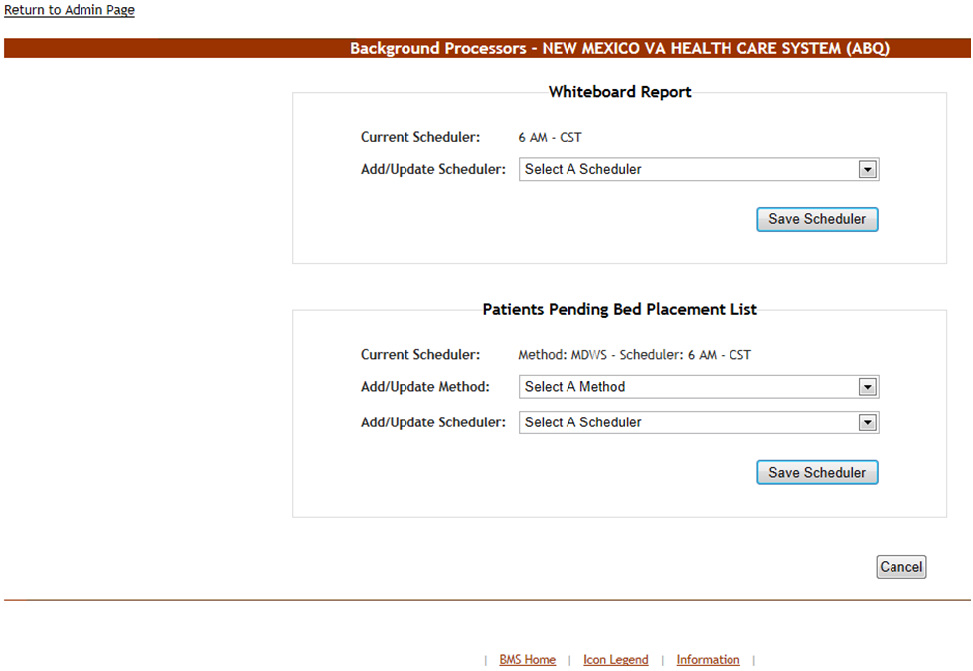

Figure 110 – Facility Background Processors

The options available in this screen allow the administrator user to manage the schedulers which collect data for the Whiteboard report and for the Patients Pending Bed Placement list.

In the Whiteboard report area the Current Scheduler field will display the name of the scheduler that is currently used to collect data for the Whiteboard report. To select another scheduler use the arrow button of the **Add/Update Scheduler** field to display the available schedulers, select the one you want to use and press the **Save Scheduler** button.

In the Patients Pending Bed Placement list area the **Current Scheduler** field will display the name of the scheduler that is currently used to generate the local Facility Patients Pending Bed Placement List entries for the VistA Scheduled Admissions due for the current day. From the **Add/Update Method** drop down select the connection method (at this time only select “MDWS”) associated with the scheduler you want to use. To select a new scheduler use the arrow button of the **Add/Update Scheduler** drop down, to display the available schedulers, select the one you want to use and click the Save Scheduler button. Under normal circumstances this is only scheduled to run once a day in the mornings.

If your facility does not want VistA Scheduled Admissions automatically added to the Facility Patients Pending Bed Placement list, use the arrow button of the **Add/Update Scheduler** drop down and select “Delete Scheduler”, and click the Save Scheduler button.

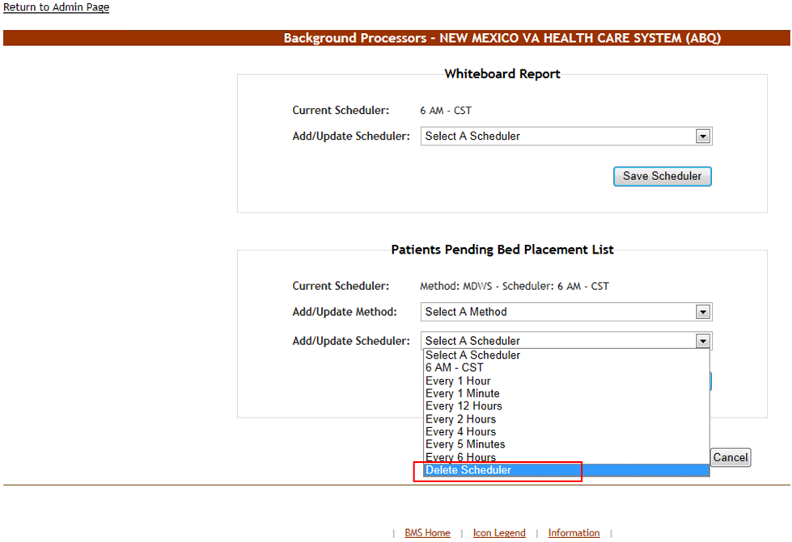

Figure 111 – Facility Background Processors

### Patient Waiting Areas Page

From the facility home page, click the **Site Options** link.



Figure 112 – Selecting Site Options

The **Bed Board Site Configuration** page is displayed as in the image below.

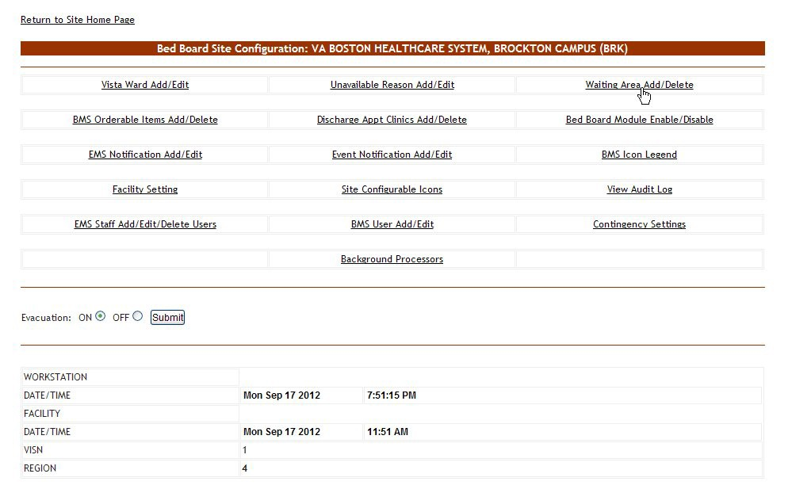

Figure 113 – Selecting Waiting Area Add/Edit

Select the **Wa**i**ting Area Add/Edit** link to display the page in the following image.

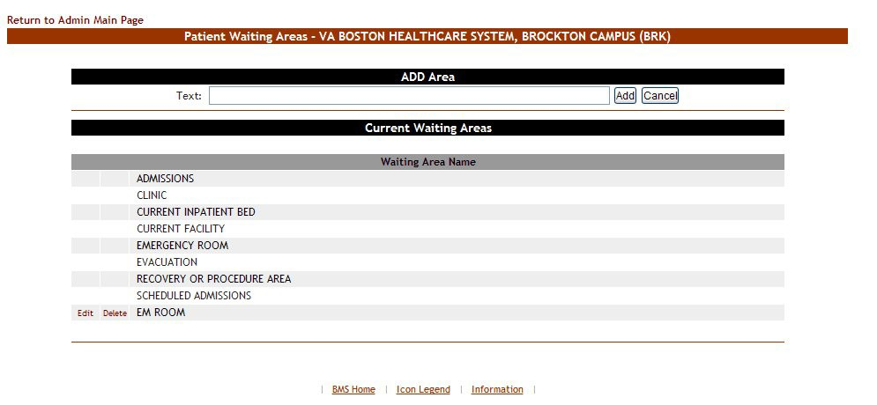

Figure 114 – Patient Waiting Areas

This is where you will add the locations for patients pending bed placement. You may decide to list only outside facilities. Some sites have chosen to list internal areas like the Emergency Room, Recovery or Procedure Area, and Clinic.

The options in the upper part of the screen allow the administrator user to define/add a new waiting area in the system and to decide whether the patients waiting in the new area will appear in the national list of patients pending bed placement (the National option top center of the page). Non-editable waiting areas will be pre-defined for national tracking.

The list in the lower part of the screen presents the waiting areas already defined in the system. The links Edit and Delete to the left of each entry in the list allow the administrator user to modify the name of the selected waiting area or to delete the entry from the system.

To go back to the **Bed Board Site Configuration** page click the link **Return to the Admin Main Page** in the upper left corner of the page.

#### 4.1.13.1 Adding a Waiting Area

To add a waiting area, follow the instructions below. From the facility home page, click the **Site Options** link.



Figure 115 – Selecting Site Options

The **Bed Board Site Configuration** page is displayed as in the image below.



Figure 116 – Selecting Waiting Area Add/Edit

Select the **Waiting Area Add/Edit** link to display the page in the following image.

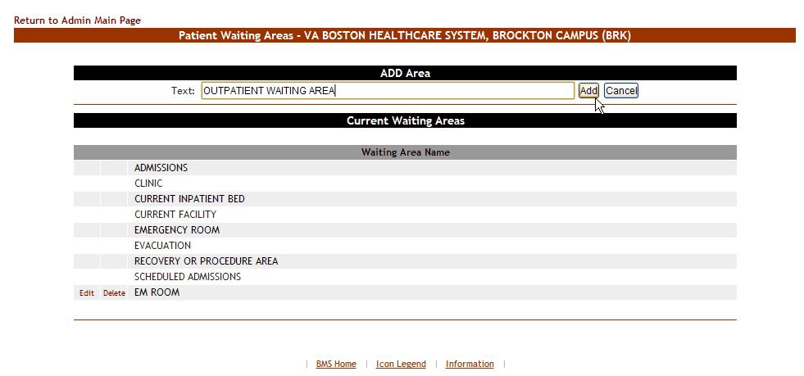

Figure 117 – Adding a Waiting Area

In the **Text** field from the ADD Area enter the name of the new waiting area, then, press the **Add** button: a confirmation message is displayed and the newly added waiting area is displayed in the Current Waiting Areas list.

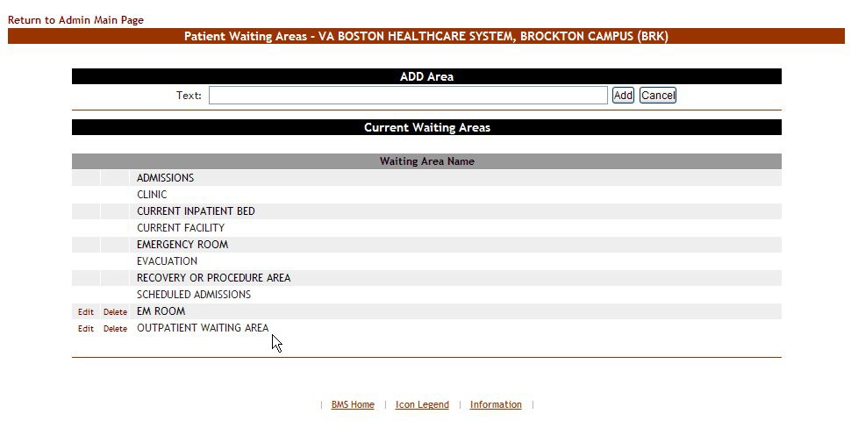

Figure 118 – Waiting Area Added to the List

#### 4.1.13.2 Editing a Waiting Area

To edit the name of an existing waiting area*,* follow the instructions below. From the facility home page, click the **Site Options** link.



Figure 119 – Selecting Site Options

The **Bed Board Site Configuration** page is displayed as in the image below.



Figure 120 – Selecting Waiting Area Add/Edit

Select the **Waiting Area Add/Edit** link to display the page in the following image.

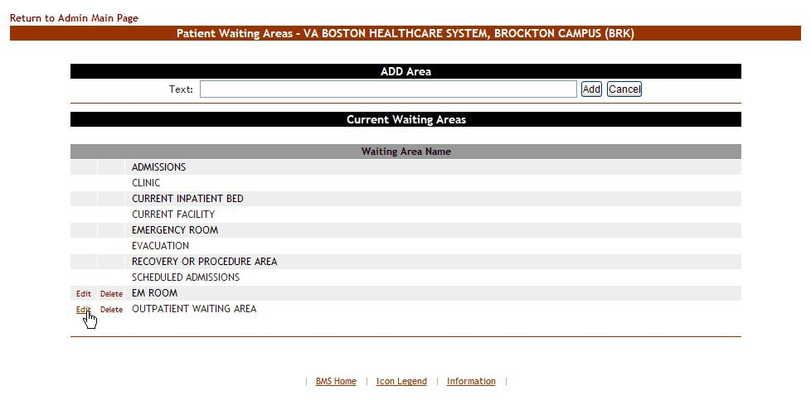

Figure 121 – Selecting Waiting Area for Edit

Selecting the **Edit** link will display the **Waiting Areas: Edit** page as in the following image.

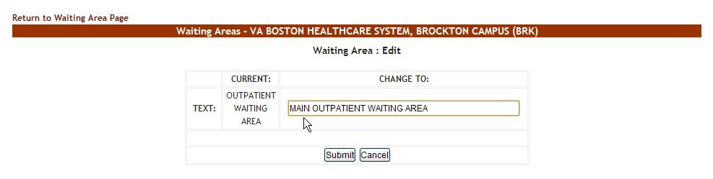

Figure 122 – Edit Waiting Area Name

In the field **CHANGE TO:** enter the new name for the waiting area then press the **Submit** button. A confirmation message will be displayed and the waiting area with the new name will be displayed in the Current Waiting Areas list.

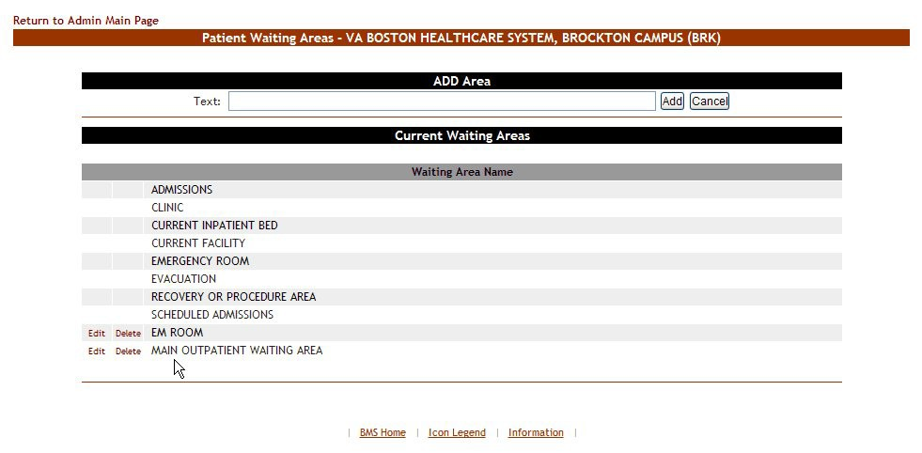

Figure 123 – Waiting Area Edited

#### 4.1.13.3 Deleting a Waiting Area

To delete a waiting area defined for the current facility, follow the instructions below.

From the facility home page, click the Site Options link.



Figure 124 – Selecting Site Options

The **Bed Board Site Configuration** page is displayed as in the image below.



Figure 125 – Selecting Waiting Area Add/Edit

Select the **Waiting Area Add/Edit** link to display the page in the following image.

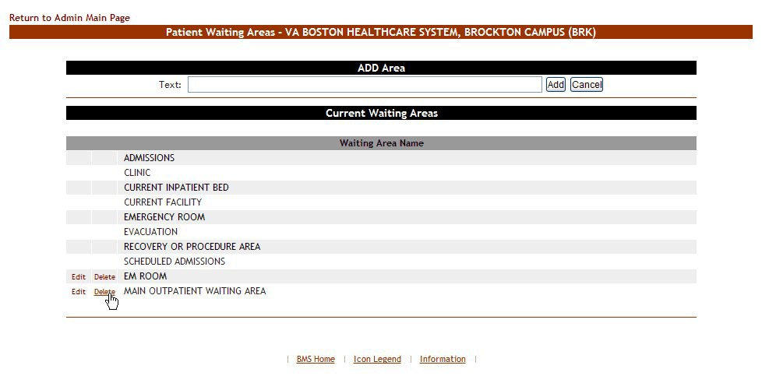

Figure 126 – Select a Waiting Area for Deletion

Click the **Delete** link associated to the waiting area that you want to delete: a confirmation screen is displayed as in the following image.

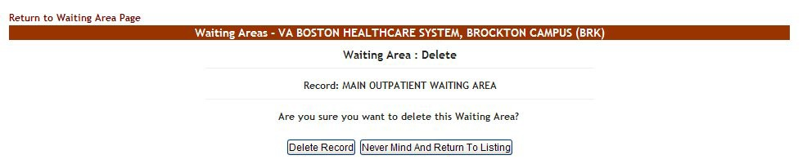

Figure 127 – Deleting a Waiting Area

Click the **Delete Record** button to delete the waiting area from the list.

### Bed Board Module Activation and Configuration Page

From the **Bed Board Site Configuration** page, click the **Bed Board Module Enable/Disable** link to display the following page



Figure 128 – BMS Bed Board Site Configuration Bed Board Module Enable/Disable Screen

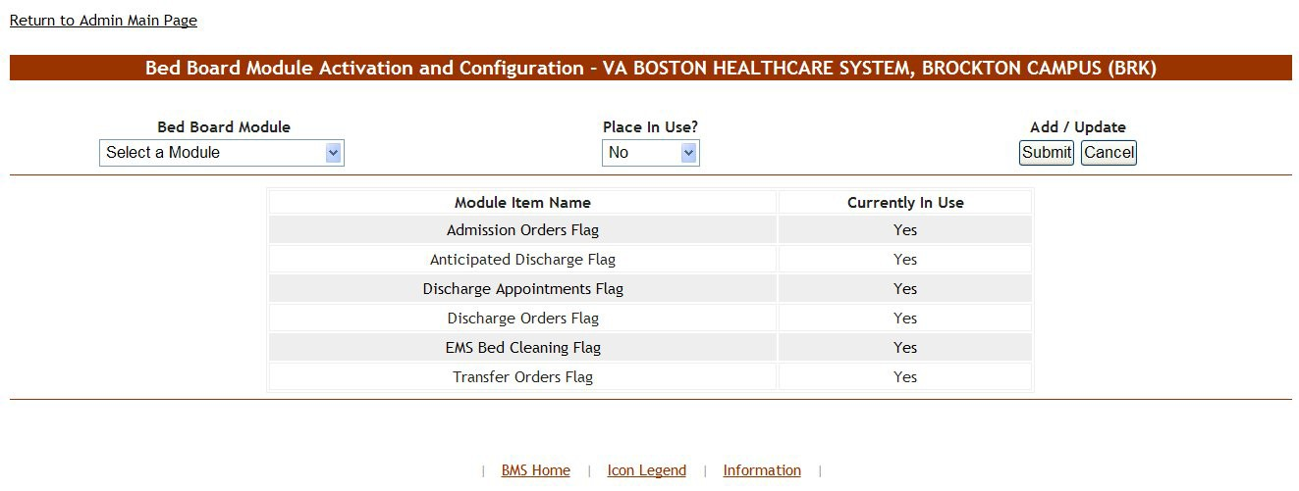

Figure 129 – Bed Board Module Activation and Configuration

The options available in this screen allow the administrator user to manage the on/off status of the Bed Board modules.

The options in the upper part of the screen allow the administrator user to place in use or disable one of the Bed Board modules defined in the system.

The list in the lower part of the screen presents the Bed Board modules defined in the system and their status.

To go back to the **Bed Board Site Configuration** page click the link **Return to the Admin Main Page** in the upper left corner of the page.

#### 4.1.14.1 Activating a Bed Board Module

In the **Bed Board Module Activation and Configuration** page click the arrow button of the field **Bed Board Module** to display a list of available modules and select the module you want to activate. Then from the **Place in Use?** field, select “Yes” then click the **Submit** button.

#### 4.1.14.2 Disabling a Bed Board Module

In the **Bed Board Module Activation and Configuration** page click the arrow button of the field **Bed Board Module** to display a list of available modules and select the module you want to disable. Then from the **Place in Use?** field, select “No” then click the **Submit** button.

### Bed Management Board Icons Page

From the **Bed Board Site Configuration** page, click the **BMS Icon Legend** link to display the following page.



Figure 130 – BMS Bed Board Site Configuration BMS Icon Legend Screen

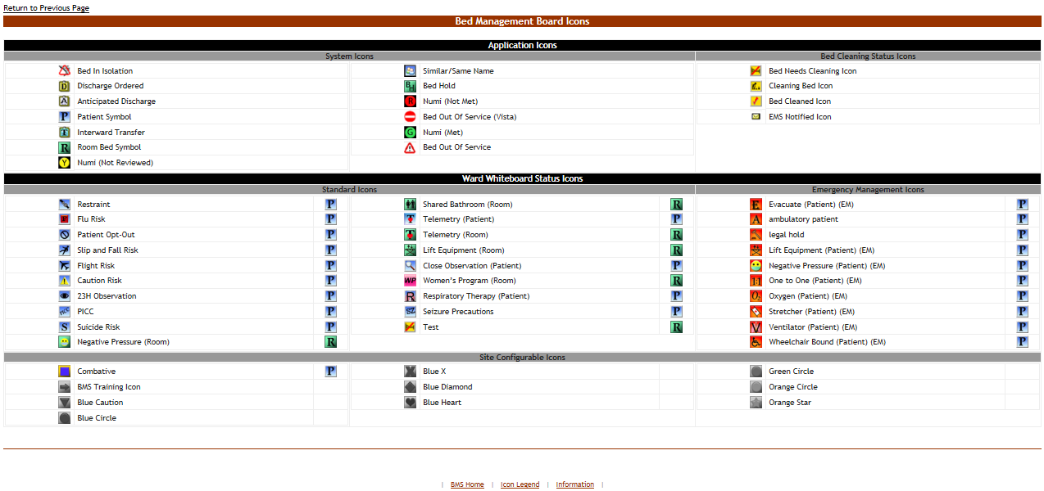

Figure 131 – Bed Management Board Icon Legend Page

The page presents the icons that can be used throughout the application, their corresponding significance and the application element to which they can be attached (patient, room/bed). The icons are grouped according to area of the application where they are likely to be used and the type of information they convey: Application Icons (System and Bed Cleaning Status), Ward Whiteboard Status Icons (Standard and Emergency Management) and Site Configurable Icons.

### Audit Log Report Page

From the **Bed Board Site Configuration** page, click the **Audit Log Report** link to display the following page.



Figure 132 – BMS Bed Board Site Configuration / View Audit Log Screen

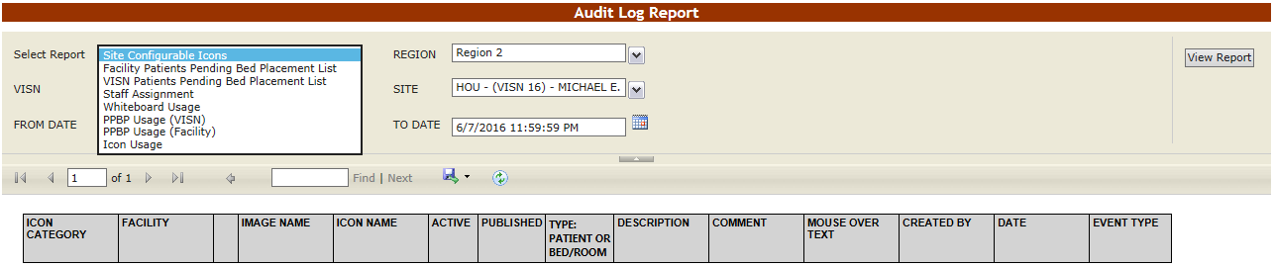

Figure 133 – Audit Log Report

The Audit Log reports present information about what users have performed what actions in different areas of the application (such as icons, pending bed placements or staff assignment). See the following sections for details on each report.

#### 4.1.16.1 Site Configurable Icons Report

The Site Configurable Icons Report presents information about the usage of the site configurable icons within the system.

In the **Audit Log Report** page use the **Select Report** field to select the Site Icons report, then select **Date from/Date to** determine the time interval for the report, the **Region**, **VISN** and **Site** and press the **View Report** button. The image below presents an example of a Site Configurable Icons Report.

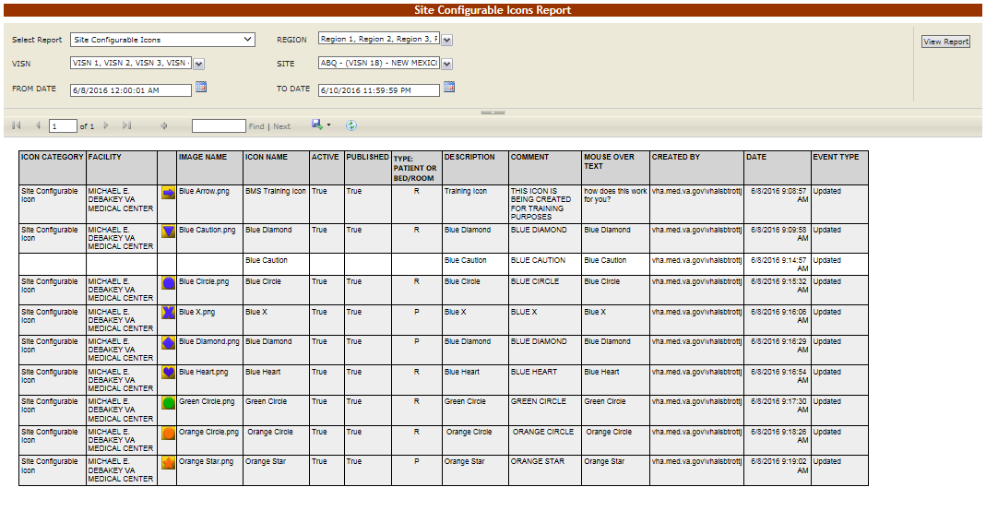

Figure 134 – Site Configurable Icons Report

For each entry the following data is available:

Table 13– Site Configurable Icons Report Parameters

| **Column** | **Description** |
| --- | --- |
| Icon Type | The type of icon: can only be Site Configurable Icon. |
| Facility | The name of the facility for which the icon has been configured and used. |
| (Icon image) | The icon image. |
| Image Name | The name of the image entered in the Image Name field in the Edit Icon page. |
| Icon Name | The name assigned to the icon. |
| Active | If the icon is active. |
| Published | If the icon has been published. |
| Type: Patient or RoomBed | If the icon is used to flag a patient or a room or a bed. |
| Description | The description of the icon as entered in the Icon Description field in the Edit Icon page. |
| Comment | Any comment entered in the Comments field in the Edit Icon page. |
| Mouse Over Text | The text entered in the Mouse Over Text field in the Edit Icon page. |
| Created By | The name of the user who performed the current operation on the icon. |
| Date | The date and time when the current operation has been performed on the icon. |
| Event Type | The type of operation that has been performed on the icon. |

#### 4.1.16.2 Facility Patient Pending Bed Placement List Report

The Facility Patient Pending Bed Placement List Report presents information about what users have performed what actions on a facility pending bed placement list.

In the **Audit Log Report** page use the **Select Report** field to select the Facility Pending Bed Placement List report, then select **Date from/Date to** determine the time interval for the report, the **Region**, **VISN** and **Site** and press the **View Report** button. The image below presents an example of a Facility Patient Pending Bed Placement List Report.

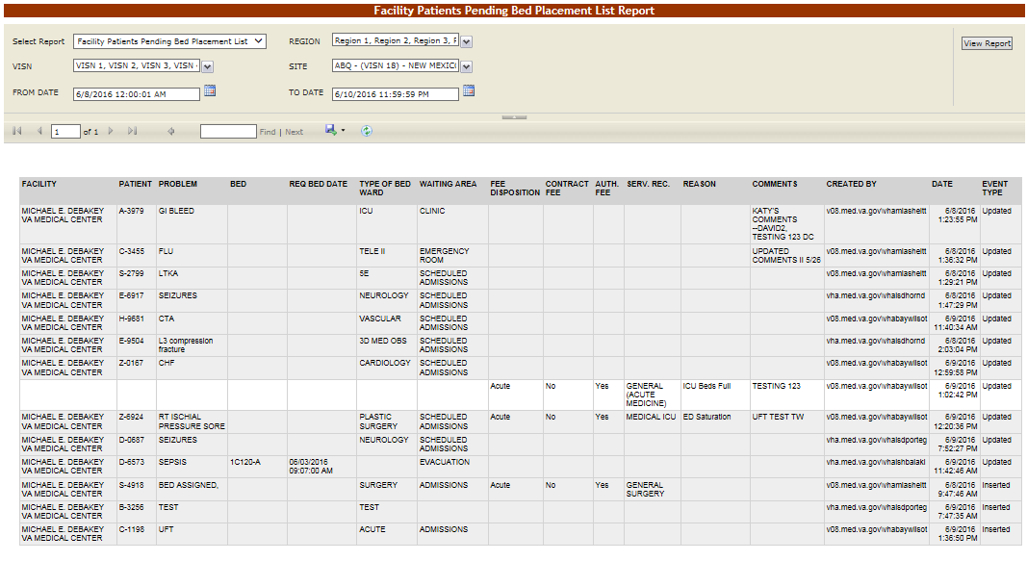

Figure 135 – Facility Patient Pending Bed Placement List Report

For each entry the following data is available:

Table 14 – Facility Patient Pending Bed Placement List Report Parameters

| **COLUMN** | **DESCRIPTION** |
| --- | --- |
| Facility | The name of the VA facility. |
| Patient | The code of the patient. |
| Problem | The problem for which the patient needed treatment. |
| Bed | The bed assigned to the patient. |
| Req Bed Date | The date when the bed was requested for the patient. |
| Type of Bed Ward | The type of bed/ward requested for the patient. |
| Waiting Area | The waiting area where the patient has been placed. |
| Fee Disposition | The fee disposition associated to the patient. |
| Contract Fee | The contract fee. |
| Auth. Fee | The authorization to use the fee. |
| Serv. Rec. | The type of service requested according to the patient’s problem. |
| Reason | The reason for using the fee. |
| Comments | Any comments entered in the Comments field. |
| Created by | The user who created the event. |
| Date | The date and time when the event was created. |
| Event Type | The type of event. |

#### 4.1.16.3 VISN Patient Pending Bed Placement List Report

The VISN Patient Pending Bed Placement List Report presents information about what users have performed what actions on a VISN pending bed placement list.

In the **Audit Log Report** page use the **Select Report** field to select the VISN Patient Pending Bed Placement List report, then select **Date from/Date to** determine the time interval for the report, the **Region**, **VISN** and **Site** and press the **View Report** button. The image below presents an example of a VISN Patient Pending Bed Placement List Report.

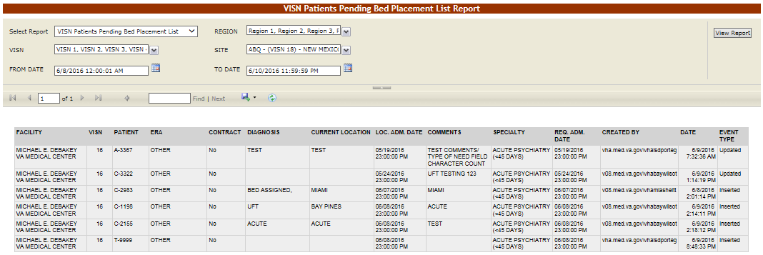

Figure 136 – VISN Patient Pending Bed Placement List Report

For each entry the following data is available:

Table 15 – VISN Patient Pending Bed Placement List Report Parameters

| **COLUMN** | **DESCRIPTION** |
| --- | --- |
| Facility | The name of the VA facility. |
| VISN | The VISN where the VA facility is located. |
| Patient | The code of the patient. |
| ERA | The period of service that the patient served. |
| Contract | Whether or not the VA facility has a contract with the selected community hospital. |
| Diagnosis | The diagnosis for which the patient requests admission to the community hospital. |
| Current location | The name of the community hospital where the patient is currently being treated |
| Location Adm. Date | The date when the patient has been admitted in the selected location. |
| Comments | Any comments entered in the Comments field. |
| Specialty | The treating specialty corresponding to the type of need. |
| Req. Adm. Date | The date when the patient should be able to be admitted to the VA facility. |
| Created by | The name of the user who created the event. |
| Date | The date and time when the event has been created. |
| Event Type | The type of the event. |

#### 4.1.16.4 Staff Assignment Report

The Staff Assignment Report presents information about what users have assigned staff personnel to the beds in the wards of a facility.

In the **Audit Log Report** page use the **Select Report** field to select the Staff Assignment report, then select **Date from/Date to** determine the time interval for the report, the **Region**, **VISN** and **Site** and press the **View Report** button. The image below presents an example of a Staff Assignment Report.

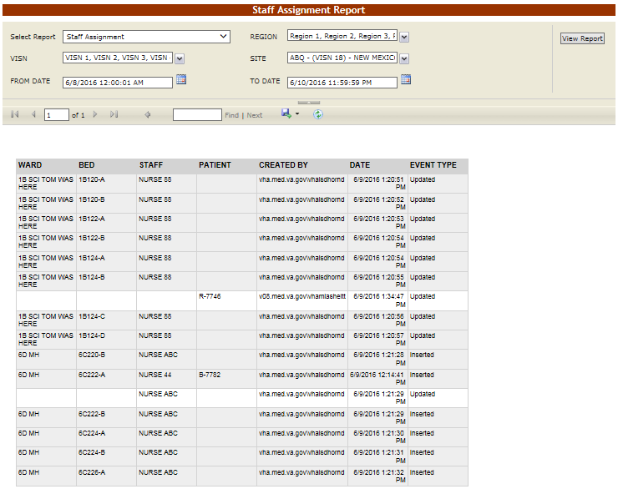

Figure 137 – Staff Assignment Report

For each entry the following data is available:

Table 16 – Staff Assignment Report Parameters

| **COLUMN** | **DESCRIPTION** |
| --- | --- |
| Ward | The ward where the bed is. |
| Bed | The code of the bed. |
| Staff | The name of the person assigned to the bed. |
| Patient | The code of the patient occupying the bed. |
| Created by | The name of the user who created the event. |
| Date | The date and time when the event has been created. |
| Event Type | The type of the event. |

#### 4.1.16.5 Whiteboard Usage Report

The WhiteBoard Usage Report presents information about any and all modifications users have made from the Whiteboard.

In the **Audit Log Report** page use the **Select Report** field to select the Whiteboard Usage report, then select **Date from/Date to** determine the time interval for the report, the **Region**, **VISN** and **Site** and press the **View Report** button. The image below presents an example of the Whiteboard Usage Report.

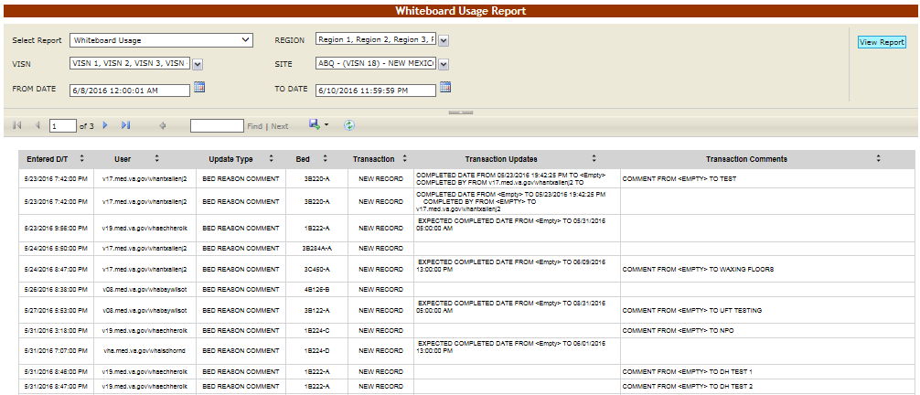

Figure 138.1 – Whiteboard Usage Report

For each entry the following data is available:

Table 16.1 – Whiteboard Usage Report Parameters

| **COLUMN** | **DESCRIPTION** |
| --- | --- |
| Entered D/T | The Date/Time of the modification to the Whiteboard |
| User | The BMS User who made the modification. |
| Update Type | The type of update made to the Whiteboard, such as Bed Reason Comment, Bed Unavailable, Icon Assignment, or Bed Staff Assignment. |
| Bed | The bed record affected by the modification. |
| Transaction | The type of operation performed on the record, such as Update, New Record, or Delete. |
| Transaction Updates | The updates made to the Whiteboard, not including comments |
| Transaction Comments | Any comments made for the transaction performed by the user. |

#### 4.1.16.6 PPBP Usage (VISN) Report

The PPBP Usage (VISN) Report presents information about any and all modifications users have made from the Patient Pending Bed Placement (PPBP) view.

In the **Audit Log Report** page use the **Select Report** field to select the Whiteboard Usage report, then select **Date from/Date to** determine the time interval for the report, the **Region**, **VISN** and **Site** and press the **View Report** button. The image below presents an example of the PPBP Usage (VISN) Report.

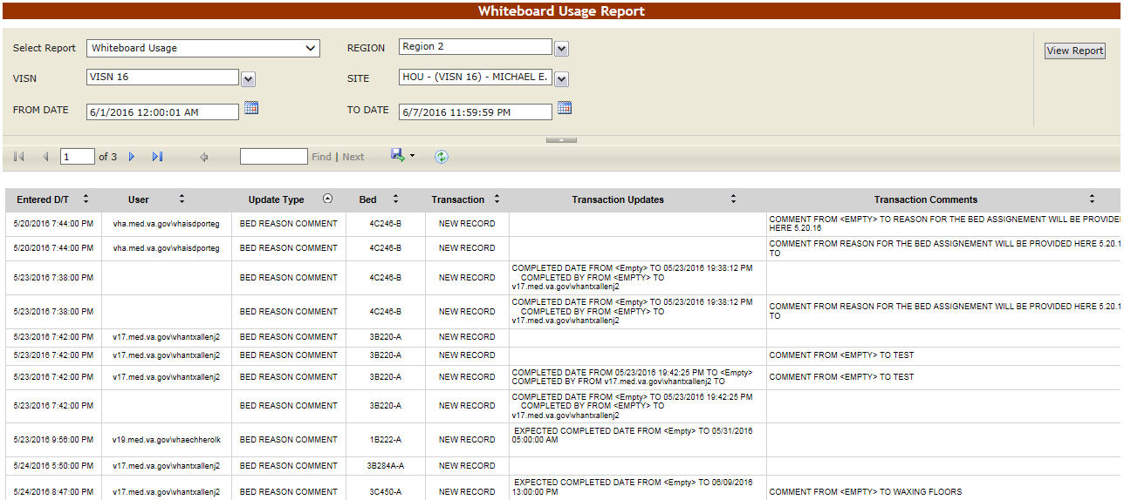

Figure 139.2 – PPBP Usage (VISN) Report

For each entry the following data is available:

Table 16.2 – PPBP Usage (VISN) Report Parameters

| **COLUMN** | **DESCRIPTION** |
| --- | --- |
| Entered D/T | The Date/Time of the modification to the Whiteboard |
| User | The BMS User who made the modification. |
| Update Type | The type of update made to the Whiteboard, such as Bed Reason Comment, Bed Unavailable, Icon Assignment, or Bed Staff Assignment. |
| Bed | The bed record affected by the modification. |
| Transaction | The type of operation performed on the record, such as Update, New Record, or Delete. |
| Transaction Updates | The updates made to the Whiteboard, not including comments |
| Transaction Comments | Any comments made for the transaction performed by the user. |

#### 4.1.16.7 PPBP Usage (Facility) Report

The PPBP Usage (Facility) Report presents information about any and all modifications users have made from the Patient Pending Bed Placement (PPBP) view.

In the **Audit Log Report** page use the **Select Report** field to select the Whiteboard Usage report, then select **Date from/Date to** determine the time interval for the report, the **Region**, **VISN** and **Site** and press the **View Report** button. The image below presents an example of the PPBP Usage (Facility) Report.

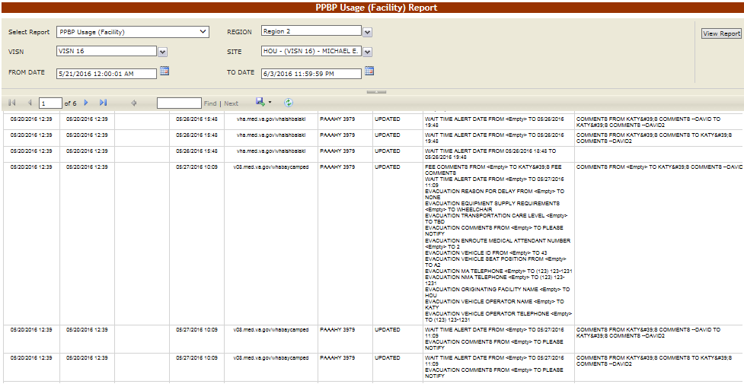

Figure 140.3 – PPBP Usage (Facility) Report

For each entry the following data is available:

Table 16.3 – PPBP Usage (Facility) Report Parameters

| **COLUMN** | **DESCRIPTION** |
| --- | --- |
| Entered D/T | The Date/Time of the modification to the Whiteboard |
| User | The BMS User who made the modification. |
| Update Type | The type of update made to the Whiteboard, such as Bed Reason Comment, Bed Unavailable, Icon Assignment, or Bed Staff Assignment. |
| Bed | The bed record affected by the modification. |
| Transaction | The type of operation performed on the record, such as Update, New Record, or Delete. |
| Transaction Updates | The updates made to the Whiteboard, not including comments |
| Transaction Comments | Any comments made for the transaction performed by the user. |

#### 4.1.16.8 Icon Usage Report

The Icon Usage Report presents information about any and all modifications users have made for Icon Assignments. This report provides a drill down capability to seeing overall icon usage as well as individual bed or patient record assignments.

In the **Audit Log Report** page use the **Select Report** field to select the Whiteboard Usage report, then select **Date from/Date to** determine the time interval for the report, the **Region**, **VISN** and **Site** and press the **View Report** button. The image below presents an example of the Icon Usage Report.

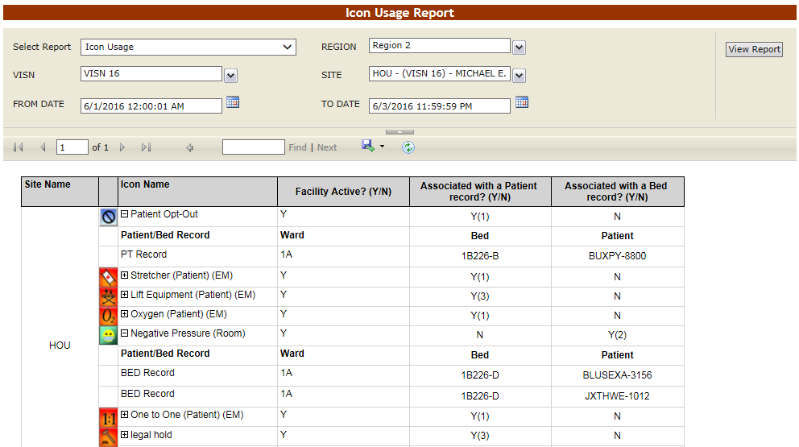

Figure 141.4 – Icon Usage Report

For each entry the following data is available:

Table 16.4 – Icon Usage Report Parameters

| **COLUMN** | **DESCRIPTION** |
| --- | --- |
| Site Name | The Facility in which the Icon assignment was made |
| Icon Image | The Icon’s graphical representation |
| Icon Name | The Name of the Icon, with a drill-down selection represented as “+/-“ indicating collapse/expand. |
| Facility Active (Y/N) | Indication of whether the facility is active or not. |
| Associated with a Patient Record (Y/N)? | Indication and (count) of whether the Icon Update is associated with a patient record. |
| Associated with a Bed Record (Y/N)? | Indication and (count) of whether the Icon Update is associated with a bed record. |
| **Sub Headers** | **These column headers display in bold when an icon audit record is expanded** |
| Patient/Bed Record | Patient/Bed Record indicator |
| Ward | Ward name |
| Bed | Bed Name/number |
| Patient | Patient First Initial, LastName, “-“, and last 4 of SSN |

### Contingency Settings

The Contingency Settings page allows the user to set up network storage area to backup an image of the current Ward Whiteboard for BMS contingency planning.

The **Contingency Settings** page is displayed as in the following image.

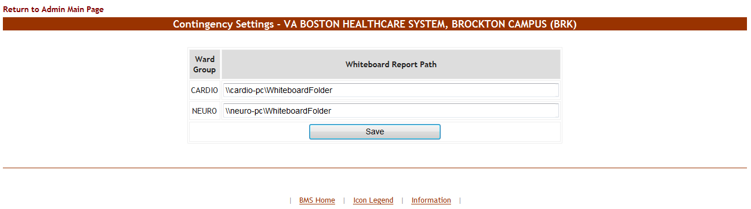

Figure 142 - Contingency Settings Page

A list of wards defined for the current facility is displayed. Enter the path for the Whiteboard Report then press the **Save** button.

**Note:** If a ward selected for the Whiteboard Contingency Report has any of the following special characters:  
( / \ : * ? " < > | )   
then these special characters will be replaced with a “**_**” in the saved file.

**Note:** The Whiteboard Report Path must be a valid network share with the correct rights/permissions assigned. If you have questions contact your local facility IS administrator for help. For detailed instructions on setting up a shared network storage area, see the BMS Technical Manual, WHITEBOARD SNAPSHOT CONFIGURATION section.

### Evacuation On/Off

In the **Bed Board Site Configuration** page the option **Evacuation On/Off** is available as in the following image.



Figure 143 – Evacuation On/Off

In case of emergency the user can set the **Evacuation** option to ON: this will cause the facility home page to be displayed as in the following image.

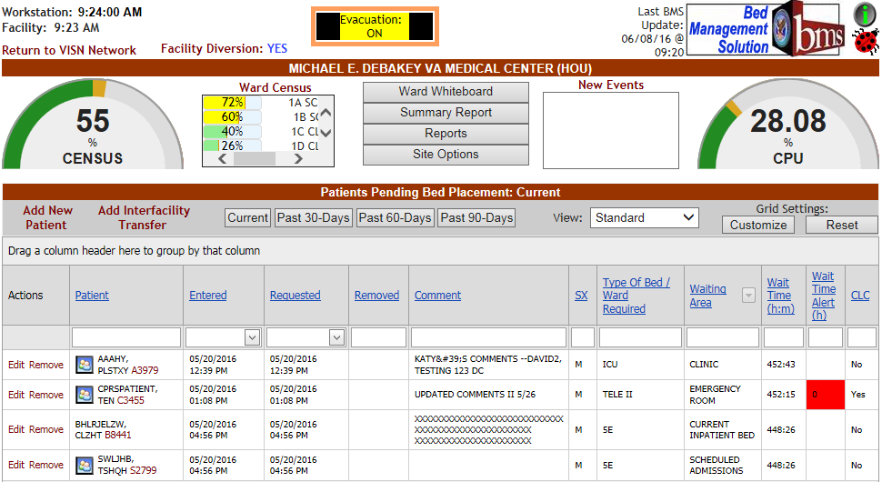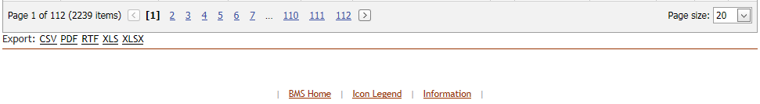

Figure 144 – Facility Home Page - Evacuation On

All the patients admitted in the current facility and for whom the Evacuation Patient option has been selected will be placed in the Pending Bed Placement List.

## Site Users

The site users have access to the following pages:

* + - Facility Home page
    - Facility Diversion page
    - Events page
    - Ward Whiteboard Home page;
    - Ward Whiteboard page

### The Facility Home Page

After logging in the BMS application the home page of the current facility is displayed as in the following image.

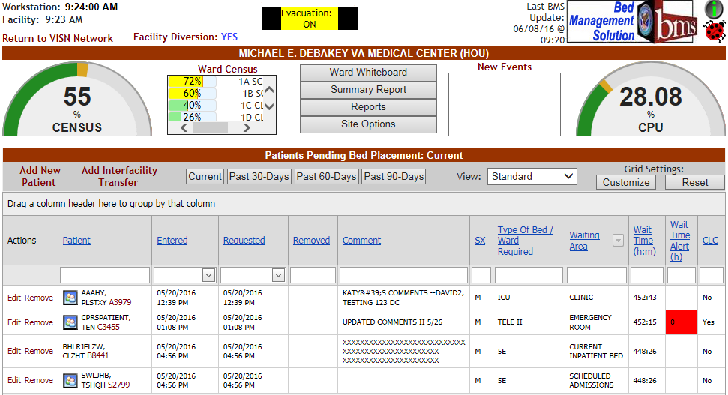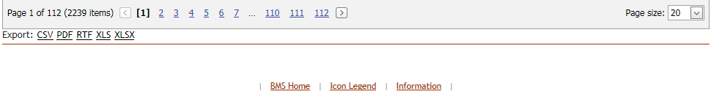

Figure 145 – VA Facility Homepage

The home page allows the administrator user to organize their admission/ discharge operations for the day by presenting the list of patients pending bed placement for a bed and a set of reports offering information about the status of the beds in the current facility.

The **Integrated Sites** dropdown field shown below will only be available for sites for which sister sites have been defined. (For details on how to define sister sites see the sections 3.9.5 Edit Sister Sites and 3.9.4 Edit BMS Facility Settings Page) The **Integrated Sites** field allows the user to switch between sister sites.

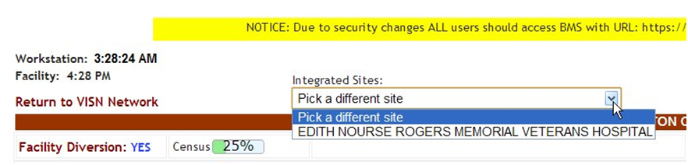

Figure 146 – Selecting from the available integrated sites

The **Facility Diversion** link in the upper left corner of the page allows the user setup a list of facilities or Emergency Departments (ED) that are not accepting patients due to insufficient resources or facility issues. For details on the **Diversion** screen and the available options see 3.2.2. The Facility Diversion Page.

Also note that the Figure below demonstrates the Facility Diversion Hover functionality.

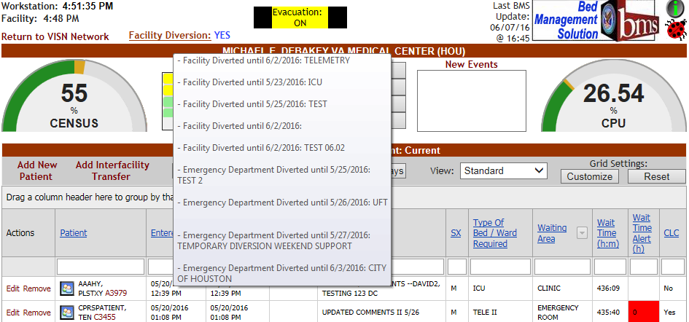

Figure 147.1 – Facility Diversion Hover

When a user hovers over the Facility Diversion hyperlink, a hover area is displayed showing the Facility Diversion History with the appropriate comments.

The **Census** graph provides information on the percentage of occupied beds out of the total beds available.

The Ward Census scroll list provides a breakdown of percentage of occupied beds out of total beds available per ward.

The ladybug button  in the upper right corner of the page is a link to an internet site that will provide information regarding the help desk process.

The green information button  in the upper right corner of the home page: This Icon links the user to VA's SharePoint System which has available information related to the project consisting of but not limited to point of contact information, sample documents, FAQs, and training instructions.

The name of the current facility is displayed in the header along with it’s three letter abbreviation.

The middle top of the page provides 4 navigation buttons: **Ward Whiteboard**, **Summary Report**, **Reports**, and **Site Options**.

The **New Events** listbox shows New Event Type categories which can be clicked on for individual reporting.

The lower part of the screen displays a data grid containing patients pending bed placement.

The **Add New Patient** link allows the site user to add a new patient to the pending bed placement list. The **Add Interfacility Transfer** link allows the site user to register an interfacility transfer.

The buttons **Current**, **Past 30-Days**, **Past 60-Days**, **Past 90-Days** allow the site user to filter the patient list according to waiting time but will also include patients who have been removed from the list. Clicking the **Current** button will display a list of patients entered in the pending bed placement list and who have not been removed.

The display of the list can be customized from the **View** drop-down field according to the following criteria:

* + - * Standard
      * Fee Utilization
      * Patient Flow
      * In-House.

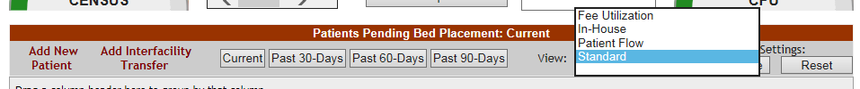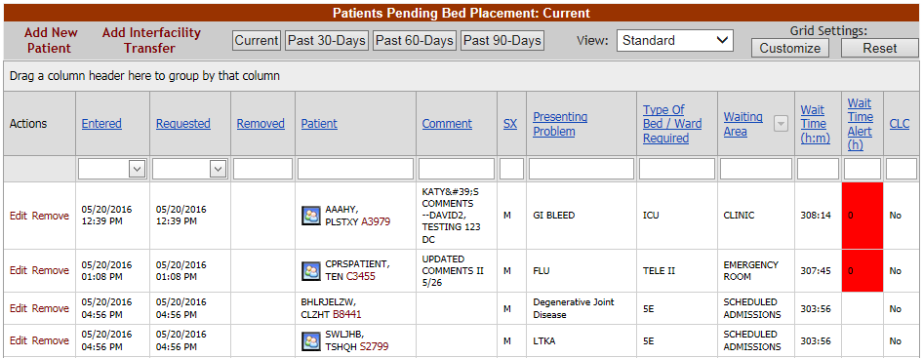

Figure 148 – BMS Facility Patients Pending Bed Placement For A Bed View Screen

In the **Standard** view (image above), the following data is available for each patient in the list:

Table 17 – VA Facility Standard View Parameters

| **Column** | **Description** |
| --- | --- |
| Entered | The date and time when the request for a bed was entered. |
| Requested | The date and time when the bed is needed. |
| Removed | The date and time when the patient has been removed from the list. |
| Patient | The name of the patient. |
| SX | The gender of the patient. |
| Presenting Problem | The main reason a patient is seeking medical care. |
| Type of Bed/Ward Required | The type of bed/ ward required according to the patient’s problem. |
| Waiting Area | The waiting area where the patient is registered. |
| Wait Time | The estimated waiting time. |
| Wait Time Alert | The time interval after which an alert is raised. When the patient is added to the waiting list, the user can enter in this field any value between 1-99. After saving the patient to the waiting list the system begins the countdown: when the value in this field is less than the value select (ex. 5 hours) then it will be displayed against a red background and the operator will know they have to urgently find a bed for that patient. |
| Community Living Center | If the patient is a resident in a Community Living Center or in house waiting for a bed at |
| (CLC) | the Community Living Center |

When selecting the **Fee Utilization** view, the patient pending bed placement list is displayed as in the following image.

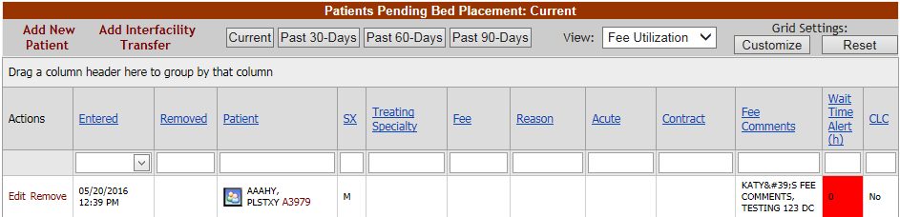

Figure 149 – Patients Pending Bed Placement for a Bed – Fee Utilization View

In the **Fee Utilization** view, the following data is available for each patient in the list:

Table 18 – VA Facility Fee Utilization View Parameters

| **Column** | **Description** |
| --- | --- |
| Entered | The date and time when the patient was added to the list of Patients Pending Bed Placement for a Bed. |
| Removed | The date and time when the patient has been removed from the list of Patients Pending Bed Placement for a Bed = the patient has been admitted to a VA facility or removed from the pending bed placement list due to one of the other reasons listed in the finalize section. |
| Patient | The Name of the patient. |
| SX | The gender of the patient. |
| Treating Specialty | The treating specialty selected when the patient was added to the pending bed placement list. |
| Fee | The fee used to generate the bill for the services. |
| Reason | The reason why a certain fee was used for the generation of the bill. |
| Acute | A disease or disorder of rapid onset or short duration with distinct symptoms. |
| Contract | Whether or not the VA facility has a contract with the selected community hospital. |
| Fee Comments | Any comments relevant/justifying the selection in the Fee field. |
| Wait Time Alert | The time interval after which an alert is raised. When the patient is added to the waiting list, the user can enter in this field any value between 1-99. After saving the patient to the waiting list the system begins the countdown: when the value in this field is less than the value select (ex. 5 hours) then it will be displayed against a red background and the operator will know they have to urgently find a bed for that patient. |
| CLC | If the patient is a resident in a Community Living Center or in house waiting for a bed at the Community Living Center |

When selecting the **Patient Flow** view, the patient pending bed placement list is displayed as in the following image.

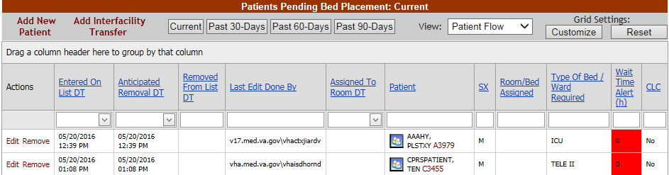

Figure 150 – Patients Pending Bed Placement for a Bed – Patient Flow View

In the **Patient Flow** view, the following data is available for each patient in the list:

Table 19 – VA Facility Patient Flow View Parameters

|  |  |
| --- | --- |
| **Column** | **Description** |
| Entered on List DT | The date and time when the patient was added to the list. |
| Anticipated Removal DT | This is the Bed Czar or Bed Controller expected date that the PT will be removed from the pending bed placement list either by admission or another outcome. |
| Removed from List DT | The date and time when the patient has been removed from the list. |
| Last Edit Done by | The name of the user who last edited the entry. |
| Assigned to Room DT | The date and time when the patient has been assigned a room. |
| Patient | The name of the patient. |
| SX | The gender of the patient. |
| Room/Bed Assigned | The number of the room and of the bed that has been assigned to the patient. |
| Type of Bed/Ward Required | The type of bed/ward required for the particular ailment of that patient. |
| Wait Time Alert | The time interval after which an alert is raised. When the patient is added to the waiting list, the user can enter in this field any value between 1-99. After saving the patient to the waiting list the system begins the countdown: when the value in this field is less than the value select (ex. 5 hours) then it will be displayed against a red background and the operator will know they have to urgently find a bed for that patient. |
| CLC | If the patient is a resident in a Community Living Center or in house waiting for a bed at the Community Living Center. |

When selecting the **In-House** view, the patients patient bed placement list is displayed as in the following image.

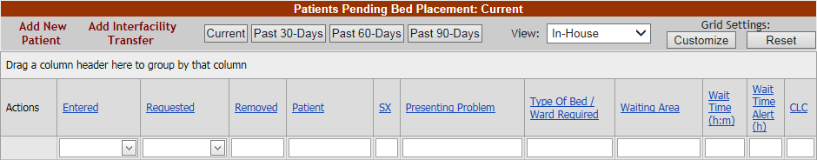

Figure 151 – Patients Patient Bed Placement for a Bed – In-House Patients View

The **In-House** view presents the patients for whom the **In-House** option has been selected when the patient was added to the pending bed placement list. This is used for those patients already admitted to a ward/bed/room but in need of a different level of care. For details see the section Adding a Patient to the Patients Pending Bed Placement List. In the **In-House** view the data available for each patient is the same as in the standard view, for details see the previous paragraphs.

The **Edit** and **Remove** links to the left of a patient line from the list, allow the site user to either edit the details, or remove the entry from the list. Once a patient has been removed from the list an **Undo** link will become available allowing the user to cancel the remove operation.

When adding a patient to the Patients Pending Bed Placement list (**Add New Patient** link in Patients Pending Bed Placement for a Bed list) BMS will create an Admission Request for the selected patient. In order to check if an Admission Order has been issued for a patient, access the New Events page and click the corresponding link to display the reports.

Once a patient has been added to the Patients Pending Bed Placement list he/she can be assigned a bed in a ward and receive the appropriate treatment. The bed assignment is done from VistA. When the patient is admitted to the VA facility he/she can be removed from the list Patients Pending Bed Placement for a Bed in two ways: manually, by clicking the associated Remove link or automatically (when he/she is assigned a bed), if the option Auto-Removal Pending Bed Placement List option has been selected in the **Facility Setting** page from **Site Options**.

After being admitted to a VA facility the patient can be either transferred to another VA facility (to a different ward of different bed) or discharged. For a transfer operation a Transfer Order or a Patient Movement of Type Transfer has to be registered in VistA. For the Discharge operation the following have to be registered in VistA: Patient Appointment, Discharge Order and Patient Movement of Type Discharge.

The actions that the site user can perform in the facility home page are as follows: adding, editing the details of an entry and removing entries from the Patients Pending Bed Placement list. In addition, the user can also add an Interfacility Transfer and generate different types of reports.

#### 4.2.1.1 Patient Pending Bed Placement (PPBP) Features

The PPBP data grid has many features which allow users to customize, sort, filter, group, export, and paginate through the PPBP data grid.

Each column within the PPBP list, or “data grid” is filterable by typing into the text box below the column header. The list is also sortable by selecting the arrow next to the column header (where applicable)**.** The PPBP is heavily customizable by allowing users to perform Grouping, re-ordering, and adding/removing columns. The Waiting Area Column allows users to select which Waiting Areas they would see, “unchecking” a Waiting Area allows users to “filter out” what they don’t want/need to see. Customizing the user’s Grid Settings allowing the user to customize their own preferred layout and also reset to the default setting. The modified layout is saved each time the user changes their own Grid Settings, Groupings, Filters, or Ordering of columns. Below and left of the PPBP Data Grid are links to allow export to CSV, PDF, RTF, XLS, or XLSX.

Each of these features are explained in the following screenshots.

#### PPBP Column Grouping

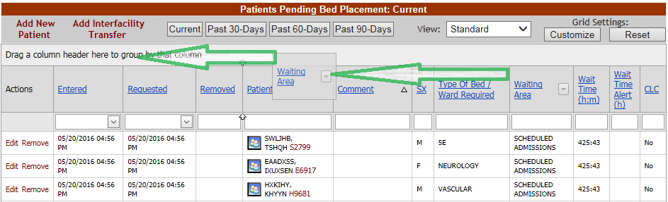

Figure 148.1 – PPBP Column Grouping Action

For users who wish to group the PPBP data in different ways, the user will click in the header they wish to group by in the grey area (not on the link which orders the columns) and drag that header to the row above where it states “Drag a column header here to group by that column”. This will group the data by that column header. In the top screen example, we have grouped by the Waiting Area.

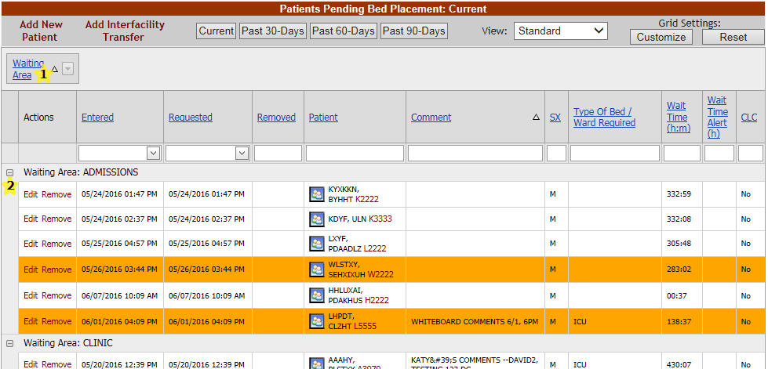

Figure 148.2 – PPBP Column Grouping Result

As indicated above, this is the result of the column grouping drag and drop action. We are now Grouping by the Waiting Area. Users can add additional column headers to group by or remove them by dragging them from the column header grouping area and placing them back into the header area in the order of their choosing. Note that this action forces a reload of the data indicated by a small “Loading” image in the center of the user’s screen. The BMS application is reloading the data for the user based on the new view selected.

The columns headers that you group by are also sortable by ascending and descending order. The small up arrow next to the indicated yellow star “1” shows column header grouping arrow. Clicking this sorts the data in ascending order (up arrow) and descending order (down arrow).

The column header grouping data is also collapse/expandable allowing users to show/hide data groupings at their choosing. Clicking the “-” button collapses, and “+” expands as indicated above the yellow star “2”.

#### PPBP Column Ordering

Users are able to further customize their own PPBP View by ordering their columns however they choose. The below screenshots show a user making the second column become “patient name”. This can be done by clicking and dragging the column header to the appropriate location. The circled arrow selectors demonstrate the location that the column will be placed upon release of the mouse button.

The second screenshot shows the result of the new column ordering.

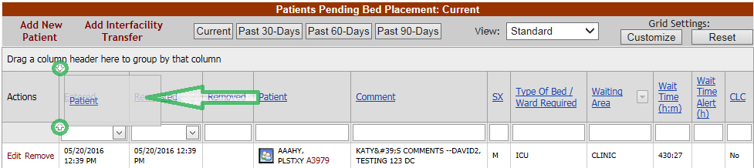

Figure 148.3 – PPBP Column Ordering Action

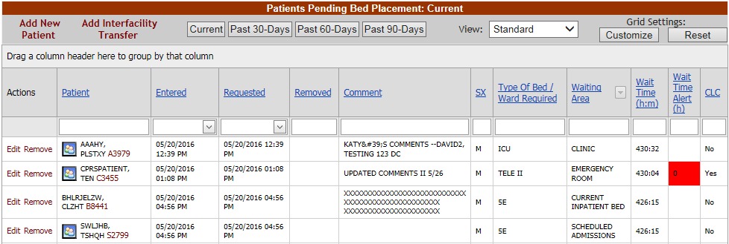

Figure 148.4 – PPBP Column Ordering Result

#### PPBP Customization

Users can even further customize their PPBP View by clicking on the “Customize” button underneath “Grid Settings” at the top right of the PPBP view, which presents the Column Chooser. In this screen shot, we can see that Presenting Problem has been removed from the column selections and placed in the Column Chooser. Users can drag into and out of the Column Chooser to add/remove the columns they wish to see. Once a column is removed from the Grid, it can always be re-added by clicking on the Customize button and then dragging it from the column chooser to the data grid.

Clicking on the Reset button resets all selections back to the default. This feature is very useful if users happen to get confused with the combination of customizations they have made and wish to start over with their own customizations.

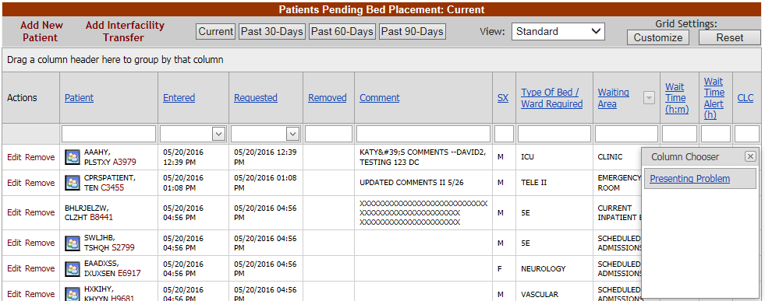

Figure 148.5 – PPBP Customize

#### Exporting PPBP Data

Below and left of the PPBP Data Grid are links to allow export to CSV, PDF, RTF, XLS, or XLSX.

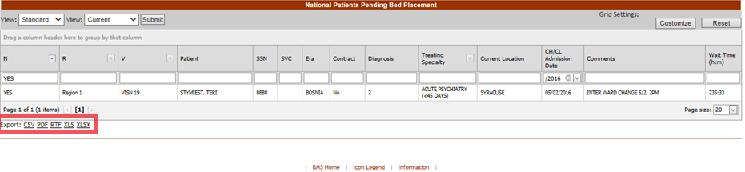

Figure 148.6 – Exporting PPBP Data

#### PPBP Page Functions

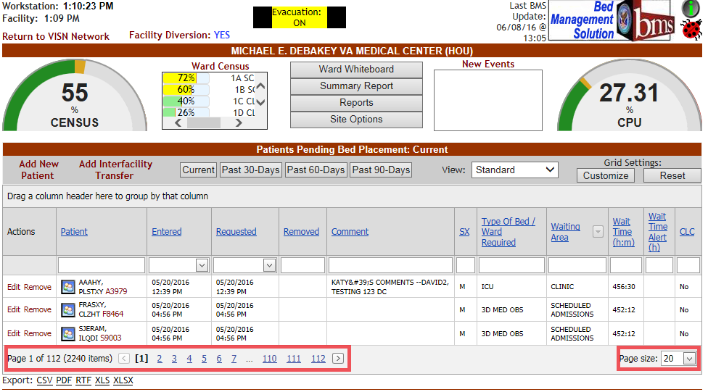

Figure 148.7 – PPBP Page Functions

The above screenshot demonstrates pagination functions available from the PPBP View. The view allows users to select specific pages quickly by clicking on a specific page # for the view. It’s also possible to select how many patient records display per page, on the bottom right of the grid.

#### 4.2.1.2 Adding a Patient to the Patients Pending Bed Placement List

To add a patient to the pending bed placement list follow the steps presented below.

From the facility home page, click the **Add New Patient** link in the Patients Pending Bed Placement area.

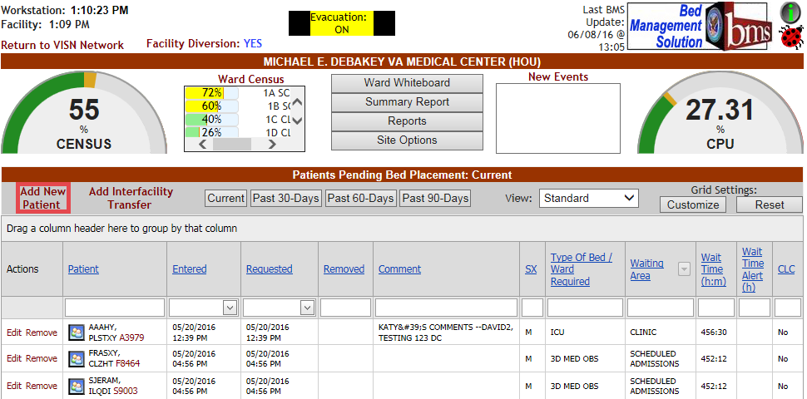

Figure 152 – Adding a Patient to the Patients Pending Bed Placement List

Clicking the **Add New Patient** link will cause the following page to be displayed.

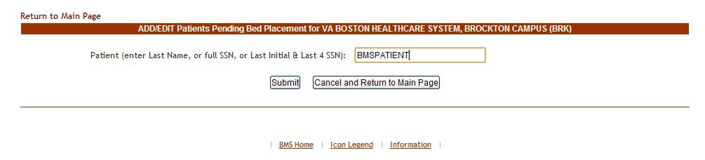

Figure 153 – Add/Edit Patients to the Patients Pending Bed Placement in the VA Facility

Enter the patient’s last name, or the full SSN, or the last initial and last 4 SSN digits then click the **Submit** button.

If there are several patients with the same last name the following page is displayed.

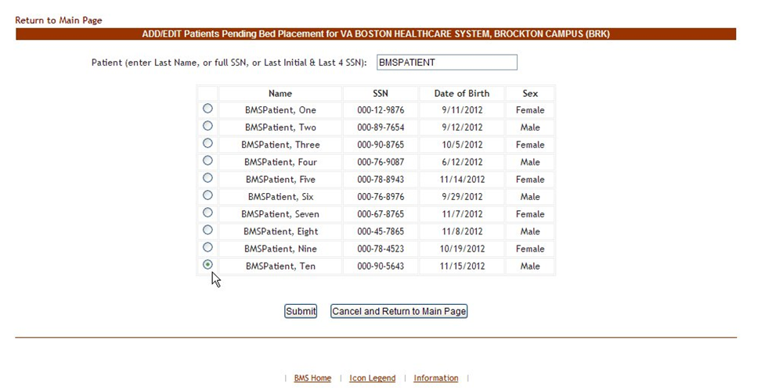

Figure 154 – Add/Edit Patients Pending Bed Placement – Select Patient

A list of all the patients with the last name entered is displayed. Select the patient you want to add then press the **Submit** button to display the following page.

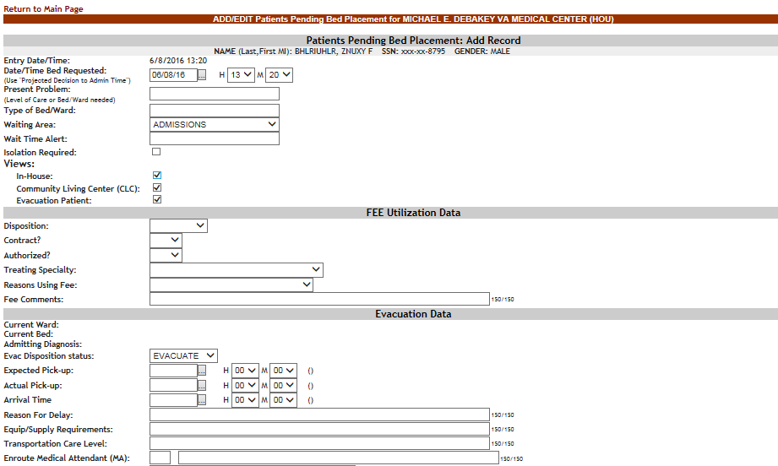 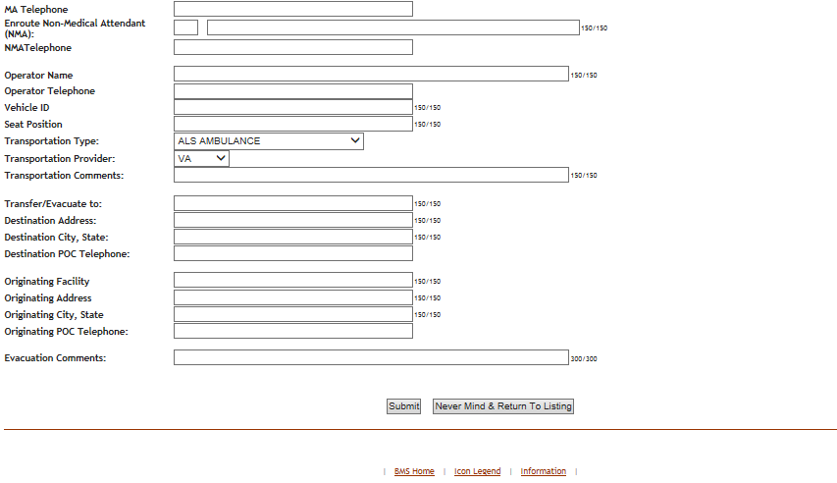

Figure 155 – Add/Edit Patients Psending Bed Placement in the VA Facility - Details

If the SSN exists in the system, the associated data will be retrieved (from VistA) and the NAME (Last, First, MI) of the patient will be displayed in the upper part of the screen.

If the SSN is not found in the system, an error message is displayed.

**Entry Date/Time**: this field is automatically filled in with the current date and time. The following data needs to be filled in:

Table 20 – Add/Edit Patients Pending Bed Placement - Parameters

| **Field** | **Enter** |
| --- | --- |
| Date/Time Bed Requested | Fill in these fields according to the instructions on screen. This is the time that the patient will need the bed. Use “projected Decision to Admit Time” |
| Present Problem (Level of Care or Bed/Ward needed) | What reason is the patient being admitted? (For example: CHF, DM, Surgery) |
| Type of Bed/Ward | The type of bed/ward needed according to the patient’s problem. |
| Waiting Area | Select the corresponding waiting area. There is a pre-defined list of waiting areas |
| Wait Time Alert | The time interval after which an alert is raised. When the patient is added to the pending bed placement list, the user can enter in this field any value between 1-99. After saving the patient to the pending bed placement list the system begins the countdown: when the value in this field is less than the value select (example: 5 hours) then it will be displayed against a red background and the site user will know they have to urgently find a bed for that patient. |
| Isolation Required | If box is checked for isolation, precautions are taken to prevent the spread of infectious disease. When checked, the isolation icon appears on the patients pending bed placement list. |
| Views |  |
| In-House | If the patient is already admitted in the hospital but needs only to be moved in another ward. |
| CLC | If the patient is a resident in a Community Living Center or in house pending bed placement at the Community Living Center |
| Evacuation Patient | If the patient has to be evacuated in case of emergency. |
| Disposition | The disposition with which the patient is added to the pending bed placement list. Within the Fee Utilization data, it is the determination of Acute or Non-Acute. |
| Contract? | Whether or not the VA facility has a contract with the selected community hospital. |
| Authorized? | Within the Fee Utilization data, it is the determination of authorized or non-authorized. |
| Treating Specialty: | The treating specialty required. |
| Reasons for Using Fee: | The reason justifying fee usage. |
| Fee Comments: | Any relevant additional information about the fee utilization. |
| ***The following fields will only be displayed if the option Evacuation Patient is selected.*** | |
| Current Ward: | The name/code of the ward where the patient is currently. |
| Current Bed: | The code of the bed where the patient is currently. |
| Admitting Diagnosis: | The admitting diagnosis. |
| Evac Disposition Status: | The disposition status in case of evacuation. |
| Expected pick-up: | The date and time when the patient is expected to be picked up in case of evacuation. |
| Actual pick-up: | The actual date and time when the patient has been picked during evacuation. |
| Reason for Delay: | The reason for the delay, if applicable. |
| Transfer/Evacuate to: | The name of the facility where the patient is evacuated to. |
| Equip/Supply Requirements | Equipment or Supply requirements for the patient in case of evacuation. |
| Transportation Care Level: | The level of the transportation care for the patient in case of evacuation. |
| Enroute Medical Attendant: | The number, qualification and name of the enroute medical attendant. |
| MA Telephone | The Enroute Medical Attendant telephone # |
| Enroute Non-Medical Attendant (NMA): | The number and the name of the enroute non-medical attendant. |
| NMA Telephone | The Enroute Non-Medical Attendant telephone #. |
| Operator Name | The vehicle operator name |
| Operator Telephone | The vehicle operator telephone # |
| Vehicle ID | The identifying # of the transportation vehicle. |
| Seat Position | The patient’s seat position on the vehicle. |
| Transportation Type: | The type of transportation required for the patient in case of evacuation. |
| Transportation Provider: | The provider of transportation. |
| Transportation Comments: | Any relevant comments regarding the transportation. |
| Transfer/Evacuate To: | The location name of the place the patient is evacuated to. |
| Destination Address: | The address of the facility where the patient is evacuated to. |
| Destination City, State: | The city and state where the patient is evacuated to. |
| Destination POC Telephone: | The telephone of the Point-of-Contact of the facility where the patient is evacuated to. |
| Originating Facility | The facility the patient is being evacuated from. |
| Originating Address | The address of the location the patient is being evacuated from. |
| Originating City, State | The city and state of the location the patient is being evacuated from. |
| Originator Telephone: | The telephone of the facility from where the patients are evacuated. |
| Evacuation Comments: | Any relevant evacuation comments. |

After filling in all the data required click the Submit button to enter the data into the system.

The newly added patient will be displayed in the area Patients Pending Bed Placement from the home page.

#### 4.2.1.3 Editing the Details of an Entry in the Patients Pending Bed Placement List

To edit the details of an entry from the Patients Pending Bed Placement list click the corresponding **Edit** link: the following page is displayed.





Figure 156 – Edit Details of the Patient Pending Bed Placement List

In the Bed Controller Data area, select the **Room/Bed Assigned** and the **Assignment Date Time**. Modify the existing data then press the **Submit** button to enter it into the system.

A screen is displayed confirming the modification of the record in the database.

#### 4.2.1.4 Removing Patient from the Patient Pending Bed Placement List

In the facility home page, in the area **Patients Pending Bed Placement** click the corresponding **Remove** link.

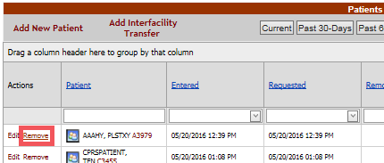

Figure 157 – Remove Patient from the Pending Bed Placement List

Before actually removing the patient from the pending bed placement list, you will be asked to confirm the operation

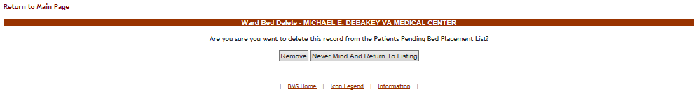

Figure 158 – Remove Patient from the Pending Bed Placement List Confirmation

#### 4.2.1.5 Undo Remove Patient from Patients Pending Bed Placement List

After removing a patient from the pending bed placement list an **Undo** link will become available as in the following image.

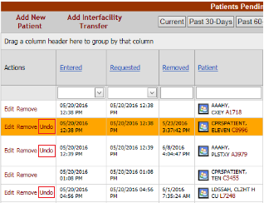

Figure 159 – Undo Remove Patient from the Patient Pending Bed Placement List

Use the **Undo** link to cancel the Remove operation.

#### 4.2.1.6 Adding an Interfacility Transfer

To add an interfacility transfer in the facility home page click the **Add Interfacility Transfer** link to display the following page: This will place the patient information on the VISN Patients Pending Bed Placement list to assist with the transfer needs of the patient.

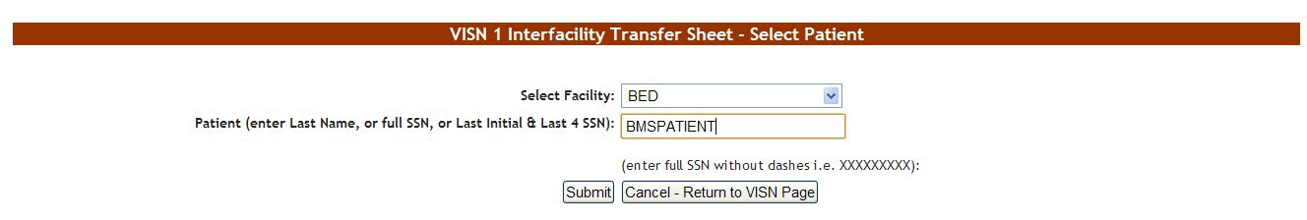

Figure 160 – VISN Interfacility Transfer Sheet – Select Patient

From the **Select Facility** field select the name of the VA facility that the patient is associated with. In the **Patient** field, enter either the patient name or the patient SSN number following the instructions on screen, then press the **Submit** button.

If there are several patients in the system with the same name the system presents a list with details of the patients so that you can identify the patient you need.

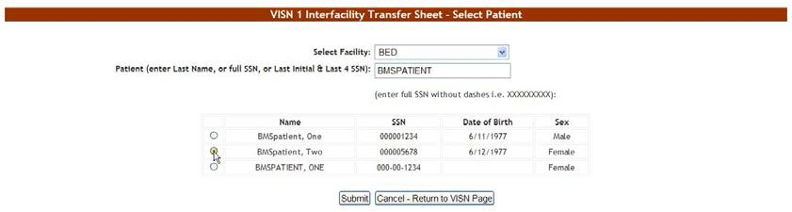

Figure 161 – VISN Interfacility Transfer Sheet – Select Patient

If you entered the patient SSN and the patient is registered in the VistA system, the associated information (patient full name, gender, service connected) will be retrieved and presented as in the following image.

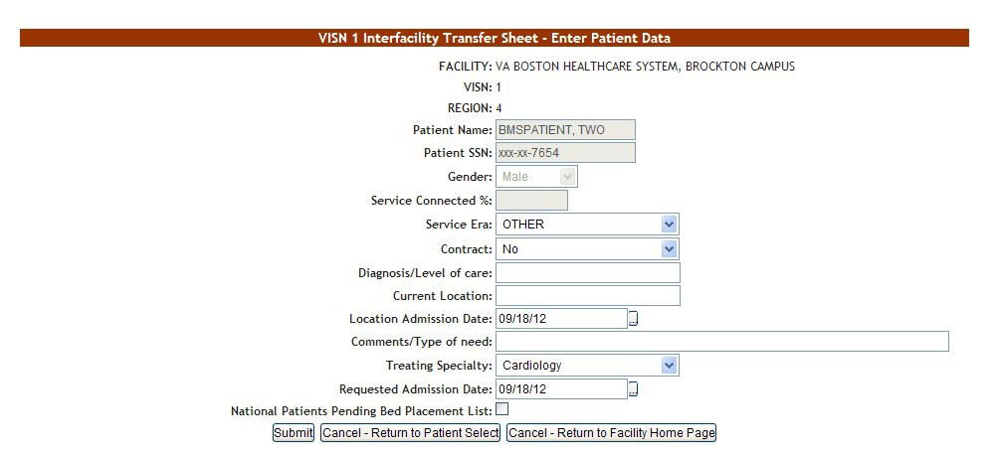

Figure 162 – VISN Interfacility Transfer Sheet – Enter Patient Data

If you entered the patient SSN but that patient has not been added yet to the VistA system you will have to fill in the associated information (patient full name, gender, service connected) as in the following image. (The verification will eventually be done by the system when using the Finalize option and if the patient is still not found in the VistA system the finalize operation cannot be completed.)

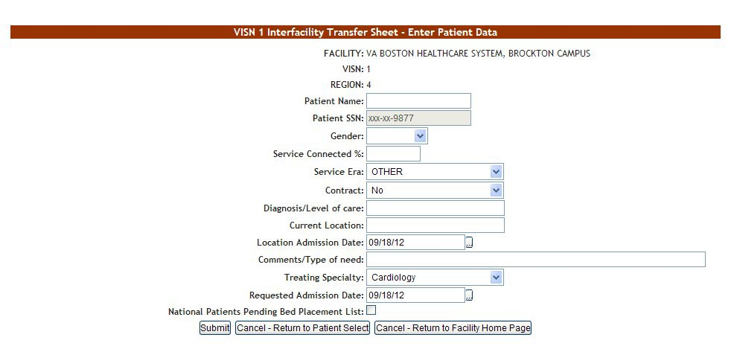

Figure 163 – VISN Interfacility Transfer Sheet – Enter Patient Data

In the **VISN Interfacility Transfer Sheet – Enter Patient Data** page the name of the current facility, the VISN it belongs to and the Region are displayed.

Enter the following data:

Table 21 – Interfacility Transfer Parameters

| **FIELD** | **ENTER** |
| --- | --- |
| Service Era | The period of service that the patient served. |
| Contract: | Whether or not the VA facility has a contract with the selected community hospital. |
| Diagnosis/Level of care | The diagnosis for which the patient requests admission to the community hospital. |
| Current Location: | The name of the location where the patient is currently being treated |
| Location Admission Date | The date when the patient has been admitted in the selected location. |
| Comments/Type of need | The type of need for which the patient is being transferred to the community hospital. |
| Treating Specialty | The treating specialty corresponding to the type of need. |
| Requested Admission Date | The date when the patient should be able to be admitted to the VA facility. |
| National Patients Pending Bed Placement List | If the patient is to be included or not in the National Patients Pending Bed Placement list. |

Click the **Submit** button to enter the data into the system.

A screen is displayed confirming the successful registration of the record in the database

#### 4.2.1.7 Ward Occupancy Report

To generate the Ward Occupancy report, follow the instructions below.

From the Facility Home page, the user will need to navigate to the Reports page by clicking the Reports button as highlighted below.

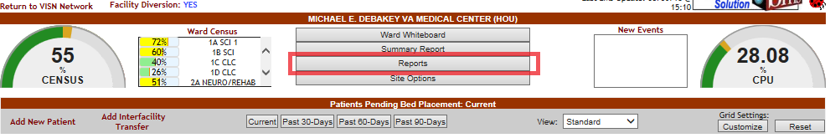

Figure 164 – Report page navigation

in the Reports… area, from the **Select Ward Group** field, click the arrow button to display a list of ward groups defined in the system and select the ward group for which you want to generate the report. Then, from the **Bed Status** field select one of the available options (All, Available, Female, Occupied).

For details on how to define ward groups see the section 3.1.2.1 Adding a VistA Ward…

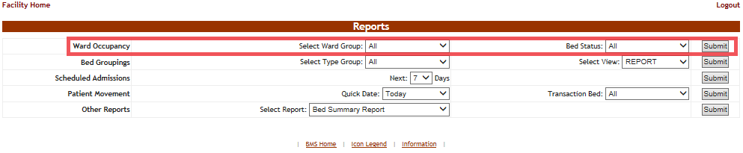

Figure 165 – Selecting Parameters for Ward Occupancy Report

After you have selected the desired criteria press the **Submit** button: The report is displayed as in the following image

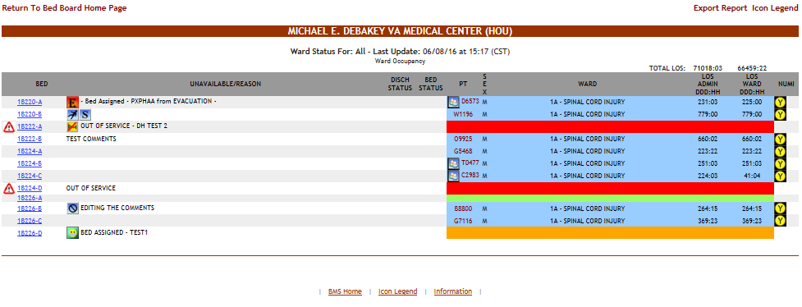

Figure 166 – Ward Occupancy Report

The following data is available for each entry:

Table 22 – Ward Status Parameters

|  |  |
| --- | --- |
| **Column** | **Description** |
| Bed | The room/bed number. |
| Unavailable/reason | The reason why it has been marked as unavailable. |
| Discharge status | The bed will be vacated for one of the following reasons: “Anticipated Discharge or Discharge Appointment,“ “Discharge Ordered,” or “Interward Transfer. See Table 42 – Beds Parameters for more information. |
| Bed status | The bed cleaning status. See the Icon Legend for the meaning of the icon. |
| PT (patient) | The name of the patient occupying the bed. |
| Sex | The gender of the patient. |
| Ward | The ward where the bed is. |
| LOS ADMIN (Length of stay) | The patient’s length of stay in the facility |
| LOS WARD (Length of stay): | The patient’s length of stay on the ward |
| NUMI | The National Utilization Management Integration (NUMI) automates utilization review assessment and outcomes. The Utilization Management (UM) Process is a tool used to help verify that patients are receiving the right care, at the right time, and in the right place. UM is both a quality and efficiency tool, as it is used to move patients efficiently through the VA system to maximize use of resources. UM reviewers assess patient admissions and hospital stay days using standardized objective evidence-based clinical criteria to determine whether patients meet criteria for acute hospital care. Refer to the NUMI icons for the different levels of care. |

#### 4.2.1.8 Bed Groupings Report

To generate the Bed Groupings report, follow the instructions below.

On the Reports page, from the Bed Groupings row, click the arrow button of the **Select Type Group** field to display a list of available wards and select the ward for which you want to generate the report. From the **Select View** field choose a type of view (“report” or “roster” are the available options). The bed grouping report allows you to see the usage of beds for a specific BMS type group such as Medical/Surgical, CLC or ICU. Using the report view will display the information by BMS type group where the roster will display by ward. The advantage over the roster view is that the beds only show once while in the report view, for wards with many type groups, the bed may show the room occupied only for the type group the patient ward location is in.

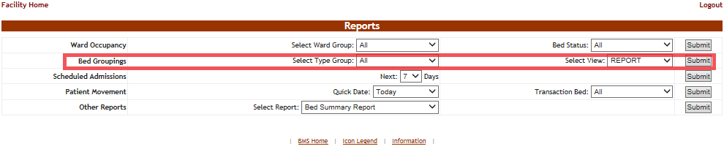

Figure 167 – Selecting Parameters for Bed Groupings Report

Click the **Submit** button: the report is displayed as in the following image.

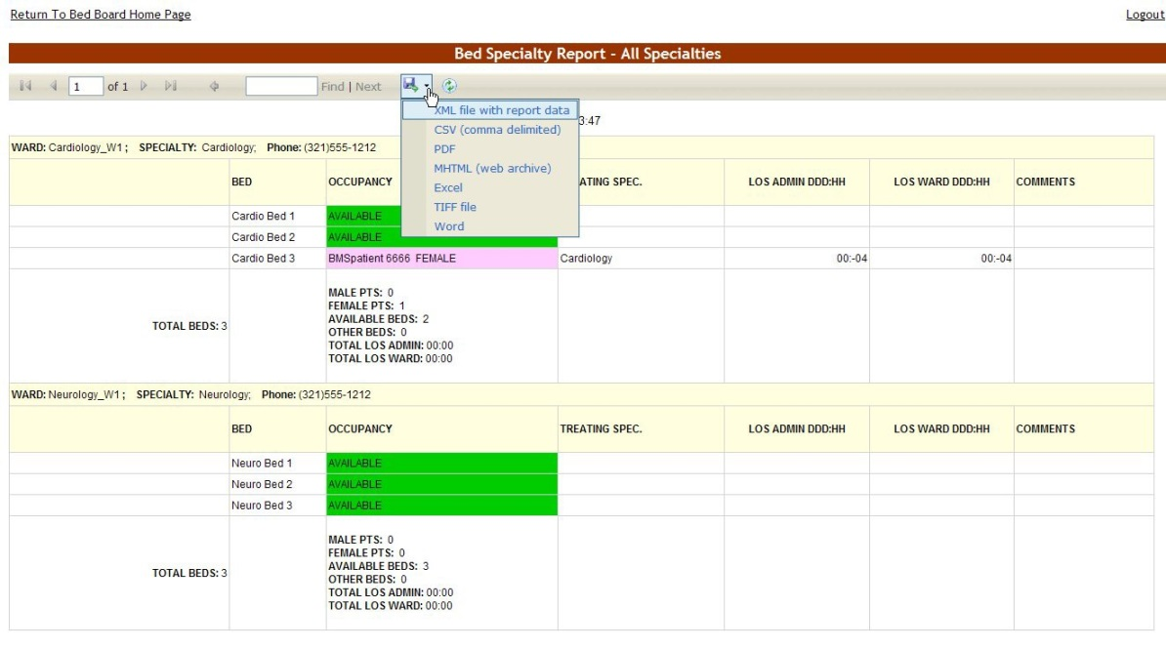

Figure 168 – Bed Specialty Report

Note: The view depends on the option chosen from the **Select View** field: “report” or “roster,” in the image above the “report” option has been chosen.

The same report in the “roster” view is displayed in the image below.

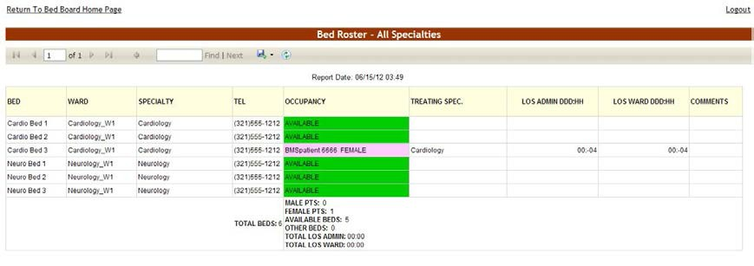

Figure 169 – Bed Specialty Report – Roster View

The title of the report is displayed in the upper part of the page. Navigation and display tools are available in the toolbar displayed across the screen. Place the mouse cursor over a button to display the corresponding tooltip.

The report can be exported to a series of formats available when clicking the **Save** button (see image above).

The **Print** button allows the site user to send the generated report to a printer.

The header of the report displays the criteria used to generate the report: the selected ward and the specialty.

The following data is available in the report:

Table 23 – Bed Specialty Parameters

| **Column** | **Description** |
| --- | --- |
| Bed | The room/bed number. |
| Ward | The name of the ward. |
| Specialty | The ward specialty. |
| Tel | The telephone number of the ward POC. |
| Occupancy | The status of the bed: available, assigned or occupied. (colors are assigned to each status so that they are easily identifiable) |
| Treating Specialty | The medical specialty to which the bed is assigned. |
| LOS ADMIN | The patient’s length of stay in the facility |
| LOS WARD | The patient’s length of stay on the ward |
| Comments | Any relevant additional info entered by the site user. |

#### 4.2.1.9 Scheduled Admissions Report

To generate the Scheduled Admissions report, follow the instructions below:

On the Reports page, from the Scheduled Admissions report select for how many days you want to generate the report. You can look ahead 1 week or back 1 week. You can now look at those patients scheduled for today.

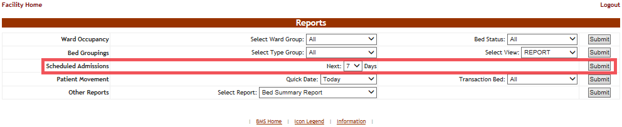

Figure 170 – Selecting Parameters for Scheduled Admissions Report

After selecting the number of days, click the **Submit** button to display the report as in the following image.

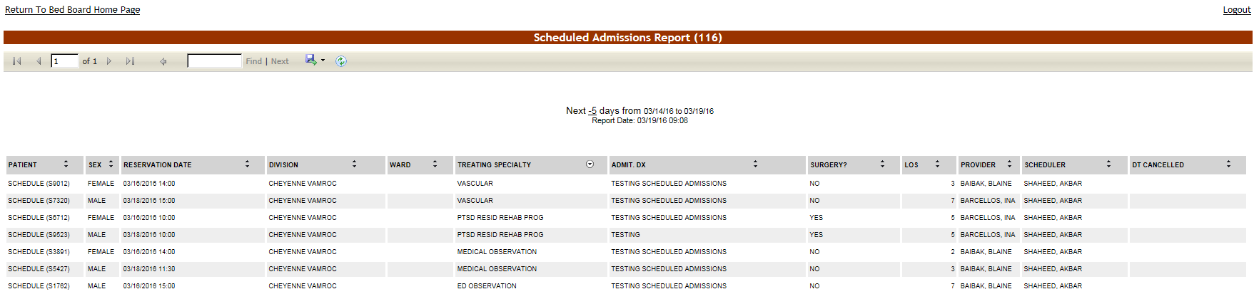

Figure 171 – Scheduled Admissions Report

The title of the report is displayed in the upper part of the page. Navigation and display tools are available in the toolbar displayed across the screen. Place the mouse cursor over a button to display the corresponding tooltip.

The report can be exported to a series of formats available when clicking the **Save** button. The **Print** button allows the site user to send the generated report to a printer.

The following data is available for each entry:

Table 24– Scheduled Admissions Parameters

| **Column** | **Description** |
| --- | --- |
| Patient | The name of the patient, displayed as Last Name plus first letter of last name and last 4 of SSN in parentheses. Example: Brown (B1234) |
| Sex | The gender of the patient. |
| Reservation Date | The date for which the admission is scheduled. |
| Division | The division where the admission has been made. |
| Ward | The ward name. |
| Treating Specialty | The treating specialty indicated when admission scheduled in VistA. This field is a preexisting field in the site’s VistA instance and BMS is just pulling this field in from VistA |
| Admt. Dx. | Reason for admission entered in VistA. This field is a preexisting field in the site’s VistA instance and BMS is just pulling this field in from VistA |
| Surgery? | Indicates if the admitted patient is scheduled for surgery. |
| LOS | Anticipated Length of Stay. This field is a preexisting field in the site’s VistA instance and BMS is just pulling this field in from VistA. |
| Provider | The physician arranging the admission. This field is a pre-existing field in the site’s VistA instance and BMS is just pulling this field in from VistA. |
| Scheduler | VA person that scheduled the admission. This filed is a preexisting field in the site’s VistA instance and BMS is just pulling this field in from VistA. |
| DT cancelled | If the admission was cancelled, the date and time of the cancellation. |

#### 4.2.1.10 Patient Movement Report

To generate the Patient Movement report, follow the instructions below.

On the facility home page, in the Reports… area from the Patient Movement report choose for how many days you want to generate the report using the Quick Date field; then from the Transaction Bed field select the type of movement/transaction you want to include in the report (admission, discharges, transfers or specialty transfers).

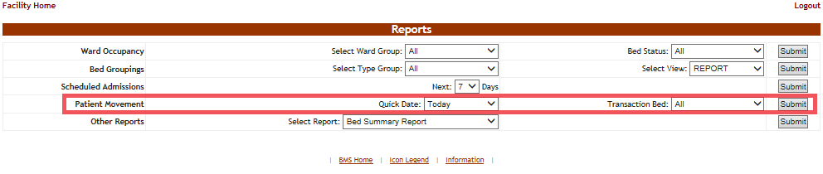

Figure 172 – Selecting Parameters for Patient Movement Report

After selecting the desired number of days and the type of transaction, you want to include in the report click the **Submit** button: the Patient Movement report is displayed as in the following image.

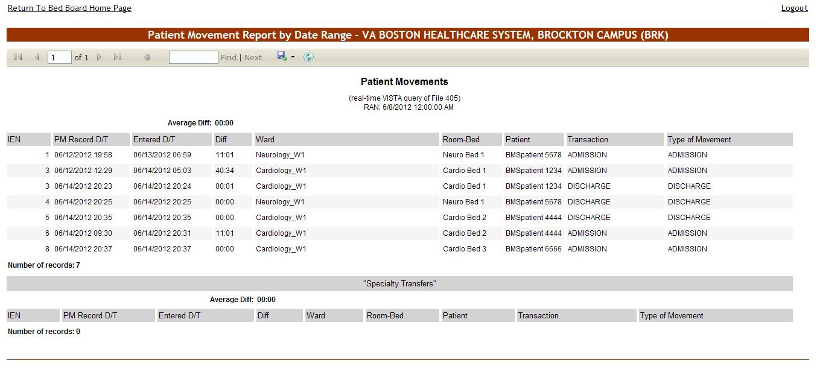

Figure 173 – Patient Movement Report

The title of the report is displayed in the upper part of the page. Navigation and display tools are available in the toolbar displayed across the screen. Place the mouse cursor over a button to display the corresponding tooltip.

The report can be exported to a series of formats available when clicking the **Save** button. The **Print** button allows the site user to send the generated report to a printer.

The following data is available for each entry:

Table 25 – Patient Movement Parameters

|  |  |
| --- | --- |
| **Column** | **Description** |
| IEN | The VistA Internal Entry Number for the primary lookup key in the Patient Movement file. |
| PM Record D/T | The date and time when the patient movement has been recorded. |
| Entered D/T | The date and time when the movement has been registered in the system. |
| Diff | The time lapse between the date/time when the movement occurred and when it has been registered. |
| Ward | The name of the ward. |
| Room-Bed | The name of the room/bed. |
| Patient | The patient name/last 4 of SSN. |
| Transaction | The type of transaction. |
| Type of movement | The type of movement. |

#### 4.2.1.11 Other Reports

Use the arrow button of the field Select Report to display a list of reports that can be generated and select the desired one then press the **Submit** button.

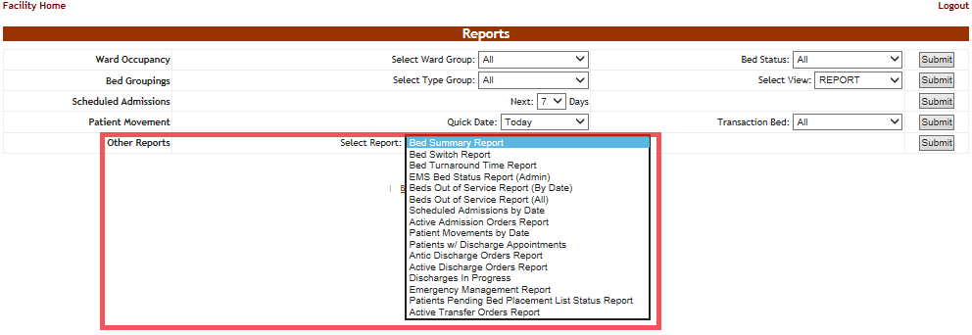

Figure 174 – Other Reports

The following sections present each of the additional reports that can be generated.

#### 4.2.1.12 Active Admission Order Report

This report shows the patients with admission orders as defined by the orderable items in the site option page. This report shows the IEN (internal entry number) of the order, the date and time it was written, the patient name, the date/time the order was signed, the provider writing the order and the date/time the order was released.

To generate the Active Admission Orders report, follow the instructions below.

On the Reports page, from the **Other Reports** field select Active Admission Orders Report then press the **Submit** button: the report is displayed as in the following image.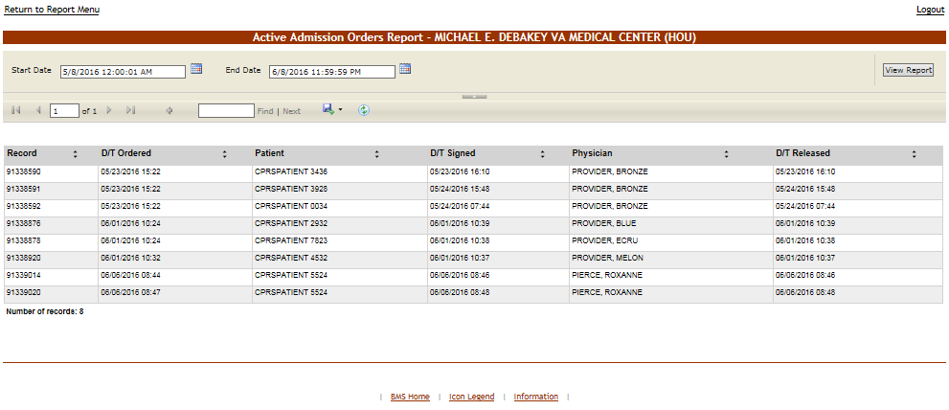

Figure 175 – Active Admission Orders Report

From the upper part of the page, you can select the time interval for which you want to generate the report: after selecting a Start Date and an End Date click the **View Report** button to generate the report for the selected time period.

The title of the report is displayed in the upper part of the page. Navigation and display tools are available in the toolbar displayed across the screen. Place the mouse cursor over a button to display the corresponding tooltip.

The report can be exported to a series of formats available when clicking the **Save** button. The **Print** button allows the site user to send the generated report to a printer.

For each admission order in the report, the following data is available: The following data is available for each entry:

Table 26 – Active Admission Orders Parameters

|  |  |
| --- | --- |
| **Column** | **Description** |
| Record (Internal entry number  - IEN) | The VistA Internal Entry Number for the primary lookup key in the Order file. |
| D(ate)/T(ime) Ordered | The date and time of the admission order. |
| Patient | The name of the patient being admitted. |
| D(ate)/T(ime) Signed | The date and time when the admission order was signed. |
| Physician | The name of the physician signing the admission order. |
| D(ate)/T(ime) Released | The date and time of the actual release. |

#### 4.2.1.13 Active Discharge Order Report

This report shows the patients with discharge orders as defined by the orderable items in the Site Options page. This report shows the IEN (internal entry number) of the order, the date and time it was written, the patient name, the date/time the order was signed, the provider writing the order and the date/time the order was released.

To generate the Active Discharge Orders report, follow the instructions below.

On the Reports page, from the **Other Reports** field select Active Discharge Orders Report then press the **Submit** button: the report is displayed as in the following image.

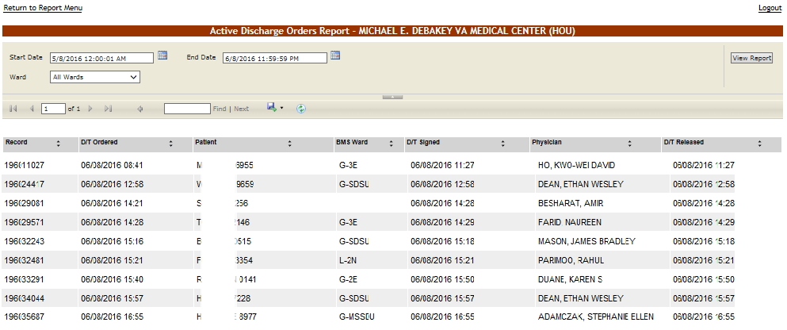

Figure 176 – Active Discharge Orders Report

From the upper part of the page, you can select the time interval for which you want to generate the report: after selecting a Start Date and an End Date, use the **Ward** field to select the ward(s) for which you want to generate the report then click the **View Report** button to generate the report for the selected time period.

The title of the report is displayed in the upper part of the page. Navigation and display tools are available in the toolbar displayed across the screen. Place the mouse cursor over a button to display the corresponding tooltip.

The report can be exported to a series of formats available when clicking the **Save** button. The **Print** button allows the site user to send the generated report to a printer.

For each discharge order in the report, the following data is available:

Table 27 – Active Discharge Orders Parameters

|  |  |
| --- | --- |
| **Column** | **Description** |
| Record | This is a unique ID automatically generated by the system identifying the patients’ discharge order. |
| D(ate)/T(ime) Ordered | The date and time of the discharge order. |
| Patient | The name of the patient being discharged. |
| BMS Ward | The BMS ward where the patient has been treated. |
| D(ate)/T(ime) Signed | The date and time when the discharge order was signed. |
| Physician | The name of the physician signing the discharge order. |
| D/T Released | The date and time of the actual discharge/release. |

#### 4.2.1.14 Anticipated Discharge Report

To generate the Anticipated Discharge report, follow the instructions below.

On the Reports Page, from the **Other Reports** field select Anticipated Discharge Report then press the **Submit** button: the report is displayed as in the following image.

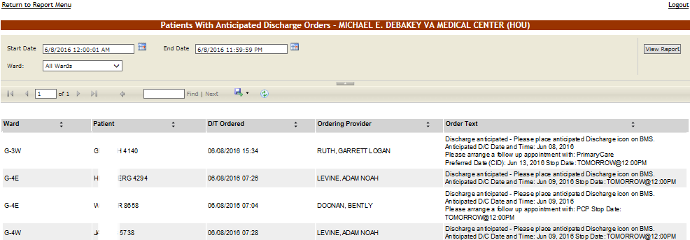

Figure 177 – Anticipated Discharge Report

Using the **Start Date** and **End Date** fields, you can define the time interval for which you want to generate the report. From the **Ward** field select the ward for which you want to generate the report. After selecting the desired parameters click the **View Report** button to generate the report for the selected time period.

The title of the report is displayed in the upper part of the page. Navigation and display tools are available in the toolbar displayed across the screen. Place the mouse cursor over a button to display the corresponding tooltip.

The report can be exported to a series of formats available when clicking the **Save** button. The **Print** button allows the site user to send the generated report to a printer.

For each anticipated discharge order in the report, the following data is available:

Table 28 – Anticipated Discharge Orders Parameters

|  |  |
| --- | --- |
| **Column** | **Description** |
| Ward | The name of the ward from where the anticipated discharge operation is being performed. |
| Patient | The name of the patient being discharged with anticipation. |
| D(ate)/T(ime) Ordered | The date and time of the anticipated discharge order. |
| Ordering Provider | The full name of the clinician ordering the patient’s discharge. |
| Order Text | The text of the anticipated discharge order. |

#### 4.2.1.15 Bed Summary Report

This report is high-level and gives a quick overall view on bed occupancy and therefore availability in the entire facility.

To generate the Bed Summary report, follow the instructions below.

On the Reports page, from the **Other Reports** field select Bed Summary Report then press the **Submit** button: the report is displayed as in the following image.

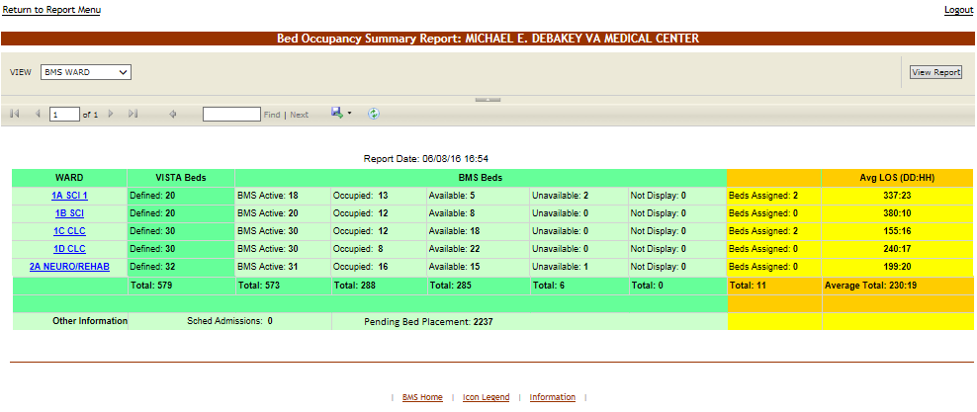

Figure 178 – Bed Summary Report – BMS Wards

From the VIEW field select one of the available options: BMS WARD, NUMA or HAvBED:

* + - * + BMS view shows the bed summary by BMS ward group text
        + NUMA shows the bed summary report by numa specialties such as acute-medical, acute- surgical or mental health /chronic
        + HavBed will convert the specialties above to a more specific group of beds used in evacuation and placement of patients.

The image above presents the report for the BMS wards. Below is an example of a report for the Nursing Unit Mapping Application (NUMA) specialty.

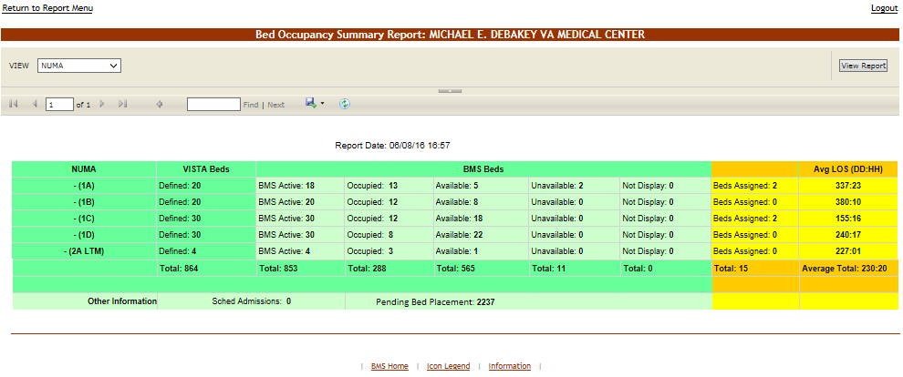

Figure 179 – Bed Summary Report – NUMA Wards

The Hospital Available Beds for Emergencies and Disasters (HAvBED) bed summary report is displayed as in the following image.

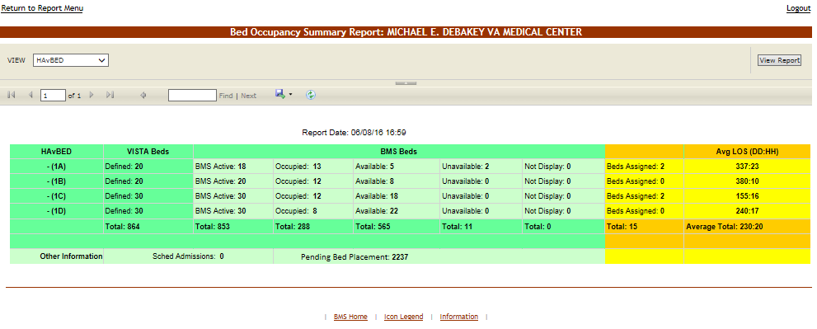

Figure 180 – Bed Summary Report – HAvBED Wards

The title of the report is displayed in the upper part of the page. Navigation and display tools are available in the toolbar displayed across the screen. Place the mouse cursor over a button to display the corresponding tooltip.

The report can be exported to a series of formats available when clicking the **Save** button. The **Print** button allows the site user to send the generated report to a printer.

The following data is available:

Table 29 – Bed Summary Parameters

|  |  |
| --- | --- |
| **Column** | **Description** |
| Ward/NUMA/HAvBED | The name of the BMS ward group or the NUMA/HAvBED associated. |
| VistA Beds | The number of active VistA Beds in the ward. |
| BMS Beds | The number of beds in the ward grouped by their corresponding status (active, occupied, available, unavailable, not displayed). |
| Beds Assigned | The number of beds which have already been assigned to a patient. |
| Avg. LOS | The average length of stay for all patients on that ward combined. |
| Other Information | This area presents the number of Scheduled Admissions for the facility as well as the number of patients pending bed placement. |

#### 4.2.1.16 Bed Turnaround Time Report

This report shows how long it takes from discharge of one patient until the bed is ready for the next. To generate the Bed Turnaround Time report, follow the instructions below.

On the Reports page, from the **Other Reports** field select Bed Turnaround Report then press the **Submit** button: the report is displayed as in the following image.

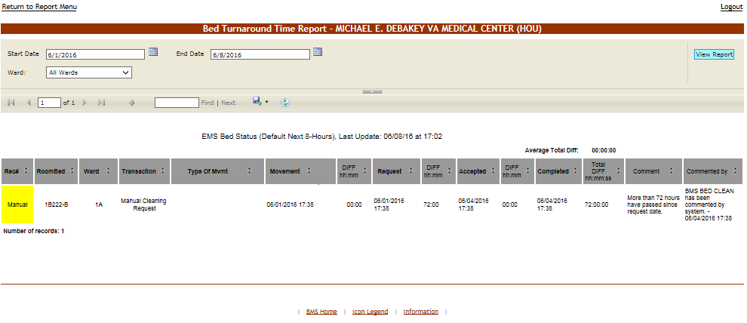

Figure 181 – Bed Turnaround Time Report

From the **Ward** field the site user can select the ward for which to generate the report. Using the **Start Date** and **End Date** fields a time interval for the report can be defined. After selecting, the desired parameters click the **View Report** button to generate the report for the selected time period.

The title of the report is displayed in the upper part of the page. Navigation and display tools are available in the toolbar displayed across the screen. Place the mouse cursor over a button to display the corresponding tooltip.

The report can be exported to a series of formats available when clicking the **Save** button. The **Print** button allows the site user to send the generated report to a printer.

The following data is available for each entry:

Table 30 – Bed Turnaround Time Parameters

| **Column** | **Description** |
| --- | --- |
| Rec# | The record number automatically assigned in the system to any request. This is the discharge entry number in the patient movement file. Manual bed cleaning requests will not display a record number but the word “manual”. |
| RoomBed | The code/number of the room/bed requested. |
| Ward | The code/name of the ward where the requested bed is. |
| Transaction | The type of transaction that caused a bed cleaning usually transfer or discharge. |
| Type of Mvmt | The type of movement. |
| Movement | The date and time when the movement has occurred. (The icon indicates that the notification has been sent by BMS). |
| DIFF | The time lapse between the date/time when the movement occurred and when it was requested. |
| Request | The date and time when a request has been issued. |
| DIFF | The time lapse between the date/time when the request is submitted and when the cleaning is accepted by the bed cleaner. |
| Accepted | The date and time when the request was accepted. |
| DIFF | The time lapse between the date/time when the request was accepted and when it was completed. |
| Completed | The date and time when the movement has completed. |
| Total DIFF | The accumulated total of time lapse between the date/time when the request is submitted and when the cleaning is completed by the bed cleaner |
| Comment | Any comments added in the Comments field. |
| Commented by | The user who entered the comments. |

#### 4.2.1.17 Beds Out of Service Report All

This report shows which beds are or were unavailable and the time they are expected to be back in service.

To generate the Beds Out of Service (All) report, follow the instructions below.

On the Reports page, from the **Other Reports** field select Beds Out of Service (All) report then press the **Submit** button: the report is displayed as in the following image.

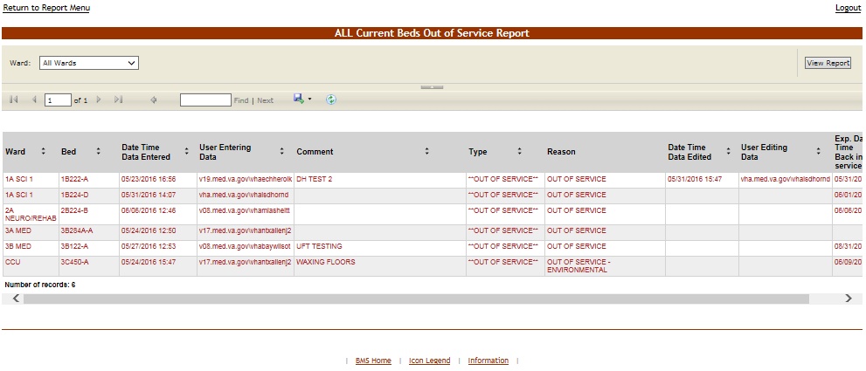

Figure 182 – Beds Out of Service Report - All

From the **Ward** field the site user can select the ward for which to generate the report. After selecting the ward(s), click the **View Report** button to generate the report.

The title of the report is displayed in the upper part of the page. Navigation and display tools are available in the toolbar displayed across the screen. Place the mouse cursor over a button to display the corresponding tooltip. Use the scroll bar to display all the data available.

The report can be exported to a series of formats available when clicking the **Save** button. The **Print** button allows the site user to send the generated report to a printer.

The following data is available for each entry:

Table 31 – Beds Out of Service (All) Parameters

| **Column** | **Description** |
| --- | --- |
| Ward | The ward where the bed is located. |
| Bed | The bed’s facility assigned number. |
| Date Time Data Entered | The date and time when the bed was marked as “out of service.” |
| User Entering Data | The user who has taken the bed out of service. |
| Comment | The comment entered by the user when taking the bed out of service. |
| Type | The type of reason for which the bed was taken out of service. |
| Data Time Data Edited | The date and time when the bed has been taken out of service. |
| User Editing Data | The name of the user who has taken the bed out of service. |
| Date Time Data Cleared | The date and time when the data has been cleared. |
| User Clearing Data | The name of the user who has performed the data clearing. |
| Exp. Date Time Back in service | The date when the bed is expected to be back in service. |

#### 4.2.1.18 Beds Out of Service Report - by Date

This Report shows which beds are or were unavailable and the date they are expected to be back in service.

To generate the Beds Out of Service (by Date) report, follow the instructions below.

On the Reports page, from the **Other Reports** field select Beds Out of Service (by Date) report then press the **Submit** button: the report is displayed as in the following image.

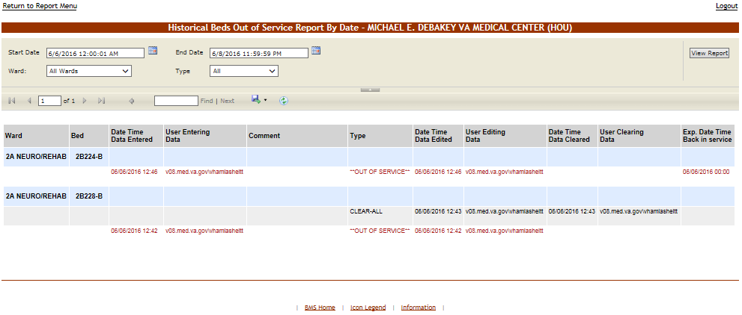

Figure 183 – Beds Out of Service Report - By Date

From the **Ward** field the site user can select the ward for which to generate the report. From the Type field the site user can select the type of reason (*Information* or *Out of service*) for the bed being out of service. Using the **Start Date** and **End Date** fields a time interval for the report can be defined. After selecting the desired parameters, click the **View Report** button to generate the report for the selected time period.

The title of the report is displayed in the upper part of the page. Navigation and display tools are available in the toolbar displayed across the screen. Place the mouse cursor over a button to display the corresponding tooltip.

The report can be exported to a series of formats available when clicking the **Save** button. The **Print** button allows the site user to send the generated report to a printer.

The following data is available for each entry:

Table 32 – Beds Out of Service (by Date) Parameters

| **Column** | **Description** |
| --- | --- |
| Ward | The ward where the bed is located. |
| Bed | The code of the bed. |
| Date Time Data Entered | The date and time when the bed was marked as “out of service.” |
| User Entering Data | The user who has taken the bed out of service. |
| Comment | The comment entered by the user when taking the bed out of service. |
| Type | The type of reason for which the bed was taken out of service, can be either (*Information* or *Out of service*). |
| Data Time Data Edited | The date and time when the bed has been taken out of service. |
| User Editing Data | The name of the user who has taken the bed out of service. |
| Date Time Data Cleared | The date and time when the data has been cleared. |
| User Clearing Data | The name of the user who has performed the data clearing. |
| Exp. Date Time Back in service | The explanation of the date when the bed was placed back in service. |

#### 4.2.1.19 Emergency Management Report

This report provides information that can be printed and used in case of an emergency:

* + - * + Roster report is a listing of those patients needing to be evacuated and transported out of the facility;
        + Regulate report provides a worksheet that can be used with some prefilled information such as admitting diagnosis;
        + Manifest report can be used by those actually evacuating the pt such as the driver/attendant of the bus or vehicle.

To generate the emergency management report, follow the instructions below.

On the Reports page from the **Other Reports** field select the Emergency Management Report: the following page is displayed.

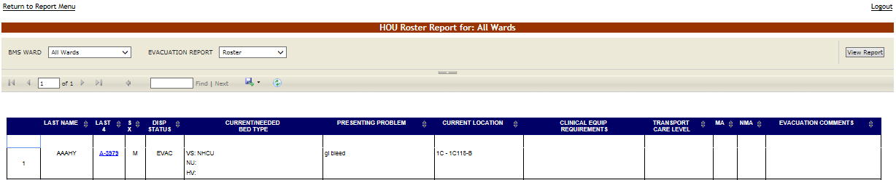

Figure 184 – Emergency Management Report

The emergency management report presents a list with all the patients that need to be evacuated in case of emergency: all the patients currently admitted in the facility as shown in the **Ward Whiteboard Home** page. The report presents the data entered in the Evacuation Data fields, which become available when selecting the option Evacuation patient in the **ADD/EDIT Patients Pending Bed Placement for (facility name)** page. Some data fields are designed to be filled out once the reports have been printed for use in the actual transport of those patients being evacuated.

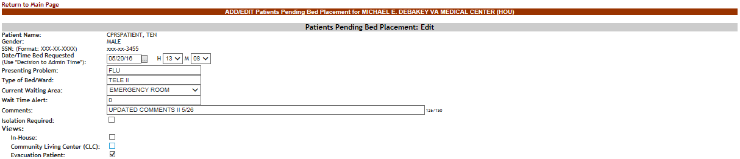

Figure 185 – Patients Pending Bed Placement- Evacuation Patient

From the BMS Ward field select the ward(s) for which you want to generate the report. From the EVACUATION REPORT field select one of the display options for the report: Roster, Regulate or Manifest.

Below is an example of a report displayed with the Regulate display option.

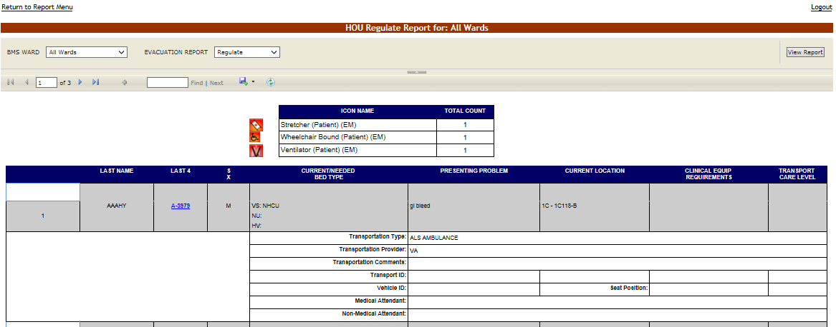

Figure 186 – Emergency Management Report - Regulate

Below is an example of a report displayed with the Manifest display option.

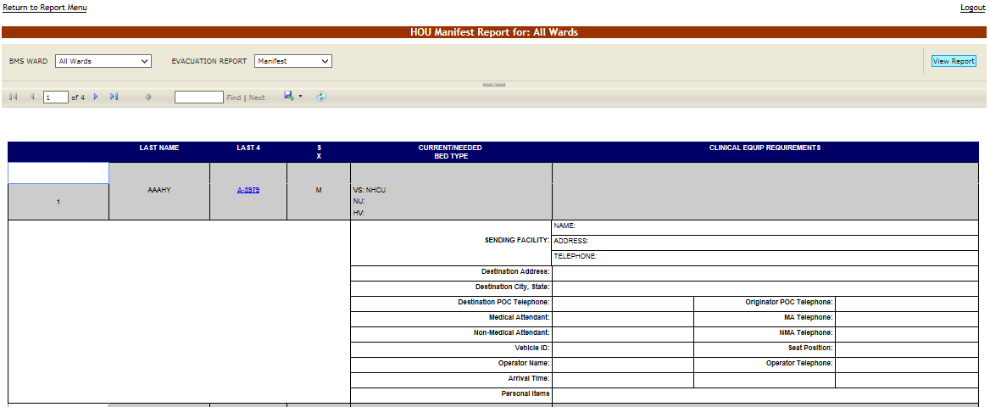

Figure 187 – Emergency Management Report – Manifest

Below is an example of a report displayed with the Patient Transfer display option.

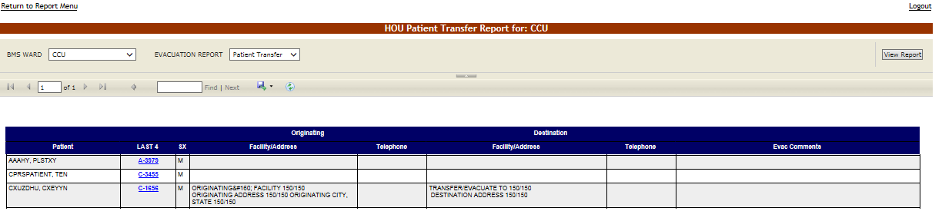

Figure 183.1 – Emergency Management Report - Manifest

The following data is available for each entry:

Table 33 – Emergency Management Reports Parameters

|  |  |
| --- | --- |
| **Column** | **Description** |
| Last Name | Last name of the patient who needs to be evacuated. |
| Last 4 | Last four digits of the patient SSN. |
| SX | The gender of the patient. |
| Disp. Status | The disposition with which the patient is added to the patient pending bed placement list. |
| Current/Needed Bed Type | The type of bed needed for the patient who is being evacuated. |
| Presenting Problem | The problem for which the patient has been admitted. Pulls in admitting Diagnosis for inpatients |
| Current Location | The current location of the patient. Pulls in current ward/room/bed |
| Clinical Equipment Requirements | The clinical equipment requirements for the patient. |
| Transport Care Level | The transport care level. |
| Originator POC Telephone | The telephone of the facility from where the patients are evacuated. |
| Destination Address | The address of the facility where the patient is evacuated to. |
| Destination City, State | The city and state where the patient is evacuated to. |
| Destination POC Telephone | The telephone of the Point-of-Contact of the facility where the patient is evacuated to. |
| Medical Attendant | The name of the Medical Attendant assigned for the patient. |
| MA Telephone | The phone # of the Medical Attendant assigned for the patient. |
| Non-Medical Attendant | The name of the non-Medical Attendant accompanying the patient or of the family member that may be transported with the patient |
| NMA Telephone | The phone # of the non-Medical Attendant accompanying the patient or of the family member that may be transported with the patient |
| Vehicle ID | The identifying # of the transportation vehicle. |
| Seat Position | The seat position of the patient for the transportation vehicle. |
| Operator Telephone | The telephone of the facility from where the patients are evacuated. |
| Evacuation Comments: | Any relevant evacuation comments. |

#### 4.2.1.20 Discharges in Progress Report

To generate the Discharges in Progress report, follow the instructions below.

On the Reports page, from the **Other Reports** field select Discharges in Progress Report then press the **Submit** button: the report is displayed as in the following image.

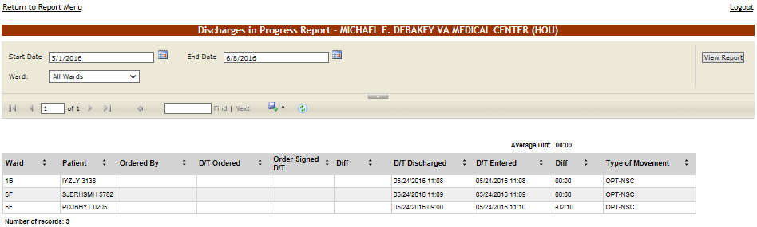

Figure 188 – Discharges in Progress Report

From the **Ward** field select the ward for which you want to generate the report. Using the **Start Date** and **End Date** fields, define the time interval for which you want to generate the report. After selecting the desired parameters, click the **View Report** button to generate the report for the selected time period.

The title of the report is displayed in the upper part of the page. Navigation and display tools are available in the toolbar displayed across the screen. Place the mouse cursor over a button to display the corresponding tooltip.

The report can be exported to a series of formats available when clicking the **Save** button. The **Print** button allows the site user to send the generated report to a printer.

The following data is available for each entry:

Table 34 – Discharges in Progress Parameters

|  |  |
| --- | --- |
| **Column** | **Description** |
| Ward | The name of the ward where the bed is. |
| Patient | The patient code of the patient who is being discharged. |
| Ordered by | The name of the clinician writing the discharge order. |
| D(ate)/T(ime) Ordered | The date and time when the discharge order has been issued. |
| Order Signed D(ate)/T(ime) | The date and time the discharge order was signed. |
| Diff | The time lapse between the date/time when the discharge was ordered and the date/time that the discharge order was signed. |
| D(ate)/T(ime) Discharged | The date and time when the actual discharge was performed. |
| D(ate)/T(ime) Entered | The date and time when the discharge was registered in the system. |
| Diff | The time lapse between the date/time when the discharge was performed and the date/time it was registered in the system. |
| Type of Movement: | The type of movement. |

#### 4.2.1.21 EMS Bed Status Report - Admin

To generate the EMS Bed Status report, follow the instructions below.

On the Reports page, from the **Other Reports** field select EMS Bed Status Report then press the **Submit** button: the report is displayed as in the following image.

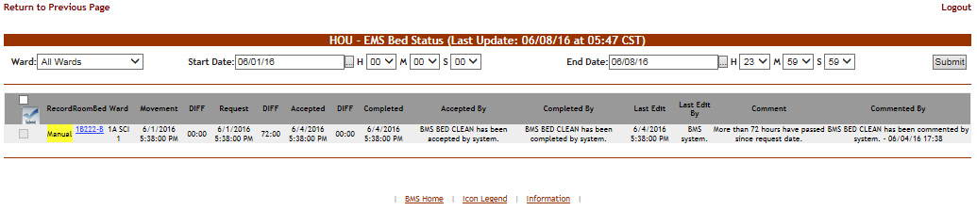

Figure 189 – EMS Bed Status Report

From the **Ward** field select the ward for which you want to generate the report. Using the **Start Date** and **End Date** fields, define the time interval for which you want to generate the report. After selecting the desired parameters, click the **View Report** button to generate the report for the selected time period.

The title of the report is displayed in the upper part of the page. Navigation and display tools are available in the toolbar displayed across the screen. Place the mouse cursor over a button to display the corresponding tooltip.

The report can be exported to a series of formats available when clicking the **Save** button. The **Print** button allows the site user to send the generated report to a printer.

The following data is available for each entry:

Table 35 – EMS Bed Status Parameters

|  |  |
| --- | --- |
| **Column** | **Description** |
| Record | The number automatically assigned in the system to the record. This is the discharge entry number in the patient movement file. |
| RoomBed | The room and bed number. |
| Ward | The ward number. |
| Movement | The date and time when the movement has been registered. |
| DIFF | The time lapse between the date/time when the movement occurred and when it was requested. |
| Request | The date and time of the request. |
| DIFF | The time lapse between the date/time when the request occurred and when it was accepted. |
| Accepted | The date and time when the request was accepted. |
| DIFF | The time lapse between the date/time when the request was accepted and the date/time when the request was completed. |
| Completed | The date and time when the movement has been completed. |
| Accepted by | The name of the person who accepted the request. |
| Completed by | The name of the person that completed the operation. |
| Last Edited | The date and time when the record was last edited. |
| Comment | The comments entered in the Comments field. |
| Commented by | The user who entered the comments. |

#### 4.2.1.22 Patients with Discharge Appointments Report

To generate the Future Discharge report, follow the instructions below.

On the Reports page, from the **Other Reports** field select Patients w(ith) Discharge Appointment Report then press the **Submit** button: the report is displayed as in the following image.

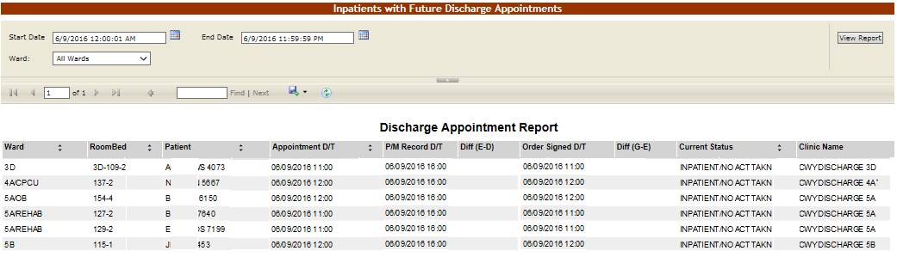

Figure 190 – Future Discharge Report

Using the **Start Date** and **End Date** fields, define the time interval for which you want to generate the report. From the **Ward** field select the ward for which you want to generate the report. After selecting the desired parameters, click the **View Report** button to generate the report for the selected time period.

The report can be exported to a series of formats available when clicking the **Save** button. The **Print** button allows the site user to send the generated report to a printer.

The following data is available for each entry:

Table 36 – Future Discharges Parameters

|  |  |
| --- | --- |
| **Column** | **Description** |
| Ward | The code/name of the ward where the bed is. |
| Room Bed | The bed where the discharge is being performed. |
| Patient | The name of the patient being discharged. |
| Appointment D(ate)/T(ime) | The scheduled date and time of the discharge. |
| P(atient)M(ovement) Record D(ate)/T(ime) | The date and time of the last patient movement |
| Diff (E-D) | The time difference between the Appointment Date/Time and the Patient Movement Record Date/Time |
| Order Signed D(ate)/T(ime) | The date and time of the time the Discharge Order was signed. |
| Diff (G-E) | The time difference between the Appointment Date/Time and the Order Signed Date/Time. |
| Current Status | The current status of the discharge operation. |
| Clinic Name | The name of the Clinic where the patient has the discharge appointment. |

#### 4.2.1.23 Patient Movements by Date

To generate the Patient Movements by Date report, follow the instructions below.

On the Reports page, from the **Other Reports** field select Patient Movements by Date then press the **Submit** button: the report is displayed as in the following image.

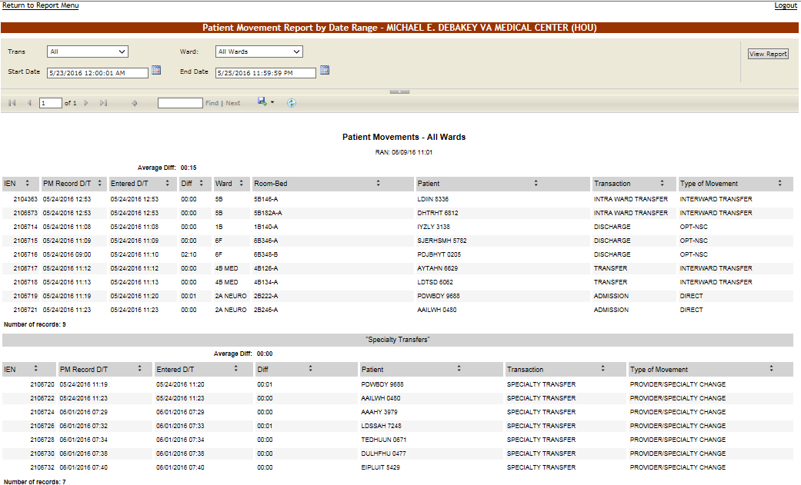

Figure 191 – Patient Movements by Date

From the **Trans** field select the type of movement (all, admissions, discharges, inter ward transfers, intra ward transfers, specialty transfers) you want to include in the report. Using the **Start Date** and **End Date** fields, define the time interval for which you want to generate the report. From the **Ward** field select the ward(s) for which you want to generate the report. After selecting the desired parameters, click the **View Report** button to generate the report for the selected time period.

The title of the report is displayed in the upper part of the page. Navigation and display tools are available

in the toolbar displayed across the screen. Place the mouse cursor over a button to display the corresponding tooltip.

The report can be exported to a series of formats available when clicking the **Save** button. The **Print** button allows the site user to send the generated report to a printer.

The following data is available for each entry:

Table 37 – Patient Movement Parameters

| **Column** | **Description** |
| --- | --- |
| Internal Entry Number (IEN) | The VistA Internal Entry Number for the primary lookup key in the Patient Movement file. |
| PM Record D(ate)/T(ime) | The date and time when the patient movement has been registered in the system. |
| Entered D(ate)/T(ime) | The data and time the patient movement was entered in the system. |
| Diff | The time lapse between the PM Record D/T and the Entered D/T. |
| Ward | The code/name of the ward. |
| Room-Bed | The code of the room/bed. |
| Patient | The code/name of the patient. |
| Transaction | The type of transaction. |
| Type of Movement | The type of the movement. |

#### 4.2.1.24 Scheduled Admissions by Date

To generate the Scheduled Admissions by Date report, follow the instructions below.

On the Reports page, from the **Other Reports** field select the Scheduled Admissions by Date then press the **Submit** button: the report is displayed as in the following image.

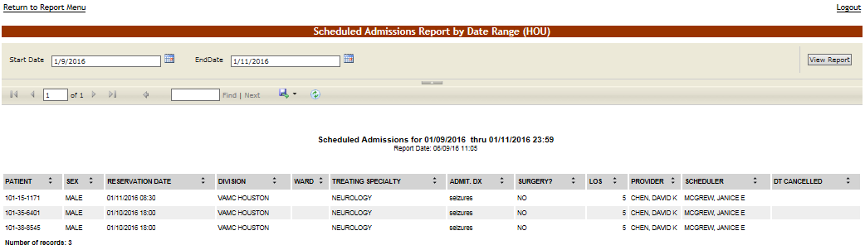

Figure 192 – Scheduled Admissions by Date

Using the **Start Date** and **End Date** fields, define the time interval for which you want to generate the report. After selecting the desired parameters, click the **View Report** button to generate the report for the selected time period.

The title of the report is displayed in the upper part of the page. Navigation and display tools are available in the toolbar displayed across the screen. Place the mouse cursor over a button to display the corresponding tooltip.

The report can be exported to a series of formats available when clicking the **Save** button. The **Print** button allows the site user to send the generated report to a printer.

The following data is available for each entry:

Table 38 – Scheduled Admissions Parameters

| **Column** | **Description** |
| --- | --- |
| Patient | The name of the patient, displayed as Last Name plus first letter of last name and last 4 of SSN in parentheses. Example: Brown (B1234) |
| Sex | The gender of the patient. |
| Reservation Date | The date of admission. |
| Division | The Division where patient will be admitted. |
| Ward | The ward where is the bed for which the admission has been made. |
| Treating Specialty: | The medical specialty to which the patient has been assigned. |
| Admt. Dx: | Diagnosis on admission |
| Surgery?: | Indicates if the patient is scheduled for surgery. |
| LOS | Length of stay. |
| Provider: | The primary care clinician for the patient. |
| Scheduler: | The name of the person scheduling the admission. |
| DT Cancelled: | If the scheduled admission was cancelled, the date and time of the cancellation. |

#### 4.2.1.25 Patients Pending Bed Placement Status Report

To generate the Patients Pending Bed Placement List Status report, follow the instructions below.

On the Reports page, from the **Other Reports** field select the Patients Pending Bed Placement List Status report then press the **Submit** button: the report is displayed as in the following image.

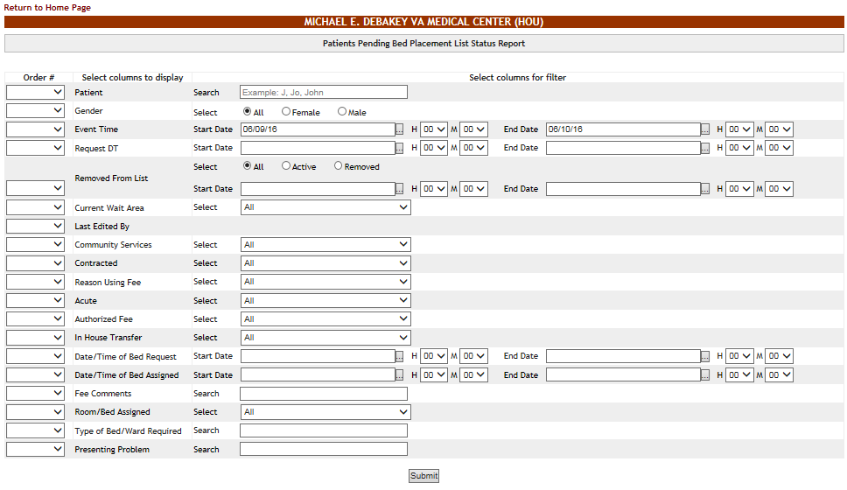

Figure 193 –Patient Pending Bed Placement List Status Report Criteria

The user can select the data to be included in report.

From the **Order #** column select the order in which the columns of the report will be arranged. If you do not select a number in this column the associated column will not be included in the report.

From the area Select columns for filter select the filter criteria for the report entries.

Make your selections then press the **Submit** button to display the report as in the following image.

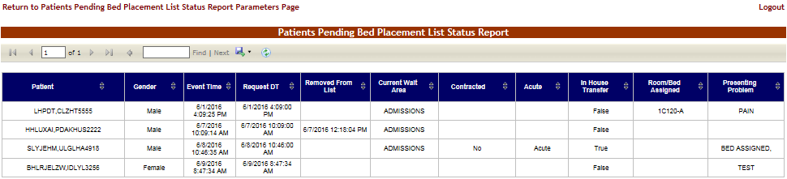

Figure 194 – Patient Pending Bed Placement List Status Report

#### 4.2.1.26 Active Transfer Orders Report

This report presents the list of active transfer orders for the current facility. To generate the Active Transfer Orders report, follow the instructions below.

On the Reports page, from the **Other Reports** field select the Active Transfer Orders then press the **Submit** button: the report is displayed as in the following image.

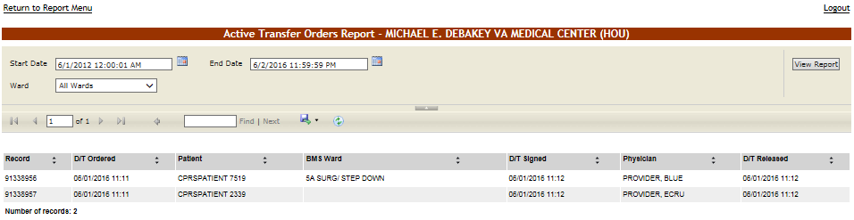

Figure 195 – Active Transfer Orders Report

Using the **Start Date** and **End Date** fields, define the time interval for which you want to generate the report. After selecting the desired parameters, click the **View Report** button to generate the report for the selected time period.

The title of the report is displayed in the upper part of the page. Navigation and display tools are available in the toolbar displayed across the screen. Place the mouse cursor over a button to display the corresponding tooltip.

The report can be exported to a series of formats available when clicking the **Save** button. The **Print** button allows the site user to send the generated report to a printer.

The following data is available for each entry:

Table 39 – Active Transfer Orders Report Parameters

|  |  |
| --- | --- |
| **Column** | **Description** |
| Record | The number automatically assigned in the system to the record. This is the transfer entry number in the patient movement file. |
| D/T Ordered | The date and time when the transfer has been ordered. |
| Patient | The patient’s first letter of their last name and the 4 digits of their SSN. |
| BMS Ward | The BMS ward where the patient is being transferred to. |
| D/T Signed | The date and time when the transfer order has been signed. |
| Physician | The name of the physician who signed the transfer order. |
| D/T Released | The date and time when the patient has been released. |

#### 4.2.1.27 Bed Switch Report

This report presents the list of active transfer orders for the current facility. To generate the Bed Switch report, follow the instructions below.

On the Reports page, from the **Other Reports** field select the Bed Switch Report then press the **Submit** button: the report is displayed as in the following image.

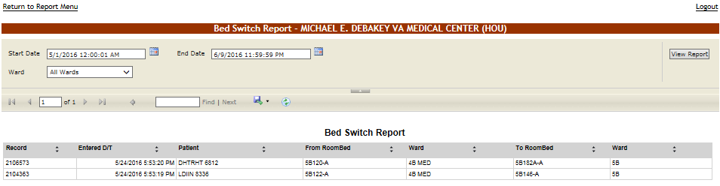

Figure 191.1 – Bed Switch Report

Using the **Start Date** and **End Date** fields, define the time interval for which you want to generate the report. After selecting the desired parameters, click the **View Report** button to generate the report for the selected time period.

The title of the report is displayed in the upper part of the page. Navigation and display tools are available in the toolbar displayed across the screen. Place the mouse cursor over a button to display the corresponding tooltip.

The report can be exported to a series of formats available when clicking the **Save** button. The **Print** button allows the site user to send the generated report to a printer.

The following data is available for each entry:

Table 39.1 – Bed Switch Report Parameters

|  |  |
| --- | --- |
| **Column** | **Description** |
| Record | The number automatically assigned in the system to the record. This is the transfer entry number in the patient movement file. |
| Entered D(ate)/T(ime) | The date and time when the bed switch was entered. |
| Patient | The patient’s first letter of their last name and the 4 digits of their SSN. |
| From RoomBed | The room/bed which the patient was switched from. |
| (From) Ward | The BMS ward where the patient was switched from |
| To RoomBed | The room/bed which the patient was switched to. |
| (To) Ward | The BMS ward where the patient was switched to. |

### The Facility Diversion Page

This page is accessed by clicking the **Facility Diversion** link in the upper left corner of the facility home page.

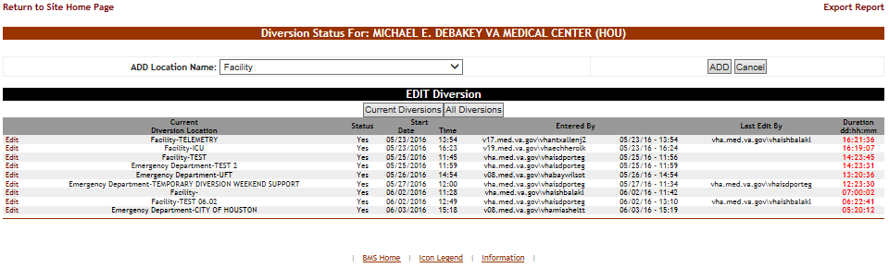

Figure 196 – Facility Diversion Page

This page presents a list of facility areas/wards or Emergency Departments (ED) that are not accepting patients due to insufficient resources or facility issues.

In the **Facility Diversion** page the user can perform the following actions: add a Facility Diversion entry and edit an existing Facility Diversion entry.

The user can add one of the locations available in the field **ADD Location Name** (populated from the VistA system).

The diversion list can be filtered to see only the Current Diversions or All Diversions. All Diversions gives the user historical diversion information for the facility or ED.

The following data is available for each entry in the list when the **Current Diversions** button is pressed:

Table 40 – Current Diversions Parameters

| **Column** | **Description** |
| --- | --- |
| Edit | Allows the user to update diversion information. |
| Current Diversion Location | The name of the facility that is in Diversion Status. |
| Status | Yes / No. |
| Start/ Date/Time | The date and time when the diversion operation has been registered. |
| Entered By | The name of the person who has registered the diversion. |
| Last Edit By | The name of the person who last modified the details of the diversion. |
| Duration | The length of time for which the facility has been on Diversion Status |

The following data is available for each entry in the list when the **All Diversions** button is pressed:

Table 41 – All Diversions Parameters

|  |  |
| --- | --- |
| **Column** | **Description** |
| Edit | Allows the user to update diversion information. |
| All Diversion Location | The name of the facility that is in Diversion Status. |
| Status | Yes / No. |
| Start/Date/Time | The date and time when the diversion operation has been registered. |
| End/Date/Time (EST) | The date and time when the diversion operation is estimated to end. |
| Entered by | The name of the person who has registered the diversion. |
| Last Edit By | The name of the person who last modified the details of the diversion. |
| Duration | The length of time for which the facility has been on Diversion Status. |

To change the details of a diversion the user can use the **Edit** link to the left of an entry.

#### 4.2.2.1 Setting a Facility Area/Ward or ED to Diversion Status

To register a Facility or ED to Diversion Status, follow the instructions below.

From the home page, click the **Facility Diversion** link in from the upper left corner of the screen

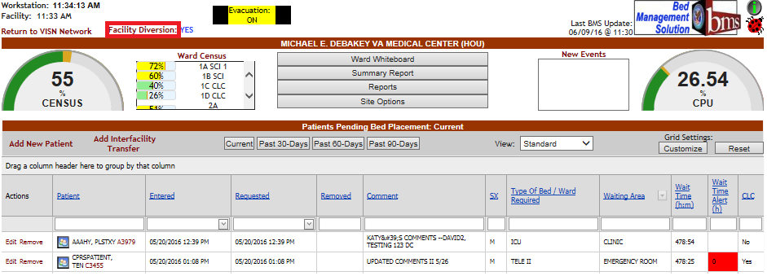

Figure 197 – Selecting Facility Diversion

The **Diversion** page is displayed as in the following image.



Figure 198 – Adding/Editing Details of Facility Diversion

From the field **ADD Location Name** select the facility or ED you want to divert then press the **ADD** button: the following screen is displayed.

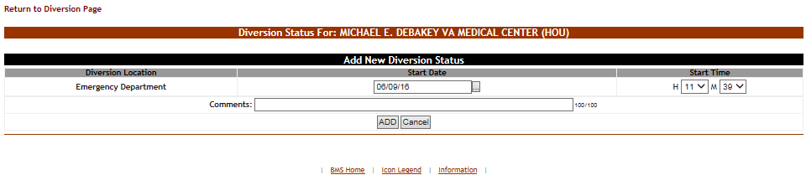

Figure 199 – Add New Diversion Status

The name of the facility selected in the previous screen is displayed in the Diversion Location column. ***The user enters the Date and Time that the Facility or ED will Start Diversion Status***. In the **Comments** field, enter any comments that you consider relevant then press the **ADD** button to enter the data into the system. If facility diversion is selected in the comments field indicate which ward/area is being diverted. For example, select Facility and in the comments section indicate Intensive Care Unit (ICU)-No beds available. The newly registered diversion will be displayed in the Current Diversions list in the main **Diversion** screen.

#### 4.2.2.2 Edit an existing Facility Diversion Entry

To edit the details of the diversion status set for a Facility or ED: in the Diversion Status for… (facility name) page click the **Edit** link to the left of the diversion status you want to modify. The following page is displayed.

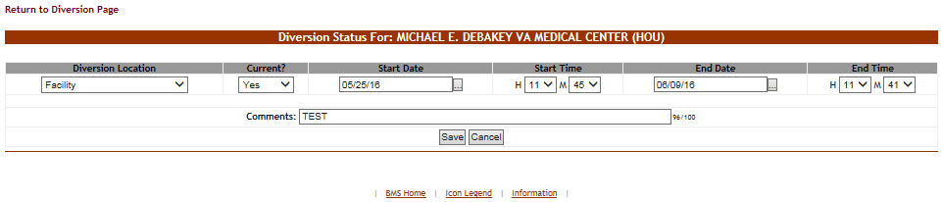

Figure 200 – Edit Diversion Status Details

Modify any of the existing parameters then press the Save button to enter the data into the system.

### The Events Page

This page is accessed by clicking the **New Events** link above the New Events List box on the right side of the screen, beside the CPU% graph.

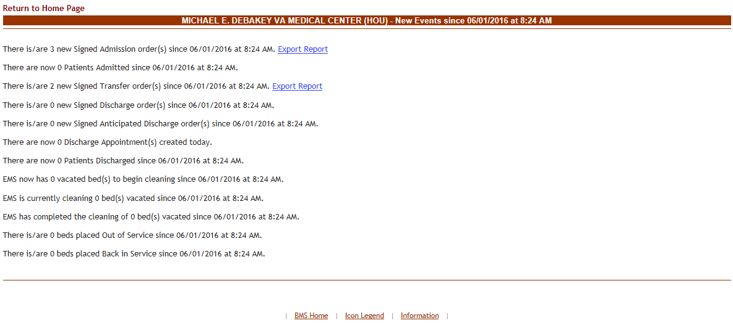

Figure 201 – New Events Page

This page presents the latest events occurring in VistA and which have an impact on the activity of the current facility as well as events occurred in the current facility during the last 8 hours. A **View Report** link is available for displaying details on the events of a certain type.

In the Events Page the user can perform a single type of action: generating a report.

#### 4.2.3.1 View/Generate Patient Movement Report

To generate a report in the **New Events** page click the **View Report** link: the following page is displayed. (In the image below the Patient Movement Report by Date Range is presented)



Figure 202 – Patient Movement Report

### The Ward Whiteboard Home Page

This page is accessed by clicking the **Ward Whiteboard** button in the middle/top section of the facility home page.

**Note:** Users are discouraged from using the words DNR/DNI in the comment of the Ward Whiteboard or using any icon to represent DNR/DNI on the Ward Whiteboard.

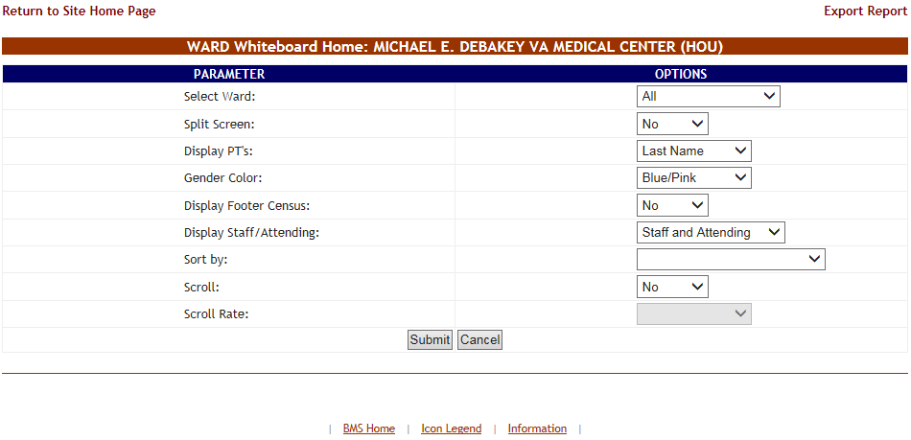

Figure 203 – Ward Whiteboard Home – Select Display Criteria

The following display criteria are available:

**Select Ward**: use the arrow button of this field to display a list of wards defined for the current facility and select the ward for which you want to display the whiteboard. A new option will allow all wards to be displayed on one screen

**Split Screen**: use the Yes/No options in this field to decide whether to display the info in one or two columns. This could be helpful if the ward to be displayed has a large number of beds associated to it.

**Display PTs**: use the arrow button of this field to select display options for the patient name. You can choose between the full name and a code made up of the 1stletter of the name of the patient + 4 last digits in their SSN. The default on a public whiteboard is the full last name.

**Gender Color**: use the arrow button of this field to determine the color-coding for the patient gender. If set to None all rooms will be displayed in shades of gray.

**Display Footer Census**: if detailed census values should be displayed at the bottom of the bed list. If set to yes, the whiteboard will be displayed with the information seen for that ward on the Bed Summary Report.



**Display Staff/Attending**: The options for this field is Staff/Attending, Staff only, or Attending only This will create the appropriate column(s) on the whiteboard, The Attending will be populated from VistA with the Attending physicians last name. **Sort by**: if the list should be sorted according to the available criteria. The available criteria is staff/attending in ascending or descending order or by ward in ascending or descending order. This would be useful for staff assignment or end of shift reporting

**Scroll**: if the scroll function should be enabled (for long lists).

**Scroll Rate**: (this option will only be available if you select “yes” for the previous option) the scroll rate. You can select the scroll rate of 2 seconds, 5 seconds, 10 seconds, 20 seconds or 30 seconds.

Select the desired display criteria from the drop-down fields, then press the **Submit** button to order the patient list according to the selected criteria. Below is an example of All wards selected with the footer census.

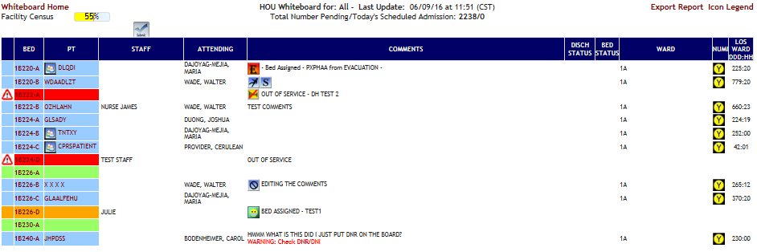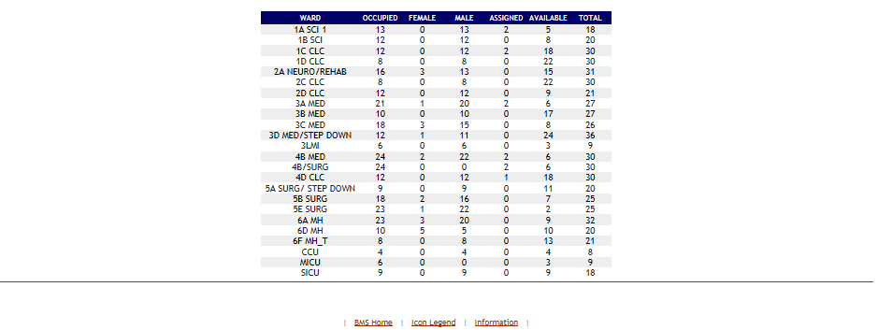

Figure 204 – Ward Whiteboard Home

NOTE: if you select only a ward group instead of the entire facility in the upper right corner of the screen a **Ward Census** field will display the percentage of occupancy for the selected ward.

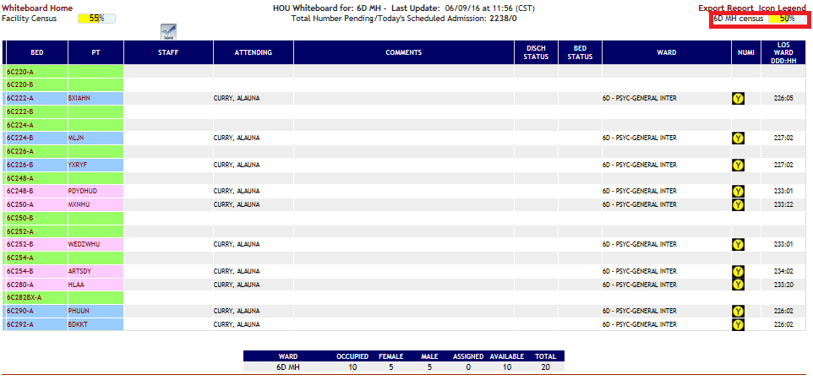

Figure 205 – Ward Whiteboard Home - Ward Census Field

The **Ward Whiteboard Home** page displays the list of beds in the selected ward(s). For each bed, the following data is available:

Table 42 – Beds Parameters

| **Column** | **Description** |
| --- | --- |
| BED | The number assigned to the bed in the ward. The site user can click this link to view and/or edit bed information. |
| PT | The patient code of the patient occupying the bed. (The format of this code can be selected from the Display PTs field at the top of the beds list). Clicking the patient code link will display the Edit Patient page where you can see details of the selected patient. An icon indicating the same or similar name may appear next to the patient name if another patient on the ward has been identified |
| STAFF | Name of Nursing personnel assigned to the bed. |
| ATTENDING | The name of the attending physician in charge of care of the patient. |
| COMMENTS | Helpful information entered by the site user when changing the bed status. Includes Patient Risk information conveyed by means of specific icons (Flight Risk, Slip, and/or Fall Risk). For details on the patient risk icons available, click the Icon Legend link - top right corner of the beds list. |
| DISCH STATUS | The DSC column displays the Discharge status of the bed; three possible statuses are available: Anticipated Discharge Anticipated Discharge or  Discharge Appointment  Discharge Ordered Discharge Ordered  Interward Transfer Interward Transfer  These icons are all triggered by Orderable Items.   They will continue to display until the Orderable Item is completed or the patient is discharged from the room.   Discharge Icons are Triggered when a patient is assigned an Orderable Item that has been defined in Site Options, BMS Orderable Items Add/Delete, as Type of “DISCHARGE”.   Interward Transfer Icons are Triggered when a patient is assigned an Orderable Item that has been defined in Site Options, BMS Orderable Items Add/Delete, as Type of “TRANSFER”.   Discharge Orders override Anticipated Discharge Orders.  Anticipated Discharge Icons are triggered off the Order Text when it contains the text “Anticipated Discharge” or “Planned Discharge”. |
| BED STATUS | The BED column displays information about the bed cleaning status: three statuses are available:  Bed Cleaned bed cleaned  Bed Needs Cleaning Bed Needs Cleaning  Cleaning Bed Cleaning Bed |
| WARD | The ward where the bed is located. |
| NUMI | NUMI automates utilization review assessment and outcomes. The Utilization Management (UM) Process is a tool used to help verify that patients are receiving the right care, at the right time, and in the right place. UM is both a quality and efficiency tool, as it is used to move patients efficiently through the VA system to maximize use of resources. UM reviewers assess patient admissions and hospital stay days using standardized objective evidence-based clinical criteria to determine whether patients meet criteria for acute hospital care. Refer to the NUMI icons for the different levels of care |
| LOS WRD D:H | Length of stay on a ward |

In this page the user can perform the following actions: take a bed out of service, flag a bed with different icons, display the patient details, generate the ward whiteboard report for the selected wards.

#### 4.2.4.1 Taking a Bed out of Service

To take a bed out of service, follow the instructions below. You must have privileges that will allow you to do this action.

From the home page, click the **Ward Whiteboard** link in from the upper right corner of the screen

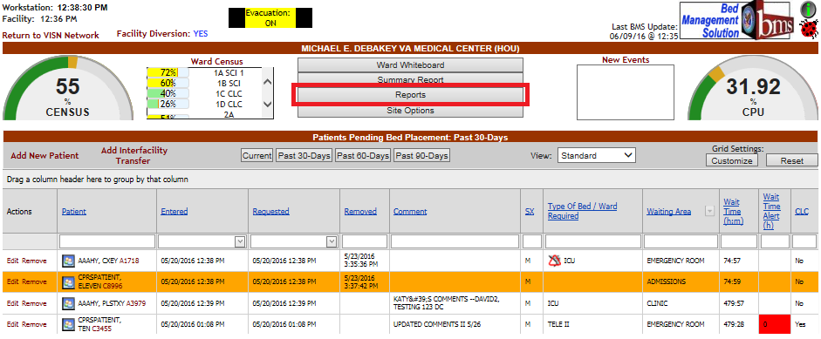

Figure 206 – Selecting Ward Whiteboard

The **Ward Whiteboard** page is displayed as in the following image.

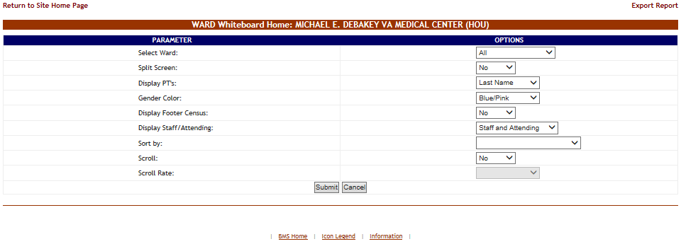

Figure 207 – Selecting Parameters for Ward Whiteboard

Click the arrow button of the **Select Ward** field to display a list of wards defined in the system and select the ward where is the bed you want to take out of service then press the **Submit** button. The list of the beds in the selected ward is displayed as in the following image.

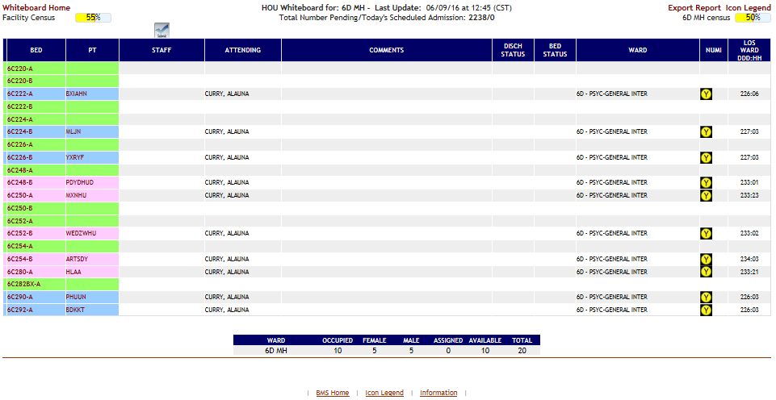

Figure 208 – Selecting a Bed from the Ward Whiteboard Page

Click the bed code link of the bed you want to take out of service. The **Ward Whiteboard** page is displayed as in the following image.

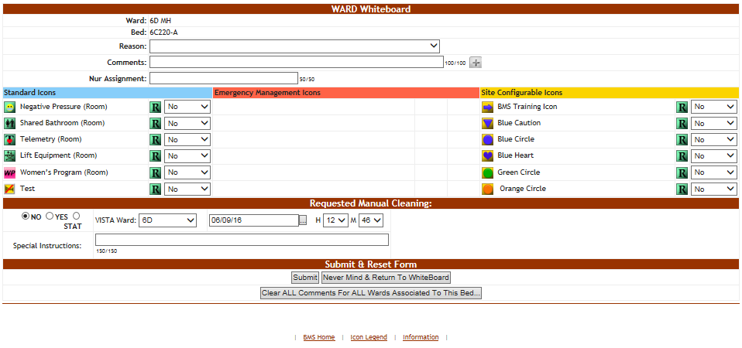

Figure 209 – Taking a Bed Out of Service

Click the arrow button of the **Reason** field to display a list of available options and select *Out of service.* Enter the date and time the bed is expected to be returned to service if it is known. This is displayed in the Beds Out of Service reports. When all the data has been entered, press the **Submit** button.

When displaying the **Ward Whiteboard Home** page, the selected bed will be marked with an icon “Out of service” and the color will be changed to Red.

If you choose a **Do Not Display** Reason, the bed will not be displayed on the Whiteboard.

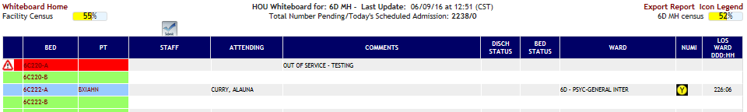

Figure 210 – Ward Whiteboard Home - Bed Out of Service

To return the Bed to In Service Status, Click the arrow button of the **Reason** field to display a list of available options and select *DELETE THIS REASON* and press the **Submit** button or click the **Clear ALL Comments For ALL Wards Associated To This Bed** button. Clicking the clear all comments will remove all icons associated to the room as well as comments.

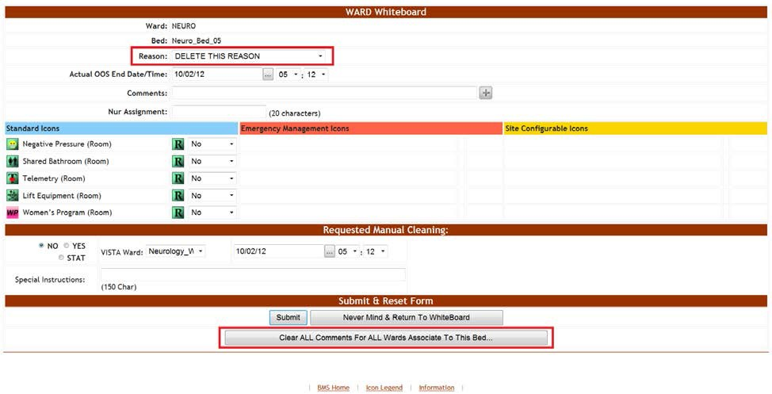

Figure 211 – Ward Whiteboard Home – Return Bed To In Service

If you’ve changed the status of a bed to a **Do Not Display** Reason and want to return the bed to service, since you cannot see the bed on the Whiteboard, you will have to go to the either the **Bed Summary Report** or the **Ward Occupancy Report,** which will show the **Do Not Display** beds, so you can put them back in service by selecting *DELETE THIS REASON* and pressing the Submit button, or by clicking the **Clear ALL Comments For ALL Wards Associated To This Bed** button. Clicking the clear all comments will remove all icons associated to the room as well as comments.

#### 4.2.4.2 Flagging a bed/patient with different icons

In the Ward Whiteboard Home page click the bed code of the bed you want to flag:

If the selected bed is empty (no patient assigned) then the Ward Whiteboard page is displayed as in the following image.   
(Only icons that can be assigned to a room/bed  will be available)

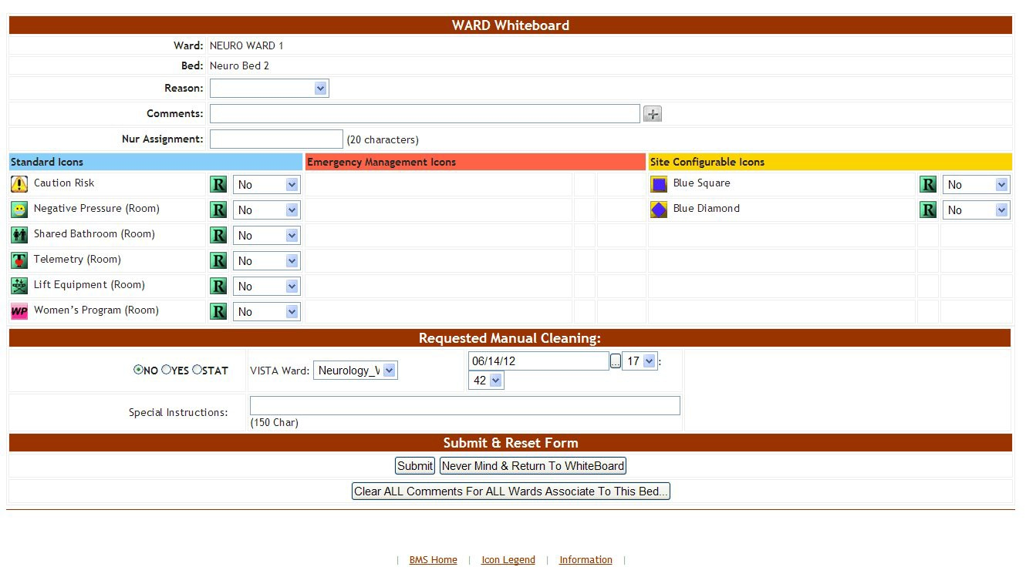

Figure 212 – Ward Whiteboard – No Patient Assigned

If the selected bed is assigned to a patient then the Ward Whiteboard page is displayed as in the following image.

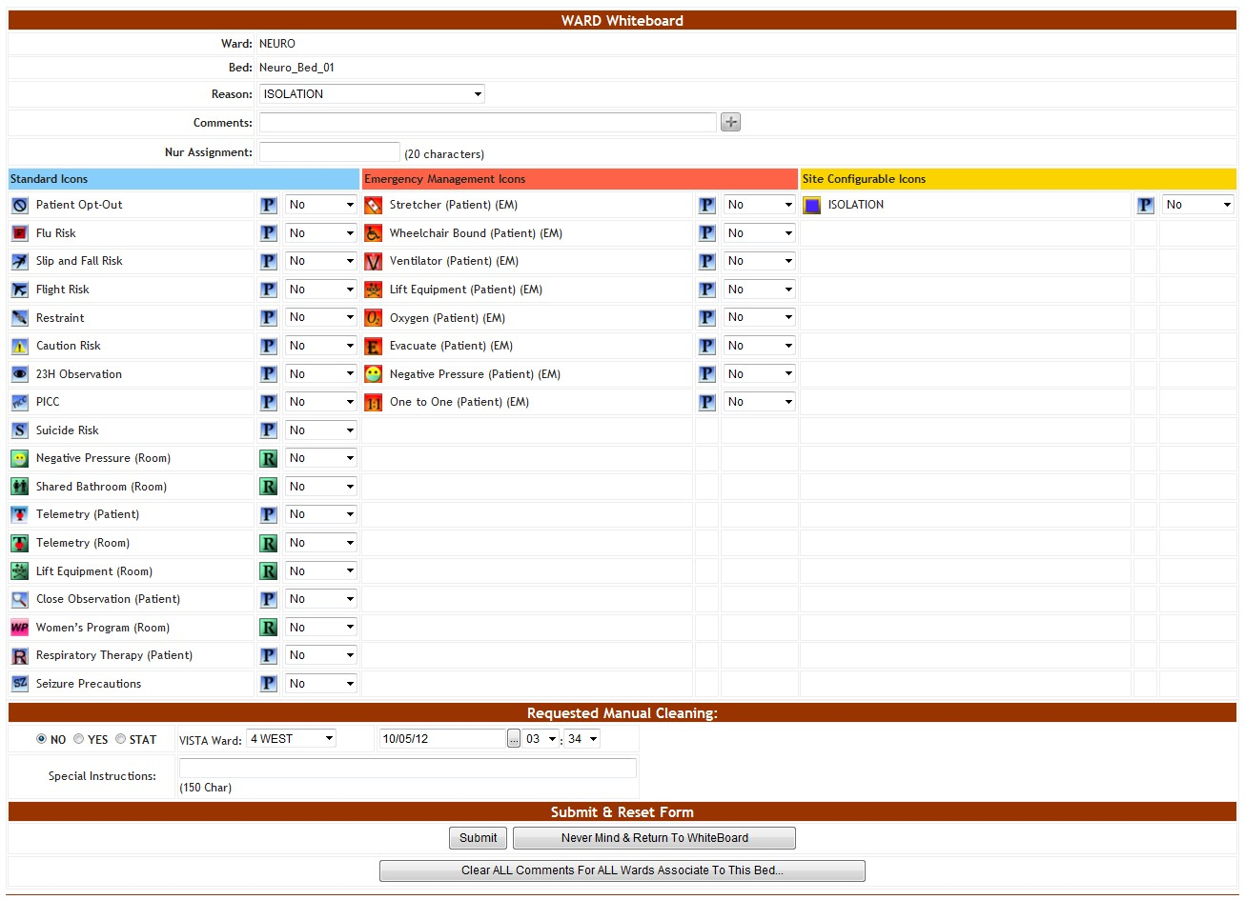

Figure 213 – Ward Whiteboard – Patient Assigned

The  image to the right of an icon indicates that it can be used to flag a person and those icons appear on a blue background. The  image to the right of an icon indicates that it can be used to flag a room or a bed and those icons appear on a green background.

To add an icon to the selected bed select “yes” from the field to the right of the icon then press the **Submit** button. To add an icon regarding the patient occupying the bed select “yes” from the field to the right of the icon then press the **Submit** button. The icons for which you selected “yes” will be displayed in the Comments column of the selected bed as in the following image.

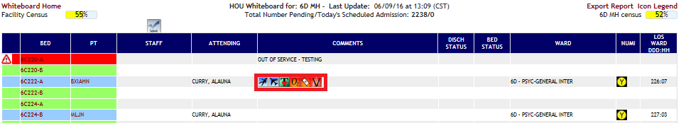

Figure 214 – Ward Whiteboard Home – Bed/Patient Flagged

#### 4.2.4.3 Assigning a bed to a nurse

To assign a bed to a nurse follow the instructions below.

In the **Ward Whiteboard Home** page click the field to the right of a bed in the STAFF column:

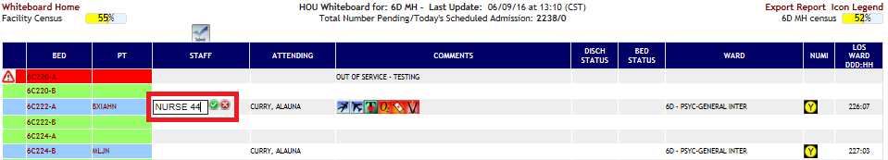

Figure 215 – Ward Whiteboard Home – Select Bed to Assign to a Nurse

In the field that becomes available enter the name of the nurse to whom you want to assign the bed then press the **Green Check** button to the right of the field to enter the data into the system. To cancel the operation, click the **Red X** button.

#### 4.2.4.4 Editing the nurse assignment for a bed

To change the nurse assignation for a bed follow the instructions below.

In the **Ward Whiteboard Home** page click the field to the right of a bed in the STAFF column where the name of the current nurse is displayed.

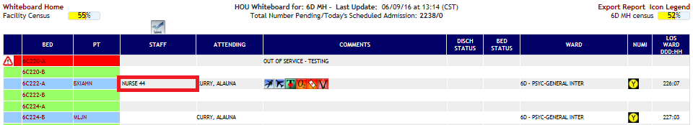

Figure 216 – Ward Whiteboard Home – Select Nurse

The field will become editable as in the following image.



Figure 217 – Ward Whiteboard Home – Change Nurse Assignment for Bed

Change the name of the nurse then press the green button to enter the data into the system or the red button to cancel the operation.

#### 4.2.4.5 Assigning several beds to medical staff

Users can assign several beds to medical personnel available from the Ward Whiteboard page.

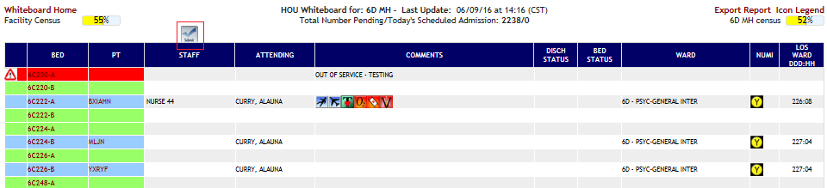

Figure 218 – Selecting a Batch Assign Button

Click the **Batch Assign Staff** button at the top of the Staff column: the following page is displayed.

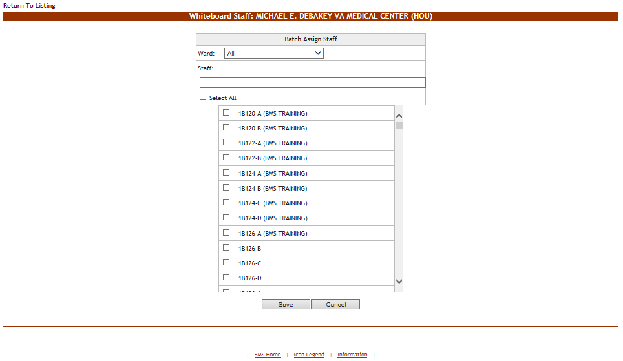

Figure 219 – Batch Assign Beds to Staff

A list of beds is displayed: use the Ward field at the top of the page to filter the bed list according to wards.

In the **Staff** field enter the name of the nurse (or other personnel) that you want to assign for the selected bed.

Use the selection box to select the beds which you want to assign to the selected nurse (or other personnel). If a nurse (or other personnel) has already been assigned to a bed their name will be displayed next to the bed name in the list.

Click the **Save** button to enter the data into the system: the name of the nurse (or other medical personnel) will be displayed in the STAFF column in the **Ward Whiteboard** homepage as in the following image.

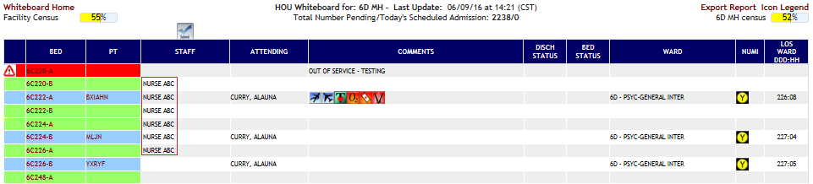

Figure 220 – Beds Assigned

#### 4.2.4.6 Display the patient details

In the **Ward Whiteboard** home page click the patient name link: the following page is displayed.

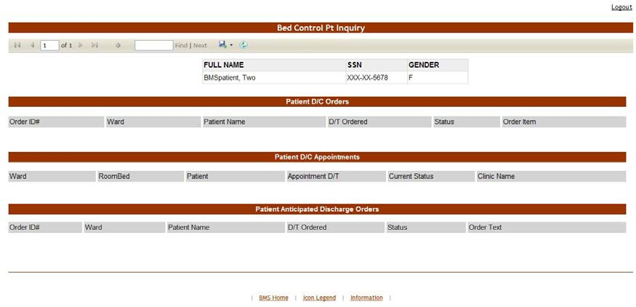

Figure 221 – Patient Details – Bed Control Pt Inquiry

A list with all the operations registered in the system for the selected patient is displayed.

#### 4.2.4.7 Generate the ward whiteboard report for the selected wards

In the **Ward Whiteboard Home** page click the **Export Report** link in the upper right corner of the page: the report is presented as in the following image.

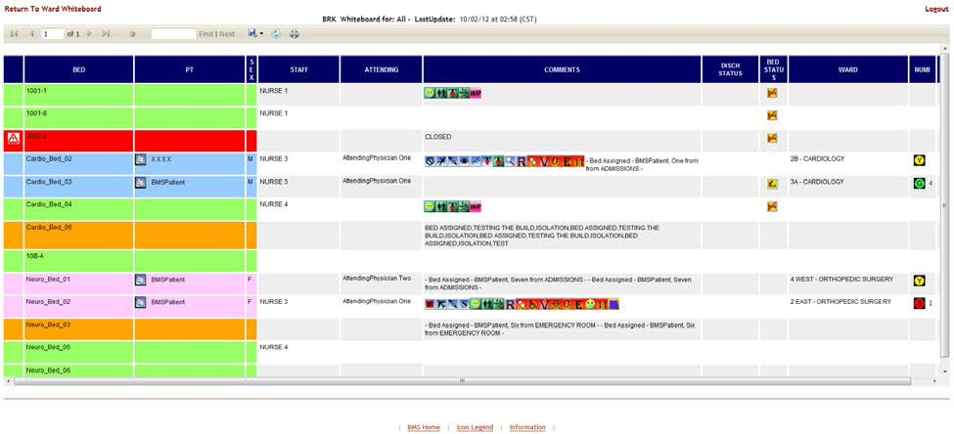

Figure 222 – Ward Whiteboard Report

### The Ward Whiteboard Page

The **Ward Whiteboard** page is accessible from the **Ward Whiteboard Home** page by clicking the corresponding bed code link in the BED column.

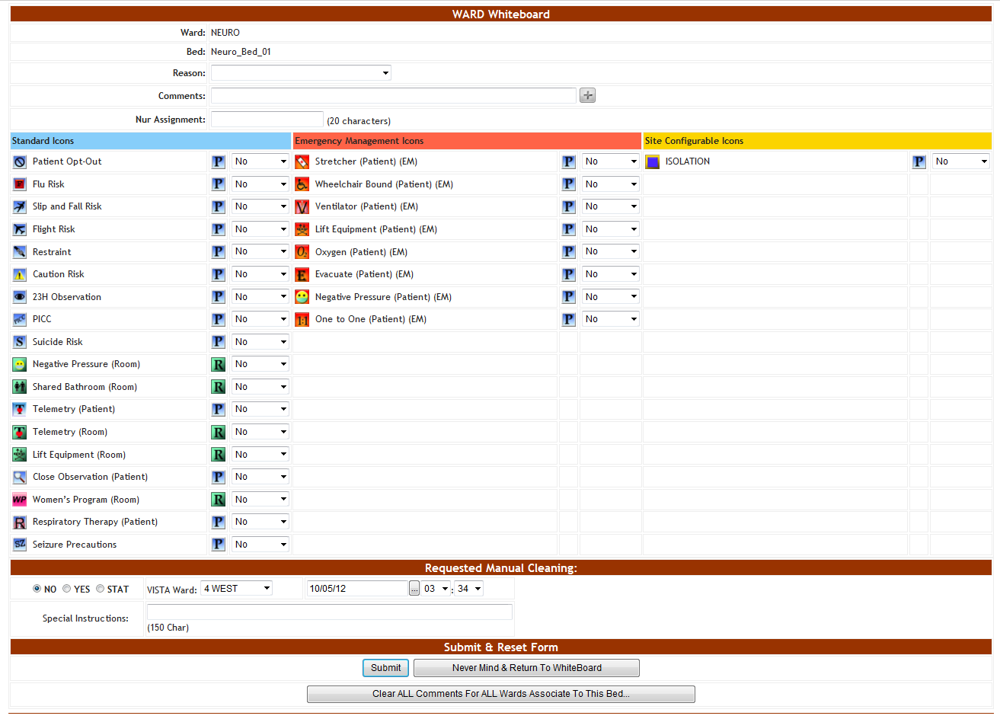

Figure 223 – The Ward Whiteboard Page

The **Ward Whiteboard** page presents information about the selected bed and allows the user to perform various operations such as taking the bed out of use, enabling/disabling patient risk flags, requesting manual cleaning.

**Note:** Users are discouraged from using the words DNR/DNI in the comment of the Ward Whiteboard or using any icon to represent DNR/DNI on the Ward Whiteboard.

The following data is available for each bed:

Table 43 – Bed Parameters

| **Column** | **Description** |
| --- | --- |
| Ward | The ward where the selected bed is. |
| Bed | The code assigned in the system to the bed. |
| Reason | The site user can use this field to enter a reason why the selected bed is unavailable. Clicking the arrow button will display a list of available reasons.  For details on how to add a reason to this list, see the section Adding an Unavailable Reason in the chapter Using BMS. |
| Comments | The site user can enter any comments that he/she considers necessary. |
| Nur Assignment | Displays the name of the nurse in charge of the selected bed. |
| PT RiskFlags | The patient risk flags can be displayed to indicate the risks associated to the patient currently occupying the selected bed. |
| Requested Manual Cleaning | The options available in this area allow the user to determine when the current bed will be cleaned.  STAT - urgent/emergent situation  YES – bed clean request at the date and time selected from the associated fields. NO - no bed clean request is generated. |
| VistA Ward | This field displays the VistA Wards with which the bed is associated. When entering a bed clean request this field allows you to determine for which of the associated VIstA wards you register the bed clean request. |
| Special Instructions | Enter any special instructions regarding the cleaning operation. |
| Submit and Reset Form | The buttons available in this area allow the user to enter the data into the system, reset the existing selections, or return to the main screen without making any changes. |

#### 4.2.5.1 Request cleaning/EMS services for a bed

In the **Ward Whiteboard** page, in the Request Manual Cleaning Area select “Yes” then enter the date and time when the bed needs to be clean. Enter all relevant comments in the **Special Instructions** field then press the **Submit** button.

Alternatively from the Request Manual Cleaning Area you can select the STAT option to request an urgent bed clean operation.

Once a cleaning operation has been requested for a bed, the Requested Manual Cleaning area is displayed as in the following image.

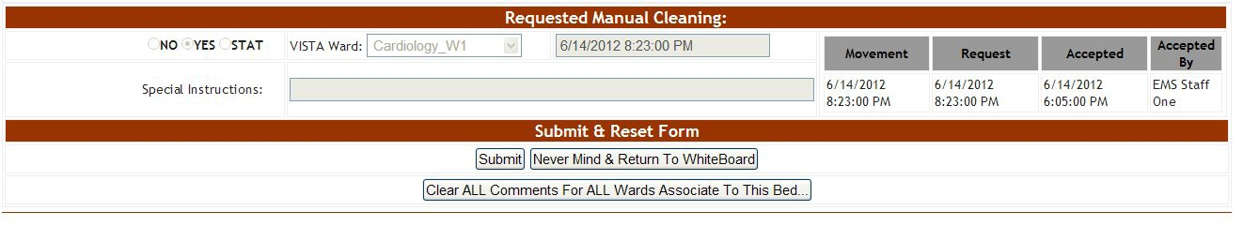

Figure 224 – Request Manual Cleaning Area

All the fields in the Requested Manual Cleaning area are disabled and the fields to the left of the area present the following data:

Movement: the date and time of the movement that generated the request Request: the date and time when the bed clean request was entered in the system.

Accepted: the date and time when the bed clean request has been accepted by the EMS personnel. Accepted by: the name of the EMS user who accepted the request.

NOTE: as long as the bed clean request has not been assigned to an EMS person you can modify the request from STAT to YES or from YES to STAT. Once a bed clean request has been assigned to an EMS person you can no longer modify your selections in this area or create a new bed clean request. A new bed clean request can only be created after the existing bed clean request has been completed.

## EMS Supervisor

The EMS supervisor users can access the following pages:

* EMS Bed Status page
* Environmental Management Service Bed Status page
* Environmental Management Service Bed Status – Batch Assign EMS Staff page.

### Environmental Management Service Bed Status Page

This page is accessed by pressing the button **Go To Facility Bed Cleaning Page (EMS Staff Only)** from the **BMS User Login** page. The **EMS Bed Status** page is displayed as in the following image.

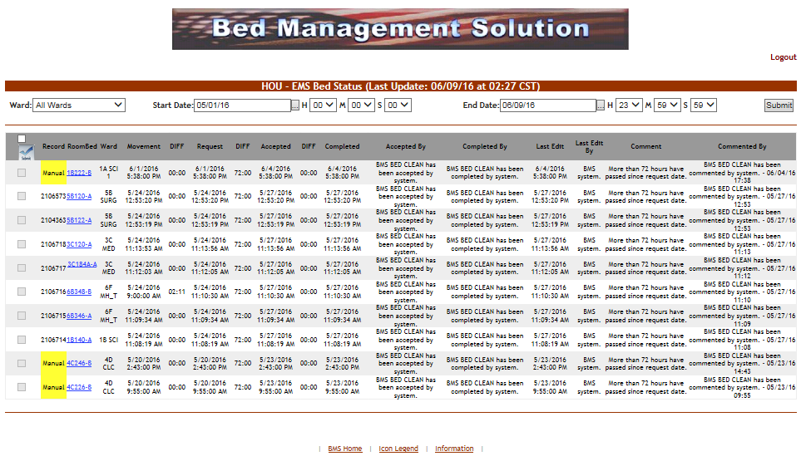

Figure 225 – EMS Bed Status Page

This page allows the EMS supervisor to view the requests for bed clean operations, to filter existing requests by different criteria and to select requests in order to assign them to EMS staff.

In the upper part of the page the filter criteria are available: **Ward** – to filter the bed clean requests by the ward for which they have been requested; **Start Date/Time** and **End Date/Time** – to filter the requests by time interval when they have been requested (the Requested column).

The following data is available for each request in the list:

Table 44 – EMS Bed Status Parameters

| **Column** | **Description** |
| --- | --- |
| Select batch Select batch | Allows the selection of several requests in the list. |
| (selection box) Selection Box | Allows the selection of the entry. |
| Record | For automatic requests, displays the record number of the movement that generated the request.  For manual urgent requests, the “Manual/STAT” is displayed against a red background. For manual requests, the word “Manual” is displayed against a yellow background. |
| RoomBed | Displays the name/code of the bed. |
| Ward | Displays the name of the ward where the bed is. |
| Movement | Displays the date and time of the movement that generated the request. |
| DIFF | The difference between the date and time of the movement and the date and time of the request. |
| Request | The date and time when the cleaning operation was requested. |
| DIFF | The difference between the time when the request for cleaning the bed was sent and the time when the request was accepted. |
| Accepted | The date and time when the request for the cleaning operation has been accepted. |
| DIFF | The difference between the time when the cleaning operation has been accepted and the time when the cleaning operation has been completed. |
| Completed | The date and time when the cleaning operation has been completed. |
| Accepted by | The name of the person who has accepted the request for the cleaning operation. |
| Completed by | The name of the person who has completed the cleaning operation. |
| Last Edit | The date and time when the record was last edited. |
| Last Edit by | The name of the person who last edited the record. |
| Comment | Any comments entered regarding the bed clean operation. |
| Commented by | The name of the person who entered the comment. |

In this page the user can perform the following operations: select a bed clean request in order to assign it, select several bed clean requests in order to assign them and comment a request.

#### 4.3.1.1 Assigning a bed clean request

To assign a bed clean request follow the instructions below.

In the (facility name) **EMS Bed Status** page click the bed code link as in the following image. NOTE: you can only select a request which has not been yet assigned. The selection box of a request

already assigned will be disabled.

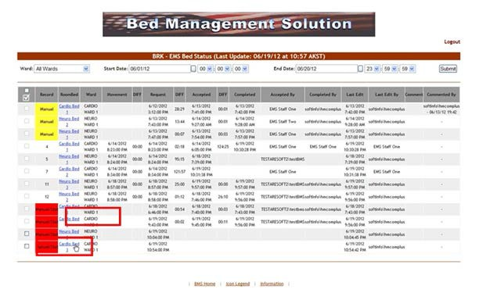

Figure 226 – Select Bed Clean Request for Assignation

Upon selection the following screen is displayed:

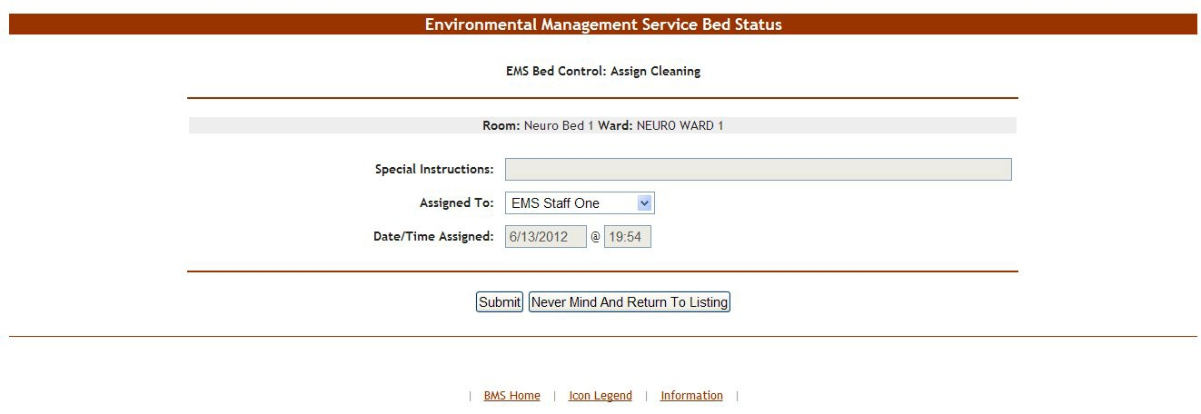

Figure 227 – EMS Bed Status Page – Assign Cleaning

At the top of the screen the name of the current operation is presented: Assign Cleaning. The **Special Instructions** field displays any comments or instructions entered by the person who requested the cleaning. From the **Assign** to field select the EMS person to whom the cleaning operation will be assigned then press the **Submit** button: the EMS Bed Status page will be displayed: the Accepted by column will present the name of the user who has accepted the request. Also, the bed will be displayed in the report “EMS is currently cleaning (x) beds” in the **New Events** screen.

In the **Ward Whiteboard Home** page the “cleaning bed” icon will be displayed next to the bed name as in the following image.

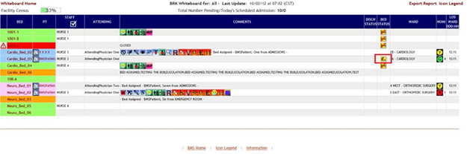

Figure 228 – Ward Whiteboard – Cleaning Bed

#### 4.3.1.2 Assigning a batch of bed clean requests

To assign a batch of bed clean requests follow the instructions below.

In the (facility name) **EMS Bed Status** page click the selection box of all the bed clean requests you want to assign as in the following image.

NOTE: you can only select a request which has not been yet assigned. The selection box of a request already assigned will be disabled.

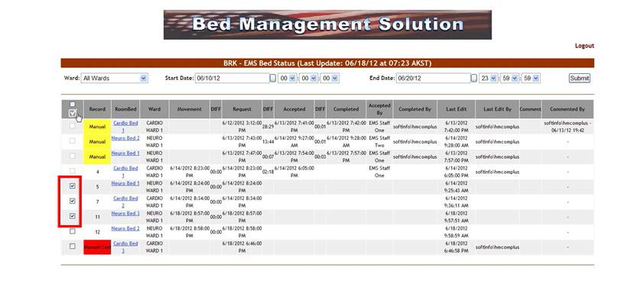

Figure 229 – Select Several Bed Clean Requests

Then click the **Batch Assign EMS staff** button  at the top of the column. Upon selection the following screen is displayed:

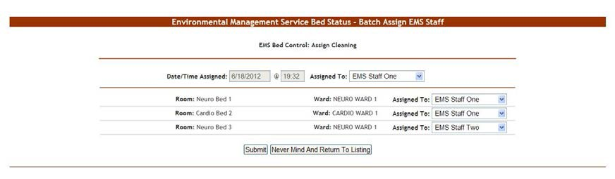

Figure 230 – Assign Several Bed Clean Requests

A list of the selected requests is displayed. You can assign all the requests to the same person or you can assign each request to a different person. Use the arrow button of the **Assigned To**: fields drop down box to display the available personnel. Click the **Submit** button to enter the data into the system.

#### 4.3.1.3 Commenting a bed clean request

To enter comments for a bed clean request follow the instructions below.

In the (facility name) **EMS Bed Status** page click the bed code link as in the following image. NOTE: you can only enter comments for a request which has been assigned.

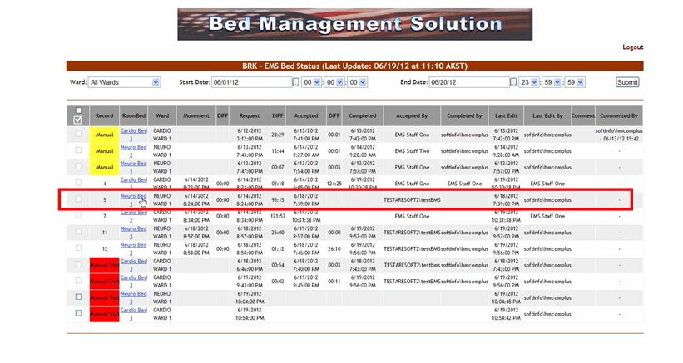

Figure 231 – Select a Bed Clean Request for Comment

Upon selection the following screen is displayed:

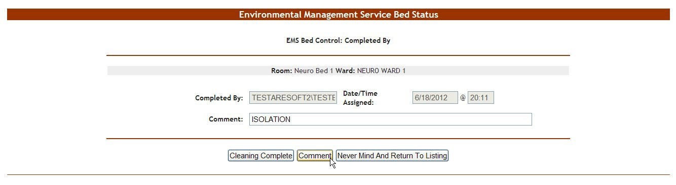

Figure 232 – EMS Bed Status Page – Comment Bed Clean Request

In the **Comment** field enter any relevant comments. Click the **Comment** button save the comment.

## EMS User

The EMS users can access the following pages:

* The (facility name) EMS Bed Status page
* The Environmental Management Service Bed Status page

### Environmental Management Service Bed Status Page

This page is accessed by pressing the button **Go To Facility Bed Cleaning Page (EMS Staff Only)** from the **BMS User Login** page. The **EMS Bed Status** page is displayed as in the following image.

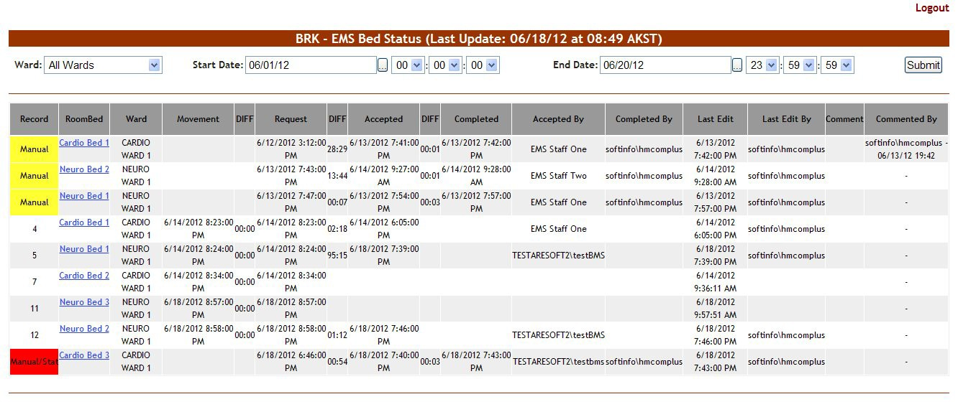

Figure 233 – EMS Bed Status Page – EMS User

This page allows the EMS user to view the requests for bed clean operations, to filter existing requests by different criteria and to select requests in order mark them as completed or to enter comments.

In the upper part of the page the filter criteria are available: **Ward** – to filter the bed clean requests by the ward for which they have been requested; **Start Date/Time** and **End Date/Time** – to filter the requests by the date/time when they have been requested (the Requested column).

The following data is available for each request in the list:

Table 45 – EMS Bed Status Parameters

| **Column** | **Description** |
| --- | --- |
| Record | For automatic requests, displays the record number of the movement that generated the request.  For manual urgent requests the “Manual/STAT” is displayed against a red background. For manual requests the word “Manual” is displayed against a yellow background. |
| RoomBed | Displays the name/code of the bed. |
| Ward | Displays the name of the ward where the bed is. |
| Movement | Displays the date and time of the movement that generated the request. |
| DIFF | The difference between the date and time of the movement and the date and time of the request. |
| Request | The date and time when the cleaning operation was requested. |
| DIFF | The difference between the time when the request for cleaning the bed was sent and the time when the request was accepted. |
| Accepted | The date and time when the request for the cleaning operation has been accepted. |
| DIFF | The difference between the time when the cleaning operation has been accepted and the time when the cleaning operation has been completed. |
| Completed | The date and time when the cleaning operation has been completed. |
| Accepted by | The name of the person who has accepted the request for the cleaning operation. |
| Completed by | The name of the person who has completed the cleaning operation. |
| Last Edit | The date and time when the record was last edited. |
| Last Edit by | The name of the person who last edited the record. |
| Comment | Any comments entered regarding the bedclean operation. |
| Commented by | The name of the person who entered the comment. |

In this page the user can perform the following operations: select a bed clean request(s) in order to mark it as completed and comment a request.

#### 4.4.1.1 Assigning a bed clean request

To assign a bed clean request follow the instructions below.

In the (facility name) **EMS Bed Status** page click the bed code link as in the following image. NOTE: you can only select a request which has not been yet assigned.

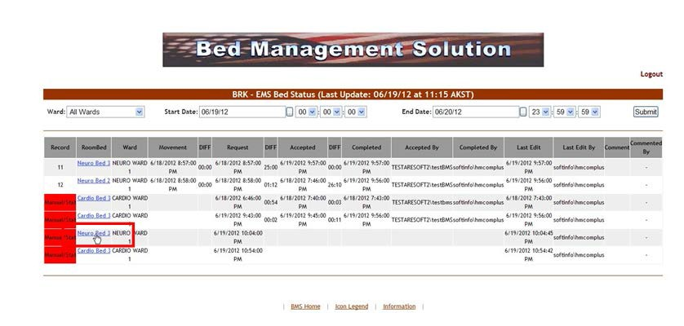

Figure 234 – EMS Bed Status Page – Select Bed Clean Request for Assigning

Upon selection the following screen is displayed:

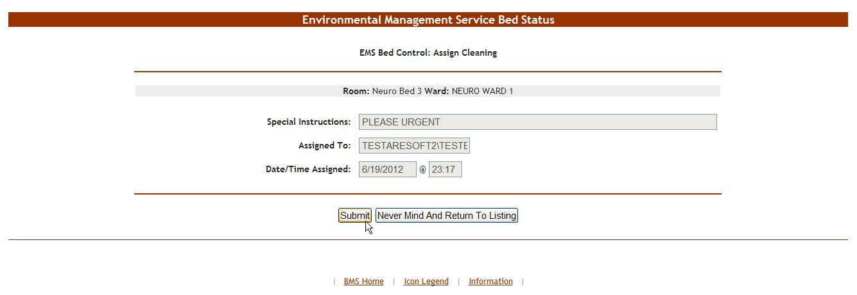

Figure 235 – EMS Bed Status Page – Assign Cleaning

At the top of the screen the name of the current operation is presented: Assign Cleaning.

The **Special Instructions** field displays any comments or instructions entered by the person who requested the cleaning.

The field **Assign to** displays the name of the current EMS user who is assigning a bed request to him/her self.

The **Date/Time Assigned** field displays the current date and time.

Press the **Submit** button: the **EMS Bed Status** page will be displayed: the Accepted by column will present the name of the user who has accepted the request. Also, the bed will be displayed in the report “EMS is currently cleaning (x) beds” in the New Events screen.

In the **Ward Whiteboard Home** page the “cleaning bed” icon will be displayed next to the bed name as in the following image.



Figure 236 – Ward Whiteboard – Cleaning Bed

#### 4.4.1.2 Mark a bed clean request as completed

To mark a bed clean operation as completed follow the instructions below.

In the (facility name) **EMS Bed Status** page click the bed code link as in the following image.

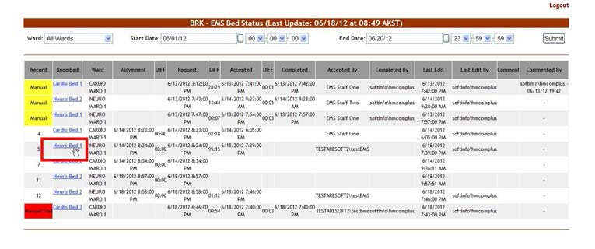

Figure 237 – Select Bed Clean Request to Mark as Completed

Upon selection the following screen is displayed:

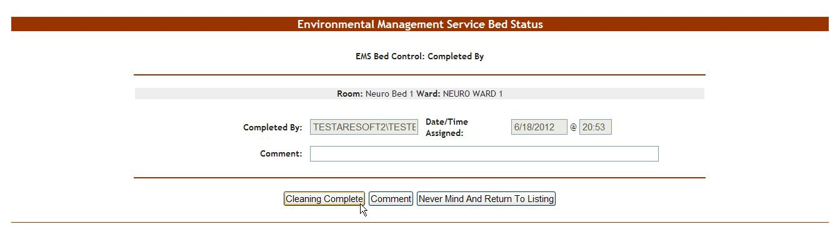

Figure 238 – EMS Bed Status Page – Completed Cleaning

At the top of the screen the name of the current operation is presented: Completed by. Click the **Cleaning Completed** button to mark the bed as “cleaned”.

In the **Ward Whiteboard Home** page the “cleaned” icon will be displayed next to the bed name as in the following image.

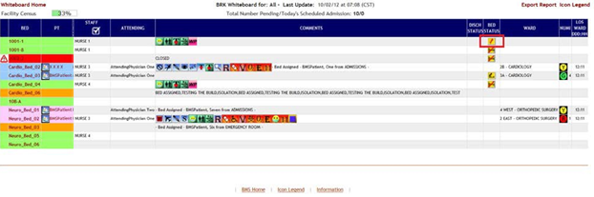

Figure 239 – Ward Whiteboard – Clean Bed

### EMS Staff Page for Mobile Devices

EMS staff can access the BMS Web page for mobile devices at the URL setup by their local IS staff. The URL is setup like this link - [https://vaww.bms.va.gov/EMSMobileLogon?code=BRK.](https://vaww.bms.va.gov/EMSMobileLogon?code=BRK)

The “BRK” is the 3 digit facility code. Make sure you use the code of the facility you want to access. The following page is displayed.

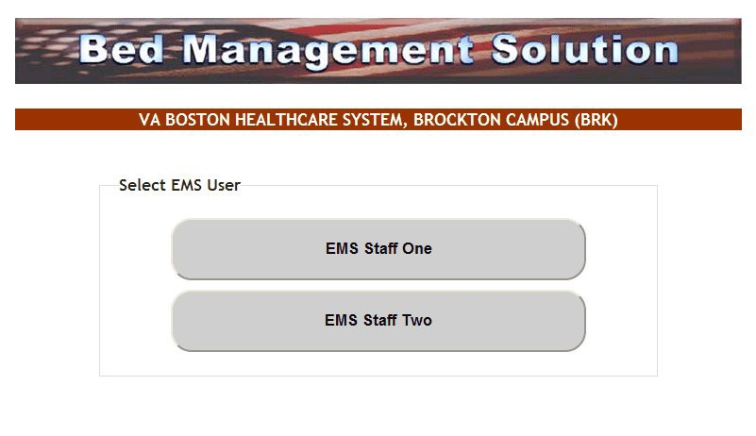

Figure 240 – EMS Staff Page for Mobile Devices

Select the EMS user name: the following page is displayed.

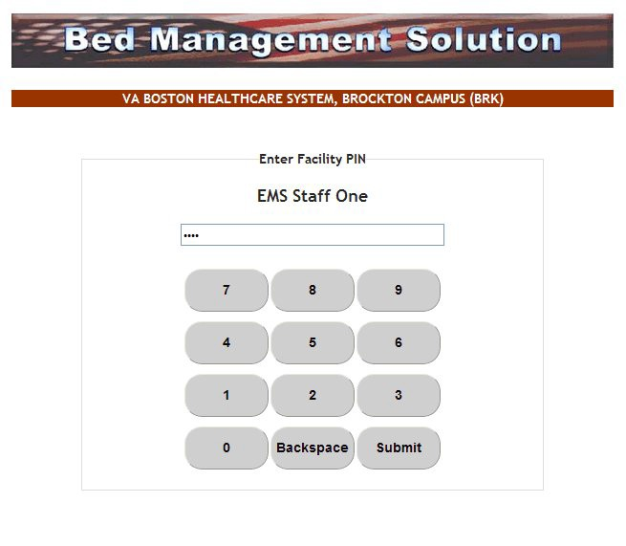

Figure 241 – EMS Staff Page for Mobile Devices – User Login

Enter the PIN associated to your EMS user name then press the **Submit** button: the following page is displayed.

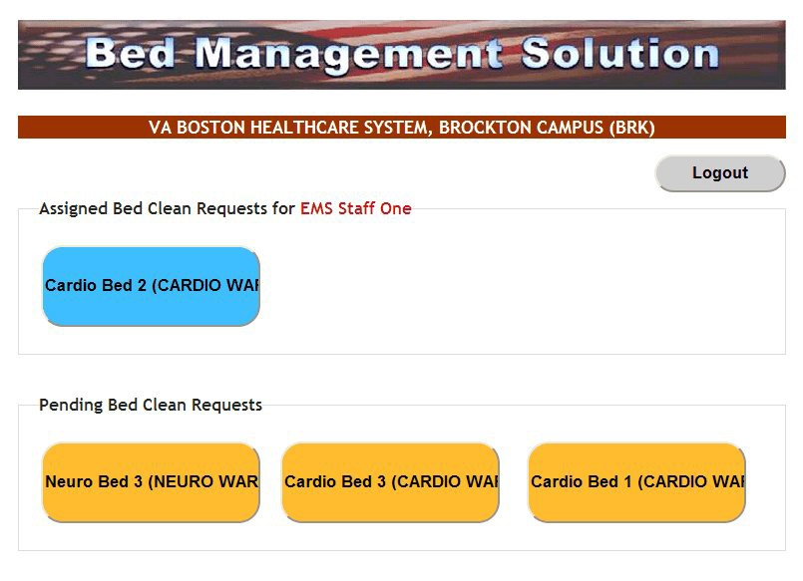

Figure 242 – EMS Staff Page for Mobile Devices – User Home Page

The blue buttons in the upper part of the screen represent bed clean requests which have been assigned to the current EMS user. Clicking a blue button will mark the request as “completed” and will cause the button to disappear.

The yellow buttons in the lower part of the screen represent bed clean requests which have not yet been assigned to any EMS personnel. Clicking a yellow button will assign the pending request to the current user and will cause the yellow button to be displayed as a blue button in the upper part of the screen.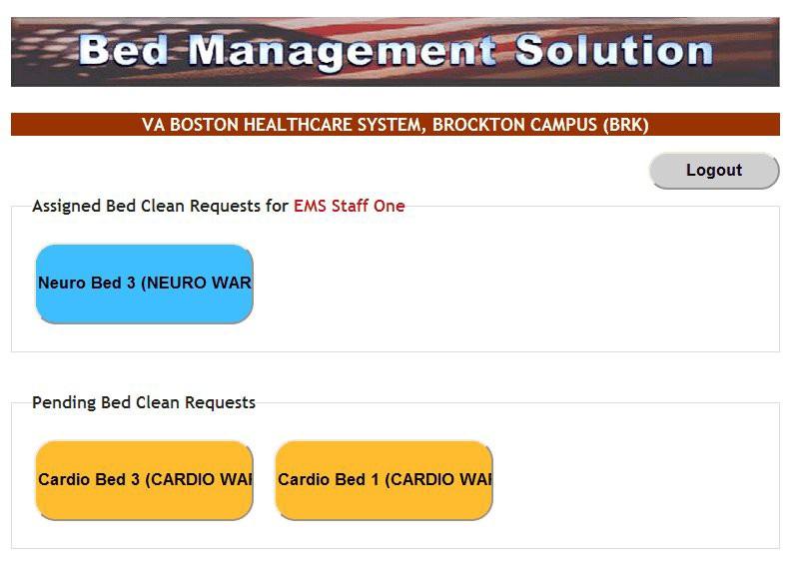

Figure 243 – EMS Staff Page for Mobile Devices – Pending to Assigned

## VISN Users

VISN User can access the **VISN Network Bed Boards** Page.

VISN Users----Please Note: This page allows the user to keep track of Veteran Patients who are currently being treated in community hospitals on Fee Basis or requiring a service that the current facility does not provide or cannot accommodate the patient. In other words, this is a list of patients that could not be admitted to a VA facility or in need of care not available at the facility they currently are admitted.

### VISN Network Bed Boards Page

The **VISN Bed Boards** page is displayed after logging in the BMS system.

From the current facility home page, the VISN Bed Boards page is accessible by clicking the link **Return to VISN Network**.

From the **National/Regional BMS** home page the **VISN Bed Boards** page is accessible by the clicking the corresponding VISN link.

The **VISN Bed Boards** page is displayed as in the following image.

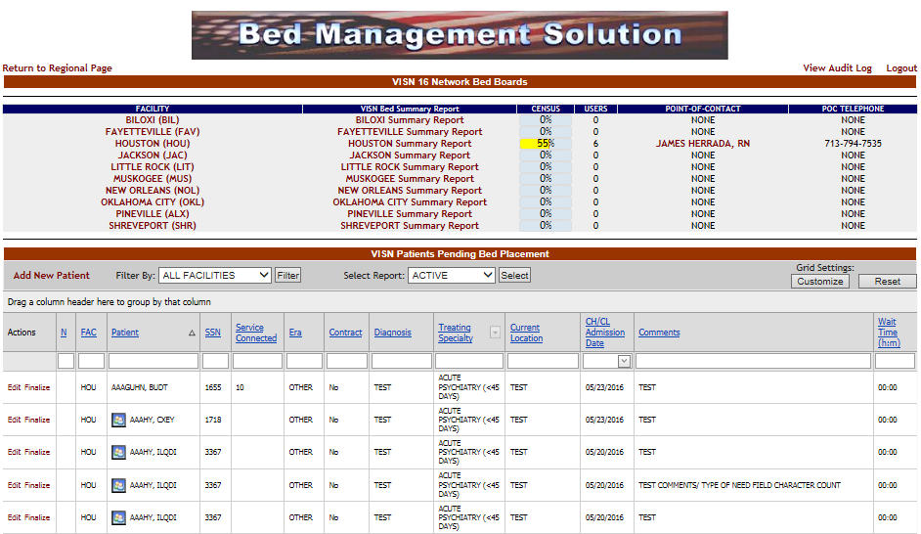

Figure 244 – VISN Bed Boards Page

This page allows the user to keep track of Veteran Patients who are currently being treated in community hospitals on Fee Basis or requiring a service that the current facility does not provide or cannot accommodate the patient. In other words, this is a list of patients that could not be admitted to a VA facility or in need of care not available at the facility they currently are admitted.

The upper part of the page presents a list of VISN facilities. Clicking one of the links in the Facility column will display the corresponding home page of the selected facility.

The VISN Bed Summary Report link (the column title) will generate a bed summary report for all the facilities in the current VISN. (See VISN Bed Summary Report for details). The links in the VISN Bed Summary Report column will display the bed summary report for the corresponding facility.

The **Census** fields display the bed occupancy percentage of the facility. The Users column displays the number of users currently logged on the facility site.

The links in the Point of Contact column will automatically connect to your default email client (such as Outlook for example) and will open an New Message window that can be used to send an email to the corresponding facility. The POC Telephone column displays the telephone number for the facility.

The **View Audit Log** link provides access to the Audit reports, for details on the Audit reports see the section Audit Log Report Page.

The lower part of the page presents the list of patients currently in community hospitals, who are benefitting from VA coverage, and who might be admitted to a VA facility.

At the top of the list, the following filter/order options are available:

**Filter by**: this field allows the user to select the facility for which he/she wants to display the patients pending bed placement.

**Select report:** this drop-down field allows the user to organize the list of Patients in Community Hospitals according to the following criteria:

* + - * Active
      * Contract
      * Date audit
      * Dispositions

For each entry in the list, the following data is available:

Table 46 – Patients Pending Bed Placement - Parameters

|  |  |
| --- | --- |
| **Column** | **Description** |
| N | If the patient is to be included or not in the National Patients Pending Bed Placement list. |
| Facility | The facility associated with the Community Hospital the patient was admitted to. |
| Patient | The patient name. |
| SSN | The social security number of the patient. |
| Service Connected | The patients percent service connected disability (default of NULL, this is an integer % value). |
| Era | The period of service that the patient served. |
| Contract: | Whether or not the VA facility has a contract with the selected community hospital. |
| Diagnosis | The diagnosis for which the patient was admitted to the community hospital. |
| Treating Specialty | The medical specialty dealing with the diagnosis. |
| Current Location | The name of the community hospital where the patient has been admitted. |
| CH/CL (Community Hospital/Current Location) Admission Date | The date when the patient was admitted to the community hospital. |
| Comments | Any relevant info entered by VISN user. |

The **Add New** link allows the VISN user to add a new patient to the list.

The **Edit** link allows the VISN user to modify/update some of the patient data as per communications with community hospital staff.

The **Finalize** link allows the VISN user to finalize the patient’s stay in the community hospital: after being discharged from the community hospital, the patient might be admitted to the VA facility or go home.

### Adding a Patient to the Patients Pending Bed Placement List

From the home page of your facility, click the link **Return to VISN Network** to display the page in the following image.



Figure 245 – Adding a Patient to Patients Pending Bed Placement List

When adding a patient to the VISN Patients Pending Bed Placement list BMS will verify if the patient SSN exists in the system (if the patient is registered in VistA or if of the patient has been admitted before to a VA facility).

In the area VISN Patients Pending Bed Placement, click the **Add New Patient** link: the following page is displayed.

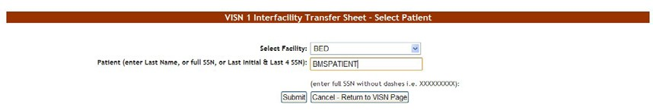

Figure 246 – VISN Interfacility Transfer Sheet – Select Patient

From the **Select Facility** field select the name of the VA facility that the patient is associated with. In the **Patient** field, enter either the patient SSN number or the patient name following the instructions on screen, then press the **Submit** button: the following page is displayed.

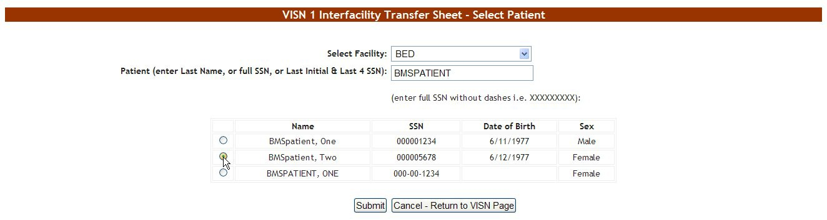

Figure 247 – VISN Interfacility Transfer Sheet – Select Patient from List

If there are several patients in the system with the same name the system presents a list with details of the patients so that you can identify the patient you need.

If the patient SSN is not found in the system a warning is displayed on screen. Press the **Submit** button to register the patient in the system: the following screen is displayed.

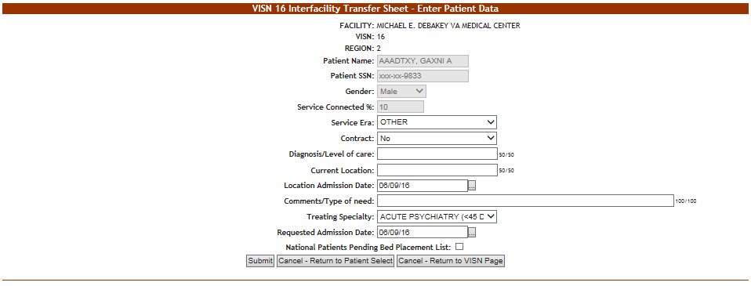

Figure 248 – VISN Interfacility Transfer Sheet – Enter Patient Data

The name of the current facility, the VISN it belongs to, the Region, the patient SSN and full name are displayed.

Enter the following data:

Table 47 – Interfacility Transfer Parameters

| **Field** | **Enter** |
| --- | --- |
| Service Era | The period of service that the patient served. |
| Contract: | Whether or not the VA facility has a contract with the selected community hospital. |
| Diagnosis/Level of care | The diagnosis for which the patient requests admission to the community hospital. |
| Current Location: | The name of the location where the patient is currently being treated |
| Location Admission Date | The date when the patient has been admitted in the selected location. |
| Comments/Type of need | The type of need for which the patient is being transferred to the community hospital. |
| Treating Specialty | The treating specialty corresponding to the type of need. |
| Requested Admission Date | The date when the patient should be able to be admitted to the VA facility. |
| National Patients Pending Bed Placement | If the patient is to be included or not in the National Patients Pending Bed Placement list. |

Click the **Submit** button to enter the data into the system.

A screen is displayed confirming the successful registration of the record in the database.

### Editing the Details of a Patient in the Patients Pending Bed Placement List

To edit the details of a patient from the list Patients Pending Bed Placement click the corresponding **Edit** link: the **VISN Interfacility Transfer Sheet – Select Patient** screen is displayed as in the following image.

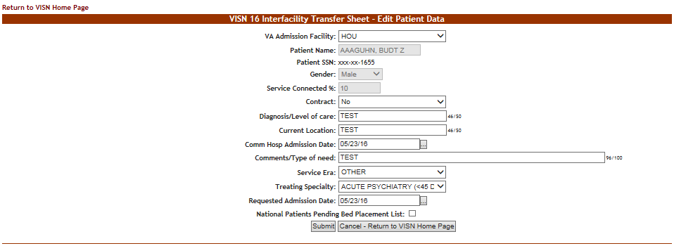

Figure 249 – Editing the Details of a Patient in the VISN Patients Pending Bed Placement List

Modify existing data as necessary then click the Submit button to enter it into the system. A screen is displayed confirming the modification of the record in the database.

### Finalizing a Patient’s Stay in the Community Hospital

To register the end of a patient’s stay in a community hospital, from the list Patients Pending Bed Placement click the corresponding **Finalize** link: the **Finalize Patient Data** page is displayed as in the following image.

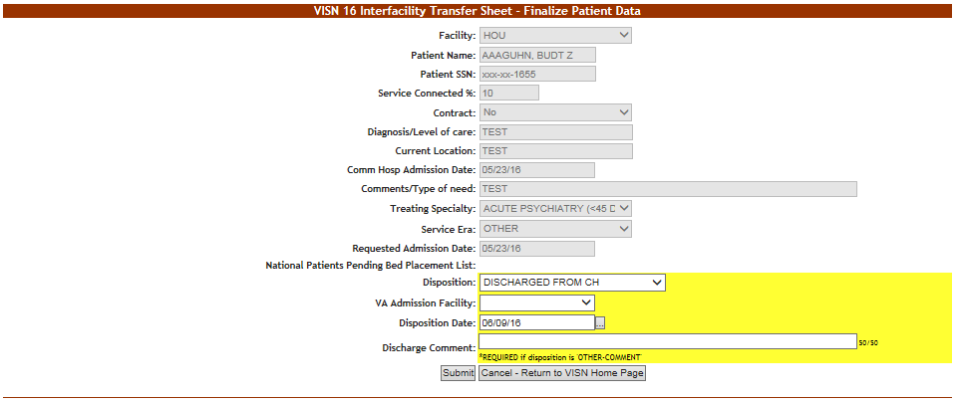

Figure 250 – Finalize a Patient’s Stay in Community Hospital

The following additional fields are available:

**Disposition**: the disposition with which the patient’s stay in the community hospital has ended. The following options are available in this field

* + - 1. VA ADMISSION-MOVE TO SITE
      2. REFUSED VA CARE
      3. EXPIRED
      4. DISCHARGED FROM COMMUNITY HOSPITAL
      5. OTHER-COMMENT

**VA Admission Facility**: from the available options, select the VA facility where the patient will be (re-) admitted.

**Disposition Date**: the current date is displayed, to change it, use the available options.

**Discharge Comment**: the VISN user can enter any comments relevant for the operation. If the option *Other* has been selected from the Disposition field the VISN user will be required to fill in a comment in this field.

A screen is displayed confirming the modification of the record in the database.

When pressing the **Finalize** link attached to a transfer in the VISN Patients Pending Bed Placement list the VISN user registers the end of a patient’s stay in a community hospital and the patient’s name will no longer appear in the list Patients Pending Bed Placement. An admission to a VA facility will follow.

### VISN Bed Boards Reports

In the **VISN Bed Boards** page several reports are available as shown in the image below.



Figure 251 – VISN Bed Boards Page – Summary Reports

The available reports are: VISN Bed Summary Report, the Summary Report corresponding to each facility in the VISN and the reports related to the Patients Pending Bed Placement. Details about these reports are available in the following sections.

#### 4.5.5.1 VISN Bed Summary Report

The VISN Bed Summary Report link (the column title) will generate a bed summary report for all the facilities in the current VISN.

The image below presents an example of a VISN Bed Summary Report

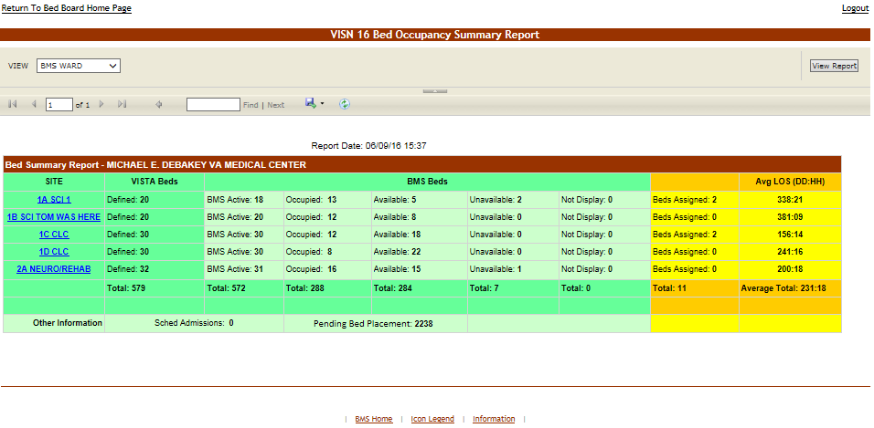

Figure 252 – VISN Bed Boards Page – Summary Reports

For details on the type of data available in this report see the section Bed Summary Report.

#### 4.5.5.2 Facility Bed Summary Report

These reports offer information about the bed occupancy situation in a facility: simply click the link adjacent to the facility name. The report is displayed as in the following image.

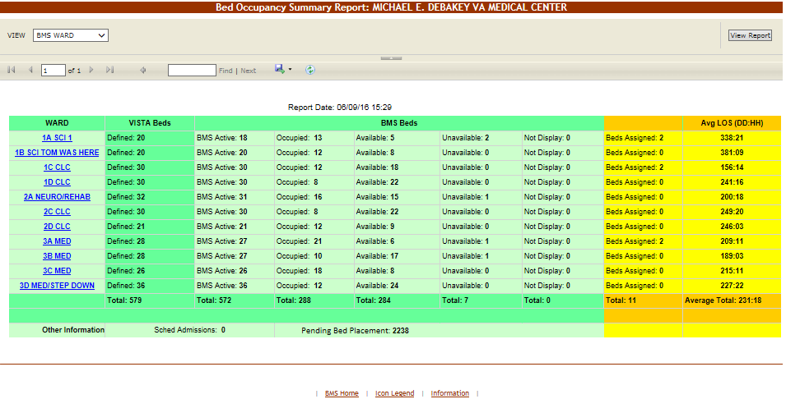

Figure 253 – Bed Occupancy Summary Report

For details on the type of data available in this report see the section Bed Summary Report.

#### 4.5.5.3 Active Patients in Community Hospitals Report

Active in Community Hospitals report presents the list of patients who are currently in Community Hospitals with or without a contract. The image below presents a report of patients in community hospitals according to the active status.

From the **Select Report** field in the VISN Patients Pending Bed Placement area select Active and press the **Submit** button to display the report as in the following image.

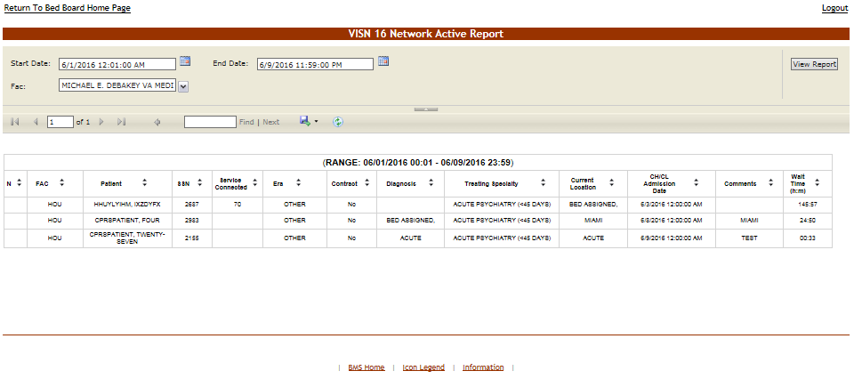

Figure 254 – Patients in Community Hospitals - Active Report

The following data is available for each patient in the report.

Table 48 – Patients in Community Hospitals - Active Report

|  |  |
| --- | --- |
| **Column** | **Description** |
| N(ational) | Indicator of whether the patient is on the National PPBP |
| FAC(ility) | The Facility from the patient has been transferred. |
| Patient | The patient’s first letter of their last name and the 4 digits of their SSN. |
| SSN | The Social Security Number of the patient. |
| Service Connected | The patients percent service connected disability (default of NULL, this is a integer % value) |
| Era | Location/Time period of where/when the patient served. |
| Contract | Whether or not the VA facility has a contract with the selected community hospital. |
| Diagnosis | The diagnosis for which the patient is sent to the community hospital. |
| Community Hospital | The Community Hospital where the patient is currently admitted. |
| CH Adm Date | The date when the patient has been admitted in the Community Hospital. |
| Comments | Comments entered in the Comments field. |
| Disposition | The disposition with which the patient had been added to the pending bed placement list. |

#### 4.5.5.4 Contract Patients in Community Hospitals Report

Contract Report presents the list of patients who are currently in Community Hospitals and/or who have been in the past in Community Hospitals, with or without a contract.

From the **Select Report** field in the VISN Patients Pending Bed Placement area select Contract and press the **Submit** button to display the report as in the following image.

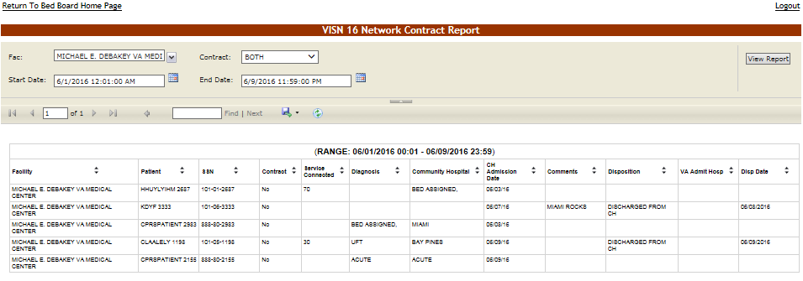

Figure 255 – Patients in Community Hospitals - Contract Report

The following data is available for each patient in the report.

Table 49 – Patients in Community Hospitals - Contract Report

| **Column** | **Description** |
| --- | --- |
| Facility | The Facility from the patient has been transferred. |
| Patient | The patient’s first letter of their last name and the 4 digits of their SSN. |
| SSN | The Social Security Number of the patient. |
| Contract | Whether or not the VA facility has a contract with the selected community hospital. |
| Service Connected | The patients percent service connected disability (default of NULL, this is a integer % value) |
| Diagnosis | The diagnosis for which the patient is sent to the community hospital. |
| Community Hospital | The Community Hospital where the patient is currently admitted. |
| CH Adm Date | The date when the patient has been admitted in the Community Hospital. |
| Comments | Comments entered in the Comments field. |
| Disposition | The disposition with which the patient had been added to the patient pending bed placement list. |
| VA Admit. Hosp. | The VA Hospital where the patient has been admitted. |
| Disp. Date | The date when the disposition was entered. |

#### 4.5.5.5 Patients in Community Hospitals Date Audit Report

The Date Audit Report presents a list of patients who are currently in Community Hospitals and/or who have been in the past in Community Hospitals and the user who has entered this data in the system as well as the date and time when he/she did so.

From the **Select Report** field in the VISN Patients Pending Bed Placement area select Date Audit and press the **Submit** button to display the report as in the following image.

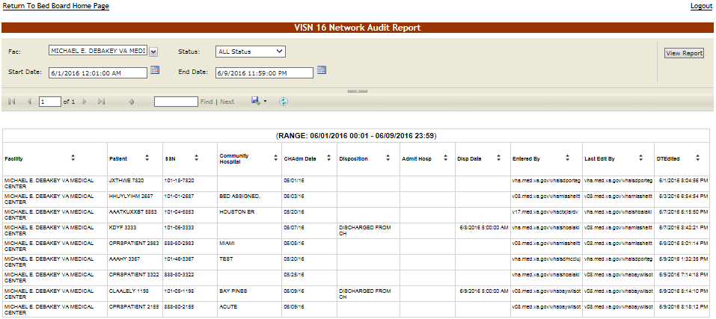

Figure 256 – Patients in Community Hospitals – Date Audit Report

The following data is available for each patient in the report.

Table 50 – Patients in Community Hospitals – Date Audit Report

| **Column** | **Description** |
| --- | --- |
| Facility | The Facility from the patient has been transferred. |
| Patient | The patient’s first letter of their last name and the 4 digits of their SSN. |
| SSN | The Social Security Number of the patient. |
| Community Hospital | The Community Hospital where the patient is currently admitted. |
| CH Adm Date | The date when the patient has been admitted in the Community Hospital. |
| Disposition | The disposition with which the patient had been added to the patient pending bed placement list. |
| Admit. Hosp. | The hospital where the patient has been admitted. |
| Disp. Date | The date when the disposition was entered. |
| Entered by | The name of the user who added the patient to the pending bed placement list. |
| Last Edit by | The name of the user who last edited the entry. |
| DT Edited | The date and time when the entry was last edited. |

#### 4.5.5.6 Disposition Report for Patients in Community Hospitals

Disposition Report presents a list of patients who have been in Community Hospitals and have been discharged and orders them according to the discharge disposition.

From the **Select Report** field in the VISN Patients Pending Bed Placement area select Disposition and press the **Submit** button to display the report as in the following image.

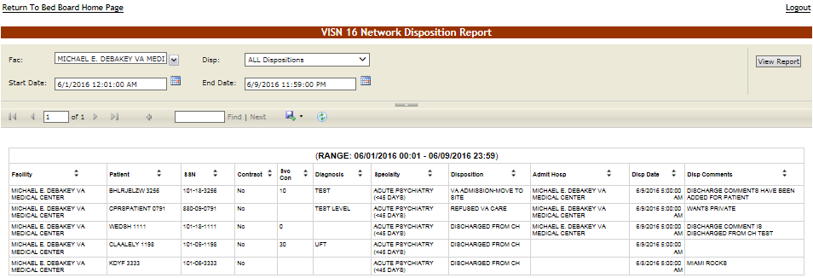

Figure 257 – Patients in Community Hospitals - Disposition Report

The following data is available for each entry in the report:

Table 51 – Patients in Community Hospitals - Disposition Report

| **Column** | **Description** |
| --- | --- |
| Facility | The Facility from the patient has been transferred. |
| Patient | The patient’s first letter of their last name and the 4 digits of their SSN. |
| SSN | The Social Security Number of the patient. |
| Contract | Whether or not the VA facility has a contract with the selected community hospital. |
| Service Connected | The patients percent service connected disability (default of NULL, this is a integer % value) |
| Diagnosis | The diagnosis for which the patient is sent to the community hospital. |
| Specialty | The treating specialty required for the patient’s problem. |
| Disposition | The disposition with which the patient had been added to the patient pending bed placement list. |
| Admit Hosp | The hospital where the patient has been admitted. |
| Disp Date | The date when the disposition was entered. |
| Disp Comments | The comments entered for the selected disposition. |

## VISN Audit Log Reports

VISN Users have access to the Audit Logs as well. They will click the **View Audit Log** link to access the page as in the following image.

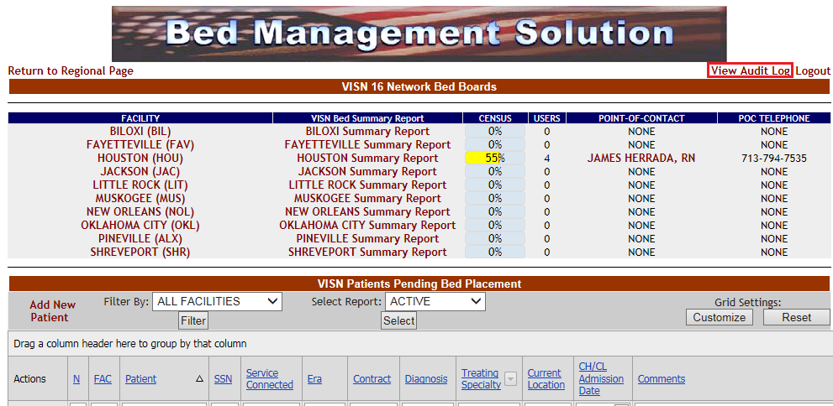

Figure 258.1 – Selecting Audit Log from VISN home page

When the View Audit Log button is clicked, users are presented with the report options available via the “Select Report” parameter as shown in the screenshot below.

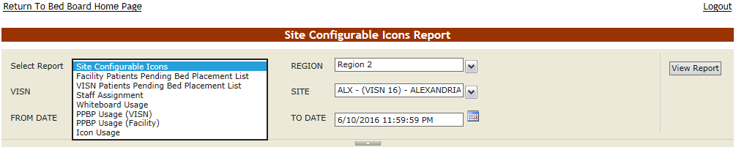

Figure 259.1 – VISN Users – Audit Log Report Types

The reports available from the VISN Audit Log Page follow below.

#### 4.5.6.1 Site Configurable Icons

This report is also present on the Facility->Site Options->Audit Log page shown in section Site Configurable Icons.

#### 4.5.6.2 Facility Patients Pending Bed Placement List Report

This report is also present on the Facility->Site Options->Audit Log page shown in section Facility Patient Pending Bed Placement List

#### 4.5.6.3 VISN Patients Pending Bed Placement List Report

This report is also present on the Facility->Site Options->Audit Log shown in section VISN Patient Pending Bed Placement List Report

#### 4.5.6.4 Staff Assignment Report

This report is also present on the Facility->Site Options->Audit Log page shown in section Staff Assignment

#### 4.5.6.5 Whiteboard Usage Report

This report is also present on the Facility->Site Options->Audit Log page shown in section Whiteboard Usage Report

#### 4.5.6.6 PPBP Usage (VISN)

This report is also present on the Facility->Site Options->Audit Log page shown in section PPBP Usage (VISN) Report.

#### 4.5.6.7 PPBP Usage (Facility)

This report is also present on the Facility->Site Options->Audit Log page shown in section PPBP Usage (Facility) Report

#### 4.5.6.8 Icon Usage

For more information regarding the Icon Usage report, see the section Icon Usage Report.

## Regional Users

Regional users can access the **National/Regional** page displayed as in the following image.

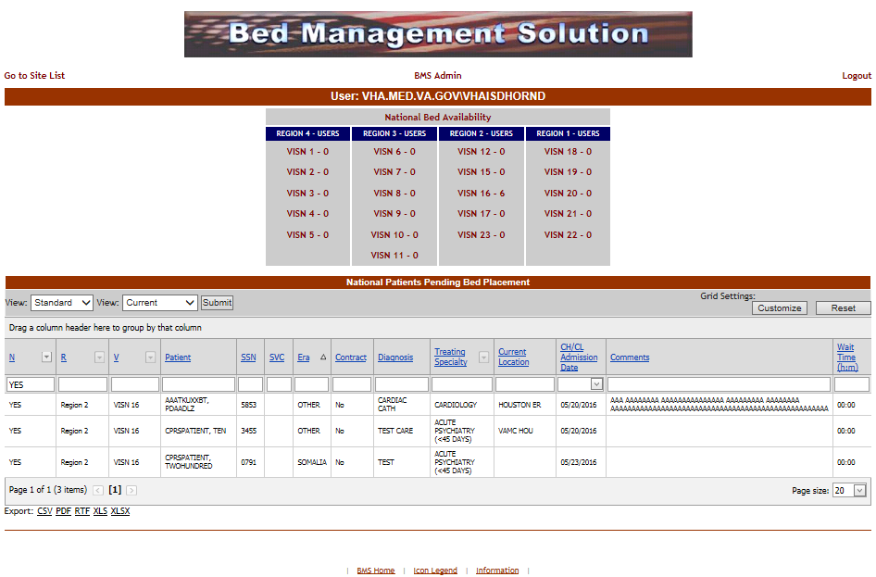

Figure 260 – BMS National/Regional Home Page

The **National Bed Availability** link at the center of the page generates the National Bed Availability Report, for details see the section National Bed Availability Report.

A list of VISN networks grouped by regions is displayed. To display the homepage of a VISN click the corresponding link.

In the lower part of the screen, a list of National Patients Pending Bed Placement List is displayed.

The list can be sorted using the following criteria: REGION, VISN, and TREATING SPECIALTY. The patient list can be filtered by View and waiting time.

For each patient in the list the following data is available:

Table 52 – National Patients Pending Bed Placement - Parameters

| **Column** | **Description** |
| --- | --- |
| N | If the patient was flagged to be included in the National Patients Pending Bed Placement list. |
| R | The region of the facility |
| V | The VISN of the facility |
| Patient | The name of the patient. |
| SSN | The social security number of the patient. |
| SVC | The patients percent service connected disability (default of NULL, this is a integer % value) |
| ERA | The period of service that the patient served. |
| Contract | Whether or not the VA facility has a contract with the selected community hospital. |
| Diagnosis | The diagnosis for which the patient is sent to the community hospital. |
| Treating Specialty | The medical specialty, which treats the selected diagnosis. |
| Current Location | The name of the community hospital where the patient has been admitted. |
| CH/CL Admission Date | The date when the patient has been admitted to the community hospital. |
| Comments | Any relevant information entered by the Regional user. |
| Wait Time | The time lapse between the request and the actual admission of the patient to the community hospital. |

### National Bed Availability Report

In the **National/Regional Page** click the **National Bed Availability** link to display the corresponding report as in the following image.

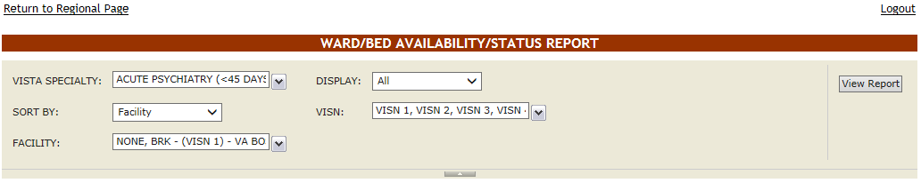

Figure 261 – National Bed Availability Report – Select Criteria

Select the **VistA Specialty**, the **Sort** and **Display** criteria then the **Facilities** and **VISNs** you want to include in the report then press the **View Report** button to display the report as in the following image.

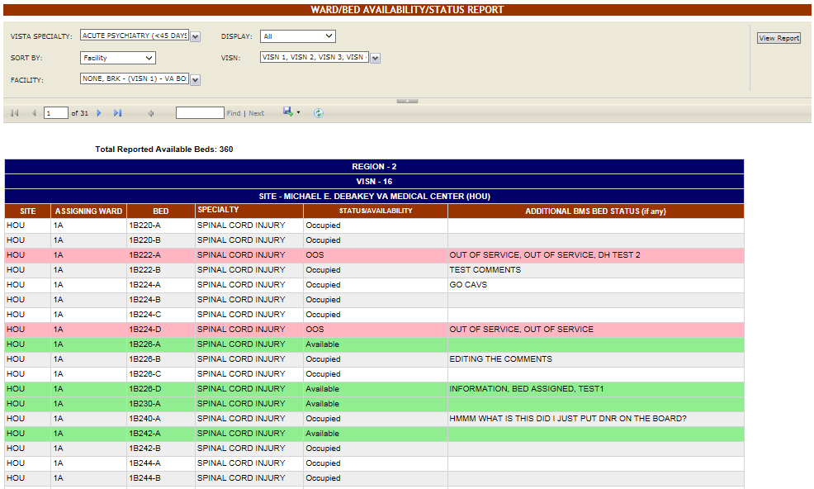

Figure 262 – National Bed Availability

The following data is available for each entry:

Table 53 – National Beds Availability

|  |  |
| --- | --- |
| **Column** | **Description** |
| Site | The code of the facility. |
| Assigning Ward | The ward where the available bed is located. |
| Bed | The code of the available bed. |
| Specialty | The treating specialty. |
| Status/Availability | The status of the bed. |
| Additional BMS Bed Status (if any) | Additional status if defined by the facility site administrator. |

## National Users

National users can access the **National/Regional** page.

See the previous section for details on the **National/Regional** page.

## Guest User

The guest user can only access the **National/Regional** page and the only action he/she can perform is to generate the National Bed Availability report.

For details see the section National Bed Availability Report.

## Support Users

The support users can access the following pages:

* Administration Section page
* Maintain Marquee Text page
* Add/Edit BMS User page
* Edit BMS Facility Settings page
* Edit Sister Sites page
* Add/Edit Icon page
* Common Medical Terms page
* View Audit Log page
* Treating Specialty/NUMA/HAvBED Edit page
* National Waiting Area page
* National Unavailable Reason page
* Background Processors page
* Clear Cache page

### Log in to the Administration Section Page

After logging in the BMS solution use the links **Return to VISN Network** and **Return to Regional Page** (in the upper left corner of the page) to display the National/Regional page as in the following image.

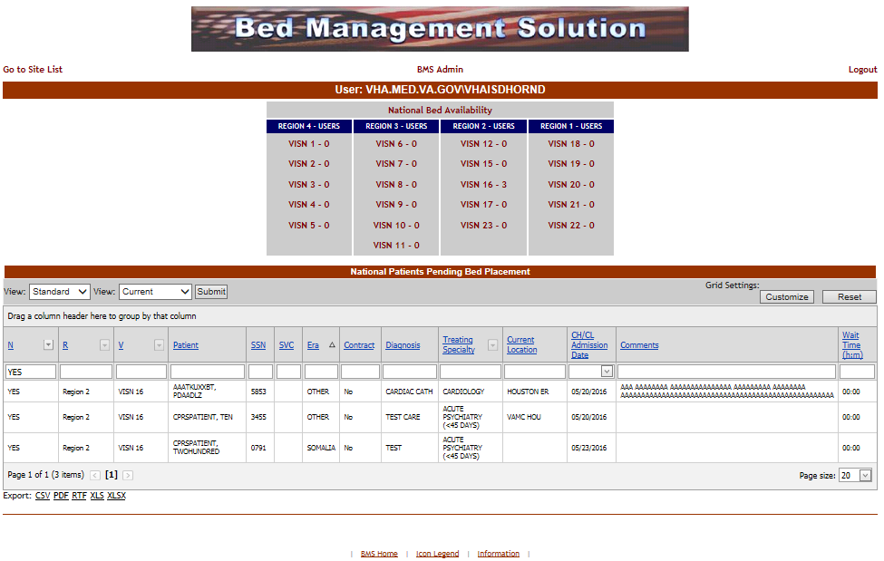

Figure 263 – Accessing Administration Section Page from National/Regional page

Click the **BMS Admin** link to access the Administration Section as in the following image.

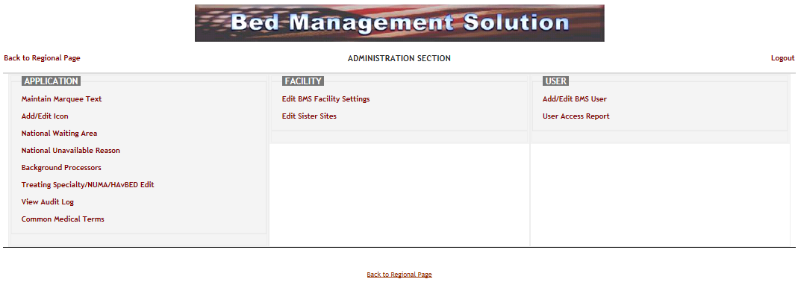

Figure 264 – Administration Section Page

### Maintain Marquee Text Page

In the main **Administration section** page, click the **Maintain Marquee Text** link to access the page in the following image.

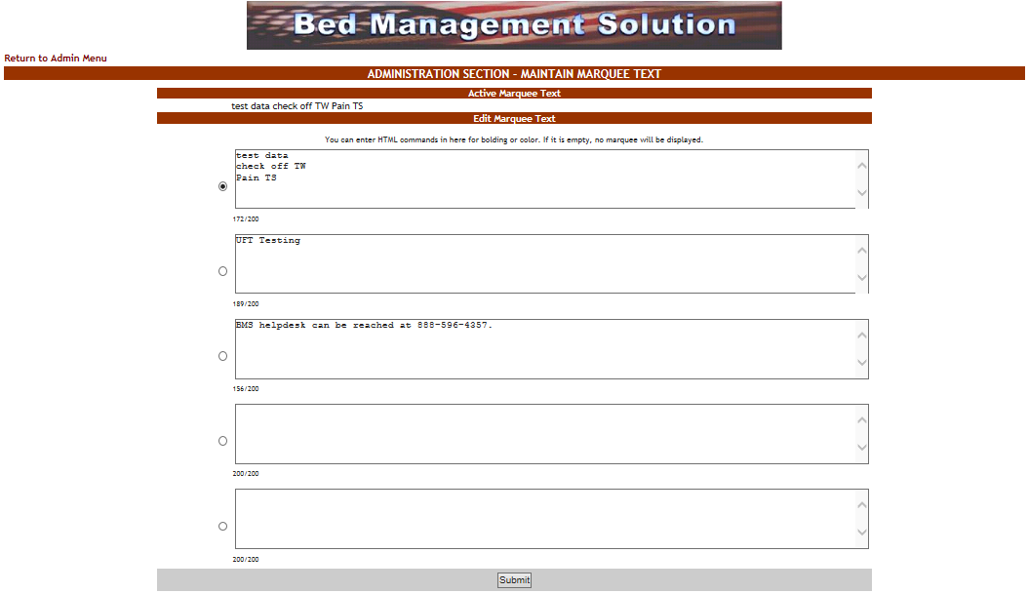

Figure 265 – Add/ Edit Marquee Text

BMS Allows you to maintain 5 different marquee messages. The current marquee text in use is selected by clicking the radio button next to the message text box. Enter the text in any of these 5 fields, select the appropriate marquee message, then press the **Submit** button. You can change this text at any time according to the organization needs.

### Add/Edit BMS User Page

In the main **Administration section** page, click the **Add/Edit BMS User** link to access the page in the following image.

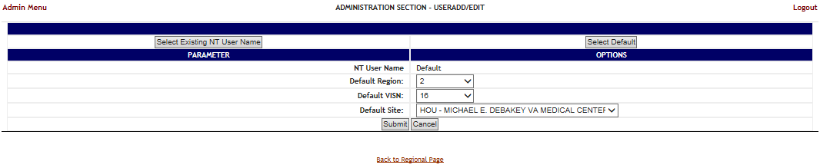

Figure 266 – Administration Section – User Add/Edit Page

In this page the system administrator can add a new user to the list of users who have access to a certain site, also the administrator can edit the rights granted to an existing user.

#### 4.9.3.1 Adding a user

To add a user to one of the existing facility sites: in the **Administration Section – User Add/Edit page** click the button **Select Existing NT User Name**: (the user must have an account in VA’s Active Directory) click this button to display the following screen:

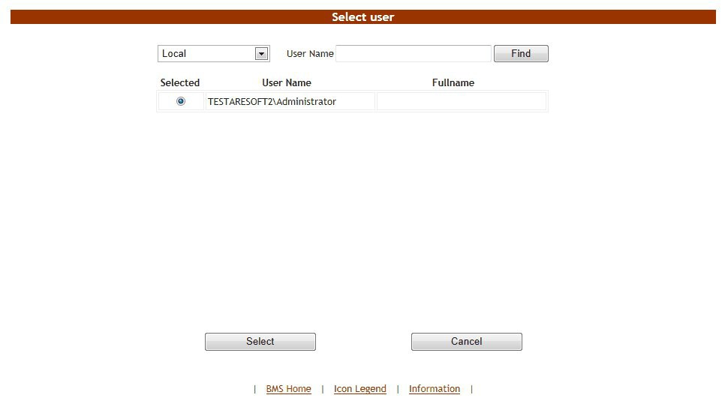

Figure 267 – Select User

From the **Local** field select the domain to which the user currently belongs to. Enter part of the name of the user in the **User Name** field then press the Find button to locate the user.

From the list in the central part of the screen select the user to whom grant access to the BMS system then press the **Select** button: the following screen is displayed.

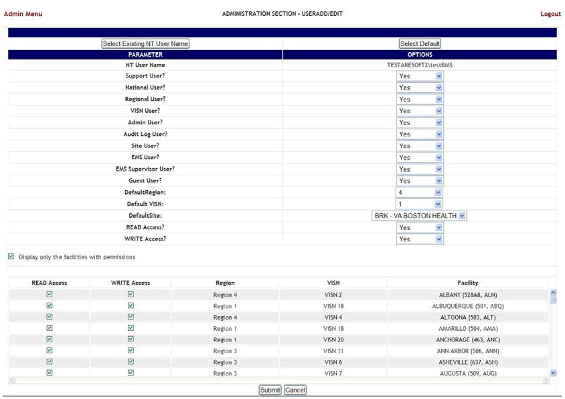

Figure 268 – Customize BMS user rights

The following parameters can be set for a user of the BMS system:

Table 54 – BMS User Parameters

| **Column** | **Description** |
| --- | --- |
| NT User Name: | NT user who will be given access rights to the BMS system. |
| Support User? | If the new user will have to perform support tasks. |
| National User? | If the new user will have access to the national sites. |
| Regional User? | If the new user will have access to the regional sites. |
| VISN User? | If the new user will have access to other VISN sites. |
| Admin User? | If the new user will have access to the Administration section page. |
| Audit Log User? | If the new user will have access to the Audit Log function. |
| Site User? | These are the facility level read and write users. This gives the user access to specific sites. |
| EMS User? | If the new user is part of EMS group. |
| EMS Supervisor User? | If the new user has EMS supervisor rights. |
| Guest User? | If the new user will only have guest user rights. |
| Default Region? | The default region to be displayed when the new user logs into the system. |
| Default VISN? | The default VISN to be displayed when the new user logs into the system. |
| DefaultSite | The default site to be displayed when the new user logs into the system. |
| READ Access | If the selected user has READ rights on the sites in the selected Region/VISN. |
| WRITE Access | If the selected user has WRITE rights on the sites in the selected Region/VISN. |

*Display only the facilities with permissions*: this option is selected by default, to see all the facilities in the system de-select this option.

The list in the lower part of the screen will be updated according to the selections made in the fields in the upper part of the screen. For example if in the **National User** field you selected the option *No*, from the Regional User, the option *Yes* then the list will display only the facilities in the region selected from the field Default Region.

For each facility displayed in the list in the lower part of the screen you can define READ/WRITE Access rights.

After setting the desired parameters for the selected user, click the **Submit** button to enter the data into the system.

#### 4.9.3.2 Editing user rights

To edit the rights granted to a user of a facility site: in the **Administration Section – User Add/Edit** page click the button **Select Existing NT User Name**: click this button to display the following screen:



Figure 269 – Select User

From the **Local** field select the domain to which the user currently belongs to. Enter part of the name of the user in the **User Name** field then press the **Find** button to locate the user.

From the list in the central part of the screen select the user whose access rights you want to edit then press the **Select** button: the following screen is displayed.



Figure 270 – Customize BMS user rights

Make the appropriate changes then press the **Submit** button to enter the data into the system. See Adding a user for details.

#### 4.9.3.3 Deleting a user

To delete the rights granted to a user of a facility site: in the **Administration Section – User Add/Edit** page click the button **Select Existing NT User Name**: click this button to display the following screen:



Figure 271 – Select User

From the **Local** field select the domain to which the user currently belongs to. Enter part of the name of the user in the **User Name** field then press the **Find** button to locate the user.

From the list in the central part of the screen select the user whose access rights you want to delete then press the **Select** button: the following screen is displayed.

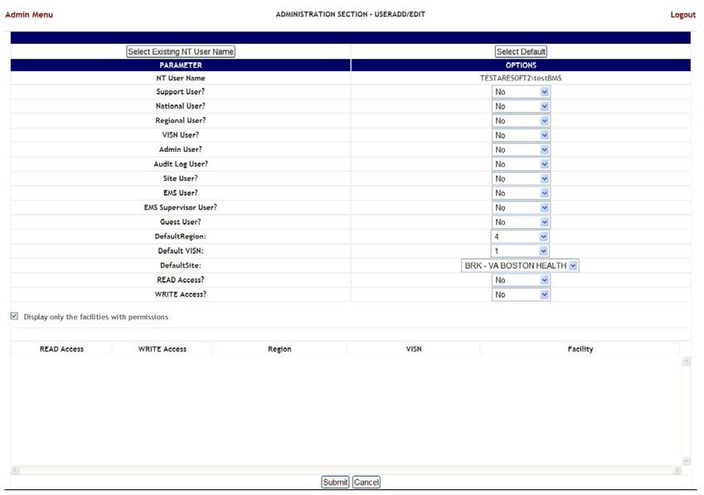

Figure 272 – Customize BMS user rights

Select No for all the parameters then press the **Submit** button.

### Edit BMS Facility Settings Page

In the main **Administration section** page, click the **Edit BMS Facility Settings** link to access the page in the following image.

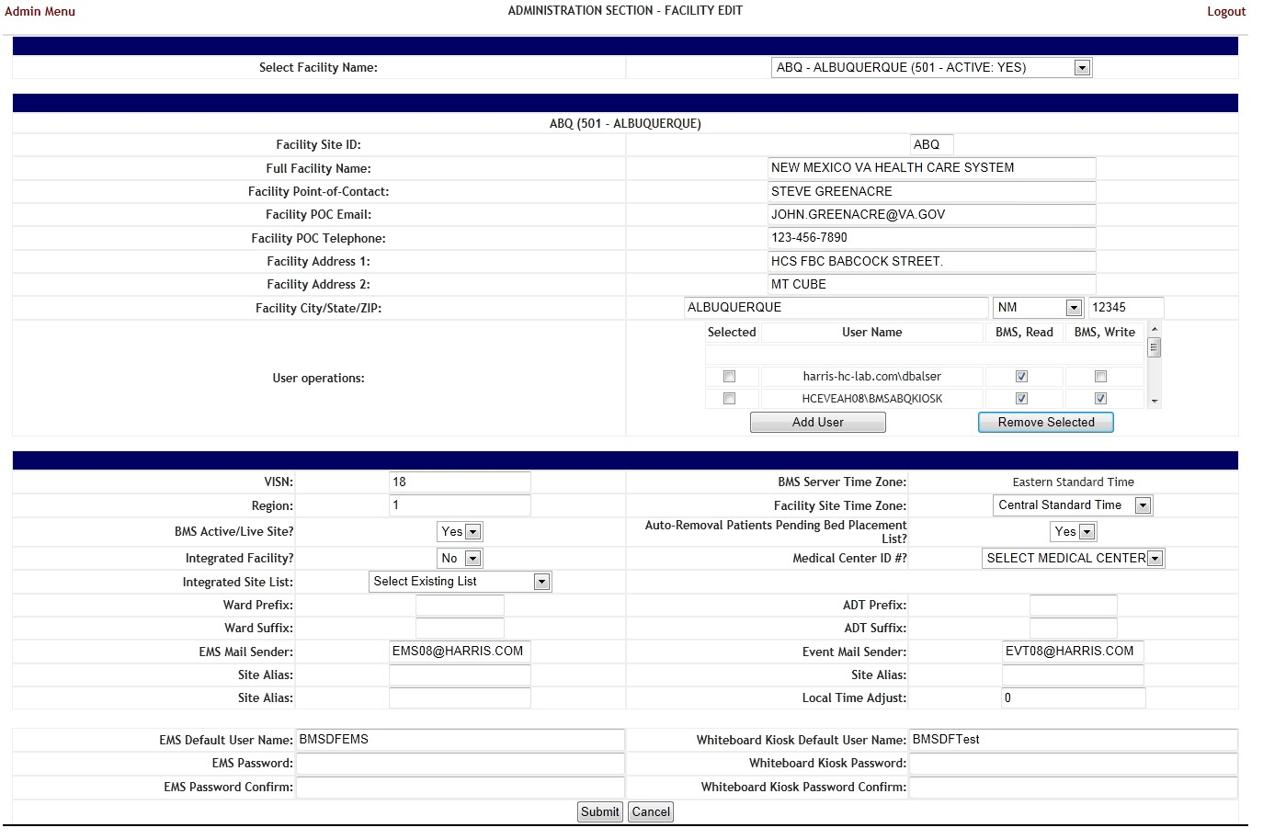

Figure 273 – Edit BMS Site

In this page the user can edit the settings of a BMS facility site.

Select **Facility Name**: click the arrow button of this field to display a list of existing facilities. The following parameters can be set for a Facility in the BMS system:

Table 55 – BMS Site Parameters

| **Column** | **Description** |
| --- | --- |
| Facility Site ID | A unique ID number assigned to each facility. |
| Full Facility Name | The full name of the facility. |
| Facility Point-of-Contact: | The facility point of contact, this can be the triage room, or the front desk. |
| Facility POC email: | The email for the point of contact with the facility. |
| Facility POC Telephone: | The telephone of the point of contact. |
| Facility Address 1: | The main address of the facility. |
| Facility Address 2: | If applicable, any secondary address of the facility. |
| Facility City/State/ZIP: | The ZIP code, city, and state where the facility is. |
| User Operations | The users who can access the facility site and the read/write permissions granted to these users. |
| VISN | The VISN to which the facility belongs. |
| Region: | The region to which the facility belongs. |
| BMS Active/Live Site? | If the site is active for use in BMS. |
| Integrated Facility? | If the facility has an integrated VistA instance? |
| Integrated Site List: | This is the list of integrated sites that are sharing the same VistA instance. |
| Ward Prefix | The prefix used for the wards in the current integrated facility. |
| Ward Suffix | The suffix used for the wards in the current integrated facility. |
| EMS Mail Sender | This is the “FROM “ user/group used to send EMS emails via the SMTP server |
| Site Alias | This is the alternate 3-char identifier for a site that may be used instead of its own, i.e. West Las Angeles (WLA) is an Alias for Greater Las Angeles (GLA), both names are the same site, and users could possibly log in as VHAGLAxxxxx or VHAWLAxxxxx. |
| EMS Default User Name: | The BMS Service Account ID needed to load the EMS Mobile Page for Mobile Devices. |
| EMS Password: | The BMS Service Account ID password needed to load the EMS Mobile Page for Mobile Devices. |
| EMS Password confirm: | The confirmation of the password. |
| Whiteboard Kiosk Default User Name: | The BMS Service Account ID needed to load the Whiteboard URL in Kiosk Mode. |
| Whiteboard Kiosk Password: | The BMS Service Account ID password needed to load the Whiteboard URL in Kiosk Mode. |
| Whiteboard Kiosk Password confirm: | The confirmation of the password. |
| BMS Server Time Zone | The time zone of the BMS server. |
| Facility Site Time Zone | The time zone of the facility. |
| Auto-Removal Pending Bed Placement List? | If patients in the list Patients at the facility level are automatically removed from the Pending Bed Placement List when they are assigned a Room/Bed. |
| Medical Center ID#? | The ID # of the medical center. |
| Allowed Access – Integrated Sites (All users can see these sites also) | The list of integrated sites is displayed; select the sites where the users of the current facility have access. |
| ADT Prefix: | This is the unique identifier that is the leading part of the ADT (Admission/Discharge/Transfer Orderable Item) and is used to filter the list of ADT OIs that will be displayed, i.e. “BO” for Boston. |
| ADT Suffix: | This is the unique identifier that is the trailing part of the ADT (Admission/Discharge/Transfer Orderable Item) and is used to filter the list of ADT OIs that will be displayed, i.e. “-BO“ for Boston. |
| Event Mail Sender: | This is the “FROM” user/group used to send Event emails via the SMTP server. |
| Site Alias: | This is the alternate 3-char identifier for a site that may be used instead of its own, i.e. West Las Angeles (WLA) is an Alias for Greater Las Angeles (GLA), both names are the same site, and users could possibly log in as VHAGLAxxxxx or VHAWLAxxxxx. |
| Local Time Adjust: | .The difference between the local time and the server time. |

After setting the desired parameters for the selected user, click the **Submit** button to enter the data into the system.

### Edit Sister Sites Page

In the main **Administration Section** page, click the **Edit Sister Sites** link to access the page in the following image.

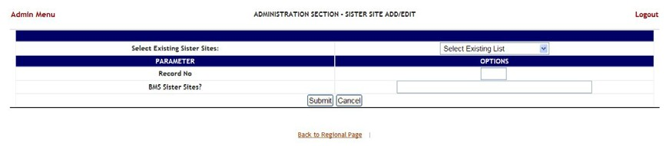

Figure 274 – Edit BMS Sister Sites

In this page the user can define a list of sister sites or can edit one of the existing sister sites lists.

#### 4.9.5.1 Adding a Sister Sites List

In the **Administration Section – Sister Site Add/Edit** page: to define a list of sister sites enter a **Record No** then in the **BMS Sister Sites?** field, enter the abbreviation of the sites sharing the same VistA instance, separated by coma. Press the **Submit** button to enter the data into the system: the defined list will be available in the dropdown field **Select Existing Sister Sites**.

The following parameters can be set:

Table 56 – BMS Sister Site Parameters

|  |  |
| --- | --- |
| **Column** | **Description** |
| Record No | Unique record number for the particular record. |
| BMS Sister Sites? | This is the list of sister sites that are sharing the same VistA instance. |

After setting the desired parameters, click the **Submit** button to enter the data into the system.

#### 4.9.5.2 Editing a Sister Sites List

In the **Administration Section – Sister Site Add/Edit** page: to edit an existing list of sister sites click the arrow button of the field **Select Existing Sister Sites** to display existing sister sites lists and select the one for which you want to modify parameters. The **BMS Sister Sites?** field will display the list of abbreviations for the sister sites in the list: add or remove the desired abbreviation(s) then click the **Submit** button.

### Add/Edit Icon Page

In the main **Administration Section** page, click the **Add/Edit Icon** link to access the page in the following image.

**Note:** Users are discouraged from using the words DNR/DNI in the comment of the Ward Whiteboard or using any icon to represent DNR/DNI on the Ward Whiteboard.

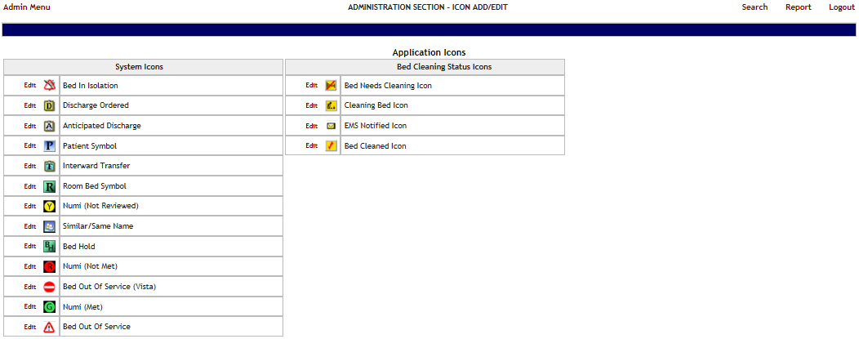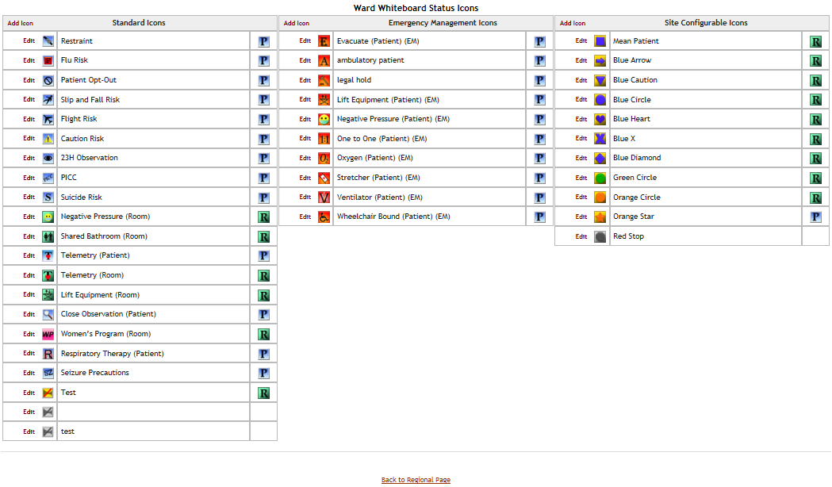

Figure 275 – Administration Section – Icon Add/Edit

The following icon types are available: Application icons (System icons and Bed Cleaning Status icons), Ward Whiteboard Status Icons (Standard icons, Emergency Management Icons and Site Configurable icons).

In this page the user can perform the following actions: modify the position of an icon in any of the icon lists available, edit the details of an icon in any of the icons list, add an icon to one of the existing icon lists, search for an icon, generate a report on the icon usage within a facility site.

#### 4.9.6.1 Modifying the position of an icon in the icon list

To modify the position of an icon in the list simply click and drag the icon to it’s appropriate position.

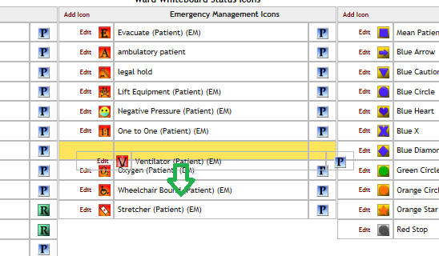

Figure 276 – Administration Section – Change Icon Position in the Icon List

#### 4.9.6.2 Editing the details of an icon in the icon list

To edit the details of an icon in the list click the Edit link to the left of the icon image: the following page is displayed.

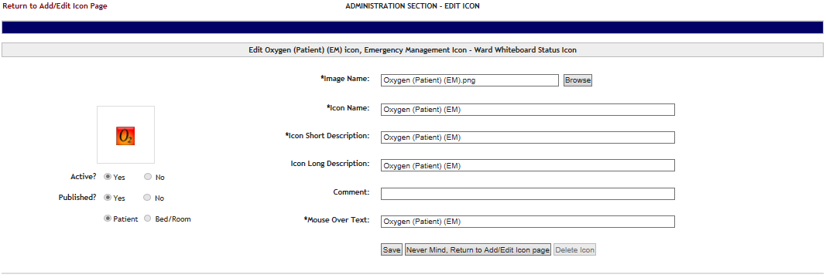

Figure 277 – Administration Section – Edit Icon

To select another image for the icon click the **Browse** button of the **Image Name** field then, locate the file containing the new image and select it. Make the desired changes in the rest of the fields then press the Save button to apply the changes. The fields marked with the asterisk sign “*” are mandatory.

#### 4.9.6.3 Adding an icon to the icon list

To add an icon to an icon list click the **Add Icon** link in the top left corner of an icon list: the following page is displayed.

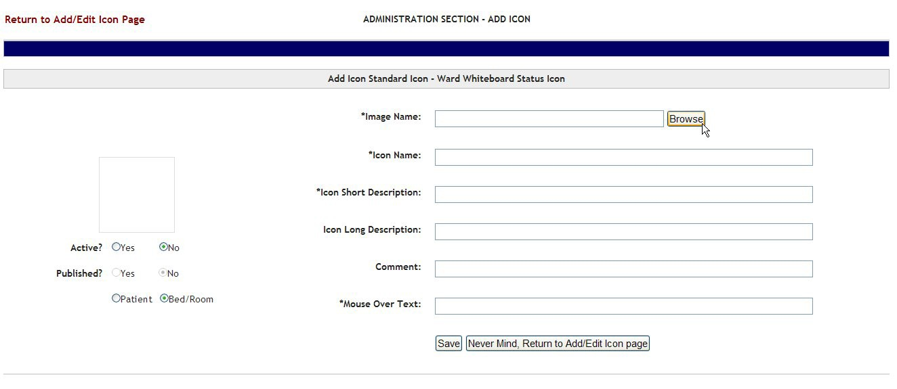

Figure 278 – Administration Section – Add Icon

Click the **Browse** button to locate the file containing the icon image and select it.

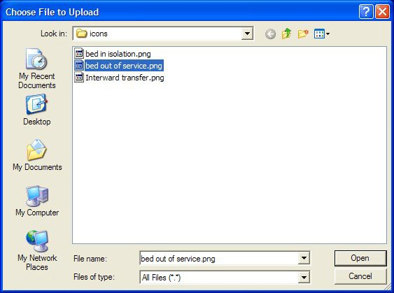

Figure 279 – Selecting an Icon Image File

After selecting the file a preview of the selected icon image will be displayed to the left of the screen. Active: if an icon is not active it will appear grayed in the icon list.

NOTE: once an icon has been used to flag a patient or a bed, it cannot be inactivated. In order to be able to make the icon inactive the user will have to remove the icon from Whiteboard where it has been used. Use the **Search** link in the upper right corner of the **Administration Section – Icon Add/Edit** page to locate the facility site where an icon has been used. For details see the section Searching an icon.

**Published**: if an icon is not published it will not appear in the facility **Bed Management Board Icons** page or in the **Site Configurable Icons** page.

**Patient/Bed/Room**: this option indicates whether the icon is used to flag a patient or a room/bed.

Enter the required information in the fields marked with the asterisk sign“*”: the fields marked with the asterisk sign “*” are mandatory. (The fields will only be mandatory if the icon is active.)

Press the Save button to add the new icon the icon list.

#### 4.9.6.4 Searching an Icon

To search an icon click the **Search** link to the top right corner of the **Administration Section – Add/Edit page**: the following screen is displayed.

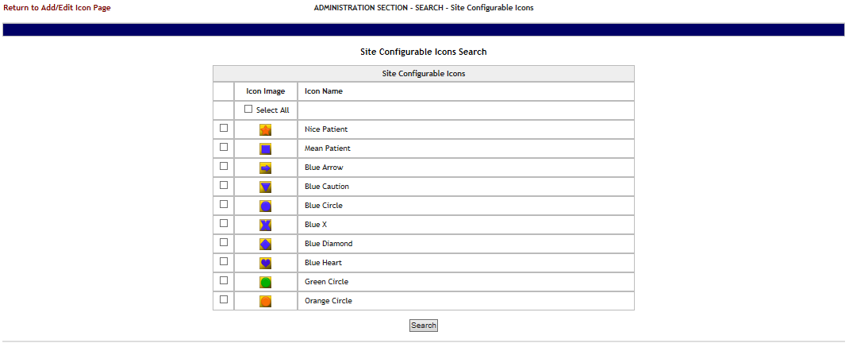

Figure 280 – Administration Section – Icon Search

Select the icon(s) which you want to locate then press the Search button to display the page with the search results as in the following image.



Figure 281 – Site Configurable Icon Search Result

The search results will present the code of the facility where the icon is used, the icon name and the description given to the icon on the facility site.

#### 4.9.6.5 Generating an icon usage report

To generate an icon usage report click the **Report** link to the top right corner of the **Administration Section – Add/Edit** page: the following screen is displayed.

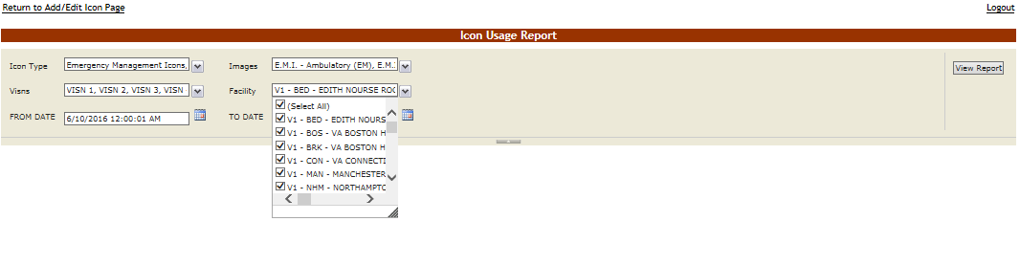

Figure 282 – Administration Section – Icon Usage Report

By default, Icon Type, Images, and VISNs have all options selected, but can be changed by selecting the drop-down. Use the drop-down for Facility to select for which facility or facilities and the date range you want to generate the Icon Usage report, then press the **View Report** button. The report is displayed as in the following image.

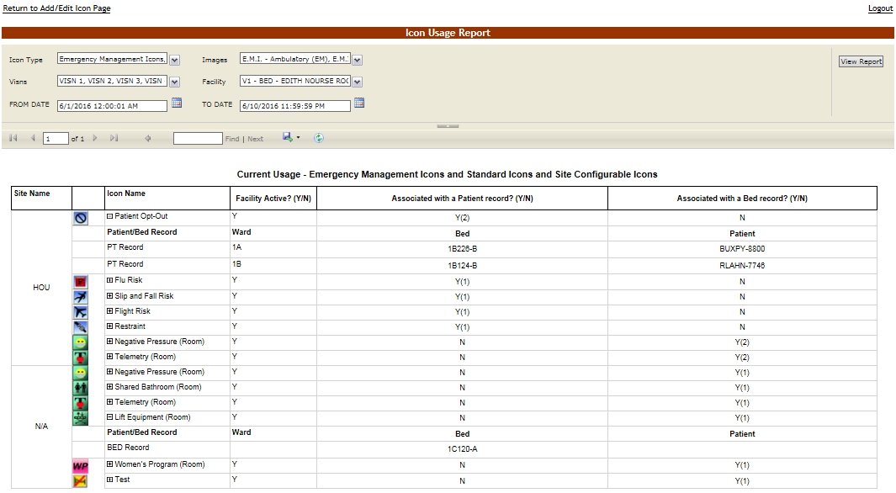

Figure 283 – Administration Section – Icon Usage Report

Icon Usage Report Drill-Down feature.

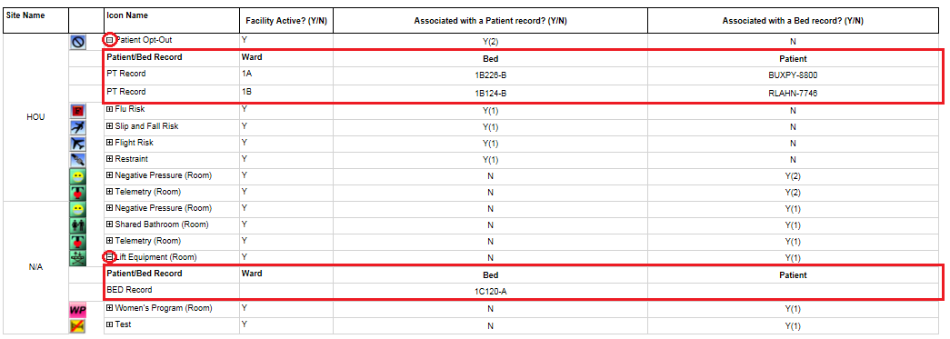

Figure 284.1 – Administration Section – Icon Usage Report Drill-Down Feature

Also note that this report is a drill-down report, in which the rows can be collapsed/expanded to drill into the individual patient or bed records that have had the icon associated with it within the date range selected.

For each entry the following data is available:

Table 57 – Icon Usage Report

| **Column** | **Description** |
| --- | --- |
| Site Name | The Facility site where the icon has been used. |
| Icon Short Description for Facility | The short description of the icon. |
| Icon Name | The icon name. |
| Facility Active? (Y/N) | If the icon is active on the facility site. |
| Associated with a Patient Record? (Y/N) | If the icon is currently associated with a patient record. |
| Associated with a bed record? (Y/N) | If the icon is currently associated with a bed record. |
| **Drill-Down Columns** | **These additional columns are revealed once you “drill-into” the appropriate record.** |
| Patient/Bed Record | Indicator of whether the record is a P(atien)T record or a BED record |
| Ward | The name of the ward for the PT/BED that the icon is associated to. |
| Bed | The name of the bed the icon is associated to. |
| Patient | The name of the patient the icon is associated to. |

### Common Medical Terms Page

In the **Administration Section** page click the **Common Medical Terms** link to access the page as in the following image.

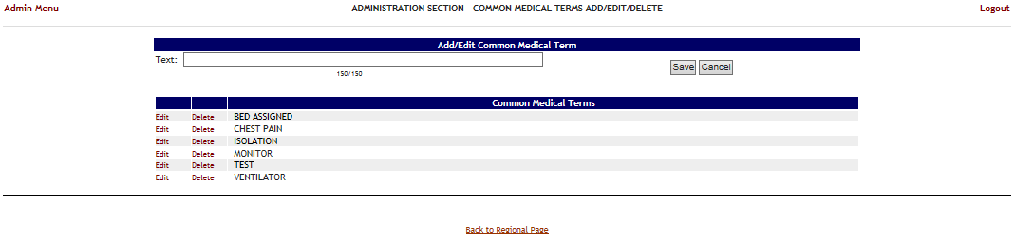

Figure 285 – Administration Section – Common Medical Terms Add/Edit/Delete

This page is used to define a series of common medical terms or comments used frequently by the medical personnel when entering data into the application. After this list of common medical terms has been defined, when the user types in a field the first letters of a word the application will present a list of common medical terms than can be used to fill in that field.

In this page you can perform the following actions: add a common medical term, edit an existing common medical term and delete an existing common medical term.

#### 4.9.7.1 Adding a Common Medical Term

To add a common medical term: in the Common Medical Terms Add/Edit/Delete page enter the text of the term in the Text field then press the **Save** button. The new common medical term will be displayed in the **Common Medical Terms** list.

#### 4.9.7.2 Editing a Common Medical Term

To edit an existing common medical term: in the **Common Medical Terms Add/Edit/Delete** page click the **Edit** link to the left of the common medical term you want to edit. The text of the selected common medical term will be displayed in the Text field as in the following image:

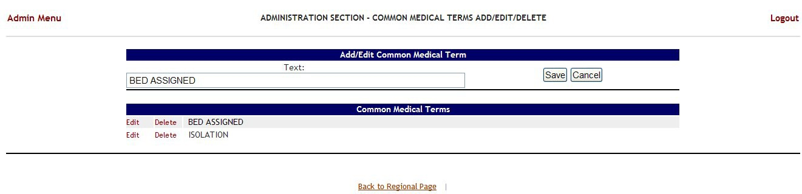

Figure 286 – Administration Section – Common Medical Terms Add/Edit/Delete

Modify the text of the term then press the **Save** button: the new text of the term will be displayed in the **Common Medical Terms** list.

#### 4.9.7.3 Deleting a Common Medical Term

To delete an common medical term: in the **Common Medical Terms Add/Edit/Delete** page click the **Delete** link to the left of the common medical term you want to delete. The **Common Medical Terms** list will be updated to reflect the change.

### View Audit Log Page - Support

In the **Administration Section** page click the **View Audit Log** link to access the page as in the following image.

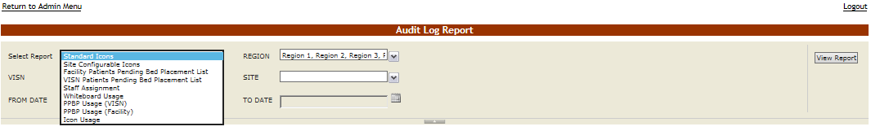

Figure 287 – Administration Section – Audit Log Report Types

The reports available from the National Admin Audit Log Page follow below.

#### 4.9.8.1 Standard Icons

This is a report of the standard icons modified for the specified Region, VISN, Site, and Date Range.

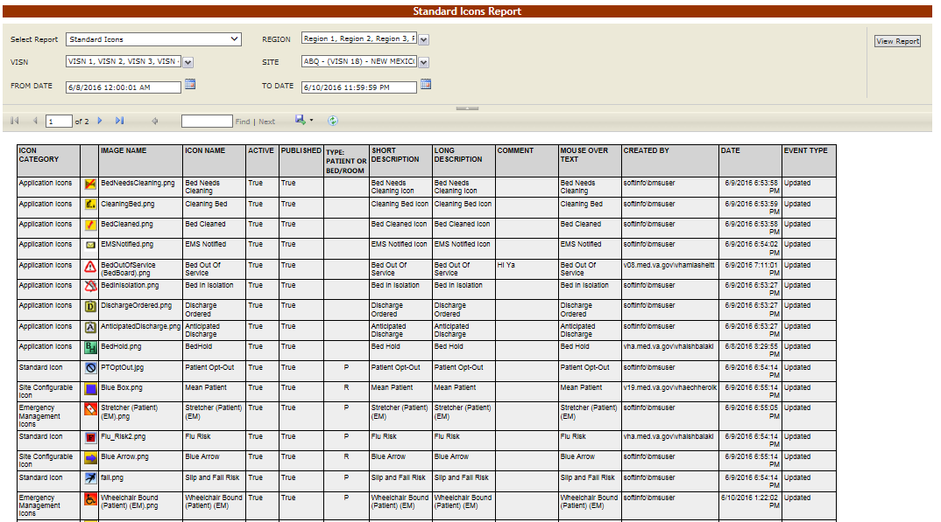

Figure 288.1– Standard Icons

#### 4.9.8.2 Site Configurable Icons

This report is also present on the Facility->Site Options->Audit Log page shown in section Site Configurable Icons.

#### 4.9.8.3 Facility Patients Pending Bed Placement List Report

This report is also present on the Facility->Site Options->Audit Log page shown in section Facility Patient Pending Bed Placement List

#### 4.9.8.4 VISN Patients Pending Bed Placement List Report

This report is also present on the Facility->Site Options->Audit Log shown in section VISN Patient Pending Bed Placement List Report

#### 4.9.8.5 Staff Assignment Report

This report is also present on the Facility->Site Options->Audit Log page shown in section Staff Assignment

#### 4.9.8.6 Whiteboard Usage Report

This report is also present on the Facility->Site Options->Audit Log page shown in section Whiteboard Usage Report

#### 4.9.8.7 PPBP Usage (VISN)

This report is also present on the Facility->Site Options->Audit Log page shown in section PPBP Usage (VISN) Report.

#### 4.9.8.8 PPBP Usage (Facility)

This report is also present on the Facility->Site Options->Audit Log page shown in section PPBP Usage (Facility) Report

#### 4.9.8.9 Icon Usage

For more information regarding the Icon Usage report, see the section Icon Usage Report.

### Treating Specialty/NUMA/HAvBED Edit Page

In the **Administration Section** page click the **Treating Specialty/NUMA/HAvBED Edit** link to access the page as in the following image.

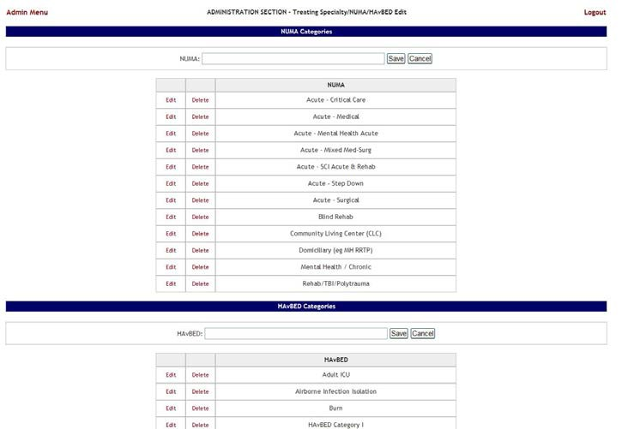

Figure 289 – Administration Section – Treating Specialty/NUMA/HAvBED Edit

In this page the user can add, edit and delete NUMA and HAvBED treating specialties. Also the user can map the defined VistA specialties with the NUMA and HAvBED treating specialties.

#### 4.9.9.1 Adding a NUMA Specialty

In the **Administration Section** page click the **Treating Specialty/NUMA/HAvBED Edit** link to display the page in the following image.

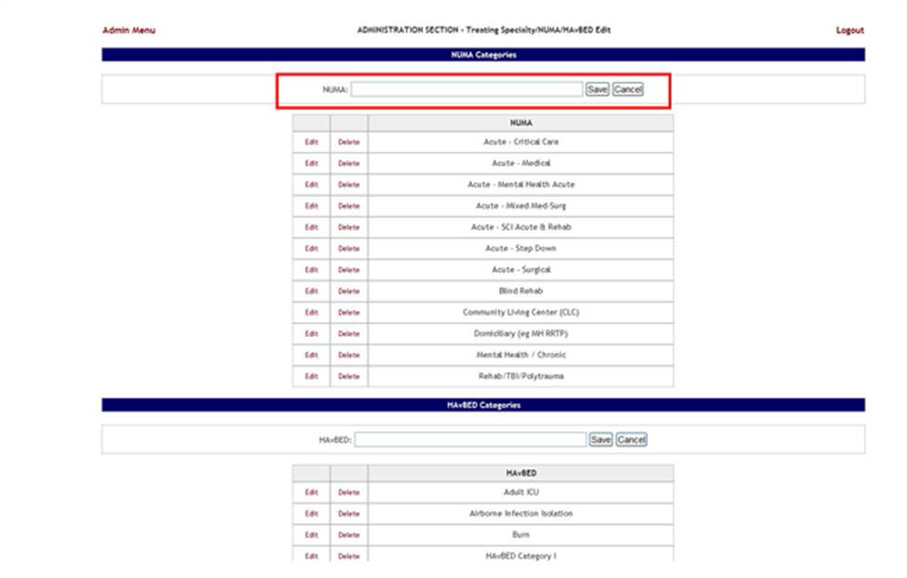

Figure 290 – Administration Section – Treating Specialty/NUMA/HAvBED Edit

A list of NUMA specialties already defined is available.

To add a NUMA specialty: enter the name of the new NUMA specialty in the NUMA field then press the Save button. The newly added specialty will be displayed in the NUMA list.

#### 4.9.9.2 Adding a HAvBED Specialty

In the **Administration Section** page click the **Treating Specialty/NUMA/HAvBED Edit** link to display the page in the following image.

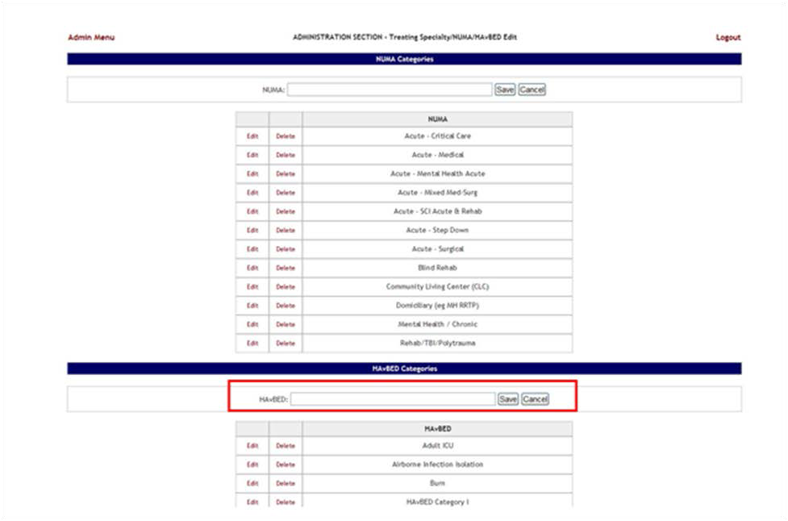

Figure 291 – Administration Section – Treating Specialty/NUMA/HAvBED Edit

A list of HAvBED specialties already defined is available.

To add a HAvBED specialty: enter the name of the new HAvBED specialty in the HAvBED field then press the Save button. The newly added specialty will be displayed in the HAvBED list.

#### 4.9.9.3 Editing a NUMA/HavBED Specialty

To edit an existing NUMA specialty: in the **Administration Section - Treating specialty/NUMA/HAvBED Edit** page click the **Edit** link associated to the NUMA specialty you want to edit: its name will be displayed in the **NUMA** field at the top of the list. Make the desired changes then press the **Save** button. The NUMA Categories list will display the modified NUMA specialty.

To edit an existing a HAvBED specialty: in the **Administration Section - Treating specialty/NUMA/HAvBED Edit** page click the **Edit** link associated to the HAvBED specialty you want to edit: its name will be displayed in the a **HAvBED** field at the top of the list. Make the desired changes then press the **Save** button. The HAvBED Categories list will display the modified a HAvBED specialty.

#### 4.9.9.4 Deleting a NUMA/HavBED Specialty

To delete an existing NUMA specialty: in the **Administration Section - Treating specialty/NUMA/HAvBED Edit** page click the **Delete** link associated to the NUMA specialty you want to delete. The NUMA Categories list will be updated to reflect the change.

To delete an existing HAvBED specialty: in the **Administration Section - Treating specialty/NUMA/HAvBED Edit** page click the **Delete** link associated to the HAvBED specialty you want to delete. The HAvBED Categories list will be updated to reflect the change.

#### 4.9.9.5 Mapping a VistA specialty with a NUMA/HavBED Specialty

In the **Administration Section** page click the **Treating Specialty/NUMA/HAvBED Edit** link to display the page in the following image. (Use the scroll bar to display the VistA Specialty Crosswalk section)

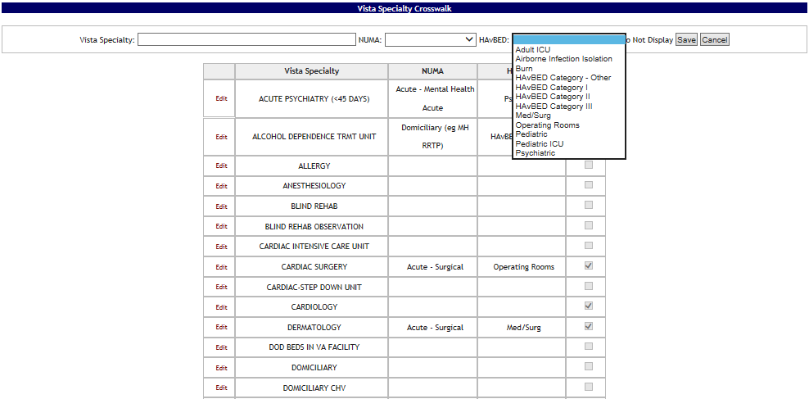

Figure 292 – Mapping A VistA Specialty with NUMA/HAvBED Specialty

A list of VistA specialties is displayed with existing NUMA and/or HAvBED specialties mappings. To associate a VistA Specialty with a NUMA/HAvBED specialty: click the **Edit** link to the left of the

VistA specialty to which you want to associate NUMA/HAvBED specialties. The name of the selected VistA specialty will be displayed in the **VistA Specialty** field. From the **NUMA** and **HAvBED** fields select the desired specialties then press the **Save** button. The association defined will be displayed in the VistA Specialty Crosswalk list.

Also note that the Vista Specialty Crosswalk provides the ability to hide specialties by selecting the appropriate “Hidden” checkboxes as in the screenshot below:

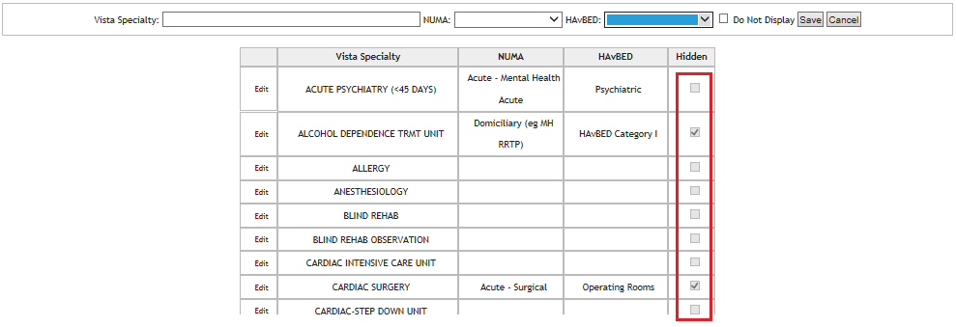

Figure 293.1 –Hiding a NUMA/HAvBED Specialty

### National Waiting Area

To access the National Waiting Area page, in the Administration Section page click the National Waiting Area link.

The **National Wa**i**ting Area Add/Edit** page is displayed as in the following image.

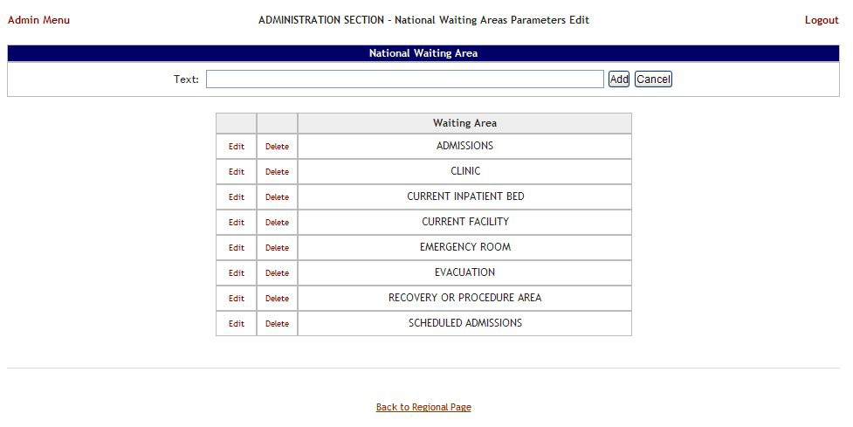

Figure 294 – National Waiting Areas

This is where you will add the locations for patients pending bed placement. These entries will appear on all sites and cannot be edited or deleted.

The options in the upper part of the screen allow the support user to define/add a new national waiting area in the system.

The list in the lower part of the screen presents the national waiting areas already defined in the system.

The links Edit and Delete to the left of each entry in the list allow the support user to modify the name of the selected waiting area or to delete the entry from the system.

To go back to the **Administration Section** page click the link **Admin Menu** in the upper left corner of the page.

#### 4.9.10.1 Adding a National Waiting Area

To add a national waiting area*,* follow the instructions below.

From the **Administration Section** page, click the **National Waiting Area** link.

The **National Waiting Area** page is displayed as in the image below.

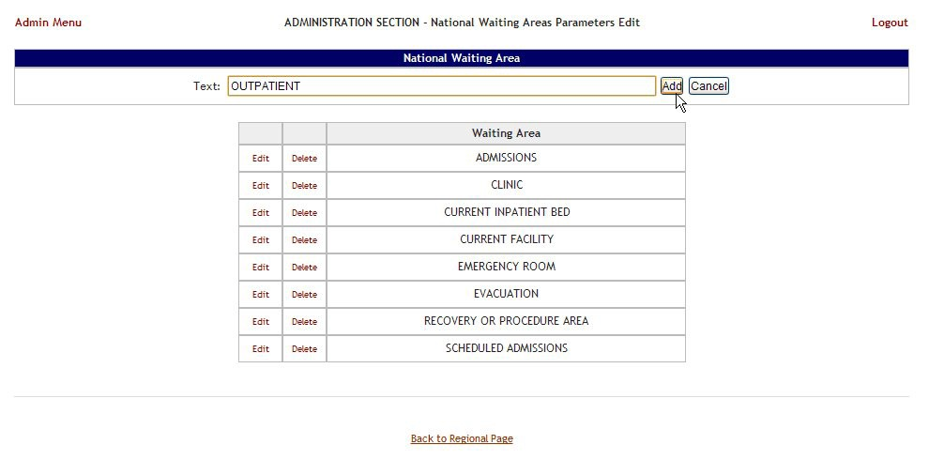

Figure 295 – Adding a Waiting Area

In the Text field from the ADD Area enter the name of the new waiting area, then, press the Add button: a confirmation message is displayed and the newly added waiting area is displayed in the Waiting Area list.

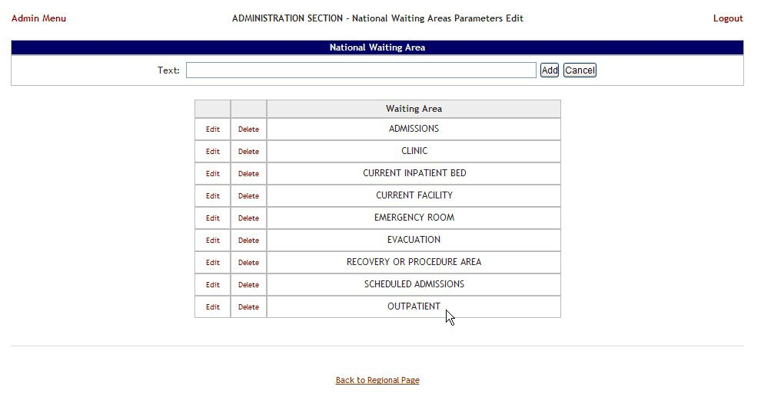

Figure 296 – Waiting Area Added to the List

#### 4.9.10.2 Editing a National Waiting Area

To edit the name of an existing national waiting area*,* follow the instructions below. From the **Administration Section** page, click the **National Waiting Area** link.

Figure 297Selecting National Waiting Area

The **National Waiting Area** page is displayed as in the image below.

This is a picture of the ADMINISTRATION SECTION - National Waiting Areas Parameters Edit page, showing the selection of an Edit link to the left of a Waiting Area.

Figure 298 – Selecting Waiting Area for Edit

Selecting the **Edit** link will display the page in the following image.

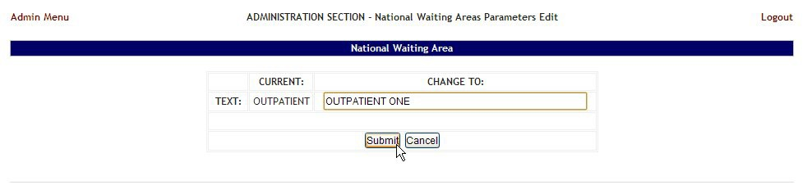

Figure 299 – Edit Waiting Area Name

In the field **CHANGE TO:** enter the new name for the national waiting area then press the **Submit** button. A confirmation message will be displayed and the national waiting area with the new name will be displayed in the Waiting Area list.

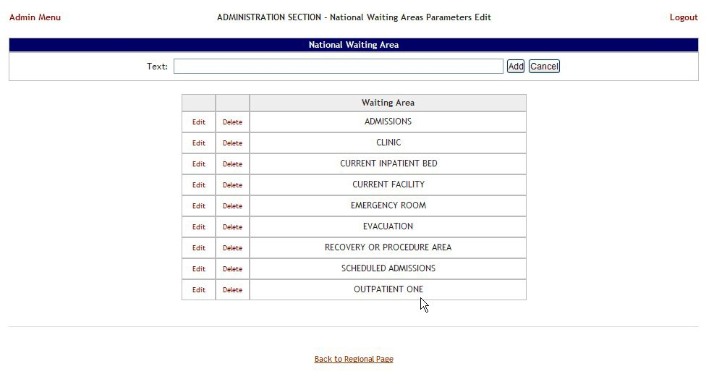

Figure 300 – Waiting Area Edited

#### 4.9.10.3 Deleting a Waiting Area

To delete a national waiting area defined for the current facility*,* follow the instructions below. From the **Administration Section** page, click the **National Waiting Area** link.

Figure 301 – Selecting National Waiting Area

The **National Waiting Area** page is displayed as in the image below.

.

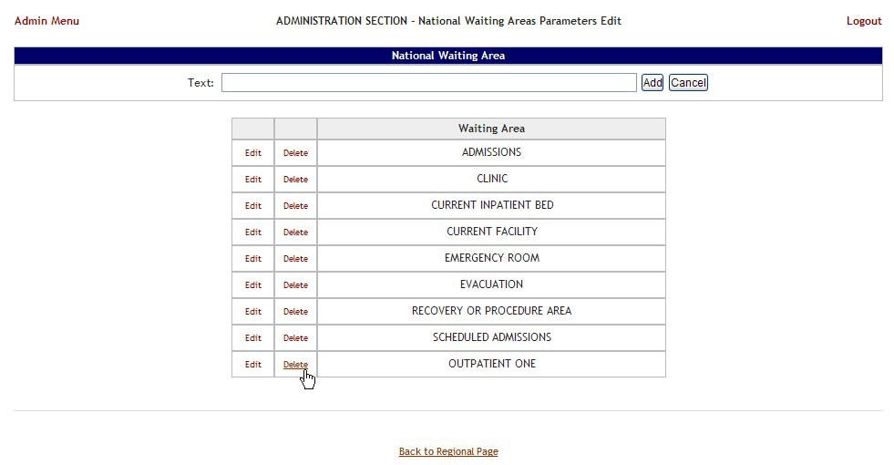

Figure 302 – Select a National Waiting Area for Deletion

Click the **Delete** link associated to the waiting area that you want to delete: a confirmation screen is displayed as in the following image.

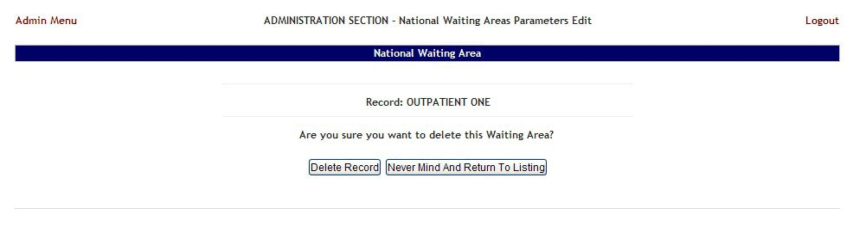

Figure 303 – Deleting a National Waiting Area

Click the **Delete Record** button to delete the national waiting area from the list.

### National Unavailable Reason

To access the National Unavailable Reason page, in the Administration Section page click the National Unavailable Reason link.

The **National Unavailable Reason** page is displayed as in the following image.

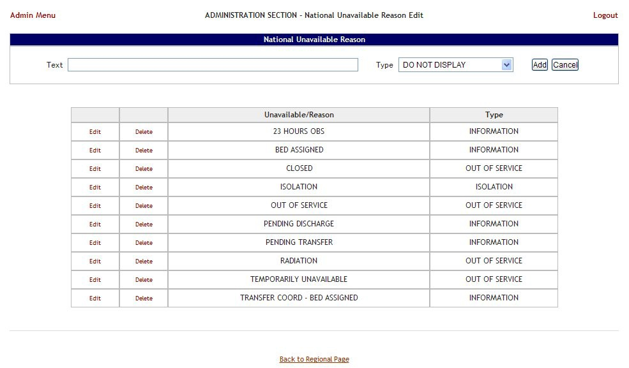

Figure 304 – National Unavailable Reason Page

The options in this page allow the support user to add a new national *unavailable reason*.

The list in the lower part of the screen presents the national *unavailable* reasons already defined in the system.

For each entry in the list, the following data is available:

Table 58 – Unavailable Reason Parameters

|  |  |
| --- | --- |
| **Column** | **Description** |
| Unavailable Reason | The reason why a bed is made unavailable. |
| Type | The type of reason. |

The links **Edit** and **Delete** allow the support user to modify the details of a reason or delete it from the system.

The link **Admin Menu** in the upper left corner of the page allows the support user to go back to the Administration Section **page.**

#### 4.9.11.1 Adding an National Unavailable Reason

To add a national *unavailable reason,* follow the instructions below.

From the Administration Section page, click the National Unavailable Reason link.

The **National Unavailable Reason** page is displayed as in the following image.

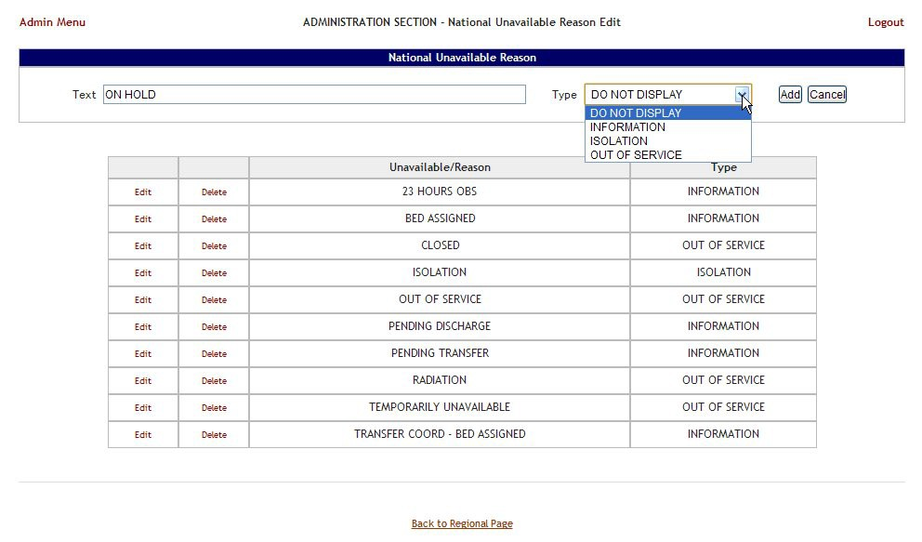

Figure 305 – Adding a National Unavailable Reason

In the **Text** field enter the explanation, the reason for the bed unavailability then, from the **Type** field select the type of reason, and click the **Add** button.

In the **Type** field, four types of ‘unavailable’ reasons can be selected:

* Information (no icon appears on the whiteboard)
* Isolation (isolation icon appears on the whiteboard)
* Do Not Display (bed does not appear on the whiteboard)
* Out of Service (bed is colored RED on the whiteboard).

The newly defined reason will be added to list of existing reasons.

You can use the **Edit** link to modify either the text or the type of the reason. Use the **Delete** link to remove the link from the list.

#### 4.9.11.2 Editing an National Unavailable Reason

To edit a national *unavailable reason,* follow the instructions below.

From the Administration Section page, click the National Unavailable Reason link.

The **National Unavailable Reason** page is displayed as in the following image.

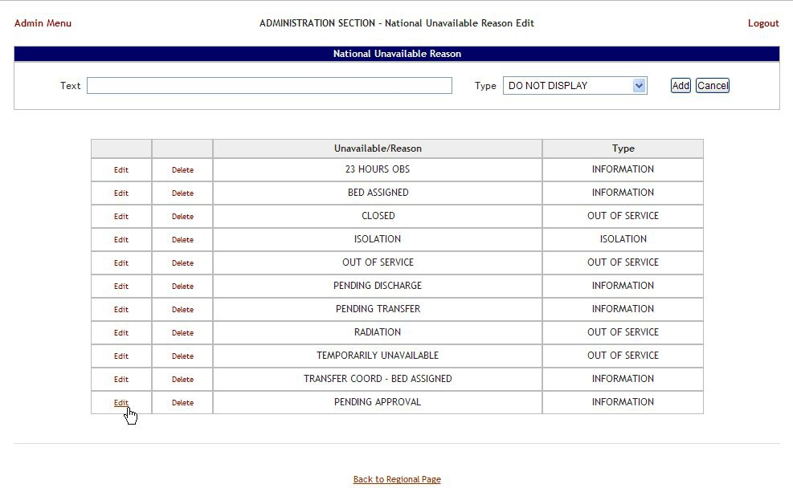

Figure 306 – Selecting Unavailable Reason for Edit

Click the **Edit** link associated to the national *unavailable reason* that you want to modify; the following page is displayed:

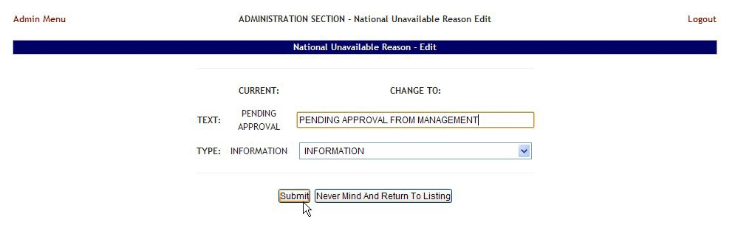

Figure 307 – Editing an Unavailable Reason

Operate the desired changes in the **Text** and/or **Type** fields then press the **Submit** button to enter the data into the system.

#### 4.9.11.3 Deleting a National Unavailable Reason

To delete a national *unavailable reason,* follow the instructions below.

From the Administration Section page, click the National Unavailable Reason link.

The **National Unavailable Reason** page is displayed as in the following image.

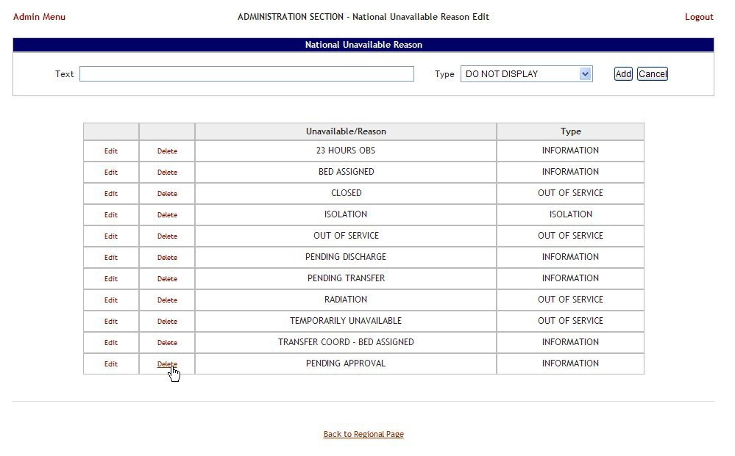

Figure 308 – Selecting a National Unavailable Reason for Deletion

Click the **Delete** link associated to the national *unavailable reason* that you want to delete: a confirmation screen is displayed as in the following image.

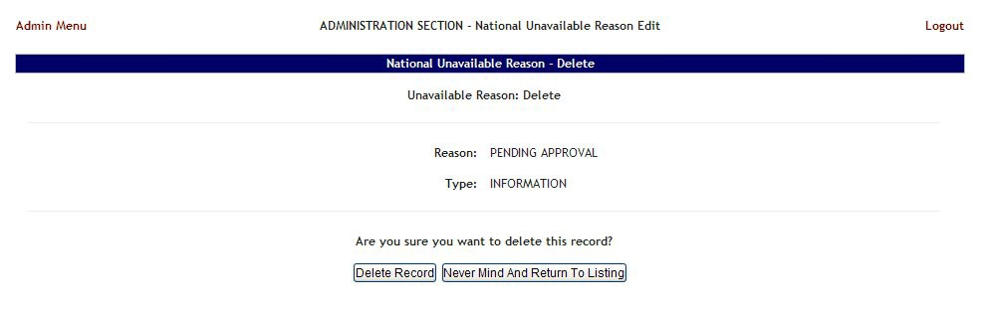

Figure 309 – Delete a National Unavailable Reason

Click the **Delete Record** button to delete the national *unavailable reason* from the list

### Background Processors Page

This section is used to determine which are the VA facility sites sharing the same VistA instance, to set up the Schedulers, to determine the Categories which will be affected by the Schedulers’ action (VistA Integration), to set up the scope of the Audit action, NUMI and Whiteboard report.

The **Background Processors** page is displayed as in the following image.  
  
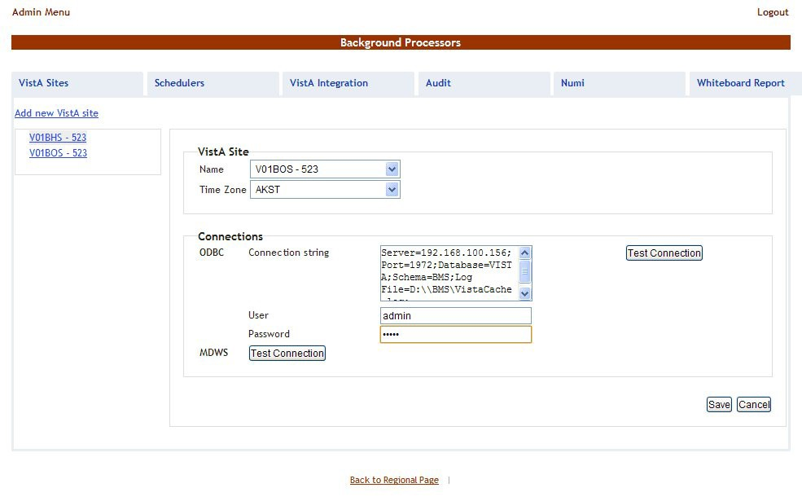

Figure 310 – Background Processors Page

Six tabs are available in the Background Processors page: **VistA Sites**, **Schedulers**, **VistA Integration**, **Audit**, **NUMI** and **Whiteboard Report**. The following sections contain the detailed description of the options available in each tab.

#### 4.9.12.1 VistA Sites

The **VistA Sites** page allows the user to view the list of VA facility sites sharing the same VistA instance, and to to add a new VA facility to a VistA instance.

To add a VA facility site to a VistA instance follow the steps presented below.

From the **Background Processors** page select **VistA Sites** to display the page shown in the following figure.

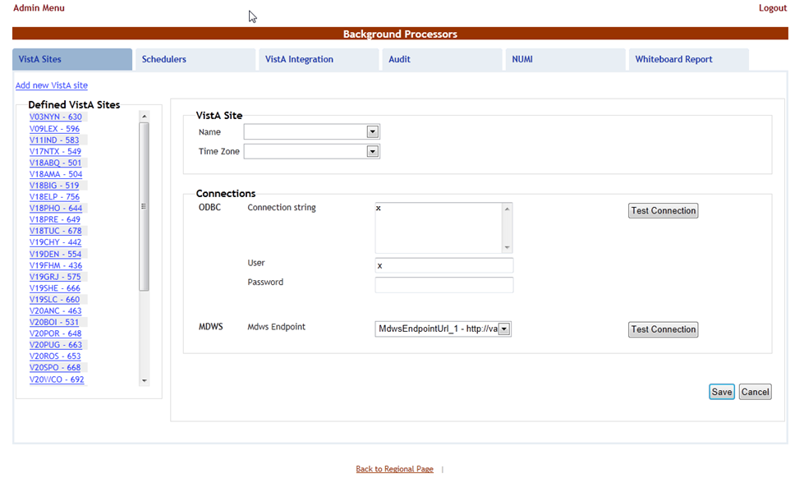

Figure 311 – Background Processors Page – Adding a VistA Site

A list of VA facility sites is displayed in the column to the left of the page.

Click the **Add new VistA site** link then, from the VistA Site area use the **Name** field to select the site you want to add to the current VistA instance then select the **Time Zone**.

In the Connections area you can choose between two connection methods: ODBC and MDWS. NOTE: At this time BMS does not use ODBC to connect to Vista. Enter “**x**” in the **Connection Sting**, **User**, and **Password** fields.

Table 59 – New VistA Site Parameters

|  |  |
| --- | --- |
| **Column** | **Description** |
| Connection String | The connection string for the ODBC method. |
| User | The username for the connection. |
| Password | The password associated to the user account. |
| MDWS Endpoint | The specific instance of MDWS that the individual site will bind too. |

After you have filled in the required data use the **Test Connection** buttons to verify the connection and press the **Save** button to enter the data into the system.

The newly added site will be added in the sites list to the left of the screen.

#### 4.9.12.2 Schedulers

The **Schedulers** page displays a list of defined schedulers and allows the support user to add new ones. NOTE: in this page you can only define the schedulers, to actually run the defined schedulers you have to use thin in the **VistA Integration** tab, see the VistA Integration section for details.

The **Schedulers** page is displayed as in the following image.

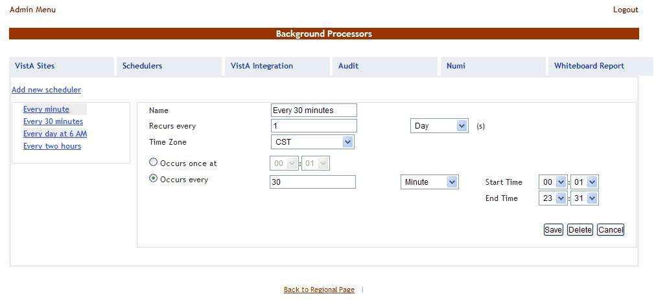

Figure 312 – Schedulers page

#### 4.9.12.3 Adding a new scheduler

To add a new scheduler follow the steps presented below.

From the **Background Processors** page select the **Schedulers** tab. In the **Schedulers** tab fill in the following data:

Table 60 – New Scheduler Parameters

|  |  |
| --- | --- |
| **Column** | **Description** |
| Name | The name of the scheduler. |
| Recurs every | The frequency. |
| Occurs once at/Occurs every | The frequency values. |

After you have set the desired frequency for the new scheduler do not forget to press the **Save** button to enter the data into the system.

#### 4.9.12.4 VistA Integration

The **VistA Integration** tab is used to run (automatically or manually) the defined schedulers and to select which data categories will be affected by a scheduler’s action.

The **VistA Integration** tab is displayed as in the following image.

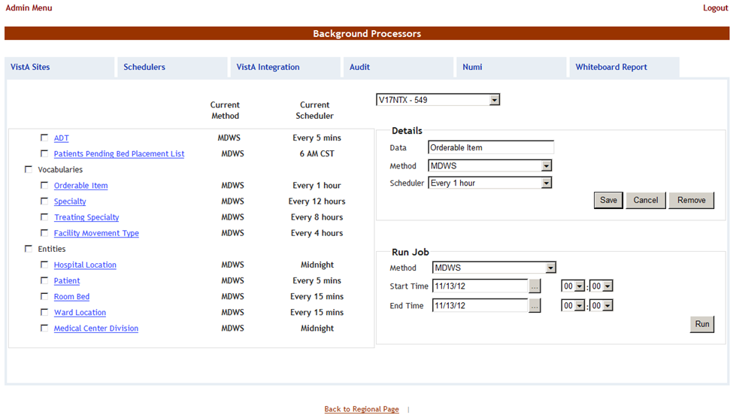

Figure 313 – VistA Integration Tab

From the field in the upper part of the page, select the VistA site where the scheduler(s) will run.

* To setup a scheduler for any of these jobs, click one data category from the column on the left (its name will appear in the Data field) and then select a method and scheduler from the Method and Schedulers fields in the Details area and click the Save button. This will cause the selected scheduler to run at the time set for it in the Schedulers tab and to retrieve the data from VistA for the selected category.
* To Execute/Run any of the data jobs, select any of the data categories using the check-boxes, select a connection method from the Run Job area, set the Start time/End time, and click the Run button. This will cause the selected scheduler to run using the selected method and retrieve the data from VistA for the selected data categories.

Here is a brief description of the VistA data gathering jobs:

**ADT:** the job will query from VistA ADT data (Orders, Movements, Scheduled Admissions, Patient Appointments) dated since the last run. Typically this job should be scheduled to run at least every 5 minutes. The movements are processed into BMS and are reconciled back the number of days governed by a configuration setting in BMS. Currently this configuration setting is set to reconcile back 60 days.

**Patient Pending Bed Placement List:** the job will look into the Scheduled Admission VistA file and extracts all the entries that have the “reservation date” field due for the current day. For these items the job adds associated entries into the facility patients pending bed placement list. Typically if a facility chooses to run this job it would be scheduled once a day in the early morning.

**Vocabularies:**

**Orderable Items:** the job will look into the Orderable Items VistA file and gets into BMS all the modifications discovered in Vista (items newly added and items updated). Typically this job should be scheduled to run once a day at Midnight.

**Specialty:** the job will look into the Specialty VistA file and gets into BMS all the modifications discovered in Vista (items newly added and items updated). Typically this job should be scheduled to run once a day at Midnight.

**Treating Specialty:** the job will look into the Treating Specialty VistA file and gets into BMS all the modifications discovered in Vista (items newly added and items updated). Typically this job should be scheduled to run once a day at Midnight.

**Facility Movement Type:** the job will look into the Facility Movement Type VistA file and gets into BMS all the modifications discovered in Vista (items newly added and items updated). Typically this job should be scheduled to run once a day at Midnight.

**Entities:**

**Hospital Location:** the job will look into the Hospital Location VistA file and gets into BMS all the modifications discovered in VistA (items newly added and items updated). Also for the items that are Wards, the Ward list in BMS is updated accordingly. Typically this job should be scheduled to run once a day at Midnight.

**Patient:** the job will look into the Patient file and gets all the patients that have been added since the last run (they are filtered by the “date entered into file” field). Typically this job should be scheduled to run at least every 5 minutes.

**Room Bed:** the job will look into the Room Bed VistA file and gets into BMS all the modifications discovered in Vista (items newly added and items updated, also Beds Set Out of Service or Returned into Service. Typically this job should be scheduled to run at least every 15 minutes.

**Ward Location:** the job will look into the Ward Location VistA file and gets into BMS all the modifications discovered in Vista (items newly added and items updated). Typically this job should be scheduled to run at least every 15 minutes.

**Medical Center Division:** the job will look into the Ward Location VistA file and gets into BMS all the modifications discovered in Vista (items newly added and items updated). Typically this job should be scheduled to run once a day at Midnight.

#### 4.9.12.5 Audit

The Audit tab displays the results of the operations performed in the VistA Integration tab. The **Audit** tab is displayed as in the following image.

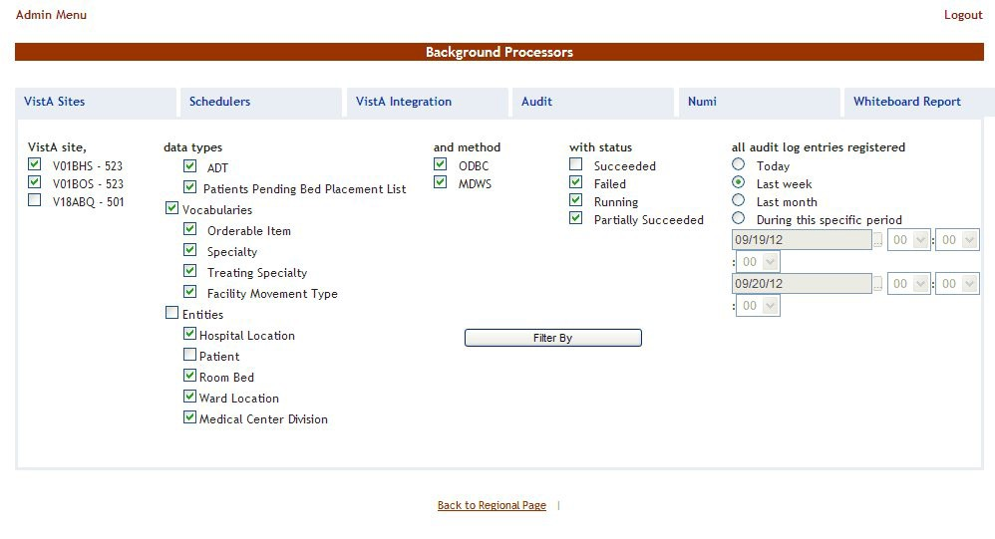

Figure 314 – Audit Page

The options to the left of the page allow the user to determine the filter criteria for the generated audit reports. The options to the right of the screen allow the user to select the type of operation to be captured by the audit report as well as the time interval for the audit.

After you have selected the desired criteria click the **Filter By** button to display the page as in the following image.

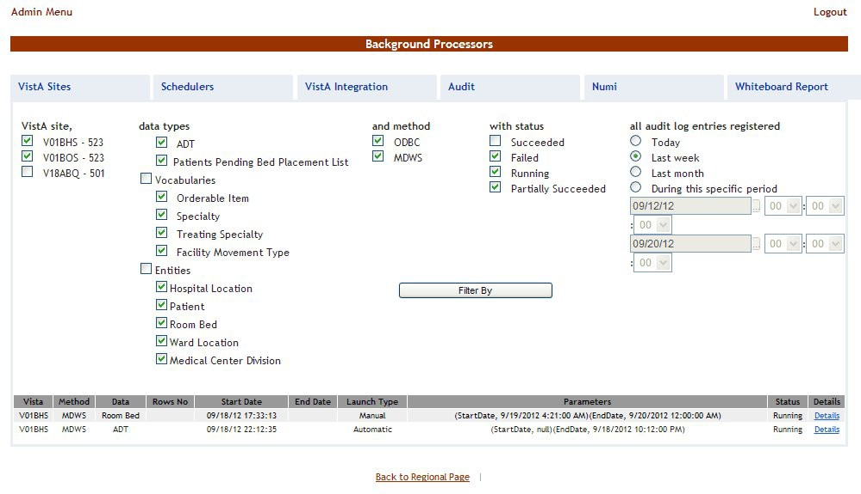

Figure 315 – View Audit Results

A list of operations is displayed, for each entry the following data is available:

Table 61 – Patients in Community Hospitals - Active Report

| **Column** | **Description** |
| --- | --- |
| VistA | The VistA site where the audit action has been performed. |
| Method | The method used for connecting to the VistA site. |
| Data | The type of data retrieved by the VistA integration operation. |
| Rows no | The number of operations of the selected type captured by the audit action. |
| Start Date | The start date of the retrieval operation. |
| End Date | The end date of the retrieval operation. |
| Launch Type | The way the audit action has been launched. |
| Parameters | The start date and time and the end date and time of the audit operation. |
| Status | The status of the VistA integration action. |
| Details | Clicking this link will display the number of entries in the report. |

#### 4.9.12.6 NUMI

The **NUMI** tab is used to select the scheduler that will connect to the NUMI server, and will retrieve data for a certain VistA site.

The **NUMI** tab is displayed as in the following image.

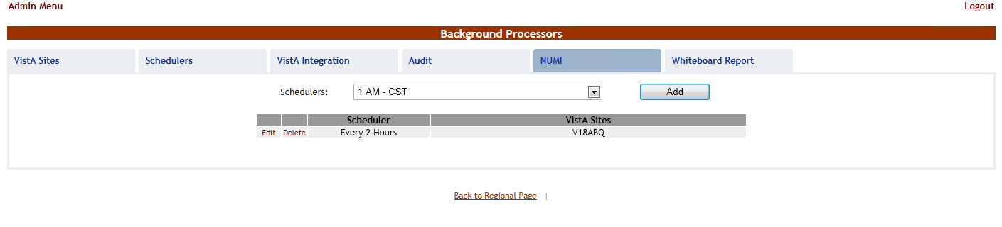

Figure 316 – NUMI Page

From the **Schedulers** field select the scheduler created to retrieve the NUMI data then click the **Add**

button: following page is displayed.

 **Note:** It is not recommended that any VistA Site Schedule the NUMI Background process to run m**o**re frequently than every 2 hours. Doing so may reduce overall system performance.

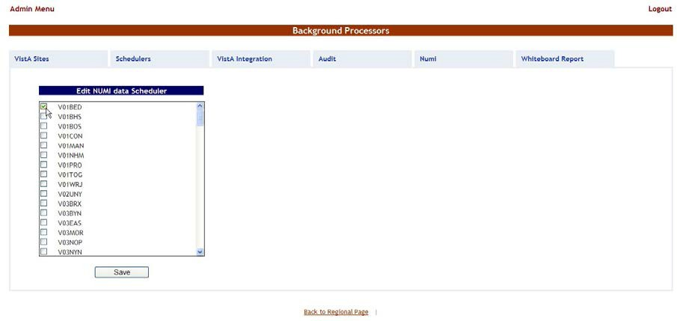

Figure 317 – Selecting the VistA Site for Which to Gather NUMI Data

Select the VistA site for which the selected scheduler will retrieve NUMI data then press the **Save** button. Use the **Edit** link to select a different site for which the scheduler should retrieve NUMI data.

#### 4.9.12.7 Whiteboard Report

The **Whiteboard Report** tab is used to select the scheduler that will gather data for the Whiteboard report. For details on the Whiteboard report see the section Generate the whiteboard report for the selected wards.

The **Whiteboard Report** tab is displayed as in the following image.

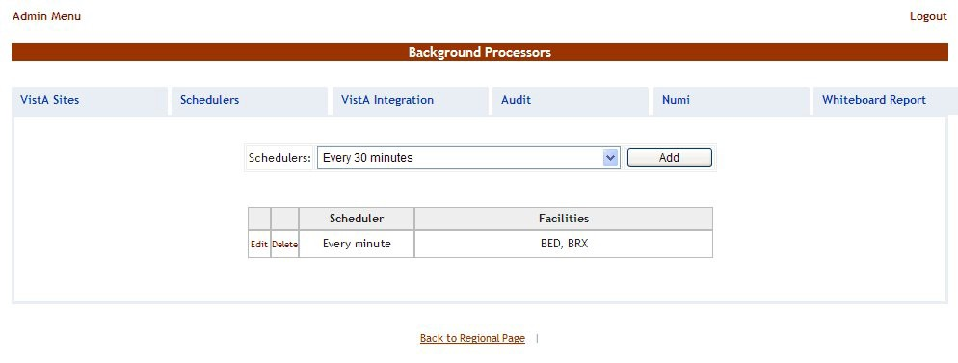

Figure 318 – Whiteboard Report page

From the **Schedulers** field select one of the schedulers defined then press the **Add** button to display the following image.

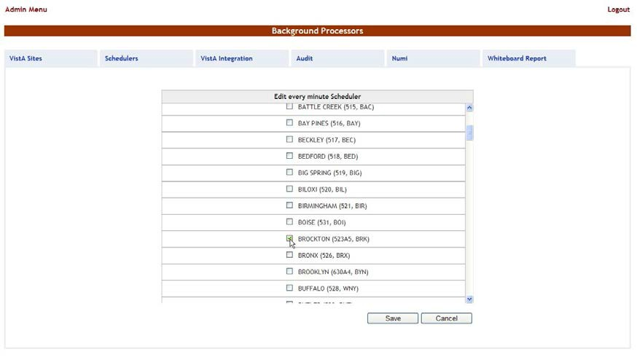

Figure 319 – Selecting the Facility Site Where to Run the Scheduler for the Whiteboard Report

The name of the selected scheduler is displayed in the upper part of the screen. Also a list of VistA sites is displayed: select the site(s) where you want the scheduler to run then press the **Save** button.

# Troubleshooting

The BMS project team is working to develop a frequently asked questions (FAQs) section for this User Guide, which will contain user-related troubleshooting tips, known issues, and anomalies. This section will be made available as those items are realized and documented.

# Acronyms/Glossary

In addition to the acronyms defined below, the OI&T Master Glossary can be found at: <http://vaww.oed.wss.va.gov/process/Library/master_glossary/masterglossary.htm>

Table 62 – Acronyms/Glossary

| **Term** | **Definition** |
| --- | --- |
| ADT | Admission, Discharge, and Transfer |
| BMS | Bed Management Solution |
| BN | Business Need |
| BRD | Business Requirements Document |
| CFM | Comprehensive Flow Management |
| CH/CL | Community Hospital / Current Location |
| CHF | Congestive Heart Failure |
| CLC | Community Living Center |
| COW | Computer on Wheels |
| CPRS | Computerized Patient Record System |
| D/C | Discharge |
| DM | Diabetes Mellitus |
| DOB | Date of Birth |
| DOM | Domiciliary |
| DRG | Diagnostic Related Group |
| DUSH | Deputy Under Secretary for Health |
| ED | Emergency Department |
| EMS | Environmental Management Service |
| EMSHG | Emergency Management Strategic Healthcare Group |
| ERR | Enterprise Requirements Repository |
| FAQs | Frequently Asked Questions |
| FIPS | Federal Information Processing Standard |
| GUI | Graphical User Interface |
| HavBed | Hospital Available Beds for Emergencies & Disasters |
| HVAC | House Veterans Affairs Committee |
| ICU | Intensive Care Unit |
| IEN | Internal Entry Number. The primary keys for VistA files. |
| IT | Information Technology |
| LOS | Length of Stay |
| MDWS | Medical Domain Web Service |
| M (MUMPS) | Massachusetts General Hospital Utility Multi-Programming System |
| NIST | National Institute of Standards and Technology |
| NUMA | Nursing Unit Mapping Application |
| NUMI | National Utilization Management Integration |
| ODBC | Open Database Connectivity |
| OED | Office of Enterprise Development |
| OOS | Out of Service |
| OI&T | Office of Information and Technology |
| PICC | Peripherally Inserted Central Catheter |
| PT | Patient |
| SSN | Social Security Number |
| Service Era or ERA | The period of service that the patient served. |
| STAT | Indicates an emergent or extremely urgent situation |
| TAG | Flow Improvement Technical Advisory Group |
| UM | Utilization Management |
| VA | Department of Veterans Affairs |
| VAMC | VA Medical Center |
| VHA | Veterans Health Administration |
| VISN | Veterans Integrated Service Network |
| VistA | Veterans Health Information Systems and Technology Architecture |

# Index

**A**

Active Admission Orders Report.................... 112, 113, 115

Adding a Discharge Appointment Location 48

Adding a patient to the Patients in Community Hospitals List 163

Adding a VistA ward ..................................................13, 15

Adding a Waiting Area .............................................71, 197

Adding an ADT Orderable Item 19

Adding an EMS Bed Notification 23

Adding an Event Notification .....................................51, 67

Adding an Unavailable Reason.................................41, 203

Anticipated Discharge Report 114

**B**

Bed Summary Report 115

Bed Turnaround Time Report 117

Beds Out of Service Report (All) 119

Beds Out of Service Report (by Date) 120

**D**

Data grids Sort columns 9

Discharges in Progress Report 123

**E**

Edit BMS Site 182

Editing a Waiting Area ............................... 73, 76, 198, 200

Editing an Event Notification .....................................53, 55

Editing an Unavailable Reason .................................43, 205

Editing the details of a patient 166

Editing the details of an entry in the Patients Waiting for a Bed 100

EMS Bed Status 124

**F**

Finalizing a patient’s stay in the Community Hospital... 166 Future Discharge Report 125

**P**

Patient Movement Report 109

Patient Movements by Date 126

**R**

Removing patient from waiting list 101

**S**

Scheduled Admissions by Date 127

Scheduled Admissions Report 108

Setting a Facility or ED to Diversion Status 132

Sort columns 9

**T**

Taking a bed out of service 138

**W**

What is BMS 3